Appendix to the 2013 BSAI Tanner Crab SAFE Report:

Recruitment Analysis for Stock Status Determination and Harvest Recommendations

William T. Stockhausen

Alaska Fisheries Science Center

9 April 2013

THIS INFORMATION IS DISTRIBUTED SOLELY FOR THE PURPOSE OF PREDISSEMINATION PEER REVIEW UNDER APPLICABLE INFORMATION QUALITY GUIDELINES. IT HAS NOT BEEN FORMALLY DISSEMINATED BY NOAA FISHERIES/ALASKA FISHERIES SCIENCE CENTER AND SHOULD NOT BE CONSTRUED TO REPRESENT ANY AGENCY DETERMINATION OR POLICY

# Introduction

In June 2012, following recommendations by both the Crab Plan Team (CPT) and its own Science and Statistical Committee (SSC), the North Pacific Fishery Management Council accepted the Tanner Crab Stock Assessment Model (TCSAM) developed by Rugolo and Turnock (2012) for use in management of the Tanner crab fishery in 2012. The Council also approved further recommendations by the CPT and SSC that Tanner crab be assessed as a Tier 3 stock for determining stock status and overfishing levels.

Tier 3 stocks are regarded as having reliable estimates of current spawning biomass (*B*), *F35%* and *B35%* (as proxies for *Fmsy* and *Bmsy*, respectively; NMFS 2008). Estimation of *F35%* is based on a spawning biomass-per-recruit analysis: if *φ100%* is the spawning biomass-per-recruit for the unfished stock as determined by the assessment model, then *F35%* is the fishing mortality rate that results in a spawning biomass-per-recruit equal to *φ* = *φ35%* = 0.35 x *φ100%*. Once *φ100%* and *F35%* have been estimated, then $B_{35\%}=\overline{R}∙ϕ_{35\%}=0.35∙\overline{R}∙ϕ_{100\%}$, where $\overline{R}$ represents average recruitment when the stock is harvested at maximum sustainable yield (MSY). For Tier 3 stocks, $\overline{R}$ cannot be determined directly because a reliable stock-recruitment relationship does not exist for these stocks (hence the use of proxies for MSY). Instead, $\overline{R}$ for Tier 3 stocks should be average recruitment over a time period “representative of the stock being fished at an average rate near *Fmsy*” (i.e., *F35%* for Tier 3 stocks) and thus “fluctuating around *Bmsy*” (NMFS 2012). For Tanner crab, spawning biomass is taken as mature male biomass at time of mating (*MMB*).

The assessment authors provided 5 scenarios for estimating $\overline{R}$ as average recruitment from the accepted TCSAM results: 1) R1: 1966-1972, 2) R2: 1966-1988, 3) R3: 1982-2012, 4) R4: 1966-2012, and 5) R5: 1990-2012 (Rugolo and Turnock, 2012). The range of years for each scenario refers to the years at which recruits enter the population, not the years at which fertilization is assumed to occur (the latter can be obtained by subtracting 5). The assessment authors recommended using R2 (SSC, 2012) to determine $\overline{R}$, as this range of years “…although it includes recruitments that did not result from a stock at BMSY nor that subsequently yielded *Bmsy*, it captures the mode of secondary *MMB* in 1990 but not beyond mid-1990 when the stock was declared overfished” (Rugolo and Turnock, 2012). The CPT recommended using R5 based on a breakpoint analysis of stock recruitment relationships by Andre Punt (Punt, 2012) conducted during the Sept. 2012 CPT meeting that identified a potential change in stock productivity (i.e., in the stock-recruit relationship) in fertilization year 1985, corresponding to recruitment year 1990 (CPT, 2012).

The SSC was hesitant to accept either the assessment authors’ or the CPT’s recommendations, and instead recommended using R3 as an interim measure pending “…further analysis of alternative recruitment time periods by the stock assessment authors and Crab Plan Team to include options based on years in which recruitment was [reasonably] estimated, additional breakpoint analyses, and evidence for shifts in Tanner crab life history and ecology.” The SSC also requested that “that one option should include a time series spanning the extent of reasonably estimated recruitments based on confidence intervals for recruitment…it would seem that this time series should start with fertilization years beginning in the late 1960s (e.g., 1966), corresponding to a years of recruitment to the model starting in the early 1970s (e.g., 1971).”

This appendix is an attempt to address some of the SSC’s requests regarding this issue. In it, I provide expanded results from a re-analysis of Andre Punt’s breakpoint analysis as well as results from applying 4 averaging methods to recruitment estimates from the accepted 2012 TCSAM over a variety of potential time intervals, including the R1-R5 scenarios considered in the 2012 SAFE chapter (Rugolo and Turnock, 2012) and one labeled “R6” corresponding to the SSC’s specific request to consider the 1971-2012 time frame. The analyses presented here are based on output from the accepted 2012 TCSAM (Model 0 in Rugolo and Turnock [2012]). The ADMB code for that model was revised by this author to provide additional model output used here. In doing so, it was realized that the original model output reflecting the estimated covariance matrix for ln(R/MMB) provided by Rugolo and Turnock to Andre Punt at the Sept. 2012 CPT Meeting was incorrect for one year (fertilization year 1969) due to an indexing error which did not otherwise affect the model results. Consequently, I have re-run Andre’s breakpoint analysis with the corrected TCSAM model output.

The author wishes to acknowledge and thank Jack Turnock and Lou Rugolo for providing the TCSAM model code and Andre Punt for providing his breakpoint analysis code and data.

# 2012 TCSAM Output

The time series of the 2012 TCSAM estimates for the ratio of total fishing mortality (*F*) to *F35%*, mature male biomass (MMB) at time of spawning, recruitment (R), and ln(R/MMB) are listed in Table 1 for the time period 1950-2007, with recruitment lagged to fertilization year assuming a 5 year span between fertilization year and recruitment into the model size classes. The recruitment and MMB time series are plotted, along with estimated 80% confidence intervals, for the period 1961-2007 in Fig. 1. MMB displays decadal-scale variability, building to its largest value in 1972 (359.3 thousand t), then declining to a local minimum in 1985 (21.5 thousand t), followed by an increase to a much smaller peak (72 thousand t) in 1989, declining again to a local minimum (14.6 thousand t) in 1999, and subsequently increasing to 56.7 thousand t in 2007. The largest uncertainties in MMB, both in absolute and relative terms, occurred early in the time series. After 1970, cv’s were less than 0.3. Estimated recruitment also displays decadal-scale variability, but this tends to be negatively correlated with MMB. The largest recruitments occur early in the time series, declining to a local minimum in 1969; these are also the least well estimated recruitments in terms of absolute uncertainties. However, the largest relative uncertainty in recruitment occurs in fertilization year 1975 (model year 1980; Fig. 2). Estimated cv’s are generally less than 0.3 after 1976 (model year 1981), the exceptions being 1990 (model year 1986) and 2007 (model year 2012).

The quantity ln(R/MMB) reflects stock productivity. The time series of ln(R/MMB) over the 1961-2007 fertilization year time period is plotted in Fig. 3, together with estimated 80% confidence intervals (MMB is plotted again for reference, as well). It also displays decadal-scale variability, but with no obvious trends over the entire time period. As with recruitment, this variability appears to be negatively correlated with MMB. A plot of ln(R/MMB) vs. MMB (Fig. 4) suggests that ln(R/MMB) is linearly related to MMB (and consequently follows a Ricker-type stock recruit relationship) but that the relationship exhibited different slopes in at least two time periods (fertilization years 1961 to early 1980s and early 1990s-2007).

# Average recruitment

Based on a simple average of estimated recruitment over the appropriate time period, $\overline{R}$ for the five recruitment scenarios considered in the 2012 SAFE chapter is: R1) 515 million, R2) 288 million, R3) 107 million, R4) 179 million, and R5) 73 million. As noted previously, $\overline{R}$ should be “representative of the stock being fished at an average rate near *Fmsy*”. Because *F35%* represents the Tier 3 proxy for *Fmsy*, the ratio *F/F35%* indicates when the stock was fished below or above *Fmsy* and provides a means for deciding when the stock was fished “at an average rate near *Fmsy*”. If one adopts the (not unreasonable but rather arbitrary) definition that “near” means $0.25≤F/F_{35\%}≤4$, this results in two time periods across which one might calculate $\overline{R}$: 1) 1973-1987 (excepting 1979), and 2) 1994-2002 (both time periods expressed as recruitment years, not fertilization years, to be consistent with scenarios R1-R5). Taking a simple average of estimated recruitment across these two time periods, one obtains $\overline{R}=140$ million, which results in *B35%* = 43.9 thousand t. Under this scenario, the MMB at mating in 2011/2012 would have been 1.34 *x* *B35%* and the stock would have been declared rebuilt, similar to status determinations obtained under scenarios R3, R4, and R5.

The SSC also requested “further analysis of alternative recruitment time periods…to include options based on years in which recruitment was [reasonably] estimated” in their October 2012 minutes (SSC, 2012). Based on the estimated cv’s for the recruitment estimates (Fig. 2), one might recommend model years 1981-2011 as a period in which recruitments were “reasonably” estimated because all cv’s except one were less than 0.3 in this time period. However, other choices for what constitutes a “reasonably” estimated recruitment estimate would result in other time periods being selected. As such, I’ve calculated average recruitment for the 5 recruitment scenarios considered in the 2012 SAFE report (Rugolo and Turnock, 2012; Table 2, Fig. 5), as well as all time periods of the form *y*-2012 for *y* from 1966 to 2007 (Table 3, Fig. 5). In this respect, the SSC specifically requested consideration of the 1971-2012 time period, which is referred to here as R6. The value of $\overline{R}$ for R6 using a simple average is 128 million, which results in *B35%* = 40 thousand t. Under this scenario, the MMB at mating in 2011/2012 would have been 1.46 *x* *B35%* and the stock would have been declared rebuilt, similar to status determinations obtained under scenarios R3, R4, and R5.

In addition to the “standard” calculation $\overline{x}=\frac{1}{N}\sum_{i=1}^{N}{x_{i}}$ for the average of a series of *N* observations {*xi*}, there are a variety of approaches to calculating averages that incorporate observations (i.e., the TCSAM recruitment estimates) with observation error. Here, I’ve considered three additional methods to calculate average recruitment over any given time period: a variance-weighted mean, a covariance-weighted mean, and a process-error weighted mean. All four methods can be calculated based on minimizing the following negative log-likelihood function with respect to its parameters

$-\ln\left(L\right)=0.5∙\ln\left(\left|Ω\right|\right)+0.5∙\sum_{i}{\sum_{j}{\left(y_{i}-{\hat{y}}_{i}\right)∙{[Ω^{-1}]}_{i,j}∙\left(y_{j}-{\hat{y}}_{j}\right)}}$ (1)

where ${\hat{y}}_{i}=\overline{R}$ is mean recruitment, $y_{i}=R_{i}$ is the recruitment estimate for year *i*, and $Ω$ incorporates observation and process error in the form $Ω=O+P$, where **O** is the observation error covariance matrix and **P** is the process error matrix. Here, **P** is assumed to reflect a first-order autoregressive process and has elements $P_{i,j}=σ_{}^{2}∙ρ^{|i-j|}$, where $σ_{}^{2}$ represents process error variance and $ρ$ represents the degree of autocorrelation.

For the standard, variance-weighted, and covariance-weighted methods, process error is ignored (both $σ_{}^{2}$ and $ρ$ are set to 0) and Eq. 1 is minimized with respect to the single parameter $\overline{R}$ (although there is really no need to perform the minimization numerically because exact solutions exist). For the standard method, **O** is simply a diagonal matrix with 1’s on the diagonal, although in this case estimates of uncertainty obtained from the model hessian are invalid. For the variance-weighted method, **O** is a diagonal matrix with $O_{i,i}=σ_{i}^{2}$, where $σ_{i}^{2}$ is the estimated variance of *Ri* (available from the .std or .cor file from an ADMB model run). For the covariance-weighted method, $O_{i,j}=σ_{i}^{}∙σ_{j}^{}∙ρ_{i,j}$, where $σ_{i}^{2}$ is (again) the estimated variance of *Ri* and $ρ_{i,j}$ is the estimated correlation between *Ri* and *Rj* (also available from the .cor file). For the process error-weighted method, **O** is the same matrix as in the covariance-weighted method and Eq. 1 is minimized with respect to the three parameters $\overline{R}$, $ln⁡(σ)$, and $tan⁡(ρ)$. Equation 1 was solved for each time period and each averaging method using the “mle” function from the R statistical package (Table 2, Figure 5). This analysis was also repeated on the log-scale recruitments and covariance structure, because the error structure in TCSAM is on the natural log scale (Table 3, Figure 6). This yielded estimates of median recruitment (once back-transformed to the arithmetic scale), not average (or mean) recruitment. Rather different results were obtained for the two data types (i.e., arithmetic vs. log-scale recruitment estimates), as well as for each averaging method for a given data type.

Using the arithmetic-scale recruitment estimates as inputs, the four averaging methods tended to give substantially different results for each time period (Table 2, Fig. 5). The standard method always yields the largest estimate, the process error-weighted method yields the next largest (~0.8 *x* standard), the variance-weighted method yields the third largest estimate (~0.4 *x* standard), and the covariance-weighted method always yields the smallest estimate (~0.1 *x* standard). For time periods of the form *y*-2012, the minimum average recruitment occurred for *y* = 1990 (coincident with the R5 scenario) for the standard, variance-weighted and process error-weighted methods. It occurred for *y* = 1969 or 1970 for the covariance-weighted method.

The averaging methods that weighted the arithmetic-scale “observations” (i.e., 2012 TCSAM recruitment estimates) by their estimated variances or covariances systematically shrank the estimates of average recruitment over any given time period relative to the standard (unweighted) method. This occurred because the estimated observation variances are positively correlated with the observations themselves, reflecting two factors. The first is that the largest recruitment estimates (observations) occur early in the time series before there is much support by the data going in to the TCSAM, and consequently these have large associated variances because there is little data to constrain them. The second is that recruitment in TCSAM is considered to be lognormally distributed, so that variance is fundamentally related to the observation in a positive fashion. The weighting methods used in Eq. 1, however, assume a normal distribution for the observation error structure and it may thus be inappropriate to use these methods to estimate average recruitment from arithmetic-scale observations using weighting methods.

Using the log-scale recruitment estimates as inputs, three of the four averaging methods (standard, variance- and process error-weighted) tended to give similar estimates of median recruitment for each time period (Table 3, Fig. 6), whereas the covariance-weighted method resulted in substantially higher estimates for time periods that started before 1988. For time periods starting after 1988, the covariance-weighted method also gave estimates that were similar to the other methods. For time periods of the form *y*-2012, the minimum median recruitment occurred for *y* = 1990 (coincident with the R5 scenario) for the standard, variance-weighted and process error-weighted methods (similar to the arithmetic-scale recruitment results), and in 1991 for the covariance-weighted method. Over these time periods, estimated median recruitments for the standard, covariance-weighted and process error-weighted methods varied by at most a factor of 2 (i.e., max/min). In contrast, estimates for the covariance-weighted method varied by a factor of 4.5.

Although using the estimated log-scale recruitments and corresponding variance/covariance components as inputs to various the averaging methods is more consistent with the error structure assumed in the TCSAM, one is then faced with the issue of converting the resultant log-scale estimated mean (median on the arithmetic scale) to the arithmetic scale in order to obtain $\overline{R}$. Typically, if R is lognormally-distributed such that $\ln\left(R\right)\sim N(\ln\left(\hat{R}\right),σ^{2})$, one could use $\overline{R}=\hat{R}∙e^{\frac{σ^{2}}{2}}$, where $\hat{R}$ is the median and $σ^{2}$ is the log-scale variance. However, it is somewhat unclear what value should be used for $σ^{2}$ to make the conversion. The simplest choice would be to use the value assumed in the TCSAM, but it could also be estimated from the TCSAM output and the residuals to the weighted fit.

# Breakpoint Analysis for Stock-Recruit Relationships

As noted above, the model output reflecting the estimated covariance matrix for ln(R/MMB) originally provided by Rugolo and Turnock to Andre Punt at the Sept. 2012 CPT Meeting was incorrect for fertilization year 1969 due to an indexing error which did not otherwise affect the model results. Consequently, I re-ran Andre’s breakpoint analysis with the corrected data.

The breakpoint analysis uses a negative log-likelihood in the form of Eq. 1, similar to that of the average recruitment analysis, but with $y_{i}={ln⁡(\frac{R}{MMB})}_{i}$, the observation error matrix **O** reflecting the covariance matrix for ln(R/MMB), and ${\hat{y}}_{i}$ as the model estimate

${\hat{y}}_{i}=\left\{\begin{matrix}α_{1}+β_{1}∙MMB & t_{i}<b \\ α_{2}+β_{2}∙MMB & b≤t_{i}\end{matrix}\right.$ (4)

where $α_{1}, β_{1}$ are the Ricker stock-recruit function parameters for the early time period before the potential breakpoint in year *b* and $α_{2}, β_{2}$ are the parameters for the time period after the breakpoint in year *b*. For each candidate breakpoint year b, Eq. 1 was minimized with respect to the six model parameters: $α_{1}, β_{1},$ $α_{2}, β_{2}$, $ln⁡(σ)$, and $tan⁡(ρ)$. The minimum time span considered as a potential regime was 5 years. Each fertilization year from 1966 to 2002 was evaluated as a potential breakpoint *b* using time series of ln(R/MMB) and MMB for fertilization years 1961-2007. A model with no breakpoint was also evaluated. Models with different breakpoints were then ranked using AICc (AIC corrected for small sample size, where

${AIC}_{c}=-2∙\ln\left(L\right)+\frac{2∙k∙(k+1)}{n-k-1}$, (3)

*k* is the number of parameters and *n* is the number of observations. Using AICc, the model with the smallest AICc is regarded as the “best” model among the set of models evaluated. Different models can be compared in terms of $θ_{m}$, the relative probability that the model with the minimum AICc score is a better model than model *m*, where

$θ_{m}=\exp{[\left({AICc}_{m}-{AICc}_{min}\right)}/2]$. (4)

Results from the breakpoint analysis are summarized in Tables 4-5 and Figures 7-9. The results obtained here are qualitatively similar to those obtained by Punt (2012), with a breakpoint in fertilization year 1985 (model year 1990) again resulting in the model with the smallest AICc (thus supporting the use of R5 as the period over which to calculate average recruitment; Table 4, Fig. 6). The model with no breakpoint (i.e., a single time period) is over 10 times less probable than the 1985 breakpoint model, suggesting reasonably strong evidence for a change in stock productivity. However, several alternative breakpoints (1974, 1975, 1983, 1984, 1986, and 1987) are also reasonably well-supported by the data, in addition to 1985. It may thus be more appropriate to calculate an average recruitment using the appropriately-weighted estimate from all candidate breakpoints (e.g., using the Akaike weights given in Table 4), rather than basing the average recruitment on only the “best” candidate.

An interesting point to note is that the two sets of “good” models (1974-75 and 1983-1987) imply two very different mechanisms for the presumed change in productivity between the putative early and recent periods. The 1974-75 models indicate that the major difference between the two periods is a decrease the in overall productivity at all stock sizes (i.e., a change in the α parameter; Table 5, Fig.s 8 and 9), whereas the 1983-1987 models indicate that the major difference is an increase in density dependent mortality (i.e., the β parameter). The former suggest a cause that resulted in a proportional effect on early life stage survival regardless of stock size, such as a shift in oceanographic patterns that resulted in reduced larval transport from hatching to benthic nursery areas. The latter suggest a cause that increased the degree of competition at larger stock sizes, such as a reduction in available habitat due to changes in the cold pool or a general decrease in carrying capacity. However, mechanisms of either type that would be consistent with these potential breakpoints have not (yet) been explored.

The plot of ln(R/MMB) vs. MMB (Fig. 4) also reveals a potential problem with the current analysis because the confidence intervals on MMB are extremely large early in the time series. This uncertainty is not taken into account in the breakpoint analysis; MMB is treated as known with error.

# Discussion

One of the complicating factors in determining a time period for Tanner crab over which to estimate $\overline{R}$ is that the highest recruitments and stock sizes co-occurred early in the modeled time period, with large associated uncertainties, while the lowest recruitments and stock sizes (with much smaller uncertainties) have co-occurred more recently. Attempts that weight the estimate of the mean by model uncertainty, either through the selected averaging method or by selecting a time period when recruitments are “well-estimated”, consequently result in lower estimates of mean recruitment than would be obtained otherwise. For a given estimate of current population size, weighting the estimate of mean recruitment by model uncertainty thus results in a lower *B35%*—and consequently a more optimistic perception of stock size relative to *Bmsy*—than would be obtained otherwise. Conversely, attempts that exclude the more recent period of low stock size and low recruitments result in larger estimates of mean recruitment, and consequently *B35%*, and thus provide a more pessimistic assessment of stock status and resilience than would be obtained otherwise.

The stock-recruitment relationship (SRR) breakpoint analysis presented here, which is qualitatively similar to the one conducted by Andre Punt at the Sept. 2012 CPT meeting, yielded several plausible breakpoint years, but these collectively suggest two very different types of changes in the SRR: one density independent and one density dependent. Further work needs to be done to link plausible changes in environmental drivers to the candidate breakpoints and to elucidate the mechanisms underlying the putative shifts in the SRR. The impact of the large uncertainties associated with MMB in the early part of the time series used in the breakpoint analysis (Fig. 4) also needs to be assessed; currently MMB is treated as having no observation error.

Four potential methods and two potential “data” types for calculating average recruitment (once an appropriate averaging time period has been selected) were also evaluated. Three of the averaging methods (the variance-weighted, covariance-weighted, and process error-weighted methods) attempt to incorporate TCSAM observation and process error into the average recruitment estimate to varying degrees, whereas the fourth (the standard method) does not. TCSAM recruitment estimates on both the arithmetic and log-scale (with corresponding observation error structures) were considered as input “data” types to the four methods. Given the assumption in TCSAM, though, that recruitment follows a lognormal distribution, it is probably inappropriate to apply weighted-average methods to the arithmetic-scale recruitment estimates. In fact, for any given time period considered here, the three weighted-average methods yielded much smaller estimates of average recruitment using the arithmetic-scale TCSAM recruitment estimates than did the standard average calculation (Fig. 5), the former being driven by the smallest uncertainties (largest weights) being associated with the smallest recruitments.

When “average” recruitment is calculated using the log-scale TCSAM recruitment estimates, the back-transformed result is the arithmetic-scale median, not the arithmetic-scale mean. While the median can be scaled up to the mean using a correction factor, this requires estimating (or assuming a value for) another parameter: the log-scale variance. However, the error structure incorporated in the weighted-average methods is more appropriate for the log-scale recruitment estimates than it is for the arithmetic-scale estimates. On the log-scale, the variance-weighted and process error-weighted methods yielded results that were similar to the standard method for a given time period, and all three methods yielded results that were also similar over the range of potential averaging time periods considered. Results for the covariance-weighted method were substantially different from the other three methods for averaging time periods that started before recruitment year 1990 (fertilization year 1985), indicating substantial correlation structure among log-scale TCSAM recruitment estimates before recruitment year 1990. It is curious, at least, that this also corresponds to the “best” year for a change in SRR identified in the breakpoint analysis.

Tanner crab is currently a Tier 3 stock, with the implication that a reliable stock-recruit relationship cannot be estimated. Status determination and OFL setting for Tier 3 stocks are based on a control rule framed in terms of *F35%* and *B35%* as proxies for *Fmsy* and *Bmsy*. Determining *B35%* requires an estimate, $\overline{R}$, of mean recruitment during a period in which the stock was fished near *Fmsy*. However, the appropriate time period over which to estimate $\overline{R}$ for Tanner crab, as well as the appropriate method to use to estimate it, remains unclear to this author after the current analysis. Ideally, determining this averaging time period would be based on well-defined, objective criteria. However, even after several workshops (e.g., NMFS 2012) on this general issue over the past few years—despite numerous excellent presentations and discussions—definitive guidance for estimating $\overline{R}$ in general remains lacking. Although some guidance is available, it is really insufficient for Tanner crab.

The joint uncertainties in TCSAM-estimated ln(R/MMB) and MMB (Fig. 4) indicate the model estimates of recruitment and stock size appear to be fairly unreliable prior to fertilization year 1977 or 1978 (recruitment years 1982 or 1983). Based on this, I would recommend incorporating only TCSAM results subsequent to fertilization year 1977 into further SRR studies (e.g., additional breakpoint studies, etc.). Using this time frame, it appears unlikely that any breakpoints will be identified in the SRR, but this conjecture remains to be seen. If this conjecture proves to be the case, then the nominal time period recommended for calculating average recruitment (recruitment years 1982-2012) would, coincidentally, be the same as that adopted by the SSC to calculate average recruitment (scenario R3) in Sept. 2012. I, however, would recommend a further adjustment to the averaging time period and suggest dropping the recruitment estimate associated with the final model year from the it because the associated uncertainty in this year is always rather high relative to other recent years (see, e.g., Table 1).

It is worth pointing out that the costs associated with over- or under-estimating $\overline{R}$, and consequently *B35%*, are unequal in terms of setting OFL due to the sloping control rule used for Tier 3 stocks. If $\overline{R}$ is under-estimated relative to ${\overline{R}}_{true}$, then one obtains an overly-optimistic impression of stock status *B*/[*B35%*]*under* relative to the true stock status *B*/[*B35%*]*true* and OFL will be set too high unless *B* really is > [*B35%*]*true*. Conversely, if $\overline{R}$ is over-estimated relative to ${\overline{R}}_{true}$, then one obtains an overly-pessimistic impression of stock status *B*/[*B35%*]*over* relative to the true stock status *B*/[*B35%*]*true* and OFL will be set too low unless *B* is > [*B35%*]*over*, in which case it is also > [*B35%*]*true*. From a conservation perspective, one cannot go wrong when over-estimating average recruitment because overfishing never occurs—but the price is lost harvest unless *B* > [*B35%*]*over*, in which case the OFL obtained using [*B35%*]*over* is identical to that obtained using [*B35%*]*true*. However, one does go wrong, from both a conservation and (ultimately) an economic perspective if average recruitment is under-estimated and *B* < [*B35%*]*true*, because the OFL is always set too high and overfishing will occur. In this situation, decision-theoretic (i.e., risk-based) approaches that incorporate loss functions that, while they may be subjectively determined a priori, are objectively applied to assessment model results present an attractive framework for estimating average recruitment for status determination and OFL setting and should be explored.

# Future work

While this work somewhat expanded what he had done previously, as Andre Punt suggested in his analysis (CPT, 2012), there are still several potential avenues for future work on this. These include:

* Testing the inference procedure using simulations that address the uncertainty in MMB
* Applying the inference procedure to the recommended 1977-2007 fertilization year time frame
* Identifying changes in environmental drivers, and the associated mechanisms, that might correspond to identified SRR breakpoints
* Exploring alternative stock-recruit relationships (e.g., Beverton-Holt or depensatory)
* Investigating models with more than one breakpoint
* Exploring alternative approaches to breakpoint selection, such as a risk-based approach that incorporates a loss function reflecting the “price” assigned to different degrees of error in estimating mean recruitment

The author looks forward to discussion and recommendations from the CPT and the SSC on this topic.

## Literature cited

CPT. 2012. Crab Plan Team Report, Sept. 2012.

NMFS. 2008. Final Environmental Assessment for Amendment 24 to the Fishery Management Plan for Bering Sea/Aleutian Islands King and Tanner Crabs to Revise Overfishing Definitions.

NMFS. 2012. Report of the Joint Plan Team Working Group on Assessment/Management Issues Related to Recruitment.

Punt, A. 2012. A Regression Approach for Assessing if there is a Breakpoint in the Relationship between log(R/MMB) and MMB.

Rugolo, L. and J. Turnock. 2012. 2012 Stock Asssessment and Fishery Evaluation Report for the Tanner Crab Fisheries in the Bering Sea and Aleutian Islands Regions.

SSC. 2012. Final Report of the Science and Statistical Committee to the North Pacific Fishery Management Council, October 1st-October 3rd, 2012. <http://www.fakr.noaa.gov/npfmc/PDFdocuments/minutes/SSC1012.pdf>

## Tables



Table 1. Time series of *F/F35%*, mature male biomass (*MMB*), recruitment (*R*) and ln(*R/MMB*) estimates from the accepted 2012 TCSAM. Coefficients of variation are based on the model hessian. The recruitment time series has been lagged to fertilization year, assuming a 5-year lag from fertilization to recruitment to the population in the TCSAM. Values of *F/F35%* > 0.25 are highlighted in grey.



Table 2. Recruitment averaging results using arithmetic-scale TCSAM recruitment estimates for the five recruitment scenarios (R1-R5) considered in the 2012 SAFE chapter (highlighted in grey), as well as other time stanzas *y*-2012 (listed by recruitment year *y*), including R6 (highlighted in blue). Coefficients of variation are based on the hessian for the averaging method.



Table 3. Recruitment averaging results using log-scale TCSAM recruitment estimates for the five recruitment scenarios (R1-R5) considered in the 2012 SAFE chapter (highlighted in grey), as well as other time stanzas *y*-2012 (listed by recruitment year *y*) , including R6 (highlighted in blue). Coefficients of variation are based on the hessian of the averaging method.



Table 4. Results of the breakpoint analysis, with AICc, the relative odds against the model being correct, and the Akaike weights to be used in a model averaging approach listed by breakpoint year. The model with no breakpoint is listed first in the table. The “best” model is highlighted in grey.



Table 5. Parameter estimates and standard deviations for the model with no breakpoint (first row) and the single breakpoint models (by year of breakpoint). The “best” model is highlighted in grey.

# Figures



Figure 1. Time series from the accepted 2012 TCSAM of estimated MMB at mating time (black) and recruitment (blue) vs. fertilization year (1961-2007). A 5-year lag is assumed between fertilization and recruitment. Error bars represent 80% confidence intervals.



Figure 2. Time series of the cv of recruitment lagged to fertilization year. The maximum occurs in 1975.



Figure 3. Time series from the accepted 2012 TCSAM of estimated *MMB* at mating time (black) and ln(*R/MMB*) (blue) vs. fertilization year (1961-2007). A 5-year lag is assumed between fertilization and recruitment. Error bars represent 80% confidence intervals.



Figure 4. Ln(*R/MMB*) vs. *MMB* for fertilization years 1961-2007. Error bars represent 80% confidence intervals.

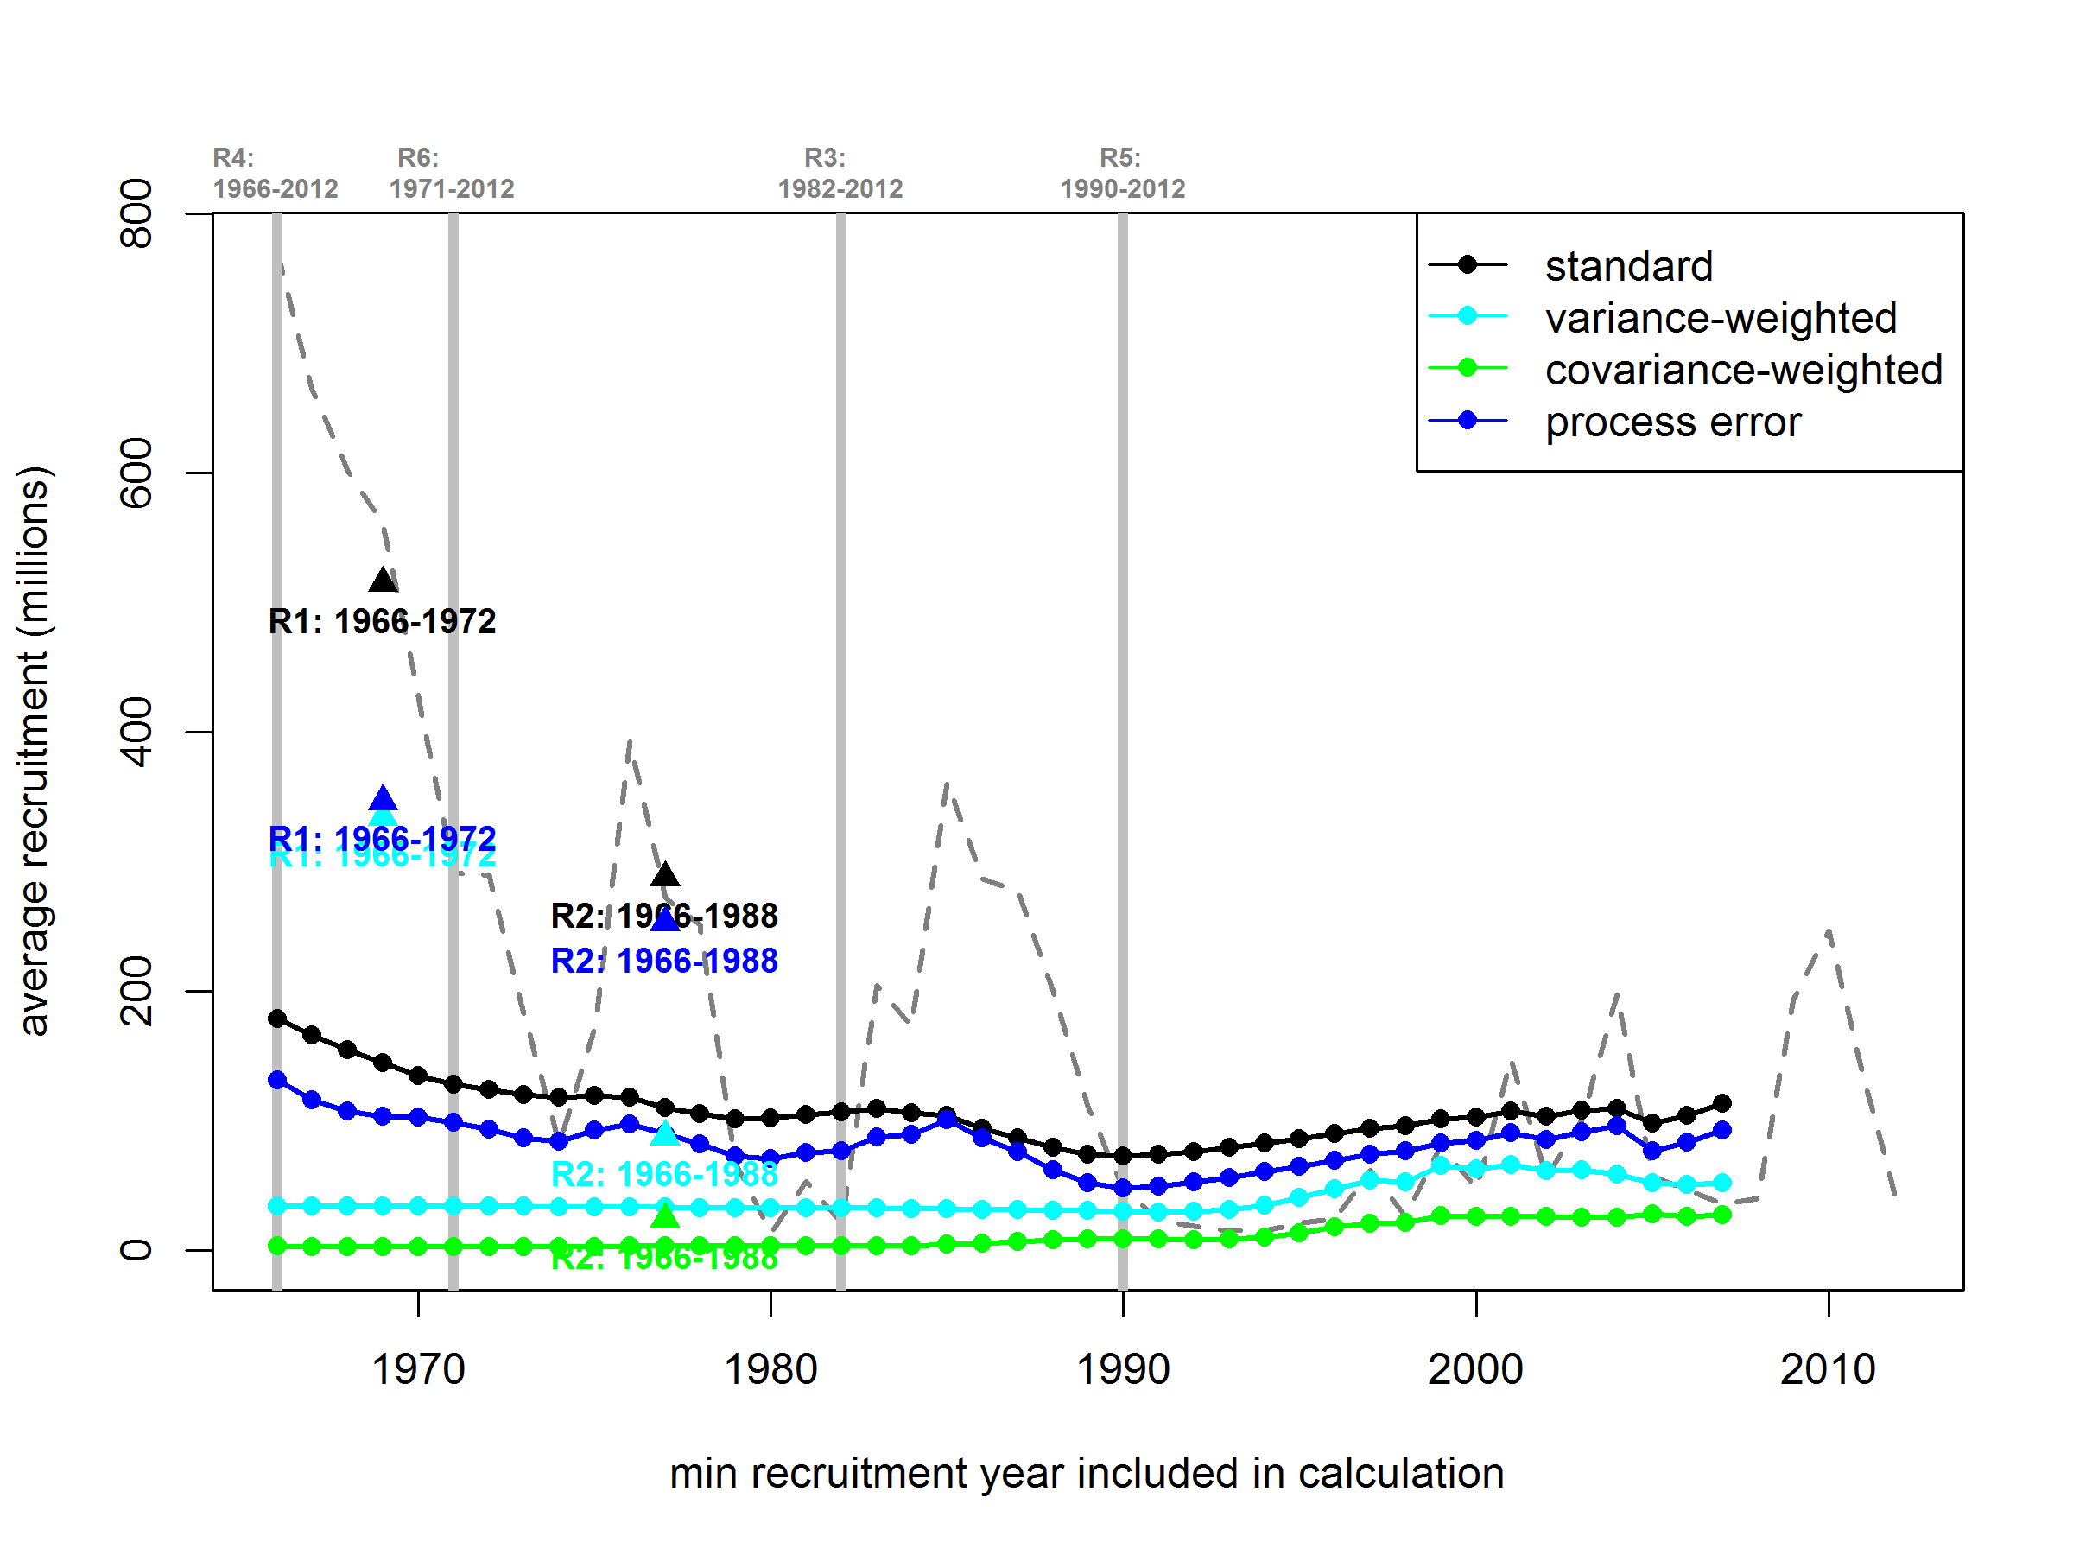

Figure 5. Estimates of *mean* recruitment using various time periods and methods for averaging the arithmetic-scale recruitment estimates (dotted grey line) from the accepted 2012 TCSAM. Colors are used to indicate results from one of four averaging methods: standard averages of the TCSAM recruitment estimates are plotted in black, weighted averages using the TCSAM-estimated variances are plotted in cyan, weighted averages using the TCSAM-estimated variance-covariance matrices are plotted in green, and weighted averages using the TCSAM-estimated variance-covariance matrices and estimated process error covariance matrices are plotted in blue. Values plotted as circles (and connected by colored line segments) were calculated using the time span *y*-2012, where “*y*” is the recruitment year at which the value is plotted. Values plotted as triangles were calculated using the time span indicated below the symbol. The labels R1-R6 refer to the five recruitment averaging scenarios considered in the 2012 SAFE chapter (Rugolo and Turnock, 2012) and the SSC-requested scenario (1971-2012). Note that the values for the covariance-weighted and process error-weighted methods are identical for scenario R1, so only the latter is plotted. The vertical grey lines indicate the first recruitment year included in the R3-R6 scenarios. Values are listed in Table 2.

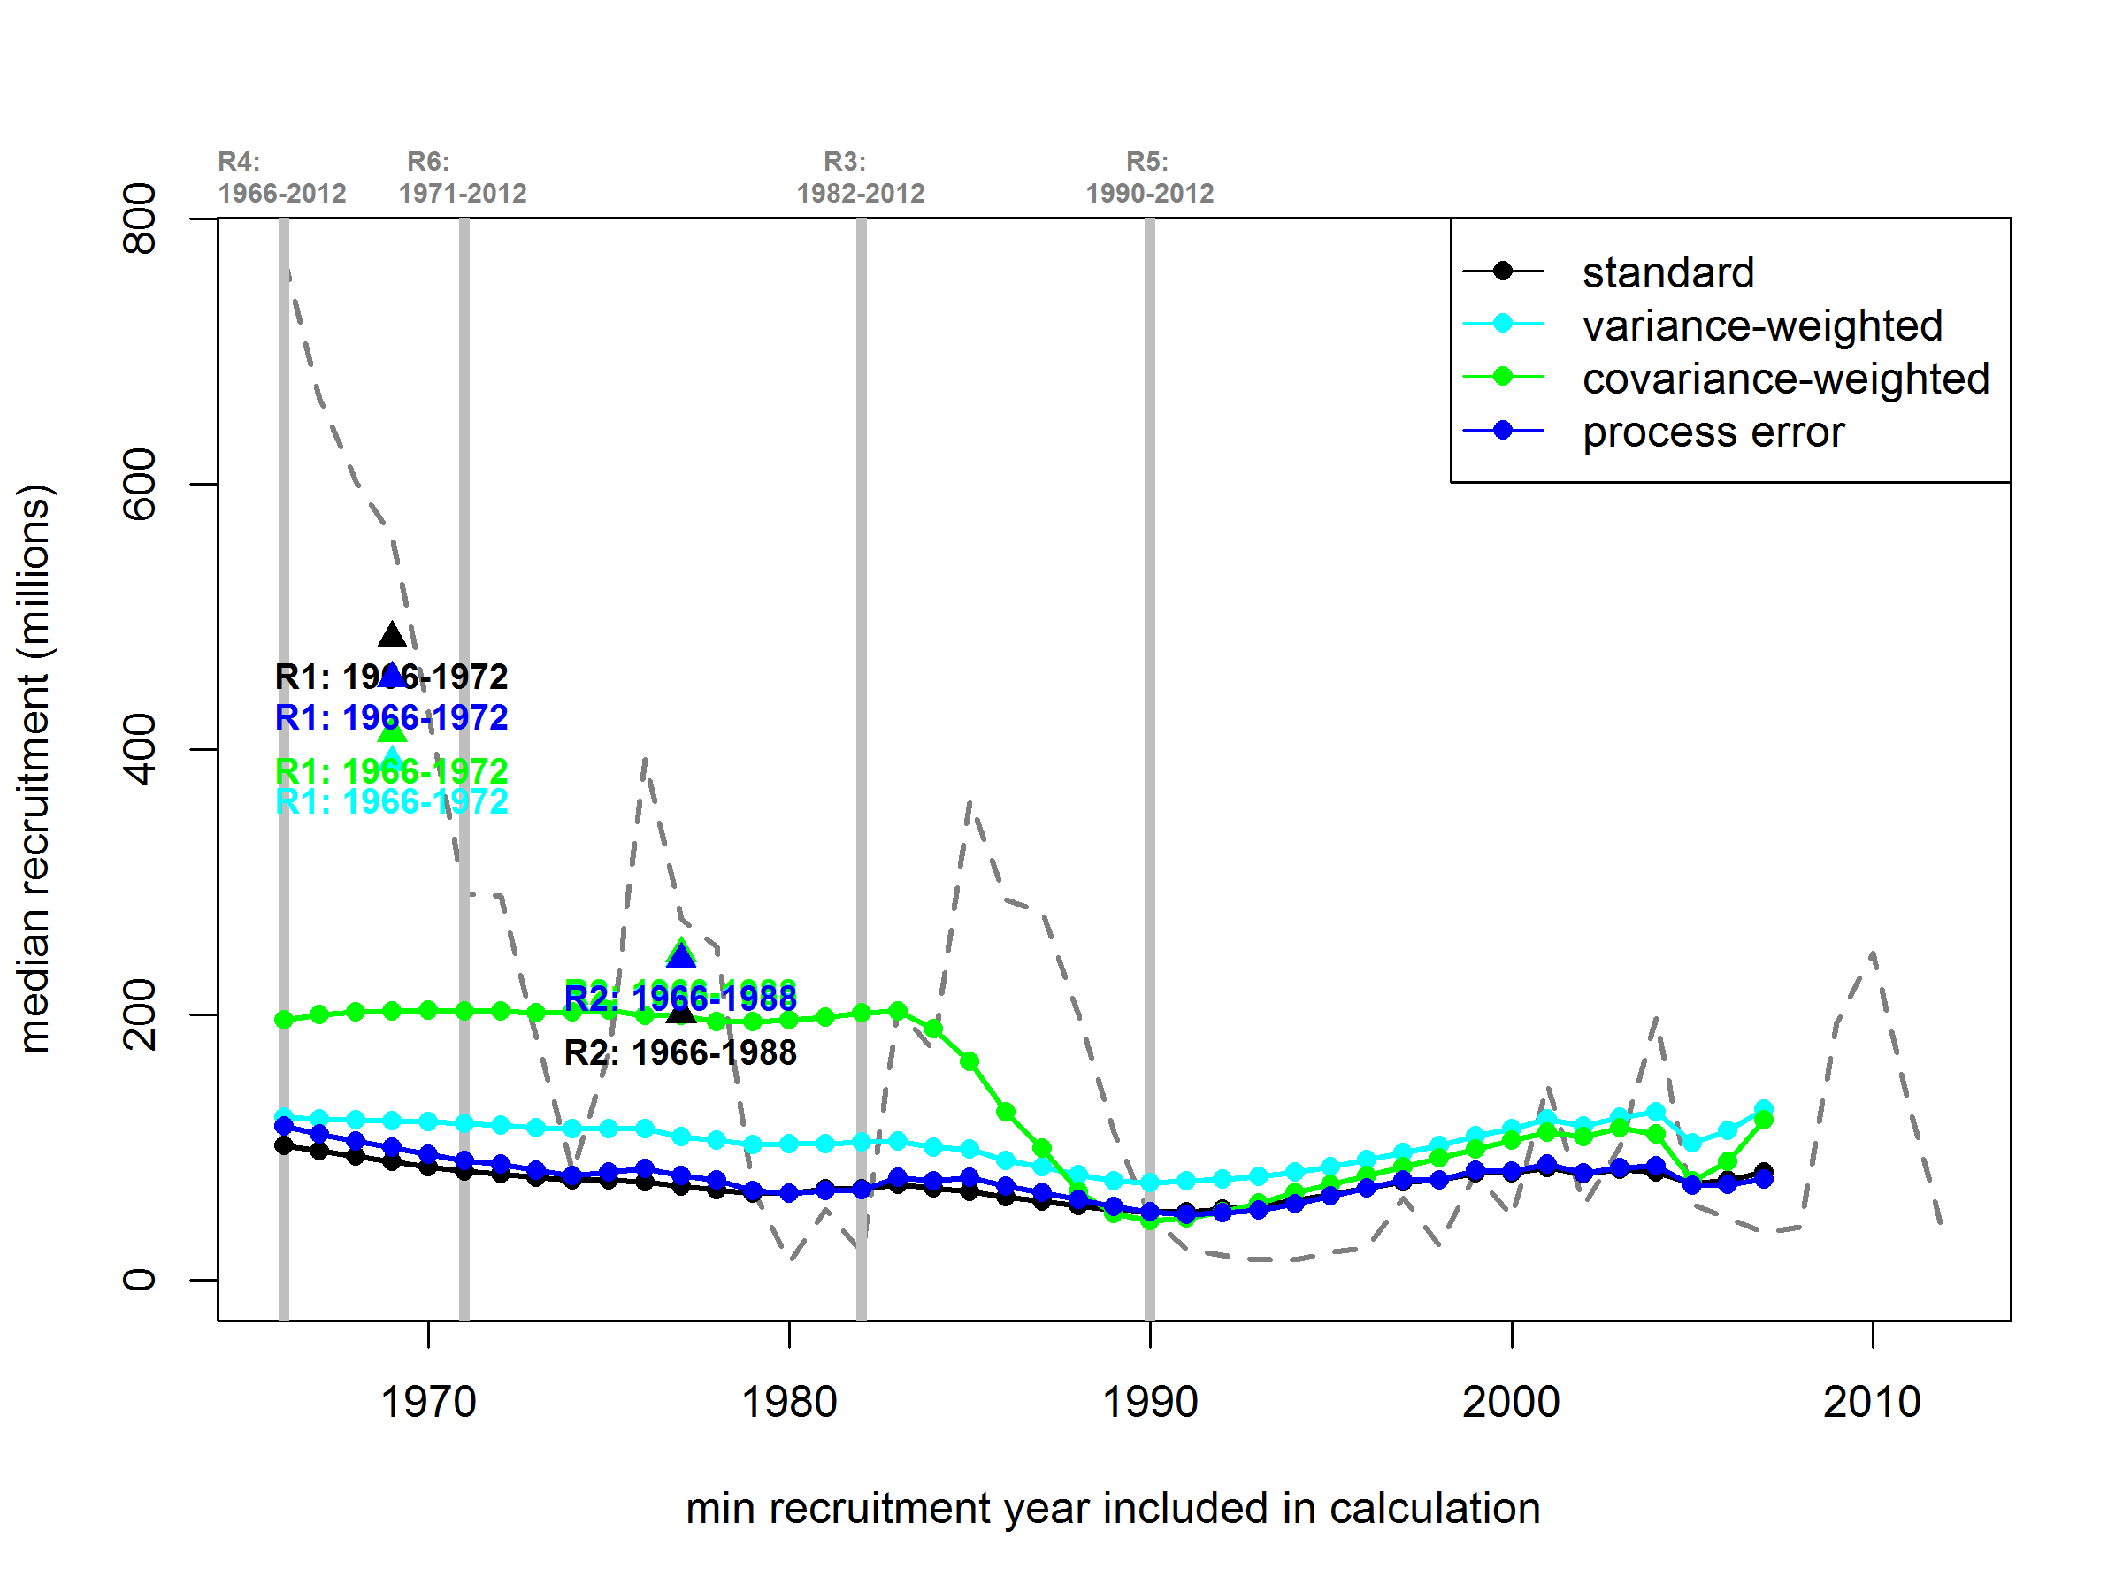

Figure 6. Estimates of *median* recruitment using various time periods and methods for averaging the log-scale recruitment estimates (dotted grey line) from the accepted 2012 TCSAM on the log scale. Colors are used to indicate results from one of four averaging methods: standard averages of the TCSAM recruitment estimates are plotted in black, weighted averages using the TCSAM-estimated variances are plotted in cyan, weighted averages using the TCSAM-estimated variance-covariance matrices are plotted in green, and weighted averages using the TCSAM-estimated variance-covariance matrices and estimated process error covariance matrices are plotted in blue. Values plotted as circles (and connected by colored line segments) were calculated using the time span *y*-2012, where “*y*” is the recruitment year at which the value is plotted. Values plotted as triangles were calculated using the time span indicated below the symbol. The labels R1-R6 refer to the five recruitment averaging scenarios considered in the 2012 SAFE chapter (Rugolo and Turnock, 2012) and the SSC-requested scenario (1971-2012). The vertical grey lines indicate the first recruitment year included in the R3-R6 scenarios. Values are listed in Table 3.

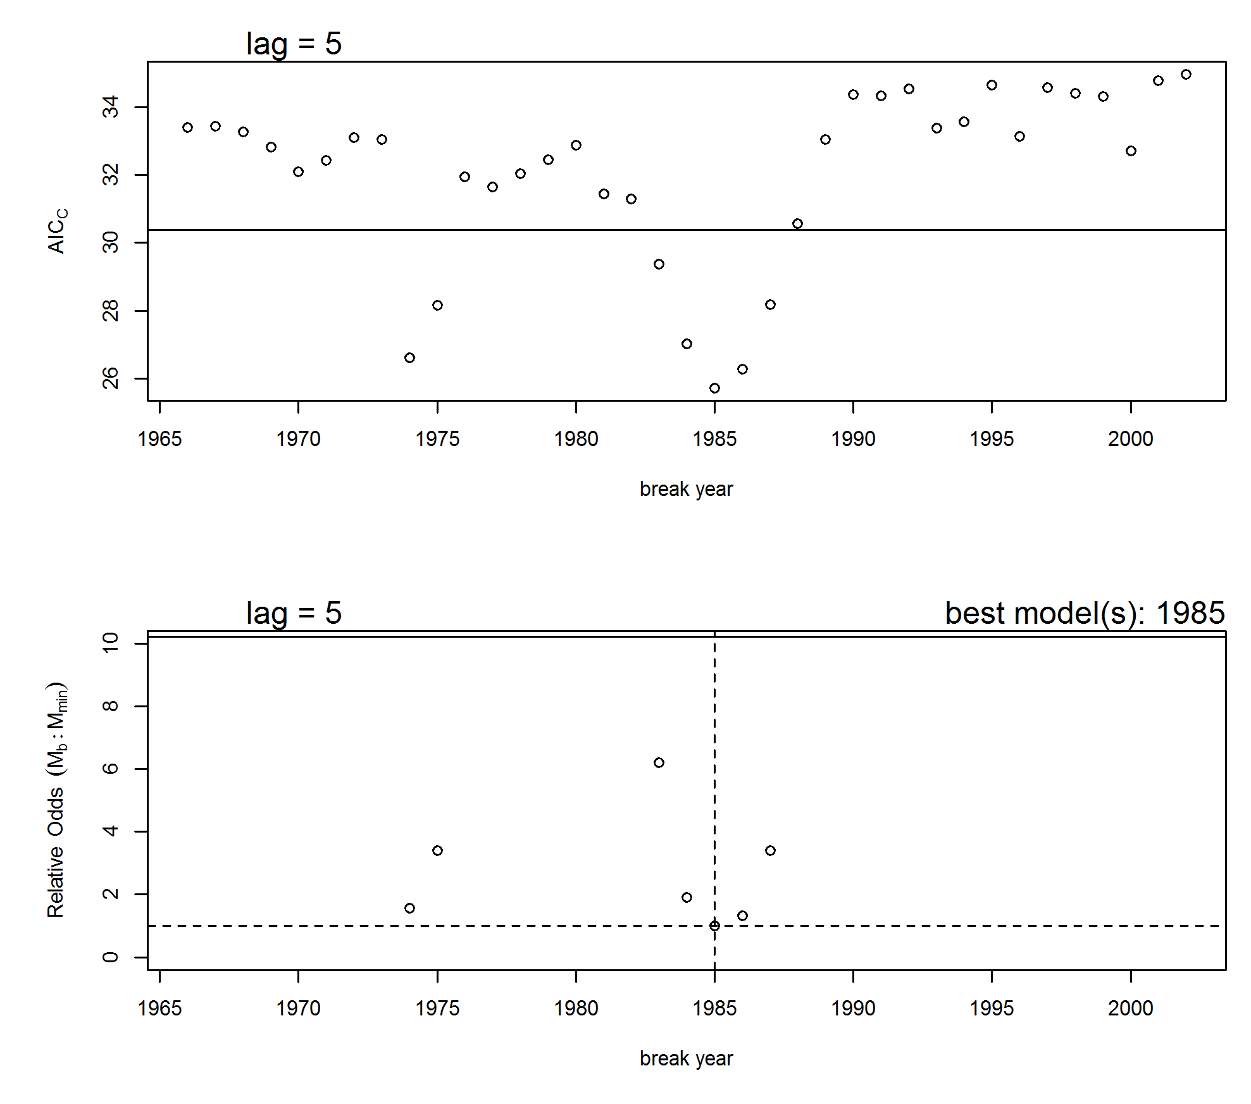

Figure 7. Results from the stock-recruit breakpoint analysis. Upper graph: AICc vs. year of breakpoint for the 1-breakpoint models (circles) and AICc for the model with no breakpoint (horizontal line). Lower graph: probabilistic odds for all 1-breakpoint models (circles) and the no breakpoint model (horizontal solid line) relative to the model with the smallest AICc score. The dashed lines indicate the value for the model with the lowest AICc score (breakpoint in 1985). 1-breakpoint models with high odds of being incorrect (>10) are not shown.

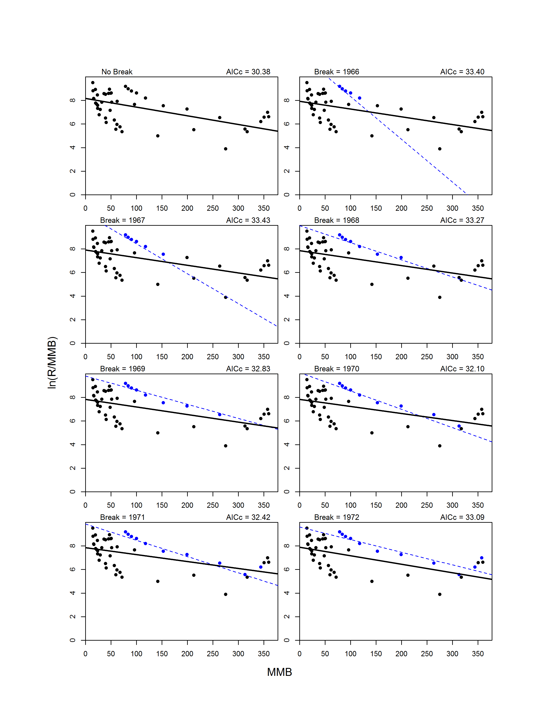

Figure 8. Model fits for the model with no breakpoint (upper left graph) and 1-breakpoint models for break years 1966-2002. For 1-breakpoint models, the pre-break data (circles) and model fit (line) are shown in blue, whereas the post-break data and fit are shown in black.

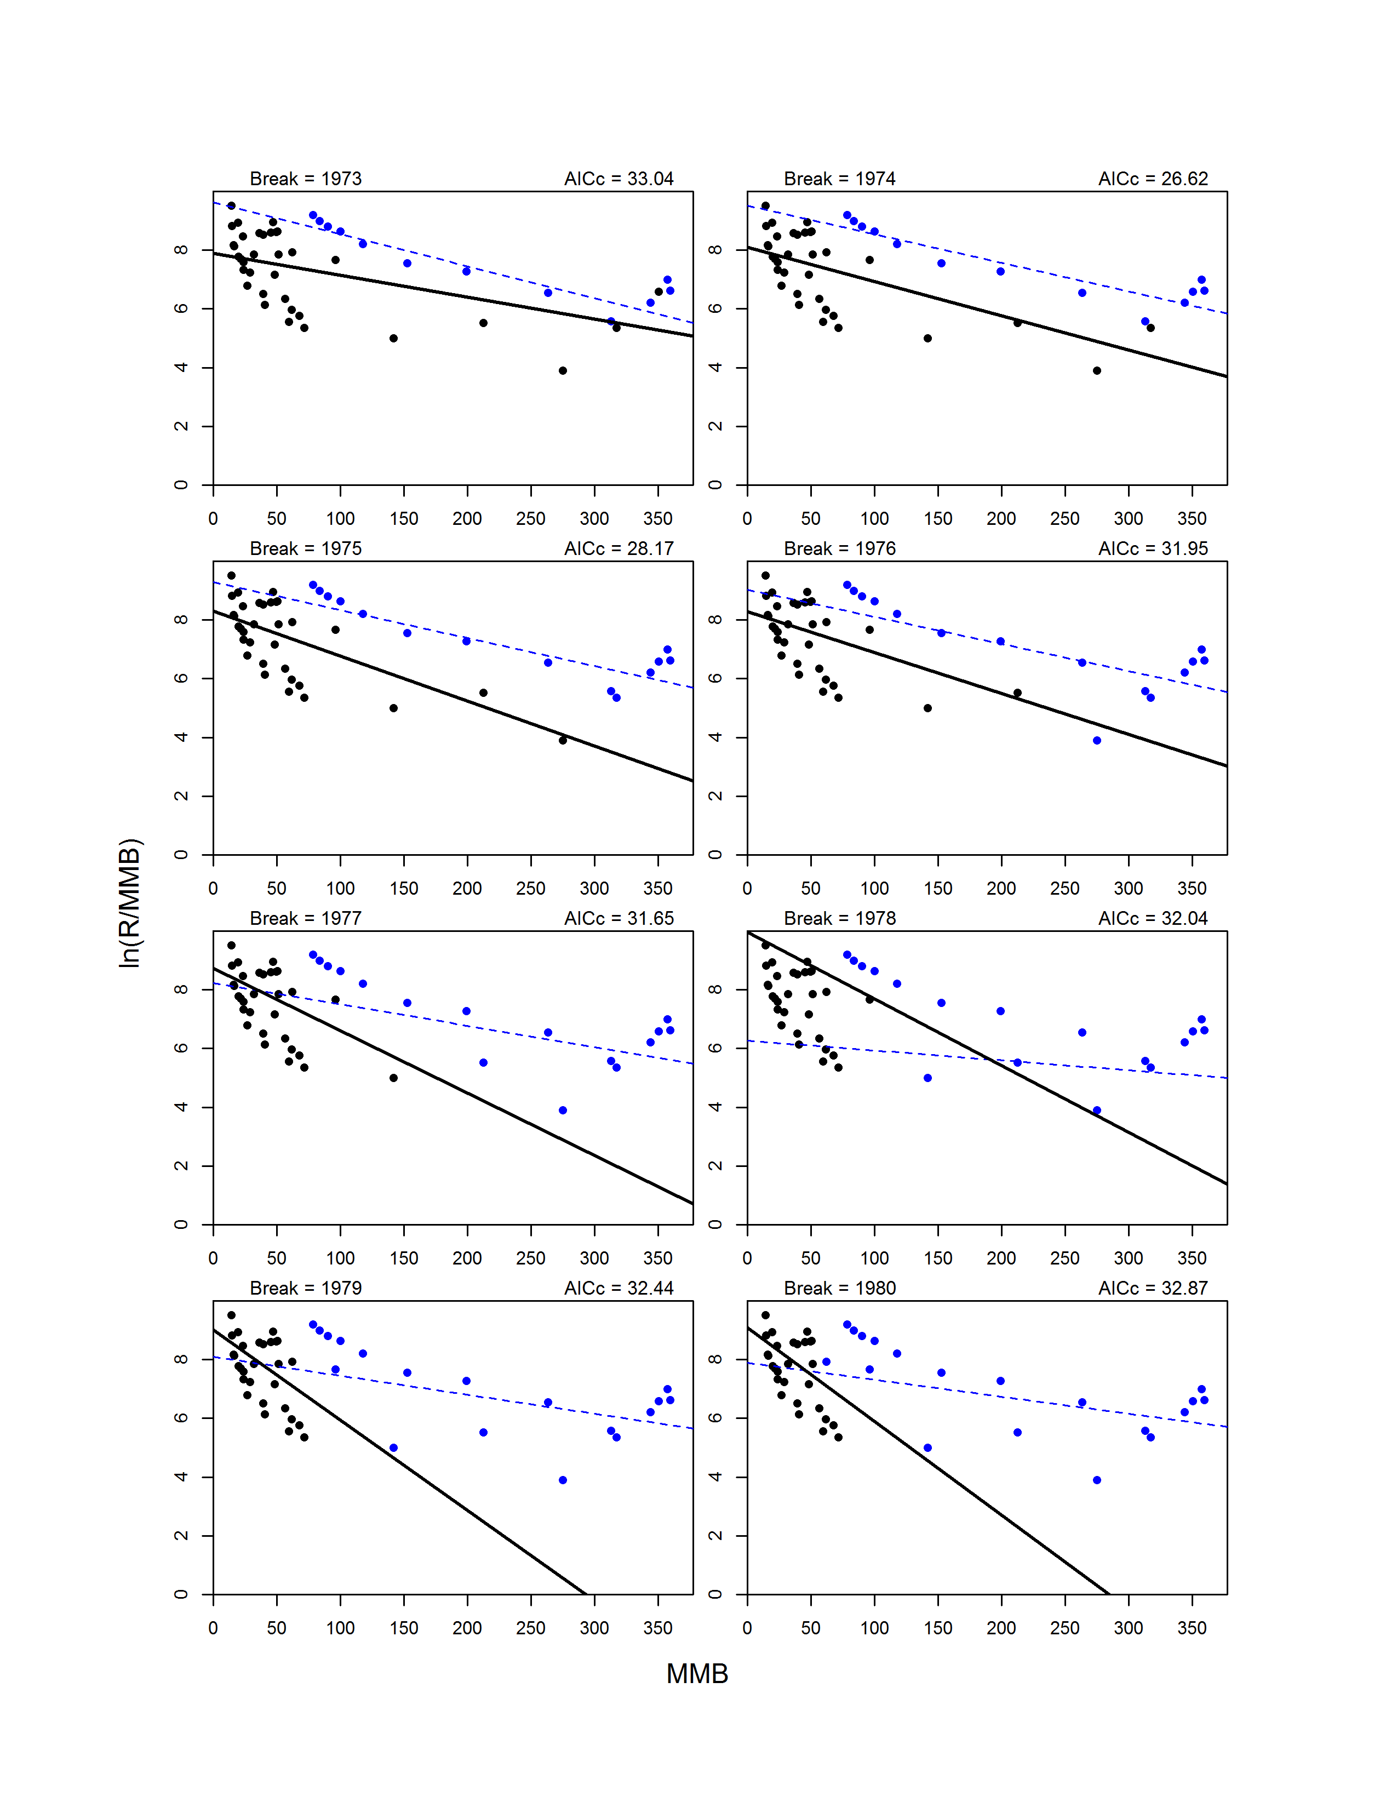

Figure 8. Continued.

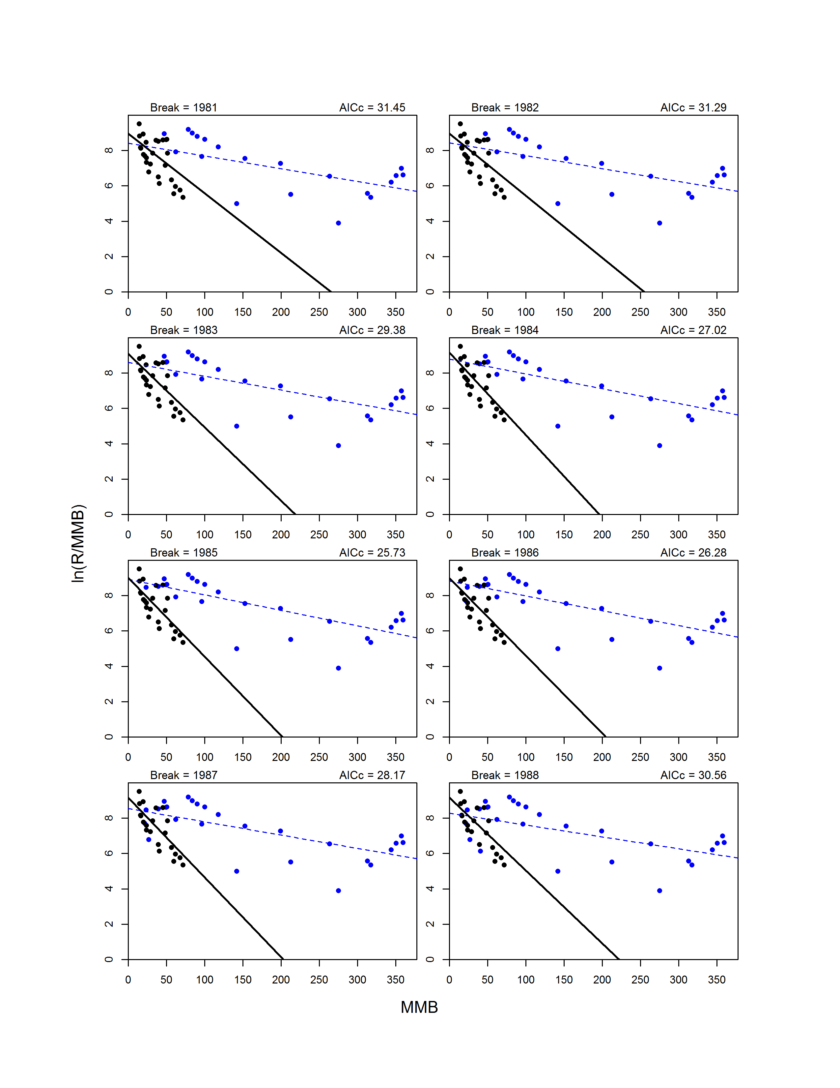

Figure 8. Continued.

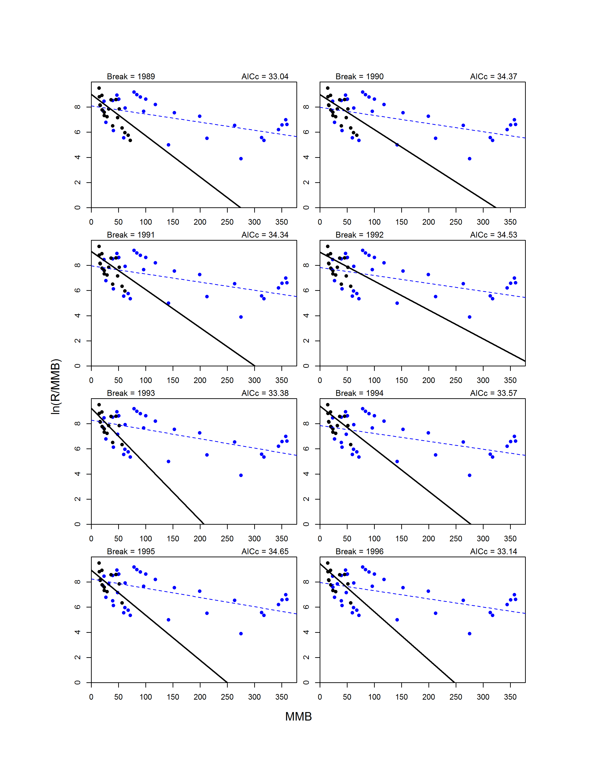

Figure 8. Continued.

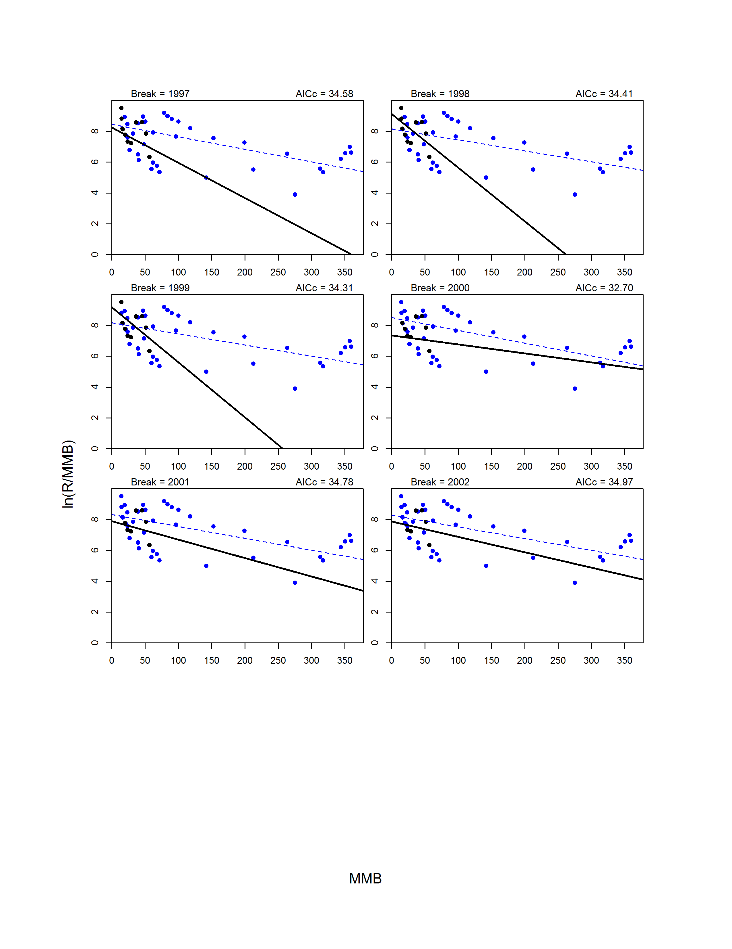

Figure 8. Continued.

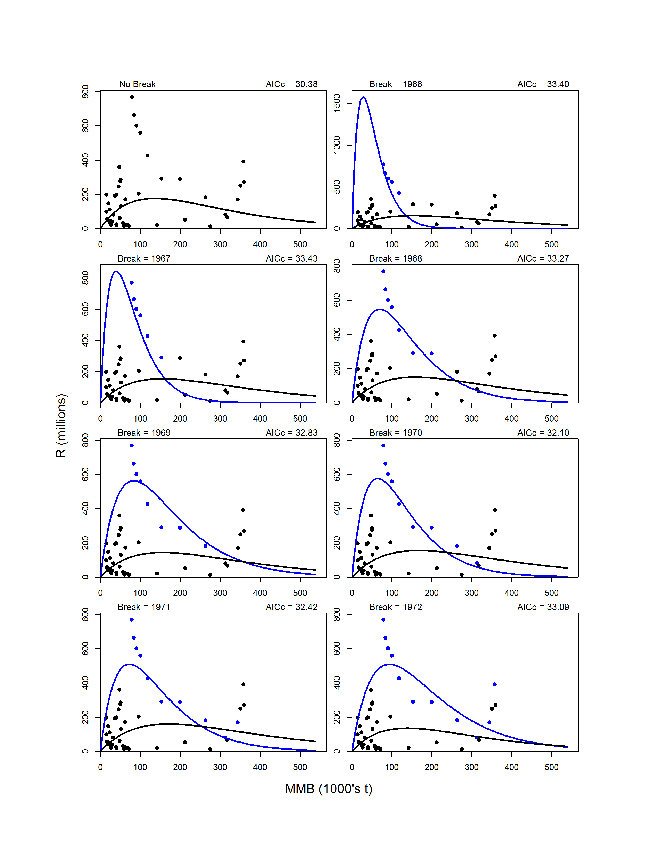

Figure 9. Model fits on the arithmetic scale for the model with no breakpoint (upper left graph) and 1-breakpoint models for break years 1966-2002. For 1-breakpoint models, the pre-break data (circles) and model fit (line) are shown in blue, whereas the post-break data and fit are shown in black.

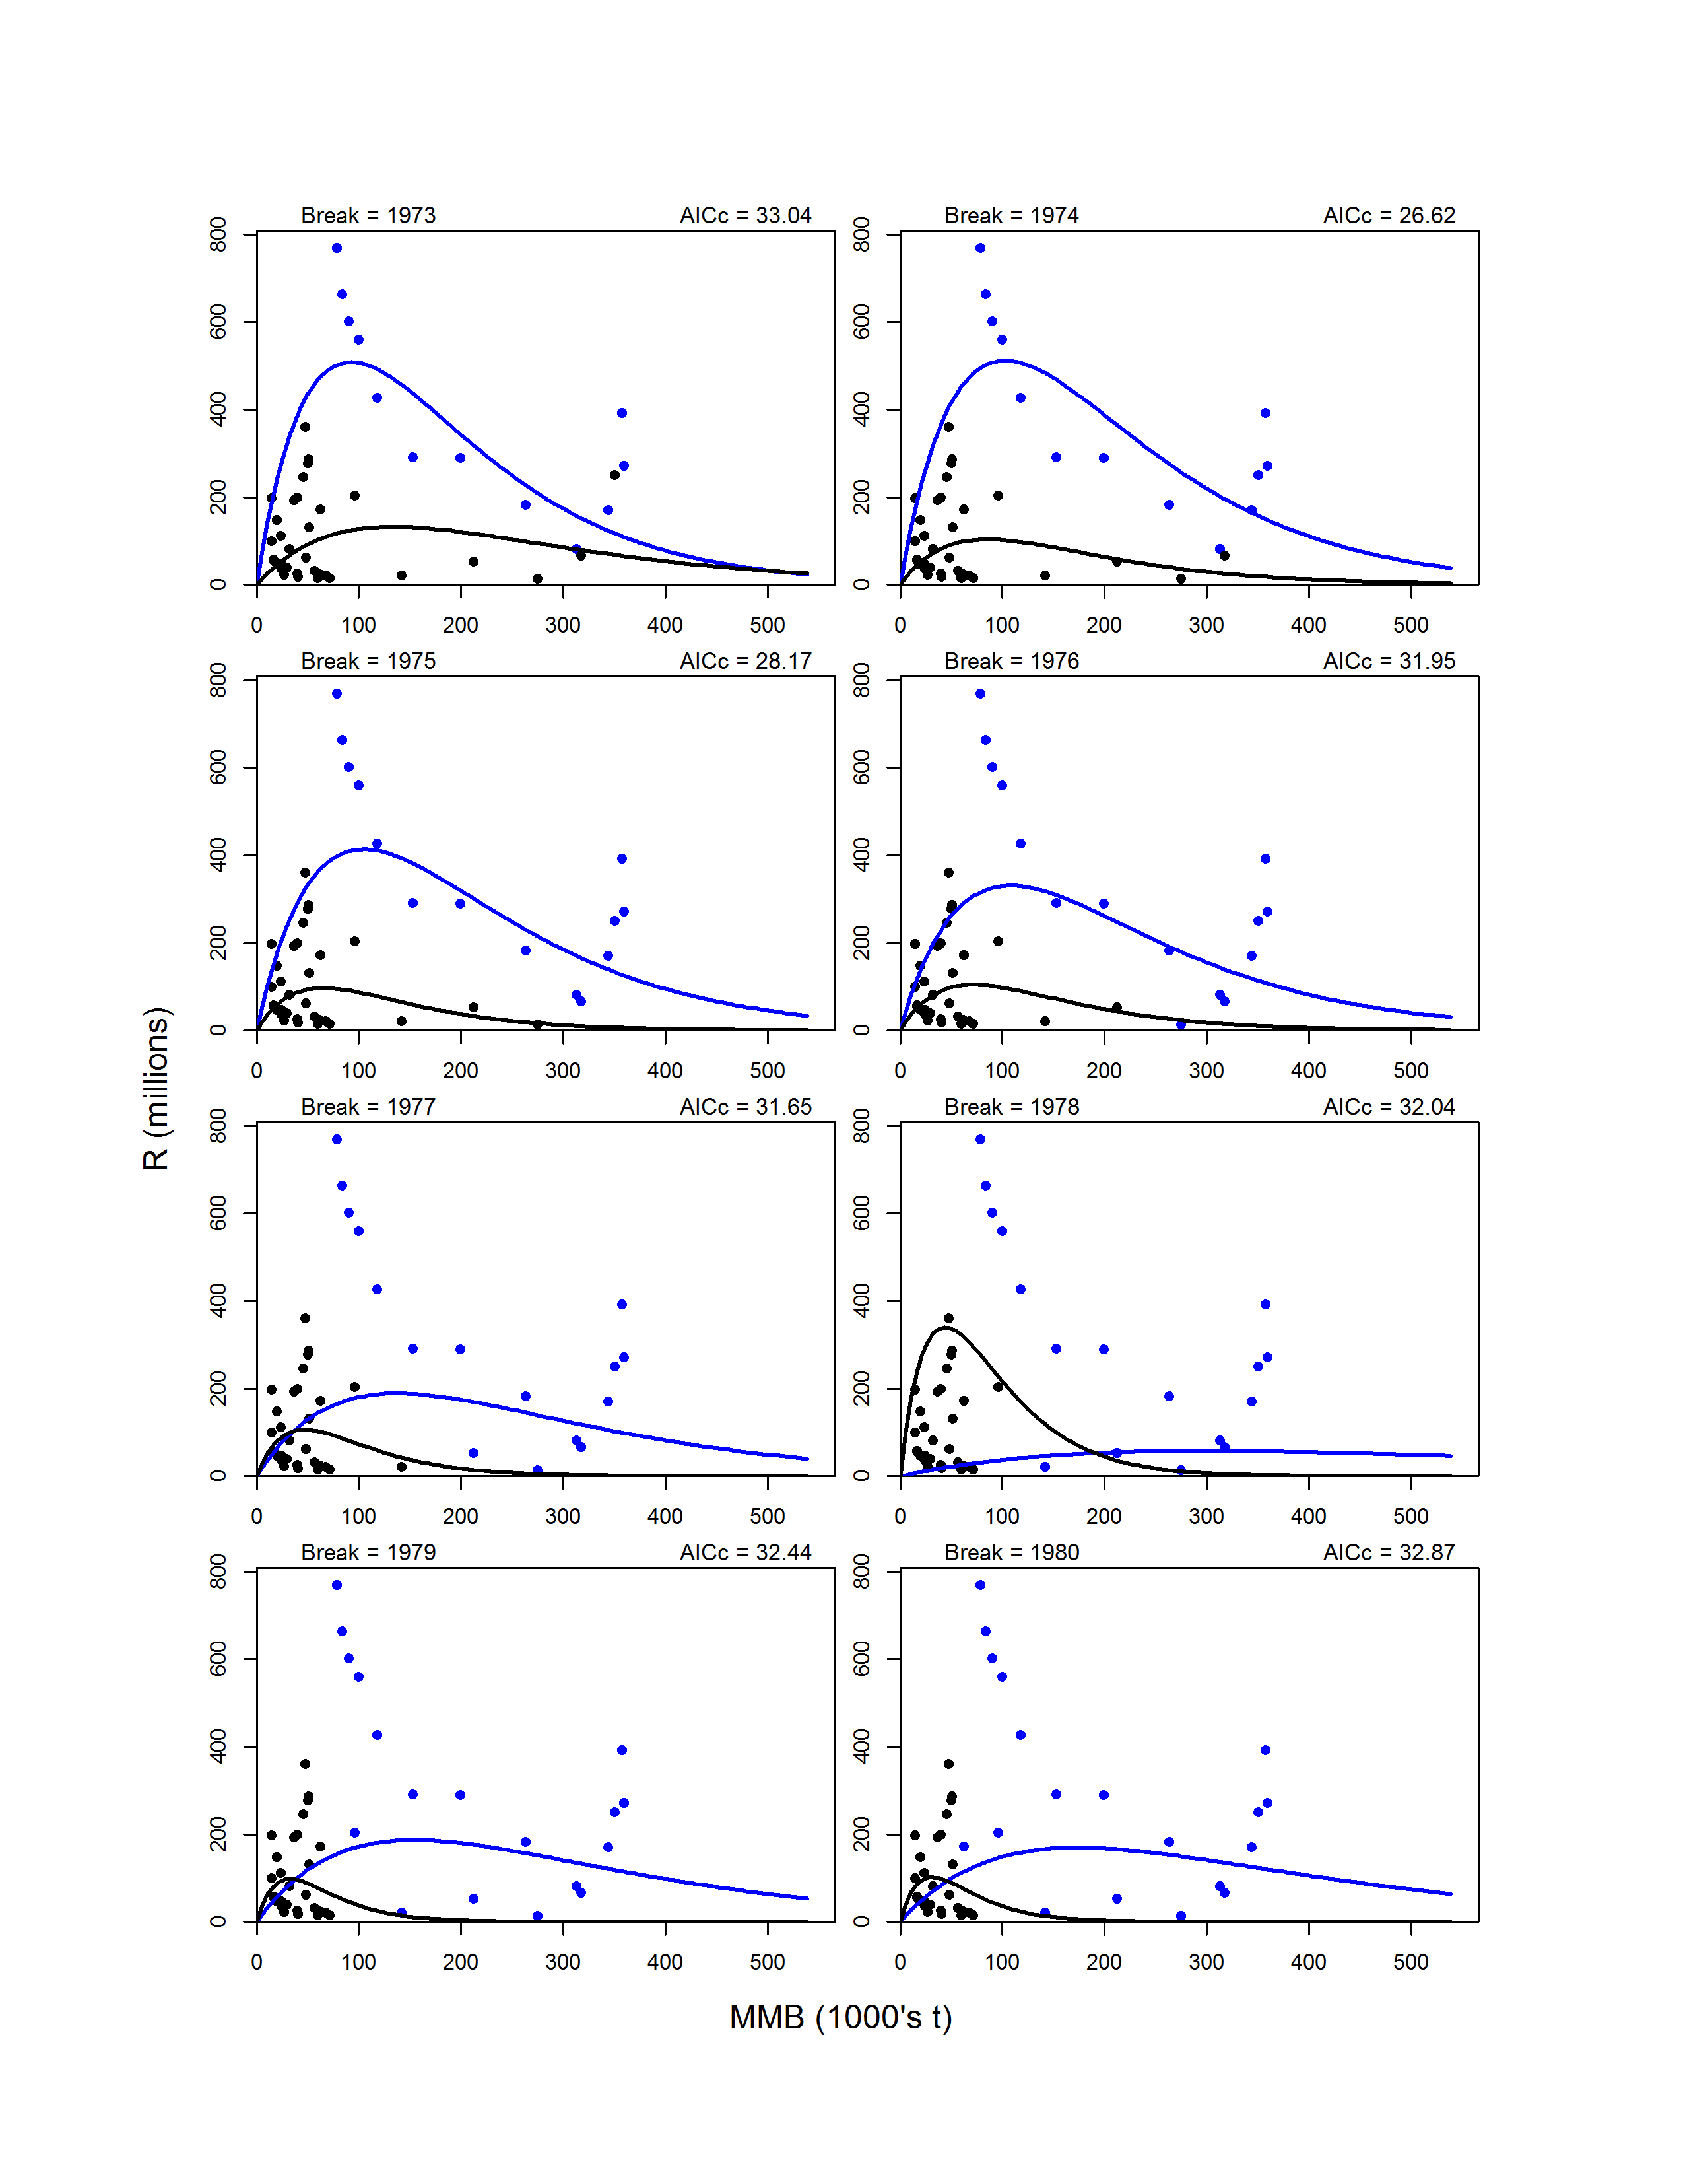

Figure 9. Continued.

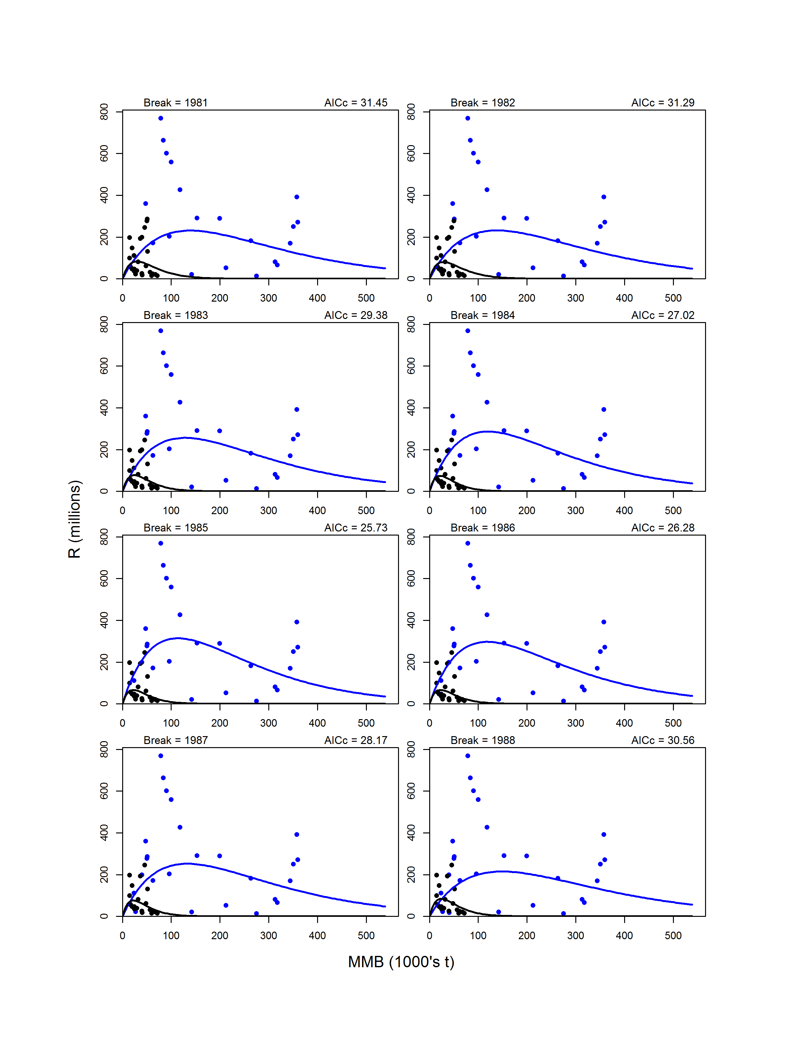

Figure 9. Continued.

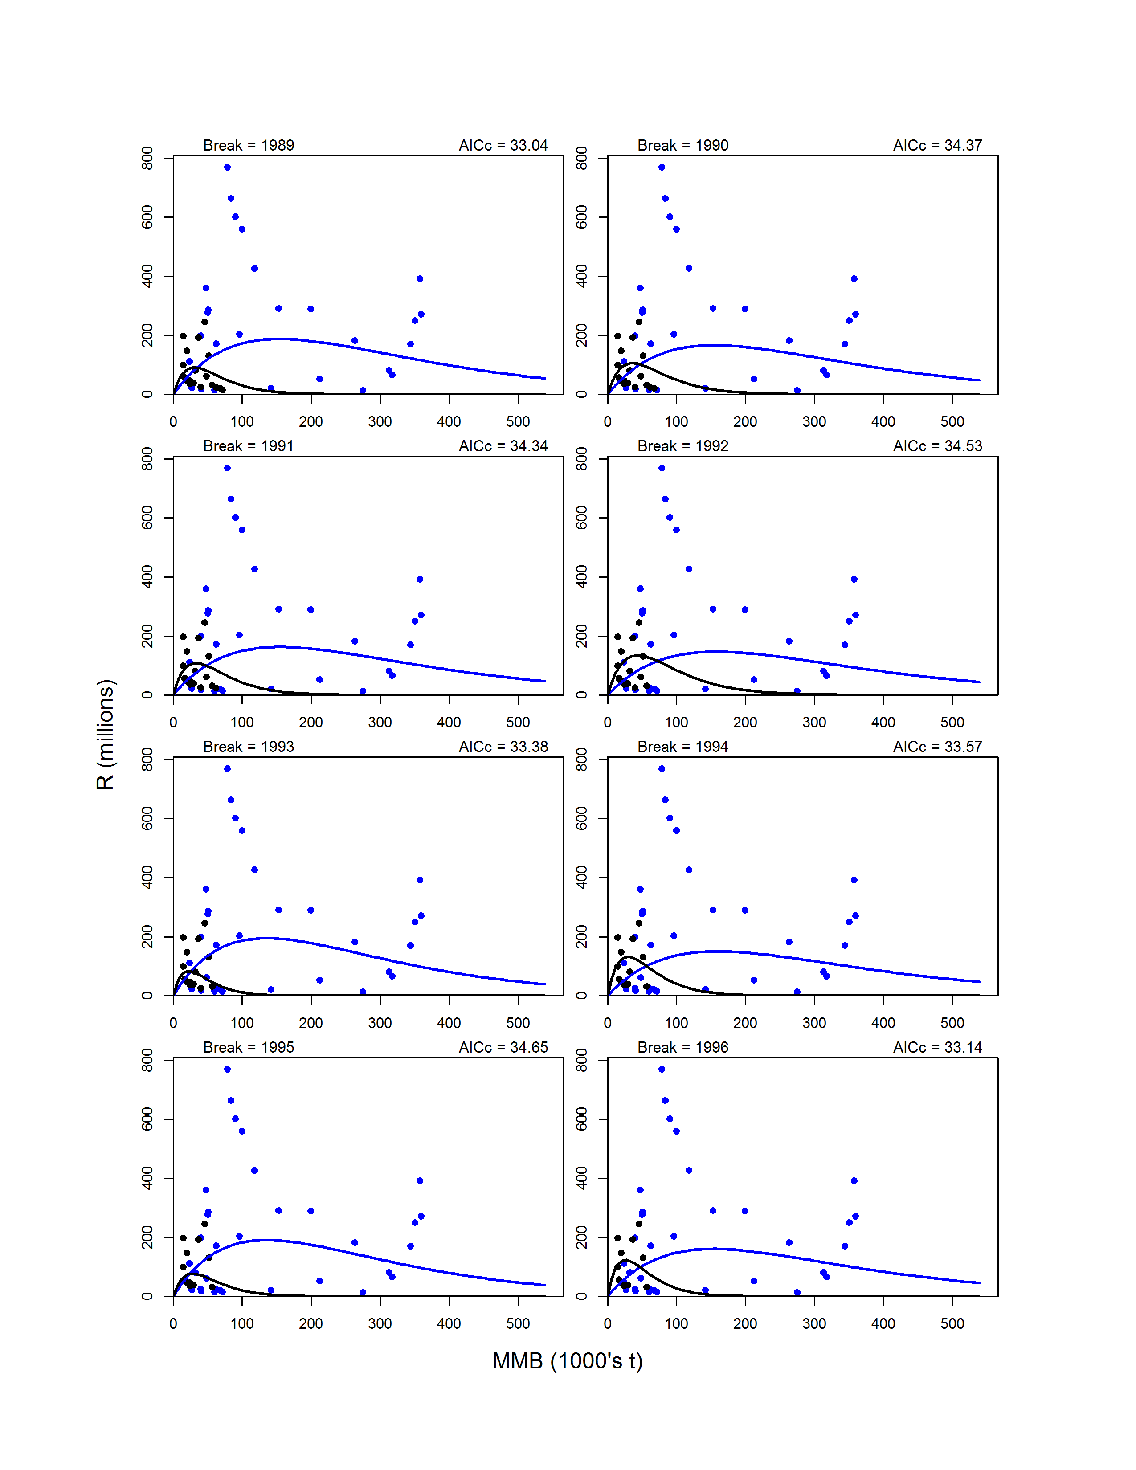

Figure 9. Continued.

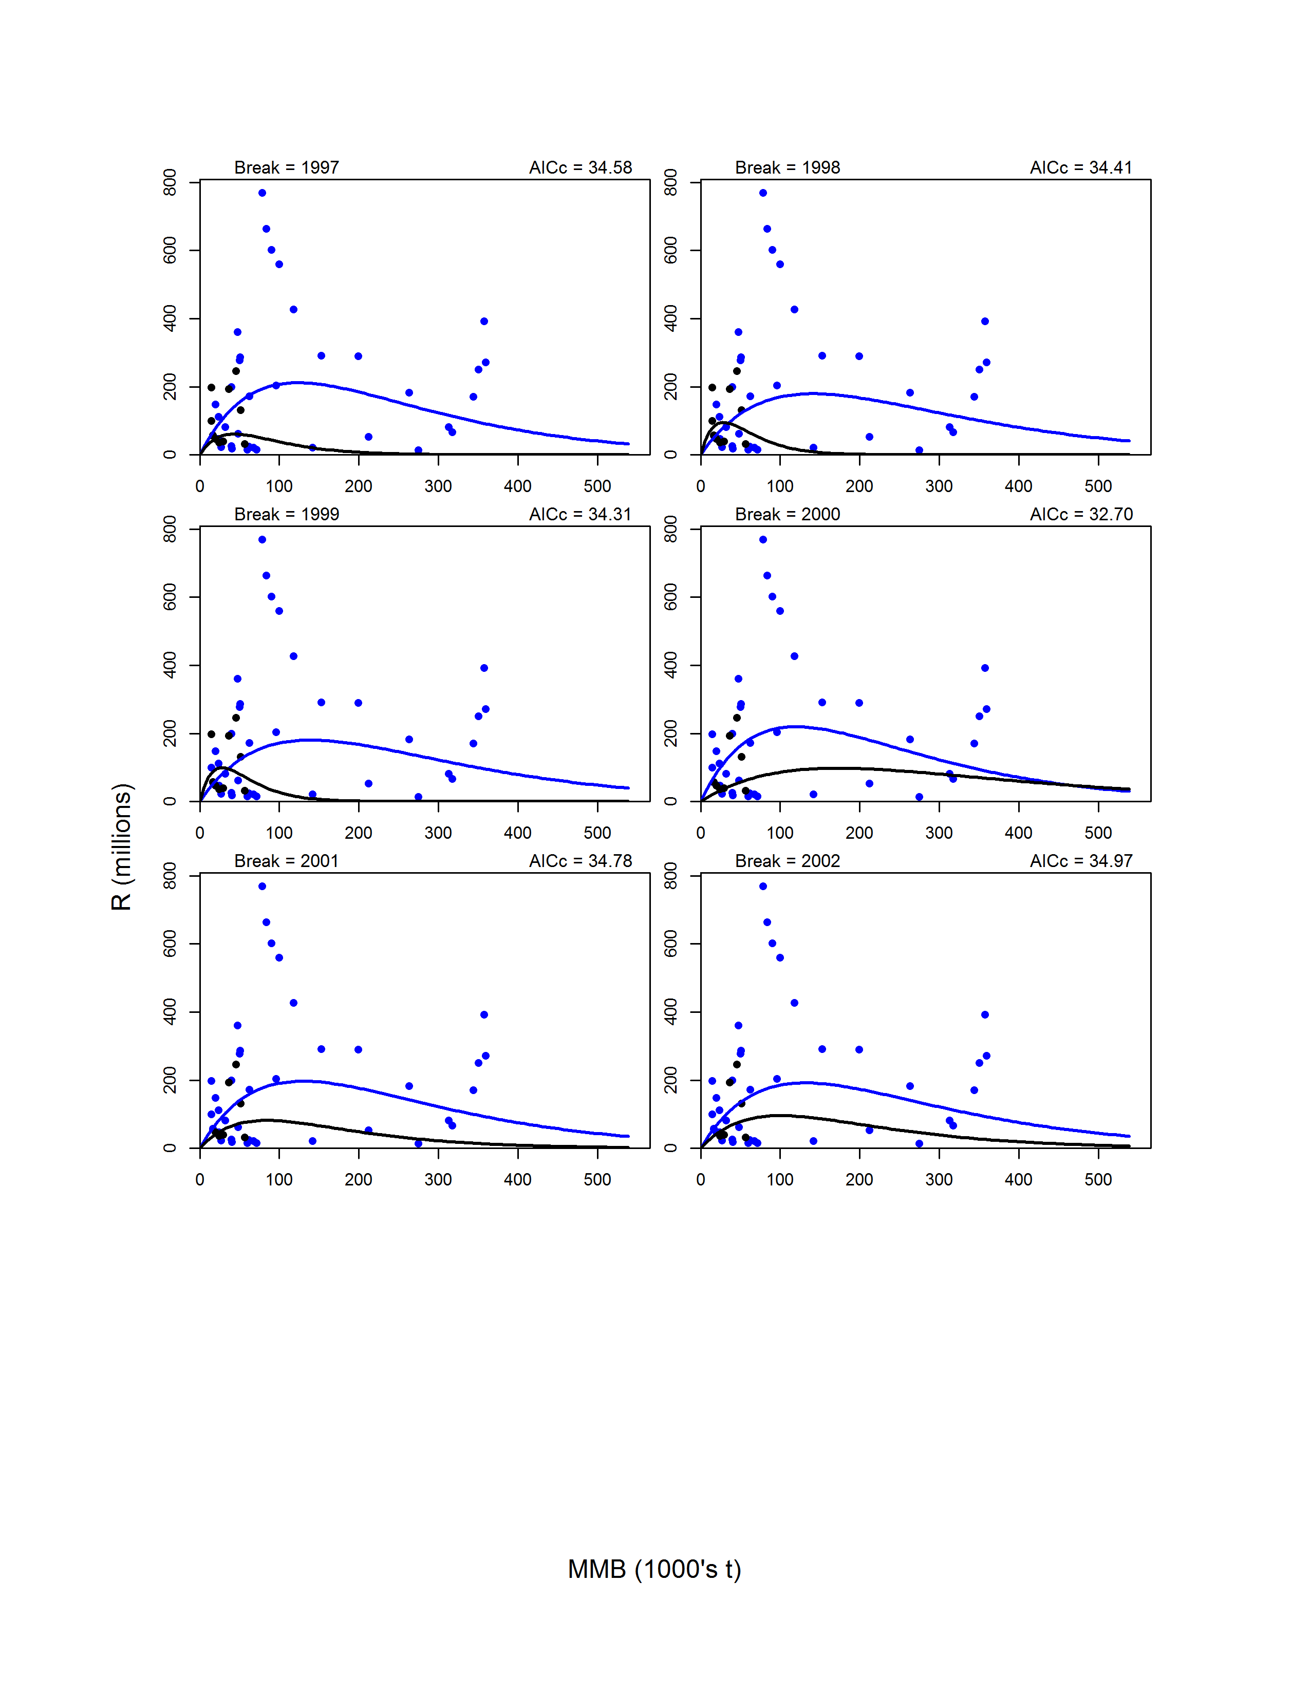

Figure 9. Continued.