**2014 Stock assessment and fishery evaluation report for the Pribilof Islands red king crab fishery of the Bering Sea and Aleutian Islands Regions**

C.S. Szuwalski, R.J. Foy, and B.J. Turnock

Alaska Fisheries Science Center

National Marine Fisheries Service

NOAA

## Executive Summary

1. Stock: Pribilof Islands red king crab, *Paralithodes camtschaticus*
2. Catches: Retained catches have not occurred since 1998/1999. Bycatch and discards have been increasing in recent years to current levels still low relative to the OFL.
3. Stock biomass:
   1. According to a 3-year running average, stock adult biomass in recent years decreased from 2007 to 2009 and increased in in 2010 through 2013.
   2. According to an integrated length-based assessment, mature male biomass increased from 2007 to 2010 and decreased from 2010 through 2013.
4. Recruitment: Recruitment appears episodic for PIRKC and has been very low since 2003.
5. Management performance:

|  |  |  |  |  |  |  |  |
| --- | --- | --- | --- | --- | --- | --- | --- |
| **Year** | **MSST** | **Biomass (MMBmating)** | **TAC** | **Retained Catch** | **Total Catch** | **OFL** | **ABC** |
| 2010/11 | 2,255  (4.97) | 2,754A (6.07) | 0 | 0 | 4.2  (0.009) | 349 (0.77) |  |
| 2011/12 | 2,571  (5.67) | 2,775B*  (6.12) | 0 | 0 | 5.4  (0.011) | 393  (0.87) | 307  (0.68) |
| 2012/13 | 2,609  (5.75) | 4,025C**  (8.87) | 0 | 0 | 13.1  (0.029) | 569  (1.25) | 455  (1.00) |
| 2013/14 | 2,582  (5.66) | 4,679 D**  (10.32) | 0 | 0 |  | 903  (1.99) | 718  (1.58) |
| 2013/14 | 705  (1.55) | 3292.46E***  (7.26) | 0 | 0 |  | 1156  (2.55) | 1151  (2.54) |

All units are in tonnes, values in parenthesis are in millions of lbs. The OFL is the total cactch OFL for each year. The stock was above MSST in 2013/2014 according to both a 3-year average and a length-based assessment method and is hence not overfished.

Notes:

A – Based on survey data available to the Crab Plan Team in September 2010 and updated with 2010/2011 catches

B – Based on survey data available to the Crab Plan Team in September 2011 and updated with 2011/2012 catches

C – Based on survey data available to the Crab Plan Team in September 2012 and updated with 2012/2013 catches

D – Based on survey data available to the Crab Plan Team in September 2013

E—Based on a length based assessment first presented to the CPT in May 2014

* – 2011/12 estimates based on 3 year running average

** –estimates based on weighted 3 year running average using inverse variance

***--estimates based on length based assessment method

1. Basis for 2014/2015 OFL projection:

|  |  |  |  |  |  |  |  |  |
| --- | --- | --- | --- | --- | --- | --- | --- | --- |
| **Year** | **Tier** | ***B*MSY**  **t**  **(106 lbs)** | **Current**  **MMBmating**  **t**  **(106 lbs)** | ***B*/*B*MSY (MMBmating)** | ***γ*** | **Years to define *B*MSY** | **Natural**  **Mortality**  yr-1 | **P\*** |
| 2014/15 | 4 | XX  (XX) | XX (XXX) | XX | 1.0 | 1991/1992-2013/2014 | 0.18 | 0.49 |
| 2014/15 | 3 | XX | XX | XX | XX | 1983-present | 0.18 | 0.49 |

1. Tier 4 OFL projections:
   1. The OFL distribution which quantifies uncertainty was constructed using bootstrapping methods approximating the lognormal distribution. Within assessment uncertainty was included based on the 2013 survey mature male biomass CV of 0.62 for the Tier 4b analysis.
   2. The ABC recommendation incorporated a σb of 0.4 to account for additional uncertainty, thus reducing the ABC from an ABCmax of 759 t (1.67 million lbs) to 718 t (1.58 million lbs).
2. Tier 3 OFL projections:
   1. An OFL distribution based on the estimated MMB and its standard deviation, 593.3 (t), was used to identify the catch for which overfishing had a 49% probability of occurring.
   2. The corresponding recommended ABC was 1151.
3. Rebuilding analyses results summary: not applicable.

**Summary of Major Changes:**

1. Management: There were no major changes to the 2012/2013 management of the fishery.
2. Input data: The crab fishery retained and discard catch time series were updated with 2013/2014 data. A new methodology for estimating discard catch was used for 2009/10-2014/15 replacing the previous estimates.
3. Assessment methodology:
   * Tier 4: MMB was estimated with an average centered on the current year and weighted by the inverse variance.
   * Tier 3: An integrated length-based assessment method incorporating key sources of mortality was used to estimate trends in fishing mortality and numbers at length for male crab.
4. Assessment results:
   * Tier 4b: The projected MMB increased and the OFL increased in this assessment. Total catch mortality in 2011/2012 increased substantially to 13.1 t due to increased bycatch in the yellowfin sole trawl fishery.
   * Tier 3: The projected MMB is 70% of the projected MMB from the Tier 4 methods. However, the calculated MSST is also lower, so the OFL from the integrated assessment is is 28% higher than the Tier 4 methodology.
5. Comparison of Tier 3 and Tier 4
   * Estimates of current biomass and target biomass using Tier 4 methodology are both higher than estimates from Tier 3 methods, however the corresponding OFLs are similar.
   * Small sample sizes are the central problem for applying either method, and it is not clear which method is most appropriate for management, but the Tier 4 methods may be considered more precautionary because their calculated MSST is higher than Tier 3 methods.

**Introduction**

**Distribution**

Red king crabs,*Paralithodes camtschaticus,* (Tilesius, 1815) are anomurans in the family lithodidae and are distributed from the Bering Sea south to the Queen Charlotte Islands and to Japan in the western Pacific (Jensen 1995; Figure 1). Red king crabs have also been introduced and become established in the Barents Sea (Jørstad et al. 2002). The Pribilof Islands red king crab stock is located in the Pribilof District of the Bering Sea Management Area Q. The Pribilof District is defined as Bering Sea waters south of the latitude of Cape Newenham (58° 39’ N lat.), west of 168° W long., east of the United States – Russian convention line of 1867 as amended in 1991, north of 54° 36’ N lat. between 168° 00’ N and 171° 00’ W long and north of 55° 30’N lat. between 171° 00’ W. long and the U.S.-Russian boundary (Figure 2).

**Stock structure**

The information on stock structure of red king crabs in the North Pacific comes from two projects. One is based on 1,800 microsatellite DNA samples from red king crabs originating from the Sea of Okhotsk to Southeast Alaska (Seeb and Smith 2005). In the Bering Sea Aleutian Island region, samples from Bristol Bay, Port Moller, and the Pribilof Islands were divergent from the Aleutian Islands and Norton Sound. A more recent study describes the genetic distinction of Southeast Alaska red king crab compared to Kodiak and the Bering Sea; the latter two being similar (Grant and Cheng 2012).

**Life History**

Red king crabs reproduce annually and mating occurs between hard-shelled males and soft-shelled females. Unlike brachyurans, red king crabs do not have spermathecae and cannot store sperm, therefore a female must mate every year to produce a fertilized clutch of eggs (Powell and Nickerson 1965). A pre-mating embrace is formed 3-7 days prior to female ecdysis, the female molts and copulation occurs within hours. During copulation, the male inverts the female so they are abdomen to abdomen and then the male extends his fifth pair of periopods to deposit sperm on the female’s gonopores. After copulation, eggs are fertilized as they are extruded through the gonopores located at the ventral surface of the coxopides of the third periopods. The eggs form a spongelike mass, adhering to the setae on the pleopods where they are brooded until hatching (Powell and Nickerson 1965). Fecundity estimates are not available for Pribilof Islands red king crab, but range from 42,736 to 497,306 for Bristol Bay red king crab (Otto et al. 1990). The estimated size at 50 percent maturity of female Pribilof Islands red king crabs is approximately 102 mm carapace length (CL) which is larger than 89 mm CL reported for Bristol Bay and 71 mm CL for Norton Sound (Otto et al. 1990). Size at maturity has not been determined specifically for Pribilof Islands red king crab males, however, approximately 103 mm CL is reported for eastern Bering Sea male red king crabs (Somerton 1980). Early studies predicted that red king crab become mature at approximately age 5 (Powell 1967; Weber 1967); however, Stevens (1990) predicted mean age at recruitment in Bristol Bay to be 7 to 12 years, and Loher et al. (2001) predicted age to recruitment to be approximately 8 to 9 years after settlement. Based upon a long-term laboratory study, longevity of red king crab males is approximately 21 years and less for females (Matsuura and Takeshita 1990).

Natural mortality of Bering Sea red king crab stocks is poorly known (Bell 2006) and estimates vary. Siddeek et al. (2002) reviewed natural mortality estimates from various sources. Natural mortality estimates based upon historical tag-recapture data range from 0.001 to 0.93 for crabs 80-169 mm CL with natural mortality increasing with size. Natural mortality estimates based on more recent tag-recovery data for Bristol Bay red king crab males range from 0.54 to 0.70, however, the authors noted that these estimates appear high considering the longevity of red king crab. Natural mortality estimates based on trawl survey data vary from 0.08 to 1.21 for the size range 85-169 mm CL, with higher mortality for crabs <125 mm CL. In an earlier analysis that utilized the same data sets, Zheng et al. (1995) concluded that natural mortality is dome shaped over length and varies over time. Natural mortality was set at 0.2 for Bering Sea king crab stocks (NPFMC 1998) and was changed to 0.18 with Amendment 24.

The reproductive cycle of Pribilof Islands red king crabs has not been established, however, in Bristol Bay, timing of molting and mating of red king crabs is variable and occurs from the end of January through the end of June (Otto et al. 1990). Primiparous Bristol Bay red king crab females (brooding their first egg clutch) extrude eggs on average 2 months earlier in the reproductive season and brood eggs longer than multiparous (brooding their second or subsequent egg clutch) females (Stevens and Swiney 2007a, Otto et al. 1990) resulting in incubation periods that are approximately eleven to twelve months in duration (Stevens and Swiney 2007a, Shirley et al. 1990). Larval hatching among red king crabs is relatively synchronous among stocks and in Bristol Bay occurs March through June with peak hatching in May and June (Otto et al. 1990), however larvae of primiparous females hatch earlier than multiparous females (Stevens and Swiney 2007b, Shirley and Shirley 1989). As larvae, red king crabs exhibit four zoeal stages and a glaucothoe stage (Marukawa 1933).

Growth parameters have not been examined for Pribilof Islands red king crabs; however they have been studied for Bristol Bay red king crab. A review by the Center for Independent Experts (CIE) reported that growth parameters are poorly known for all red king crab stocks (Bell 2006). Growth increments of immature southeastern Bering Sea red king crabs are approximately: 23% at 10 mm CL, 27% at 50 mm CL, 20% at 80 mm CL and 16 mm for immature crabs over 69 mm CL (Weber 1967). Growth of males and females is similar up to approximately 85 mm CL, thereafter females grow more slowly than males (Weber 1967; Loher et al. 2001). In a laboratory study, growth of female red king crabs was reported to vary with age; during their pubertal molt (molt to maturity) females grew on average 18.2%, whereas primiparous females grew 6.3% and multiparous females grew 3.8% (Stevens and Swiney, 2007a). Similarly, based upon tag-recapture data from 1955-1965 researchers observed that adult female growth per molt decreases with increased size (Weber 1974). Adult male growth increment averages 17.5 mm irrespective of size (Weber 1974).

Molting frequency has been studied for Alaskan red king crabs, but Pribilof Islands specific studies have not been conducted. Powell (1967) reports that the time interval between molts increases from a minimum of approximately three weeks for young juveniles to a maximum of four years for adult males. Molt frequency for juvenile males and females is similar and once mature, females molt annually and males molt annually for a few years and then biennially, triennially and quadrennial (Powell 1967). The periodicity of mature male molting is not well understood and males may not molt synchronously like females who molt prior to mating (Stevens 1990).

**Management history**

Red king crab stocks in the Bering Sea and Aleutian Islands are managed by the State of Alaska through the federal Fishery Management Plan (FMP) for Bering Sea/Aleutian Islands King and Tanner Crabs (NPFMC 1998). The Alaska Department of Fish and Game (ADF&G) has not published harvest regulations for the Pribilof district red king crab fishery. The king crab fishery in the Pribilof District began in 1973 with blue king crab *Paralithodes platypus* being targeted (Figure 3). A red king crab fishery in the Pribilof District opened for the first time in September 1993. Beginning in 1995, combined red and blue king crab GHLs were established. Declines in red and blue king crab abundance from 1996 through 1998 resulted in poor fishery performance during those seasons with annual harvests below the fishery GHL. The North Pacific Fishery Management Council (NPFMC) established the Bering Sea Community Development Quota (CDQ) for Bering Sea fisheries including the Pribilof Islands red and blue king crab fisheries which was implemented in 1998. From 1999 to 2012/2013 the Pribilof Islands fishery was not open due to low blue king crab abundance, uncertainty with estimated red king crab abundance, and concerns for blue king crab bycatch associated with a directed red king crab fishery. Pribilof Islands blue king crab was declared overfished in September of 2002 and is still considered overfished (see Bowers et al. 2011 for complete management history).

Amendment 21a to the BSAI groundfish FMP established the Pribilof Islands Habitat Conservation Area (Figure 4) which prohibits the use of trawl gear in a specified area around the Pribilof Islands year round (NPFMC 1994). The amendment went into effect January 20, 1995 and protects the majority of crab habitat in the Pribilof Islands area from impacts from trawl gear.

Pribilof Islands red king crab often occur as bycatch in the eastern Bering Sea snow crab (*Chionoecetes opilio*), eastern Bering Sea Tanner crab (*Chionoecetes bairdi*), Bering Sea hair crab (*Erimacrus isenbeckii*), and Pribilof Islands blue king crab fisheries. Limited non-directed catch exists in crab fisheries and groundfish pot and hook and line fisheries (see bycatch and discards section below).

**Data**

The standard survey time series data updated through 2012 and the standard groundfish discards time series data updated through 2012 were used in this assessment. The crab fishery retained and discard catch time series was updated with 2011/2012 data.

**Total catch**

Retained pot fishery catches (live and deadloss landings data) are provided for 1993/1994 to 1998/1999 (Tables 1 and 2), the seasons when red king crab were targeted in the Pribilof Islands District. In the 1995/1996 to 1998/1999 seasons red king crab and blue king crab were fished under the same Guideline Harvest Level (GHL). There was no GHL and therefore zero retained catch in the 2012/2013 fishing season.

**Bycatch and discards**

Non-retained (directed and non-directed) pot fishery catches are provided for sub-legal males (≤138 mm CL), legal males (>138 mm CL), and females based on data collected by onboard observers. Catch weight was calculated by first determining the mean weight (g) for crabs in each of three categories: legal non-retained, sublegal, and female. Length to weight parameters were available for two time periods: 1973 to 2009 (males: A=0.000361, B=3.16; females: A=0.022863, B=2.23382) and 2010 to 2013 (males: A=0.000403, B=3.141; ovigerous females: A=0.003593, B=2.666; non-ovigerous females: A=0.000408, B=3.128). The average weight for each category was multiplied by the number of crabs at that CL, summed, and then divided by the total number of crabs (equation 2).

Weight (g) = A * CL(mm)B (1)

Mean Weight (g) = ∑(weight at size * number at size) / ∑(crabs) (2)

Finally, weights were the product of average weight, CPUE, and total pot lifts in the fishery. To assess crab mortalities in these pot fisheries a 50% handling mortality rate is applied to these estimates.

Historical non-retained catch data are available from 1998/1999 to present from the snow crab, golden king crab (*Lithodes aequispina*), and Tanner crab fisheries (Table 3) although data may be incomplete for some of these fisheries. Prior to 1998 limited observer data exists for catcher-processor vessels only so non-retained catch before this date is not included here.

In 2012/2013, there were no Pribilof Islands red king crab incidentally caught in the crab fisheries (Table 3).

**Groundfish pot, trawl, and hook and line fisheries**

The 2012/2013 NOAA Fisheries Regional Office (J. Gasper, NMFS, personal communication) assessments of non-retained catch from all groundfish fisheries are included in this SAFE report. Groundfish catches of crab are reported for all crab combined by federal reporting areas and by State of Alaska reporting areas since 2009/2010. Catches from observed fisheries were applied to non-observed fisheries to estimate a total catch. Catch counts were converted to biomass by applying the average weight measured from observed tows from July 2011 to June 2012. Prior to this year for Pribilof Islands red king crab, Areas 513 and 521 were included likely overestimating the catch due to the extent of Area 513 into the Bristol Bay District. In 2012/2013 these data were available in State of Alaska reporting areas that overlap specifically with stock boundaries so that the management unit for each stock can be more appropriately represented. To estimate sex ratios for 2012/2013 catches, it was assumed that the male to female ratio was one. To assess crab mortalities in these groundfish fisheries a 50% handling mortality rate was applied to pot and hook and line estimates and an 80% handling mortality rate was applied to trawl estimates.

Historical non-retained groundfish catch data are available from 1991/1992 to present (J. Mondragon, NMFS, personal communication) although sex ratios have not been discriminated by each year’s survey proportions (Table 3). Prior to 1991data are only available in INPFC reports. Between 1991 and December 2001 bycatch was estimated using the “blend method”. The blend process combined data from industry production reports and observer reports to make the best, comprehensive accounting of groundfish catch. For shoreside processors, Weekly Production Reports (WPR) submitted by industry were the best source of data for retained groundfish landings. All fish delivered to shoreside processors were weighed on scales, and these weights were used to account for retained catch. Observer data from catcher vessels provided the best data on at-sea discards of groundfish by vessels delivering to shoreside processors. Discard rates from these observer data were applied to the shoreside groundfish landings to estimate total at-sea discards from both observed and unobserved catcher vessels. For observed catcher/processors and motherships, the WPR and the Observer Reports recorded estimates of total catch (retained catch plus discards). If both reports were available, one of them was selected during the “blend” process for incorporation into the catch database. If the vessel was unobserved, only the WPR was available. From January 2003 to December 2007, a new database structure named the Catch Accounting System (CAS) led to large method change. Bycatch estimates were derived from a combination of observer and landing (catcher vessels/production data). Production data included CPs and catcher vessels delivering to motherships. To obtain fishery level estimates, CAS used a ratio estimator derived from observer data (counts of crab/kg groundfish) that is applied to production/landing information. (See <http://www.afsc.noaa.gov/Publications/AFSC-TM/NOAA-TM-AFSC-205.pdf>). Estimates of crab are in numbers because the PSC is managed on numbers. There were two issues with this dataset that required estimation work outside of CAS:

1. The estimated number of crab had to be converted to weights. An average weight was calculated using groundfish observer data. This weight was specific to crab year, crab species, and fixed or trawl gear. This average was applied to the estimated number of crab for crab year by federal reporting area.
2. In some situations, crab estimates were identified and grouped in the observed data to the genus level. These crabs were apportioned to the species level using the identified crab.

From January 2008 to 2012 the observer program changed the method in which they speciate crab to better reflect their hierarchal sampling method and to account for broken crab that in the past were only identified to genus. In addition, haul-level weights collected by the observers were used to estimate the weight of crab through CAS instead of applying an annual (global) weight factor. Spatial resolution was at federal reporting area.

Starting in 2013, a new data set based on the CAS system was made available for January 2009 to current. In 2009 reporting State statistical areas was required on groundfish production reports. The level of spatial resolution in CAS was formally federal reporting area since this the highest spatial resolution at which observer data is aggregated to create bycatch rates. The federal reporting area does not follow crab stock boundaries, particular for species with small stock areas such as Pribilof Islands or St. Matthew Island stocks so the new data was provided at the State reporting areas. This method uses ratio estimator (wt crab/wt groundfish) applied to groundfish reported on production/landing reports. Where possible, this dataset aggregates observer data to the stock area level to create bycatch estimates at the stock area. There are instances where no observer data is available and aggregation could go outside of a stock area, but this practice is greatly reduced compared with the pre-2009 data, which at-best was at the Federal reporting area level.

The new time series resulted in significantly different estimates of red king crab bycatch biomass in 2009/2010-2012/2013 (Table 3). In 2012/2013, using the new database estimation, 16.46 t of male and female red king crab were caught in fixed gear (0.24 t) and trawl gear (16.23 t) groundfish fisheries which is 51% greater than was caught in 2011/2012 pot, trawl, and hook and line groundfish fisheries. The catch was mostly in non-pelagic trawls (99%) followed by longline (1%), and pot (<1%) fisheries (Table 4). The targeted species in these fisheries were Pacific cod (3%), flathead sole (18%), yellowfin sole (77%), and traces <1% found in the rockfish fisheries (Table 5). Unlike previous years no bycatch was observed in Alaska plaice fisheries in 2011/2012 or 2012/2013.

**Catch-at-length**

Catch-at-length data are not available for this fishery.

**Survey biomass**

The 2013 NOAA Fisheries EBS bottom trawl survey results (Daly et al. in press) are included in this SAFE report (Figure 5). Abundance estimates of male and female crab are assessed for 5 mm length bins and for total abundances for each EBS stock (Figure 6). Weight (equation 1) and maturity (equation 3) schedules are applied to these abundances and summed to calculate mature male, female, and legal male biomass for the Tier 4 analysis.

Proportion mature male = 1/(1 + (5.842 * 1014)* e((CL(mm)+2.5) * -0.288)

Proportion mature female = 1/(1 + (1.416 * 1013)* e((CL(mm)+2.5) * -0.297) (3)

Historical survey data are available from 1975 to the present (Tables 6 and 7, Figure 5). It should be noted that the survey data analyses were standardized in 1980.

In 2012, red king crab were caught at 14 of the 77 stations in the Pribilof District; 13 stations in the high-density sampling area and 1 station in the standard-density sampling area (Daly et al. in press; Figure 7). The density of legal-sized males caught at a station ranged from 66 to 3,770 crab nmi-2. Legal-sized male red king crab were caught at 14 of the 77 stations in the Pribilof District with a biomass estimate (± 95% CI) of 7,567 ± 9,297 t and an abundance estimate (± 95% CI) of 1.6 ± 1.9 million crab (Figure 8). Legal-size males represented 96% of the total male biomass but were below the average of 5,430 ± 2,786 t from the previous 10 years. The majority of the legal-sized males were distributed around and to the north and east of St. Paul Island.

In 2012, mature males were encountered at 14 of the 77 stations in the Pribilof District; 13 stations in the high-density sampling area, and one station in the standard-density sampling area (Figure 8). All of the 77 mature and 5 immature males caught were measured. Two stations accounted for 81% of all mature red king crab caught (Figure 9). The biomass estimate of mature males was 7,749 ± 9,409 t and represented 99% of the total male biomass with the remaining 1% represented by 104 ± 171 t of immature male red king crab. Mature males were distributed around St. Paul Island in the nearshore shallow water stations and to the west and south of St. Paul Island (Figures 8 and 9).

The 2013 size-frequency for red king crab males shows slightly more very oldshell legal-sized males compared to 2012 (Figure 6). In 2013, 24% of the legal-sized males were new hardshell crabs and distributed to the west and south of St. Paul Island (Figure 10). Seventy five percent of the legal-sized males were in oldshell and very oldshell condition and primarily distributed to the west and south of St. Paul Island. In more recent years a small cohort of crab has moved through the stock from 120 to 175 mm but large abundances of smaller crab have not been observed since prior to 2004 (Figure 11).

The 2012 biomass estimate of mature-sized red king crab females was 663 ± 710 t and abundance was 0.4 ± 0.5 million crab, representing 100% of the total female biomass collected during the survey. A majority of the mature females were carrying uneyed embryos with 43% of the mature females in new hardshell condition. The majority of mature females with uneyed embryos were in the 130 mm to 140 mm CL size class.

The 2013 biomass estimate of mature-sized red king crab females was 169 ± 194 t and abundance was 0.1 ± 0.1 million crab, representing 100% of the total female biomass collected during the survey (Tables 6 and 7). Female biomass estimates are imprecise due to the limited number of tows with positive crab catches (Appendix), yet 2013 estimates indicate mature female biomass is considerably lower than in 2012. Approximately half of the mature females were carrying uneyed embryos with 56% of the mature females in new hardshell condition (Figure 12). Females with uneyed embryos were in the 145 mm to 160 mm CL size class. Similar to males, large cohorts of younger crab have not been observed since the mid-2000s with the survey only catching female crab around 120 mm (Figure 13).

The centers of distribution for both males and females have moved within a 40 nm by 40 nm region around St. Paul Island (Figure 14). The center of the red king crab distribution moved to within 20 nm of the northeast side of St. Paul Island as the population abundance increased in the 1980’s and remained in that region until the 1990’s. Since then, the centers of distribution have been located closer to St. Paul Island the exception of 2000-2003 located towards the north east.

**Survey length frequencies**

Survey length frequencies were calculated from the survey data for use in the length-based assessment. Occasionally, several hauls were taken at a single survey station (here a ‘haul’ does not refer to the high density sampling in which the ‘corners’ of a station are trawled—‘haul’ refers to multiple samples from a given location). Treating multiple hauls as independent measurements may introduce bias when calculating the length frequencies. Therefore, whenever multiple hauls were taken at a station, their contribution to the overall length frequency was weighted by the average number of individuals caught in a haul at that station.

**CVs for survey abundance and stock boundaries**

Data available for estimating the abundance of crab around the Pribilof Islands are relatively sparse. Red king crab have been observed at 35 unique stations in the Pribilof District (22 stations on the 400 nm2 grid). The number of stations at which at least one crab was observed in a given year ranges from 0-14 over th period from 1975-2013 (figure 15). Estimates of abundance based on so few observations have very high variances, but the assumed distribution of observations also influences the associated variances.

For the results presented for the length-based assessment, the abundance estimates and CVs calculated by the Kodiak Laboratory were used, but discussion about how these should be calculated in the future would be useful. The choice of the distribution assumed to produce the data can influence the calculated variances (and therefore the CVs), but does not impact the estimates of the mean. For instance, fitting a negative binomial distribution to the data produced a markedly inflated variance and CV (figure 16). How to determine stock boundaries is another issue for discussion. Comparing estimates of abundance when stock boundaries are defined by only the 35 stations at which crab have ever been observed to estimates of abundance when stations that have never reported crab are included in the definition of the ‘stock’ have different uncertainties, as seen through the CVs (figure 17). As more zero counts are included when calculating estimated abundances, the CV increases, because, although including more zero counts decreases the variance, it decreases the mean more quickly.

**Analytic Approaches**

**History of modeling approaches**

A catch survey analysis has been used for assessing the stock in the past although is currently not in development. This year (2014), biomass and derived management quantities are estimated both by a moving average method (i.e. the methods that have been used for the past several years to calculate the OFL) and an integrated length-based assessment method (developed for the first time in 2014). These methods complement management by Tiers 4 and 3, respectively, and are presented separately below.

**Tier 4 methodology**

**Calculation of MMB**

To reduce the effect of high uncertainty in the survey based area swept estimates an average biomass across 3 years centered on the current year was used to calculate the MMB in the most recent year (Table 8, Figure 18). In addition, this average was weighted by the inverse variance of the survey biomass estimate to account for changes in variability among years. Therefore in the Tier 4 analysis the MMB was estimated by a three year moving average MMB weighted by the inverse variance. Figure 16 shows the three year running average of MMBmating with confidence intervals and CVs used for the Tier 4b analyses. The survey time series with three year moving weighted averages for each major size class for males and females is presented in Table 8.

**Calculation of reference points**

In Tier 4, maximum sustainable yield is the largest long-term average catch or yield that can be taken from a stock or stock complex under prevailing ecological and environmental conditions. The fishing mortality that, if applied over the long-term, would result in MSY is approximated by *F*MSYproxy. The MSY stock size (*B*MSY) is based on mature male biomass at mating (MMBmating) which serves as an index of reproductive potential. MMBmating is used as a basis for *B*MSY because of unknown sex ratios, a male only fishery, and the complicated female crab life history where molting and mating occur simultaneously. The *B*MSYproxy represents the equilibrium stock biomass that provides maximum sustainable yield (MSY) to a fishery exploited at *F*MSYproxy..*B*MSY can be estimated as the average biomass over a specified period that satisfies these conditions (i.e., equilibrium biomass yielding MSY by an applied *F*MSY).

The mature stock biomass ratio β where *B*/*B*MSYprox = 0.25 represents the critical biomass threshold below which directed fishing mortality is set to zero (Figure 19). The parameter α determines the slope of the non-constant portion of the control rule line and was set to 0.1. Values for α and β were based on sensitivity analysis effects on B/BMSYprox (NPFMC 2008). The FOFL derivation where *B* is greater than β includes the product of a scalar (**γ)** and *M* (equations 5 and 6) where the default **γ** value is 1 and *M* for Bering Sea red king crab is 0.18. The value of **γ** may alternatively be calculated as *F*MSY/*M* depending on the availability of data for the stock.

Overfishing is defined as any amount of fishing in excess of a maximum allowable rate, the FOFL control rule resulting in a total catch greater than the OFL. For Tier 4 stocks, a minimum stock size threshold (MSST) is specified as 0.5 *B*MSYprox; if current MMB at the time of mating drops below MSST, the stock is considered to be overfished.

**Calculation of *B*MSYprox**

The time period for establishing *B*MSYproxy was assumed to be representative of the stock being fished at an average rate near *F*MSY fluctuating around *B*MSY. The criteria to select the time period was based on 2011 CPT recommendations for this stock. For this assessment *B*MSYprox was calculated as the average MMBmating from 1991 to current based on the observation that red king crab were relatively uncommon in the area prior to 1991 and the time series is not long enough to consider additional periods. Previously, an alternative time period was considered from 2000 to current because this time period represents the only period where the MMB oscillated relatively consistently over time without fishing pressure. However, not enough data exists to suggest a shift in productivity in the time series and there are only a few years with any exploitation. The recommendation for the entire time period was based on assessment of following established criteria:

1. Production potential
   1. The stock does not appear to be below a threshold for responding to increased production given that increases in recruitment (120 – 134 mm males) lead to increases in adult biomass (Figure 20).
   2. An estimate of surplus production (ASP = MMBt+1 – MMBt + total catcht) suggested that surplus existed prior to each increase in recruitment and mature male biomass in the mid 1990s, mid 2000s, and 2010s.
   3. A climate regime shift where temperature and current structure changes are likely to impact red king crab larval dispersal and subsequent juvenile crab distribution. Subsequent to the 1978 regime shift in the North Pacific, a small increase in production of red king crab occurred in the Pribilof Islands occurred but substantial increases did not occur until the mid 1990s. There are few empirical data to identify trends that may allude to a production shift. However, further analysis is warranted to determine if subsequent climate events in the Bering Sea led to increases in production observed by the spikes in recruits (male crab 120-134 mm) per spawner (MMB) observed in the early in later years (Figure 21).
2. Exploitation rates fluctuated during the open fishery periods from 1993 to 1998 while total catch increased quickly in 1993 before declining rapidly until the fishery was closed in 1999 (Figure 22). The current *F*MSYproxy assume *F*=*M* is 0.18 so time periods with greater exploitation rates should not be considered to represent a period with an average rate of fishery removals. However, too few years with exploitation exist for there to be a trend here.
3. No trend is apparent when comparing the ln (recruits/MMB) with exploitation on MMB.

**OFL calculation**

In the Tier 4 OFL-setting approach, the “total catch OFL” and the “retained catch OFL” are calculated by applying the *F*OFL to all crab at the time of the fishery (total catch OFL) or to the mean retained catch determined for a specified period of time (retained catch OFL). The FOFL is derived using a Maximum Fishing Mortality Threshold (MFMT) or *F*OFL Control Rule (Figure 23) where Stock Status Level (level a, b or c; equations 4-6) is based on the relationship of current mature stock biomass (*B*) to *B*MSYproxy.

Stock Status Level: *F*OFL:

a. *B*/*B*MSYprox > 1.0 *F*OFL = **γ** · *M* (4)

b. β < *B*/*B*MSYprox ≤ 1.0 *F*OFL = **γ** · *M* [(*B*/*B*MSYprox - α)/(1 - α)] (5)

c. *B*/*B*MSYprox ≤ β *F*directed = 0; *F*OFL ≤*F*MSY (6)

The MMBMating projection is based on application of *M* from the 2013 NMFS trawl survey (July 15) to the period of a fishery (October 15) and to mating (February 15) and the removal of estimated retained, bycatch, and discarded catch mortality (equation 7). Catch mortalities are estimated from the proportion of catch mortalities in 2012/2013 to the 2013 survey biomass.

MMBSurvey ∙ e-PM(sm) – (projected legal male catch OFL)-(projected non-retained catch) (7)

where, MMBSurvey is the mature male biomass at the time of the survey, e-PM(sm) is the survival rate from the survey to mating. PM(sm) is the partial M from the time of the survey to mating (7 months).

To project a total catch OFL for the upcoming crab fishing season, the FOFL is estimated by an iterative solution that maximizes the projected FOFL and projected catch based on the relationship of B to BMSYprox. B is approximated by MMB at mating (equation 7).

For a total catch OFL, the annual fishing mortality rate (FOFL) is applied to the total crab biomass at the fishery (equation 8).

Projected Total Catch OFL = [1–e-Fofl] ∙ Total Crab BiomassFishery (8)

where [1–e-Fofl] is the annual fishing mortality rate.

Exploitation rates on legal male biomass (µLMB) and mature male biomass (µMMB) at the time of the fishery are calculated as:

µLMB = [Total LMB retained and non-retained catch] / LMBFishery (9)

µMMB = [Total MMB retained and non-retained catch] / MMBFishery (10)

**Recommendations based on Tier 4b**

For 2012/2013 BMSYprox=5,164 t of MMBmating derived as the mean of 1991/1992 to 2012/2013. The stock demonstrated highly variable levels of MMBmating during these periods likely leading to uncertain approximations of BMSY. Crabs were highly concentrated during the EBS bottom trawl surveys and male biomass estimates were characterized by poor precision due to a limited number of tows with crab catches.

Male mature biomass at the time of mating for 2013/2014 was estimated at 4,679 t for BMSYproxbased the inverse variance weighted survey data. The B/BMSYprox =0.91 and FOFL=0.16. The biomass reference option B/BMSYprox is < 1, therefore the stock status level is b (equation 5). For the 2013/2014 fishery, the total catch OFL was estimated at 903t of crab and legal male catch OFL was estimated at 718 t of crab. The projected exploitation rates based on full retained catches up to the OFL for LMB and MMBfishery were both 0.17.

Red king crabs in the Pribilof Islands have been historically harvested with blue king crabs and are currently the dominant of the two species in this area. There are concerns as to the low reliability of survey biomass estimates and the high levels of blue king crab incidental catch mortality that would occur in a directed Pribilof Islands red king crab fishery.

**Tier 3 methodology**

**Population dynamics model**

Management under Tier 3 harvest control rules requires proxies for FMSY and BMSY, which are provided here by an integrated length-based assessment that tracks biannual dynamics of numbers of male Pribolof Island red king crabs by maturity state. The survey initiates the beginning of the ‘model year’, and survey to fishery dynamics are described by equation 11:

|  |  |  |
| --- | --- | --- |
|  | $$N_{m,y,l}=\sum_{l^{'}}{Θ_{m,y,l^{'}}}$$ | (11) |

where $Θ_{m,y,l^{'}}$, is the number of animals of maturity state *m* in length-class *l* at time step *y*:

|  |  |  |
| --- | --- | --- |
|  | $$Θ_{m,y,l^{'}}= N_{m,y,l}e^{-M/12}$$ | (12) |

A pulse fishery is modeled one month after the survey (the fishery lasted on average two weeks, so this is a reasonable assumption) in which numbers are updated as in equation 13:

|  |  |  |
| --- | --- | --- |
|  | $$N_{m,y,l}=\sum_{l^{'}}{N_{m,y,l}e^{-F_{y,l}}}$$ | (13) |

Molting, growth, recruitment, and natural mortality occur, in that order, after the fishery (equation 4):

|  |  |  |
| --- | --- | --- |
|  | $$N_{m,y,l}=\sum_{l^{'}}{κ_{l^{'}}Θ_{m,y,l^{'}}Χ_{l,l^{'}}+ {{Pr}_{l}R}_{y}}$$ | (14) |

Where $κ_{l^{'}}$ is the probability of an animal molting at length *l*, $Θ_{m,y,l^{'}}$, is the number of animals of maturity state *m* in length-class *l* at time step y *, $Χ_{l,l^{'}}$* is the proportion of animals in length-class *l*’ that molt into length-class *l* given they molt (i.e. the size transition matrix), *Ry* is recruitment during year *y* and *Prl* is the proportion recruiting to length-class *l.* Natural mortality used in $Θ_{m,y,l^{'}}$, is 11/12 * M (i.e. the survey occurs 11 months after the fishery).

*Fishing mortality and selectivity*

Historical fishing mortality was primarily caused by landings in the directed fishery. No length frequency data are available to allocate discards from the directed fishery, so discard mortality is assumed to be zero and the knife-edge selectivity is specified for the fishery with the ‘edge’ occurring at the minimum legal size—138mm carapace length. Bycatch in the groundfish non-pelagic trawl is the second largest source of mortality, but it only comprised 3% (on average) of the catch when the directed fishery was operating. Because discards and bycatch are a very small fraction of the historical catch, excluding them will not likely affect this preliminary analysis for determining the feasibility of using Tier 3 methods for management of Pribilof Islands red king crab. Fishing mortality is assumed to be independent of whether an animal is mature or not (this may not be the case in reality, but it is assumed to be so in the assessment) and is calculated by:

|  |  |  |
| --- | --- | --- |
|  | $$F_{dir,y,l}=S_{l,dir}e^{\overline{F_{dir}}+ n_{y}}$$ | (15) |

where *Sl,dir* is the selectivity of the fishery on animals in length-class *l*, $\overline{F}$ is the average (over time) fully-selected fishing mortality, and $n_{y}$ is the deviation in fishing mortality for year *y* from the average fishing mortality. Average fishing mortality and the yearly deviations are estimated parameters.

Fishery selectivity is assumed to be a logistic function of size and constant over time:

|  |  |  |
| --- | --- | --- |
|  | $$S_{l,dir}={\left(1+\exp\left(-\frac{\log\left(19\right)\left({\overline{L}}_{l}-L_{50,dir}\right)}{L_{95,dir}-L_{50,dir}}\right)\right)}^{-1}$$ | (16) |

where *L*50,dir is the length at which 50% of animals are selected, ${\overline{L}}_{l}$ is the midpoint of length-class *l*, and *L*95,dir is the length at which 95% of animals are selected.

Survey selectivity is assumed to be a logistic function of size and constant over time. :

|  |  |  |
| --- | --- | --- |
|  | $$S_{l,surv}={Surv_{q}*\left(1+\exp\left(-\frac{\log\left(19\right)\left({\overline{L}}_{l}-L_{50,surv}\right)}{L_{95,surv}-L_{50,surv}}\right)\right)}^{-1}$$ | (17) |

where $Surv_{q},$ is the catchability coefficient for the survey gear, *L*50,surv is the length at which 50% of animals are selected, ${\overline{L}}_{l}$ is the midpoint of length-class *l*, and *L*95,surv is the length at which 95% of animals are selected. Survey selectivity parameters are all estimated.

*Survey numbers at length*

The model prediction of the number of male crab at length at the time of the survey, ${\hat{N}}_{y,l}^{surv},$ is given by:

|  |  |  |
| --- | --- | --- |
|  | $${\hat{N}}_{y,l}^{surv}= S_{l,surv}{}_{y,l}$$ | (18) |

*Catch*

The model prediction of the directed catch is given by:

|  |  |  |
| --- | --- | --- |
|  | $${\hat{C}}_{y,l}^{dir}= \sum_{m}{S_{l,dir}}N_{m,y=fishtime,l}(1-e^{-F_{y,l}})$$ | (19) |

where ${\hat{C}}_{y,l}^{dir}$ is the model estimate of the total catch of animals in length-class *l* during year *y* in numbers, *Nm,y=fishtime,l* is the number of animals in length-class *l* of maturity state *m* when the fishery occurs during year *y*. (*1-e-Ft,l*) is the proportion of crab taken by the fishery during year *y*.

*Growth*

Molting and growth occur before the survey. The probability of molting for crab is a declining logistic function of length. The parameters are fixed based on Wendel (1969) such that the probability of molting is 1 until approximately the age of maturity at which time it steadily declines:

|  |  |  |
| --- | --- | --- |
|  | $$P_{l}={\left(1+\exp\left(-\frac{\log\left(19\right)\left({\overline{L}}_{l}-L_{50,molt}\right)}{L_{95,molt}-L_{50,molt}}\right)\right)}^{-1}$$ | (20) |

where *L*50,molt is the length at which 50% of animals molt, and *L*95,molt is the length at which 95% of animals molt. The growth increment for animals that do molt is based on a gamma distribution, i.e.:

|  |  |  |
| --- | --- | --- |
|  | $$X_{l,l'}=Y_{l,l'}/\sum_{l'}{Y_{l,l'}}$$ | (21) |
|  | $$Y_{l,l'}={(∆_{l,l^{'}})}^{(L_{l}-\left(\overline{L_{l}}-2.5\right))/β}e^{-∆_{l,l^{'}}/β}$$ | (22) |

where *Ll* is the expected length for an animal in length-class *l* given that it moults:

|  |  |  |
| --- | --- | --- |
|  | $$L_{l}=δ_{1}+δ_{2}{\overline{L}}_{l}$$ | (23) |

$δ_{1},δ_{2}$ are the parameters of the relationship between length and growth increment, Δl,l’ is the difference in length between midpoints of length-classes *i* and *j*:

|  |  |  |
| --- | --- | --- |
|  | $$∆_{l,l'}={\overline{L}}_{l'}+2.5-{\overline{L}}_{l}$$ | (24) |

β is the parameter which defines the variability in growth increment and was set to 0.75 for this analysis. The constant “2.5” is half a length bin’s length. The size transition matrix can be seen in Figure 24.

*Recruitment*

The fraction of the annual recruitment in an area which recruits to length-class *l* is based on a gamma function, i.e.:

|  |  |  |
| --- | --- | --- |
|  | $${Pr}_{l}={(∆_{l,l^{'}})}^{μ_{1}/μ_{2}}e^{-∆_{l,l^{'}}/μ_{2}}/\sum_{l'}{{(∆_{l,l^{'}})}^{μ_{1}/μ_{2}}e^{-∆_{l,l^{'}}/μ_{2}}}$$ | (25) |

where  are the parameters that define the recruitment fractions. Mean recruitment and annual recruitments are treated as estimable parameters, resulting 40 total estimated parameters (Table 9). Most recruits would be expected to land in the first three length bins (37.5, 42.5, and 47.5) based on the growth per molt for the growth bins immediately beneath the first bins modeled. The parameters determining these were tuned to match this expectation (figure 25).

*Likelihood components*

The model is fit to survey length frequencies (L1, 26), a survey index of abundance (L2, 27), and directed catch (L3, 28).

|  |  |  |
| --- | --- | --- |
|  | $$L_{1}=γ_{1}\sum_{y}{\sum_{l}{p_{surv,l,y}^{obs}ln⁡({p_{surv,l,y}^{pred}}/{p_{surv,l,y}^{obs}})}}$$ | (26) |

where *L1* is the contribution to the objective function of the fit to survey length frequencies; $p_{surv,l,y}^{pred}$ is the model-estimate of the length-frequency for length-class *l* in year *y*; $p_{surv,l,y}^{obs}$ is the observed survey length-frequency length-class *l* in year *y*.

|  |  |  |
| --- | --- | --- |
|  | $$L_{2}=\sum_{y}{{\frac{(\ln\left(N_{y}^{pred}+smallNum\right)-\ln\left(N_{y}^{obs}+smallNum\right))}{\sqrt{{\ln\left({CV}_{y}\right)}^{2}+1}}}^{2}}$$ | (27) |

where $N_{y}^{pred}$ is the model-estimate of the number of crab caught in the survey in during year *y*, $N_{y}^{obs}$ is the observed number of crab in the survey in during year *y* (if spatially-disaggregated), and *CV*y is the observed coefficient of variation for $N_{y}^{obs}$. *smallNum* is a small number (equal to 0.001 here) added to avoid taking the log of zero.

|  |  |  |
| --- | --- | --- |
|  | $$L_{3}=\sum_{y}{{\frac{(\ln\left(C_{y}^{pred}+smallNum\right)-\ln\left(C_{y}^{obs}+smallNum\right))}{\sqrt{{\ln\left({CV}_{y}\right)}^{2}+1}}}^{2}}$$ | (28) |

where $C_{y}^{pred}$ is the catch in numbers predicted by the model for year *y*, $C_{y}^{obs}$ is the observed catch in numbers for year *y* (if spatially disaggregated), CVy is the assumed coefficient of variation for the observed data for year *y* (here 0.05 is used), and *smallNum* is a small number added to avoid taking the log of zero when catches do not occur.

*Penalty components*

A penalty is placed on the between-length-class variation in the initial size-structure:

|  |  |  |
| --- | --- | --- |
|  | $$P_{2}=γ_{w}\sum_{l}{(\ln\left(ŋ_{l}\right)-\ln\left(ŋ_{l-1}\right))}^2$$ | (29) |

where, ηl, is the initial number for length-class *l* or the proportion moving at length *l* and γw is the weighting factor (equal to 1 in the assessment presented).

**Data weighting**

Historically calculated CVs were used to fit the model in spite of the potential discrepancies with other methods of calculating the CVs (e.g. Figure 16). The reported number of samples used to calculate the length frequencies were used to weight the survey length frequency likelihoods unless they exceeded 200, at which point they were set to 200. CVs for catch are not known, but should be relatively small. Consequently, the CV for the catch in the directed fishery was set to 0.1.

**Model fits**

Estimated survey numbers peaked during 1992 at 1.97 million, closely followed by estimated mature male biomass at 4964.9 t during 1993 (Figures 26 and 27). Catches throughout this time period are well fit by the assessment method (Figure 26). Given a relatively low natural mortality, short series of years in which there was a directed fishery and the selectivity of the fishery, the assessment method is unable to track what appear to be large year-to-year swings in abundance. It is possible that swings in abundance were attributable to sampling error, given the few data points available to inform these estimates. This is somewhat corroborated by noting the number of observations available to inform the estimates increases over time (Figure 15) and the extreme estimates of biomass are no longer observed in the 2000s. Estimated mature male biomass for 2013 was 3292.46 t (Figure 27).

A large estimated recruitment event during 1983 and 1984 translated to a large increase in mature male biomass, but estimated recruitment events since that period have not matched their magnitude (though 1994 comes close, Figure 28). Estimated recruitment is very poor during recent years (2003-present). Estimated fishing mortality peaks in 1993 (the first year of the directed fishery) at 0.32, which is far beneath the calculated F35% of 0.52 (Figure 28). Estimated survey selectivity is gradually increases until ~155 mm length at which point 95% of crab are selected in the survey gear (Figure 28) and estimated survey catchability is 1. Fishery selectivity is not estimated as there are no catch at length or discard at length data available.

Two (possibly three) cohorts are seen to move through the size classes throughout the history of the fishery and the resulting survey length frequencies are well fit in the 1980s (Figure 29). However, during 1999 and 2001, two large peaks in small crab appear but do not carry through to larger size classes. The appearance (1999), disappearance (2000), reappearance (2001) and final disappearance (2002) of this cohort influenced the ability of the assessment method to fit the length frequencies in the 2000s. Capping the samples sizes at 200 provided slightly better fits to the length frequencies, but did not completely eliminate the poor fits.

**Calculation of reference points**

Proxies for biomass and fishing mortality reference points were calculated using spawner-per-recruit methods (e.g. Clarke, 1991). After fitting the assessment model to the data and estimating population parameters, the model was projected forward 100 years using the estimated parameters under no exploitation to find virgin mature male biomass. Projections were repeated (again for100 years) to determine the level of fishing mortality that reduced the mature male biomass to 35% of the virgin level (i.e. F35% and B35%, respectively) by using the bisection method.

Calculated values of F35% and B35% are used in conjunction with a control rule to adjust the proportion of F35% that is applied based on the status of the population relative to B35% (Amendment 24, NPFMC).

|  |  |  |
| --- | --- | --- |
|  | $$F_{OFL}=\left\{\begin{aligned}Bycatch only if \frac{B_{cur}}{B_{35\%}}≤β \\ \frac{F_{35\%}\left(\frac{B_{cur}}{B_{35\%}}-α\right)}{1-α} if β<\frac{B_{cur}}{B_{35\%}}<1 \\ F_{35\% } if B_{cur}>B_{35\%}\end{aligned}\right.$$ | (30) |

|  |  |
| --- | --- |
| Where, |  |
| $$B_{cur}$$ | current estimated mature male biomass |
| $$B_{35\%}$$ | mature male biomass at the time of mating resulting from fishing at $F_{35\%}$ |
| $$F_{35\%}$$ | Fishing mortality that reduce the spawners per recruit (measured here as mature male biomass at the time of mating) to 35% of the unfished level |
| $$α$$ | Fraction of B35% at which |
| $$β$$ | Fraction of B35% below which directed fishing mortality is zero |

Average recruitment from 1983 to present was used to estimate B35%. A large upward shift in average recruitment occurred during 1983 and was possibly related to shifting environmental conditions accompanying the late 1970s regime shift in the North Pacific. Lagged to the year of fertilization, the recruitment occurring during 1983 would likely have been produced during 1978/79. A target biomass is also calculated excluding the first two year of large recruitments (Figure 27) based on the reasoning that with a shift in environmental conditions and a sudden expansion of the population, the first years of recruitment may more accurately reflect virgin recruitment than ‘average’ recruitment in the new environmental conditions, but the presented OFL is based on a target biomass that includes recruitment from 1983.

B35% was calculated to be 1410 t and F35% is 0.52. The target F is relatively high because a large fraction of MMB is protected by the 138mm size limit. The catch corresponding to the target F (i.e. the OFL) was 1156 t.

**Calculation of the ABC**

To calculate an Annual Catch Limit (ACL) to account for scientific uncertainty in the OFL, an acceptable biological catch (ABC) control rule was developed such that ACL=ABC. The ABC is set below the OFL by a proportion based a predetermined probability that the ABC would exceed the OFL (P*). Currently, P* is set at 0.49 and represents a proportion of the OFL distribution that accounts for within assessment uncertainty (*σw*) in the OFL to establish the maximum permissible ABC (ABCmax). Any additional uncertainty to account for uncertainty outside of the assessment methods (*σb*) will be considered as a recommended ABC below ABCmax. Additional uncertainty will be included in the application of the ABC by adding the uncertainty components as .

**Specification of the probability distribution of the OFL used in the ABC**

**Tier 4**

A distribution for the OFL which quantifies uncertainty was constructed using bootstrapping methods approximating the lognormal distribution. This involves generating values for *M* and annual MMBmating (e.g. by assuming that MMB is log-normally distributed and *M* is normally distributed) and for each simulation calculating the OFL using the standard methods in sections 3 and 4 of the Tier 4 OFL Calculation section above. The OFL distribution for Pribilof Island red king crab is skewed to the right due to the patchy spatial distribution and small abundance which affects the variability of density estimates among trawl survey stations. This lognormal distribution suggests that use of the mean value (as opposed to the median) of the distribution would be appropriate as it changes with greater variability.

**Tier 3**

Estimated MMB in 2013 is 3292.46 with a standard deviation of 593.9 (t) as estimated by the length-based assessment method. An ABC of 1151 (t) was calculated based on an acceptable probability of overfishing of 49% by sampling from a normal distribution with mean 3292 and sd 593.9, calculating the OFL for that sampled value of MMB, looping over values for the OFL and identifying how many of the sampled MMBs experienced overfishing for a given OFL.

If selectivity, growth or natural mortality were estimated, MCMC could be performed to identify uncertainty in reference points. However, under the current model formulation, reference points will not change under MCMC because parameters determining fishery selectivity, growth, natural mortality, and probability of maturity are estimated outside of the model or fixed.

**Variables related to scientific uncertainty considered in the OFL probability distribution**

Compared to other BSAI crab stocks, the uncertainty associated with the estimates of stock size and OFL for Pribilof Islands red king crab is high due to insufficient data and the small distribution of the stock relative to the survey sampling density. The coefficient of variation for the estimate of mature male biomass for the most recent year is 0.62 and has ranged between 0.36 and 0.79 since the 1995 peak in biomass.

**List of additional uncertainties in the ABC**

Several sources of uncertainty are not included in the measures of uncertainty reported as part of the stock assessment:

**Tier 4:**

* Survey catchability and natural mortality uncertainties are not estimated but are rather pre-specified.
* *F*msy is assumed to be equal to *γM* (for the Tier 4 analysis) when applying the OFL control rule while *γ* is assumed to be equal to 1 and *M* is assumed to be known.
* The coefficients of variation for the survey estimates of abundance for this stock are very high.
* *B*msy is assumed to be equivalent to average mature male biomass for the Tier 4 analysis. However, stock biomass has fluctuated greatly and targeted fisheries only occurred from 1981-1988 and 1993-1999. Therefore, considerable uncertainty exists with this estimate of *B*msy.

Given the relative amount of information available for Pribilof Island’s red king crab,the author recommended ABC for Tier 4 analysis includes an additional σb of 0.4.

**Tier 3:**

* Uncertainties associated with fishery selectivity, growth, natural mortality, and probability of maturity are not fully accounted for within the presented assessment because the raw data used to characterize these processes were not readily available.
* The coefficients of variations for abundance may be higher than the figures used in the presented assessment, depending upon the methods used to calculate the variance.
* Sources of mortality from the trawl fishery, discard from the crab pot fishery and the fixed gear fishery were not included in this assessment because of a lack of length data to apportion removals correctly. Including these sources of mortality may alter the estimated MMB.

**Recommendations:**

It is unclear whether the running average methodology or the length-based model represents the best available estimate of the true stock status. However, due to harvest constraints in place for Pribilof Islands blue king crab, no directed fishery for PIRKC should occur in 2014/15. Low sample size will always be a problem for the Pribolof Island red king crab, so extra precaution should be taken given the uncertainty associated with MMB estimates. In this respect, the Tier 4 methodology is more precautionary in that it sets a higher MSST and a lower OFL and ABC. Incorporating time-varying natural mortality (as is done with BBRKC in some scenarios) or catchability (as is done with snow crab) may improve the fit of the length-based assessment to the data and change the estimated reference points. However, if the variability in estimated numbers in the survey is due to small sample sizes, introducing time-varying parameters may unnecessarily complicate the assessment and calculation of reference points.

|  |  |  |  |  |  |  |  |
| --- | --- | --- | --- | --- | --- | --- | --- |
| **Year** | **MSST** | **Biomass (MMBmating)** | **TAC** | **Retained Catch** | **Total Catch** | **OFL** | **ABC** |
| 2010/11 | 2,255  (4.97) | 2,754A (5.44) | 0 | 0 | 4.2  (0.009) | 349 (0.77) |  |
| 2011/12 | 2,571  (5.67) | 2,775B*  (5.68) | 0 | 0 | 5.4  (0.011) | 393  (0.87) | 307  (0.68) |
| 2012/13 | 2,609  (5.75) | 4,025C**  (8.87) | 0 | 0 | 13.1  (0.029) | 569  (1.25) | 455  (1.00) |
| 2013/14 | 2,582  (5.66) | 4,679 D**  (10.32) |  |  |  | 903  (1.99) | 718  (1.58) |
| 2013/14 | 705  (1.55) | 3292.46E***  (7.26) |  |  |  | 1156  (2.55) | 1151  (2.54) |

All units are in t (million lbs) of crabs and the OFL is a total catch OFL for each year. The stock was above MSST in 2012/2013 and is hence not overfished. Overfishing did not occur during the 2012/2013 fishing year.

Notes:

A – Based on survey data available to the Crab Plan Team in September 20010 and updated with 2010/2011 catches

B – Based on survey data available to the Crab Plan Team in September 2011 and updated with 2011/2012 catches

C – Based on survey data available to the Crab Plan Team in September 2012 and updated with 2012/2013 catches

D – Based on survey data available to the Crab Plan Team in September 2013

E—Based on a length based assessment first presented to the CPT in May 2014

* – 2011/12 estimates based on 3 year running average

** – estimates based on weighted 3 year running average using inverse variance

***--estimates based on length based assessment method

**Literature Cited**

ADFG. 1998. Annual management report for the shellfish fisheries of the westward region, 1997. Alaska Department of Fish and Game, Regional Information Report. 4K98-39, 308 p.

Barnard, D.R. and R. Burt. 2007. Alaska Department of Fish and Game summary of the 2005/2006 mandatory shellfish observer program database for the rationalized crab fisheries. Alaska Department of Fish and Game, Fishery Data Series No. 07-02, Anchorage.

Barnard, D.R. and R. Burt. 2008. Alaska Department of Fish and Game summary of the 2006/2007 mandatory shellfish observer program database for the rationalized crab fisheries. Alaska Department of Fish and Game, Fishery Data Series No. 08-17, Anchorage.

Bell, M. C. 2006. Review of Alaska crab overfishing definitions: Report to University of Miami Independent System for peer reviews. April 24-28, 2006 Seattle, Washington, 35 p.

Bowers, F., M. Schwenzfeier, K. Herring, M. Salmon, H. Fitch, J. Alas, B. Baechler. 2011. Annual management report for the commercial and subsistence shellfish fisheries of the Aluetian Islands, Bering Sea, and the Westward Region’s Shellfish Observer Program, 2009/2010.

Boyle, L, and M. Schwenzfeier. 2002. Alaska’s mandatory shellfish observer program, 1988-2000, p. 693-704. *In* A. J. Paul, E. G. Dawe, R. Elner, G. S. Jamieson, G. H. Kruse, R. S. Otto, B. Sainte-Marie, T. C. Shirley and D. Woodby (editors), Crabs in cold water regions: biology, management, and economics. Alaska Sea Grant College Program, Report No. AK-SG-02-01, University of Alaska, Fairbanks, AK.

Bright, D. B. 1967. Life histories of the king crab, *Paralithodes camtschatica*, and the “Tanner” crab, *Chionoecetes bairdi*, in Cook Inlet, Alaska. Ph.D. Thesis, University of Southern California.

Feder, H.M., and S.C. Jewett. 1981. Feeding interactions in the eastern Bering Sea with emphasis on the benthos, p. 1229-1261 *In* D.W. Hood and J.A. Calder (editors.), The eastern Bering Sea shelf: oceanography and resources. Vol. 2. U.S. Department of Commerce, National Oceanographic and Atmospheric Administration, Office of Marine Pollution and Assessment.

Foy R.J. and C.E. Armistead. In press. The 2012 Eastern Bering Sea Continental Shelf Bottom Trawl Survey: Results for Commercial Crab Species. U.S. Dep. Commer., NOAA Tech. Memo. NMFS-AFSC-XXX, 143 pp.

Gish, R. K. 2006. The 2005 Pribilof District king crab survey. Alaska Department of Fish and Game, Fishery Management Report. No. 06-60, 49 p.

Grant, W.S. and W. Cheng. 2012. Incorporating deep and shallow components of genetic structure into the management of Alaskan red king crab. Evolutionary Applications. Blackwell Publishing Ltd. doi:10.1111/j.1752-4571.2012.00260.x. 18 pp.

Haflinger, K. 1981. A survey of benthic infaunal communities of the Southeastern Bering Sea shelf, p. 1091-1104. *In* Hood and Calder (editors), The Eastern Bering Sea Shelf: Oceanography and Resources, Vol. 2. Office Mar. Pol. Assess., NOAA. University of Washington Wash. Press, Seattle, WA.

Ianelli, J.N.S. Barbeaux, T. Honkalehto, S. Kotwicki, K. Aydin and N. Williamson. 2007. Chapter 1: Eastern Bering Sea walleye Pollock. Stock Assessment and Fishery Evaluation Report for the Groundfish Resources of the Bering Sea/Aleutian Islands Regions, North Pacific Fishery Management Council, Anchorage, p. 41-138.

Jensen, G.C. 1995. Pacific Coast Crabs and Shrimps. Sea Challengers, Monterey, California, 87p.

Jewett, S.C., and C.P. Onuf. 1988. Habitat suitability index models: red king crab. Biological Report, 82(10.153), U.S. Fish and Wildlife Service, 34 p.

Jørstad, K.E., E. Farestveit, H. Rudra, A-L. Agnalt, and S. Olsen. 2002. Studies on red king crab (*Paralithodes camtschaticus*) introduced to the Barents Sea, p. 425-438. *In* A. J. Paul, E. G. Dawe, R. Elner, G. S. Jamieson, G. H. Kruse, R. S. Otto, B. Sainte-Marie, T. C. Shirley and D. Woodby (editors), Crabs in cold water regions: biology, management, and economics. Alaska Sea Grant College Program Report No. AK-SG-02-01, University of Alaska, Fairbanks, AK.

Lang, G.M., P.A. Livingston, and K.A. Dodd. 2005. Groundfish food habits and predation on commercially important prey species in the eastern Bering Sea from 1997 through 2001. United States Department of Commerce, NOAA Technical Memorandum NMFS-AFSC-158, 230 p.

Livingston, P. A., A. Ward, G. M. Lang, and M.S. Yang. 1993. Groundfish food habits and predation on commercially important prey species in the eastern Bering Sea from 1987 to 1989. United States Department of Commerce, NOAA Technical Memorandum. NMFD-AFSC-11, 192 p.

Livingston, P.A. 1989. Interannual trends in Pacific cod, *Gadus macrocephalus*, predation on three commercially important crab species in the Eastern Bering Sea. Fishery Bulletin 87:807-827.

Loher, T. and D.A. Armstrong. 2005. Historical changes in the abundance and distribution of ovigerous red king crabs (*Paralithodes camtschaticus*) in Bristol Bay (Alaska), and potential relationship with bottom temperature. Fisheries Oceanography 14:292-306.

Loher, T., D.A. Armstrong, and B. G. Stevens. 2001. Growth of juvenile red king crab (*Paralithodes camtschaticus*) in Bristol Bay (Alaska) elucidated from field sampling and analysis of trawl-survey data. Fishery Bulletin 99:572-587.

Lovvorn, J.R., L.W. Cooper, M.L. Brooks, C.C. De Ruyck, J.K. Bump, and J.M. Grebmeier. 2005. Organic matter pathways to zooplankton and benthos under pack ice in late winter and open water in late summer in the north-central Bering Sea. Marine Ecology Progress Series 291:135-150.

Marukawa, H. 1933. Biological and fishery research on Japanese king crab *Paralithodes camtschatica* (Tilesius). Fish. Exp. Stn, Tokyo 4:1-152.

Matsuura, S. and Takeshita, K. 1990. Longevity of red king crab, *Paralithodes camtschatica*, revealed by long-term rearing study, p. 65-90. *In* B. Melteff (editor) International Symposium on King and Tanner crabs. Alaska Sea Grant College Program Report No. 90-04, University of Alaska Fairbanks, AK.

McLaughlin, P. A. and J. F. Herberd. 1961. Stomach contents of the Bering Sea king crab. International North Pacific Commission, Bulletin 5:5-8.

NMFS. 2000. Endangered Species Act Section 7 Consultation – Biological Assessment: Crab fisheries authorized under the Fishery Management Plan for Bering Sea/Aleutian Islands king and Tanner crabs. National Marine Fisheries Service, Alaska Region, 14 p.

NMFS. 2002. Endangered Species Act Section 7 Consultation – Biological Assessment: Crab fisheries authorized under the Fishery Management Plan for Bering Sea/Aleutian Islands king and Tanner crabs. National Marine Fisheries Service, Alaska Region, 59 p.

NMFS. 2004. Final Environmental Impact Statement for Bering Sea and Aleutian Islands Crab Fisheries. National Marine Fisheries Service, Alaska Region

NPFMC (North Pacific Fishery Management Council). 1994. Environmental Assessment/Regulatory Impact/Review/Initial Regulatory Flexibility analysis for Amendment 21a to the Fishery Management Plan for Bering Sea and Aleutian Islands Groundfish. Anchorage, Alaska.

NPFMC (North Pacific Fishery Management Council). 1998. Fishery Management Plan for the Bering Sea/Aleutian Islands king and Tanner crabs. Anchorage, Alaska 105 p.

NPFMC (North Pacific Fishery Management Council). 2003. Environmental Assessment for Amendment 17 to the Fishery Management Plan for the king and Tanner crab fisheries in the Bering Sea/Aleutian Islands: A rebuilding plan for the Pribilof Islands blue king crab stock. Anchorage, Alaska 87 p.

NPFMC (North Pacific Fishery Management Council). 2008. Environmental Assessment for Amendment 24 to the Fishery Management Plan for the king and Tanner crab fisheries in the Bering Sea/Aleutian Islands: to revise overfishing definitions. Anchorage, Alaska 194 p.

Ormseth, O. and B. Matta. 2007. Chapter 17: Bering Sea and Aleutian Islands Skates. Stock Assessment and Fishery Evaluation Report for the Groundfish Resources of the Bering Sea/Aleutian Islands Regions, North Pacific Fishery Management Council, Anchorage 909-1010 p.

Otto R.S., R.A. MacIntosh, and P.A. Cummiskey. 1990. Fecundity and other reproductive parameters of female red king crab (*Paralithodes camtschatica*) in Bristol Bay and Norton Sound, Alaska, p. 65-90 *In* B. Melteff (editor) Proceedings of the International Symposium on King and Tanner crabs. Alaska Sea Grant College Program Report No. 90-04, University of Alaska Fairbanks, AK.

Overland, J.E. and P.J. Stabeno. 2004. Is the climate of the Bering Sea warming and affecting the ecosystem? EOS 85:309-316.

Powell G.C. and R.B. Nickerson. 1965. Reproduction of king crabs, *Paralithodes camtschatica* (Tilesius). Journal of Fisheries Research Board of Canada 22:101-111.

Powell, G.C. 1967. Growth of king crabs in the vicinity of Kodiak Island, Alaska. Informational Leaflet 92, Alaska Department of Fish and Game, 58 p.

Schumacher, J.D., N.A. Bond, R.D. Brodeur, P.A. Livingston, J.M. Napp, and P.J. Stabeno. 2003. Climate change in the southeastern Bering Sea and some consequences for biota, p. 17-40. *In* G. Hempel and K. Sherman (editors.) Large Marine Ecosystems of the World-Trends in Exploitation, Protection and Research. Elsevier Science, Amsterdam.

Shirley, S. M. and T. C. Shirley. 1989. Interannual variability in density, timing and survival of Alaskan red king crab *Paralithodes camtschatica* larvae. Marine Ecology Progress Series 54:51-59.

Shirley, T. C., S. M. Shirley, and S. Korn. 1990. Incubation period, molting and growth of female red king crabs: effects of temperature, p. 51-63. *In* B. Melteff (editor) Proceedings of the International Symposium on King and Tanner Crabs. Alaska Sea Grant College Program Report No. 90-04, University of Alaska Fairbanks, AK.

Siddeek, M.S.M, L. J. Watson, S. F. Blau, and H. Moore. 2002. Estimating natural mortality of king crabs from tag recapture data, p. 51-75. *In* A. J. Paul, E. G. Dawe, R. Elner, G. S. Jamieson, G. H. Kruse, R. S. Otto, B. Sainte-Marie, T. C. Shirley and D. Woodby (editors), Crabs in cold water regions: biology, management, and economics. Alaska Sea Grant College Program Report No. AK-SG-02-01, University of Alaska, Fairbanks, AK.

Somerton, D. A. 1980. A computer technique for estimating the size of sexual maturity in crabs. Canadian Journal of Fisheries and Aquatic Science 37: 1488-1494.

Sparks, A.K. and J.F. Morado. 1985. A preliminary report on the diseases of Alaska king crabs, p. 333-339. *In* B.R. Melteff (editor), Proceedings of the International King Crab Symposium. Alaska Sea Grant College Program Report No. 85-12, University of Alaska, Anchorage, AK.

Sparks, A.K. and J.F. Morado. 1997. Some diseases of northeastern Pacific commercial crabs. Journal of Shellfish Research 16:321.

Stevens, B.B. 1990. Temperature-dependent growth of juvenile red king crab (*Paralithodes camtschatica*), and its effects on size-at-age and subsequent recruitment in the eastern Bering Sea. Canadian Journal of Fisheries and Aquatic Sciences 47:1307-1317.

Stevens, B.G. and K. M. Swiney. 2007b. Growth of female red king crabs *Paralithodes camtshaticus* during pubertal, primiparous, and multiparous molts. Alaska Fisheries Research Bulletin 12:263-270.

Stevens, B.G. and K.M. Swiney. 2007a. Hatch timing, incubation period, and reproductive cycle for primiparous and multiparous red king crab *Paralithodes camtschaticus*. Journal of Crustacean Biology 27:37-48.

Thompson, G. J. Ianelli, M. Dorn, D. Nichol, S. Gaichas, and K. Aydin. 2007. Chapter 2: Assessment of the Pacific cod stock in the eastern Bering Sea and Aleutian Islands Area. Stock Assessment and Fishery Evaluation Report for the Groundfish Resources of the Bering Sea/Aleutian Islands Regions, North Pacific Fishery Management Council, Anchorage, 209-328 p.

Tyler, A.V. and G.H. Kruse. 1996. Conceptual modeling of brood strength of red king crabs in the Bristol Bay region of the Bering Sea, p. 511-543. *In* High Latitude Crabs: Biology, Management, and Economics. Alaska Sea Grant College Program Report No. 96-02, University of Alaska, Fairbanks, AK.

Wang, M., C. Ladd, J. Overland, P. Stabeno, N. Bond, and S. Salo. Eastern Bering Sea Climate-FOCI. 2008, p. 106-113. *In* J. Boldt (editor) Appendix C: Ecosystem Considerations for 2008. Stock Assessment and Fishery Evaluation Report for the Groundfish Resources of the Bering Sea/Aleutian Islands Regions, North Pacific Fishery Management Council, Anchorage, AK.

Weber, D. D. 1967. Growth of the immature king crab Paralithodes camtschatica (Tilesius). Bulletin No. 21, North Pacific Commission, 53 p.

Weber, D.D. 1974. Observations on growth of southeastern Bering Sea king crab, *Paralithodes camtschatica*, from a tag-recovery study, 1955-65. Data Report 86, National Marine Fisheries Service, 122 p.

Wilderbuer, T.K. D.G. Nichol and J. Ianelli. Chapter 4: Yellowfin sole. Stock Assessment and Fishery Evaluation Report for the Groundfish Resources of the Bering Sea/Aleutian Islands Regions, North Pacific Fishery Management Council, Anchorage 447-512 p.

Zheng, J. and G. H. Kruse. 2000. Recruitment patterns of Alaskan crabs in relation to decadal shifts in climate and physical oceanography. ICES Journal of Marine Science 57:438-451.

Zheng, J. M.C. Murphy, and G.H. Kruse. 1995. A length-based population model and stock-recruitment relationships for red king crab, *Paralithodes camtschaticus*, in Bristol Bay, Alaska. Canadian Journal of Fisheries and Aquatic Science 52:1229-1246.

Table 1. Total retained catches from directed fisheries for Pribilof Islands District red king crab (Bowers et al. 2011; D. Pengilly, ADF&G, personal communications).

|  |  |  |  |
| --- | --- | --- | --- |
| Year | Catch (count) | Catch (t) | Avg CPUE (legal crab count pot-1) |
| 1973/1974 | 0 | 0 | 0 |
| 1974/1975 | 0 | 0 | 0 |
| 1975/1976 | 0 | 0 | 0 |
| 1976/1977 | 0 | 0 | 0 |
| 1977/1978 | 0 | 0 | 0 |
| 1978/1979 | 0 | 0 | 0 |
| 1979/1980 | 0 | 0 | 0 |
| 1980/1981 | 0 | 0 | 0 |
| 1981/1982 | 0 | 0 | 0 |
| 1982/1983 | 0 | 0 | 0 |
| 1983/1984 | 0 | 0 | 0 |
| 1984/1985 | 0 | 0 | 0 |
| 1985/1986 | 0 | 0 | 0 |
| 1986/1987 | 0 | 0 | 0 |
| 1987/1988 | 0 | 0 | 0 |
| 1988/1989 | 0 | 0 | 0 |
| 1989/1990 | 0 | 0 | 0 |
| 1990/1991 | 0 | 0 | 0 |
| 1991/1992 | 0 | 0 | 0 |
| 1992/1993 | 0 | 0 | 0 |
| 1993/1994 | 380,286 | 1183.02 | 11 |
| 1994/1995 | 167,520 | 607.34 | 6 |
| 1995/1996 | 110,834 | 407.32 | 3 |
| 1996/1997 | 25,383 | 90.87 | <1 |
| 1997/1998 | 90,641 | 343.29 | 3 |
| 1998/1999 | 68,129 | 246.91 | 3 |
| 1999/2000 to  2012/2013 | 0 | 0 | 0 |

Table 2. Fishing effort during Pribilof Islands District commercial red king crab fisheries, 1993-2007/08 (Bowers et al. 2011).

|  |  |  |  |  |
| --- | --- | --- | --- | --- |
| Season | Number of Vessels | Number of Landings | Number of Pots Registered | Number of Pots Pulled |
| 1993 | 112 | 135 | 4,860 | 35,942 |
| 1994 | 104 | 121 | 4,675 | 28,976 |
| 1995 | 117 | 151 | 5,400 | 34,885 |
| 1996 | 66 | 90 | 2,730 | 29,411 |
| 1997 | 53 | 110 | 2,230 | 28,458 |
| 1998 | 57 | 57 | 2,398 | 23,381 |
| 1999-2012/13 | Fishery Closed |  |  |  |

Table 3. Non-retained total catch mortalities from directed and non-directed fisheries for Pribilof Islands District red king crab. Handling mortalities (pot and hook/line= 0.5, trawl = 0.8) were applied to the catches. (Bowers et al. 2011; D. Pengilly, ADF&G; J. Mondragon, NMFS). **\*\* NEW 2013 calculation of bycatch using AKRO Catch Accounting System with data reported from State of Alaska reporting areas that encompass the Pribilof Islands red king crab district.**

|  |  |  |  |  |  |
| --- | --- | --- | --- | --- | --- |
|  | Crab pot fisheries | | | Groundfish fisheries | |
| Year | Legal male (t) | Sublegal male (t) | Female (t) | All fixed (t) | All trawl (t) |
| 1991/1992 |  |  |  | 0.48 | 45.71 |
| 1992/1993 |  |  |  | 16.12 | 175.93 |
| 1993/1994 |  |  |  | 0.60 | 131.87 |
| 1994/1995 |  |  |  | 0.27 | 15.29 |
| 1995/1996 |  |  |  | 4.81 | 6.32 |
| 1996/1997 |  |  |  | 1.78 | 2.27 |
| 1997/1998 |  |  |  | 4.46 | 7.64 |
| 1998/1999 | 0.00 | 0.91 | 11.34 | 10.40 | 6.82 |
| 1999/2000 | 1.36 | 0.00 | 8.16 | 12.40 | 3.13 |
| 2000/2001 | 0.00 | 0.00 | 0.00 | 2.08 | 4.71 |
| 2001/2002 | 0.00 | 0.00 | 0.00 | 2.71 | 6.81 |
| 2002/2003 | 0.00 | 0.00 | 0.00 | 0.50 | 9.11 |
| 2003/2004 | 0.00 | 0.00 | 0.00 | 0.77 | 9.83 |
| 2004/2005 | 0.00 | 0.00 | 0.00 | 3.17 | 3.52 |
| 2005/2006 | 0.00 | 0.18 | 1.81 | 4.53 | 24.72 |
| 2006/2007 | 1.36 | 0.14 | 0.91 | 6.99 | 21.35 |
| 2007/2008 | 0.91 | 0.05 | 0.09 | 1.92 | 2.76 |
| 2008/2009 | 0.09 | 0.00 | 0.00 | 1.64 | 6.94 |
| 2009/2010 | 0.00 | 0.00 | 0.00 | 0.33 | 2.45 |
| **\*\*2009/2010** |  |  |  | **0.19** | **1.05** |
| 2010/2011 | 0.00 | 0.00 | 0.00 | 0.30 | 3.87 |
| **\*\*2010/2011** |  |  |  | **0.45** | **6.25** |
| 2011/2012 | 0.00 | 0.00 | 0.00 | 0.62 | 4.78 |
| **\*\*2011/2012** |  |  |  | **0.35** | **4.47** |
| **\*\*2012/2013** | 0.00 | 0.00 | 0.00 | **0.12** | **12.98** |

Table 4. Proportion by weight of the Pribilof Islands red king crab bycatch using the new 2013 calculation of bycatch using AKRO Catch Accounting System with data reported from State of Alaska reporting areas that encompass the Pribilof Islands red king crab district.

|  |  |  |  |  |  |
| --- | --- | --- | --- | --- | --- |
|  | hook and line | non-pelagic trawl | pot | pelagic trawl |  |
| Crab fishing season | % | % | % | % | TOTAL  (# crabs) |
| 2009/10 | 19 | 77 | 3 | 1 | 813 |
| 2010/11 | 10 | 90 | <1 | <1 | 3,026 |
| 2011/12 | 10 | 89 | 1 |  | 2,167 |
| 2012/13 | 1 | 99 | <1 |  | 4,517 |

Table 5. Proportion by weight of the Pribilof Islands red king crab bycatch among target species using the new 2013 calculation of bycatch using AKRO Catch Accounting System with data reported from State of Alaska reporting areas that encompass the Pribilof Islands red king crab district. Fisheries target species that caught blue king crab but made up less than 1% of the blue king crab bycatch across all years were not shown in the table and included halibut, sablefish, and Greenland turbot.

|  |  |  |  |  |  |  |  |
| --- | --- | --- | --- | --- | --- | --- | --- |
|  | yellowfin sole | Pacific cod | flathead sole | arrowtooth flounder | pollock | rockfish | TOTAL  (# crabs) |
| Crab fishing season | % | % | % | % | % | % |  |
| 2009/2010 | 1 | 23 | 62 | 12 | 1 (midwater) |  | 813 |
| 2010/2011 | 33 | 10 | 57 |  | <1  (midwater) |  | 3,026 |
| 2011/2012 | 39 | 11 | 41 |  | 5  (bottom) | 3 | 2,167 |
| 2012/2013 | 77 | 3 | 18 |  |  | 1 | 4,517 |

Table 6. Pribilof Islands District red king crab abundance, mature biomass, legal male biomass, and totals estimated based on the NMFS annual EBS bottom trawl survey with no running average.

|  |  |  |  |  |  |  |  |  |  |  |  |  |  |  |  |  |  |  |  |  |  |  |  |  |  |  |  |  |  |  |  |  |  |  |  |  |  |  |  |  |  |  |  |  |  |  |  |  |  |  |  |  |  |  |  |  |  |  |  |  |  |  |  |  |  |  |  |  |  |  |  |  |  |  |  |  |  |  |  |  |  |  |  |  |  |  |  |  |  |  |  |  |  |  |  |  |  |  |  |  |  |  |  |  |  |  |  |  |  |  |  |  |  |  |  |  |  |  |  |  |  |  |  |  |  |  |  |  |  |  |  |  |  |  |  |  |  |  |  |  |  |  |  |  |  |  |  |  |  |  |  |  |  |  |  |  |  |  |  |  |  |  |  |  |  |  |  |  |  |  |  |  |  |  |  |  |  |  |  |  |  |  |  |  |  |  |  |  |  |  |  |  |  |  |  |  |  |  |  |  |  |  |  |  |  |  |  |  |  |  |  |  |  |  |  |  |  |  |  |  |  |  |  |  |  |  |  |  |  |  |  |  |  |  |  |  |  |  |  |  |  |  |  |  |  |  |  |  |  |  |  |  |  |  |  |  |  |  |  |  |  |  |  |  |  |  |  |  |  |  |  |  |  |  |  |  |  |  |  |  |  |  |  |  |  |  |  |
| --- | --- | --- | --- | --- | --- | --- | --- | --- | --- | --- | --- | --- | --- | --- | --- | --- | --- | --- | --- | --- | --- | --- | --- | --- | --- | --- | --- | --- | --- | --- | --- | --- | --- | --- | --- | --- | --- | --- | --- | --- | --- | --- | --- | --- | --- | --- | --- | --- | --- | --- | --- | --- | --- | --- | --- | --- | --- | --- | --- | --- | --- | --- | --- | --- | --- | --- | --- | --- | --- | --- | --- | --- | --- | --- | --- | --- | --- | --- | --- | --- | --- | --- | --- | --- | --- | --- | --- | --- | --- | --- | --- | --- | --- | --- | --- | --- | --- | --- | --- | --- | --- | --- | --- | --- | --- | --- | --- | --- | --- | --- | --- | --- | --- | --- | --- | --- | --- | --- | --- | --- | --- | --- | --- | --- | --- | --- | --- | --- | --- | --- | --- | --- | --- | --- | --- | --- | --- | --- | --- | --- | --- | --- | --- | --- | --- | --- | --- | --- | --- | --- | --- | --- | --- | --- | --- | --- | --- | --- | --- | --- | --- | --- | --- | --- | --- | --- | --- | --- | --- | --- | --- | --- | --- | --- | --- | --- | --- | --- | --- | --- | --- | --- | --- | --- | --- | --- | --- | --- | --- | --- | --- | --- | --- | --- | --- | --- | --- | --- | --- | --- | --- | --- | --- | --- | --- | --- | --- | --- | --- | --- | --- | --- | --- | --- | --- | --- | --- | --- | --- | --- | --- | --- | --- | --- | --- | --- | --- | --- | --- | --- | --- | --- | --- | --- | --- | --- | --- | --- | --- | --- | --- | --- | --- | --- | --- | --- | --- | --- | --- | --- | --- | --- | --- | --- | --- | --- | --- | --- | --- | --- | --- | --- | --- | --- | --- | --- | --- | --- | --- | --- | --- | --- | --- | --- | --- | --- | --- | --- | --- | --- | --- | --- | --- | --- | --- | --- | --- |
| |  |  |  |  |  |  |  | | --- | --- | --- | --- | --- | --- | --- | | Year | Mature Male  Abundance | Mature males  @ survey | Mature males  @ mating | Legal Males  @ survey | Total males  @ survey | Total females  @ survey | |  |  | t | t | t | t | t | | 1975/1976 | 0 | 0 | 0 | 0 | 0 | 10 | | 1976/1977 | 50778 | 162 | 146 | 162 | 162 | 80 | | 1977/1978 | 76159 | 116 | 104 | 0 | 253 | 120 | | 1978/1979 | 367140 | 1228 | 712 | 1228 | 1228 | 42 | | 1979/1980 | 279707 | 859 | 229 | 790 | 859 | 76 | | 1980/1981 | 383898 | 1312 | 981 | 1312 | 1317 | 195 | | 1981/1982 | 80928 | 299 | 250 | 299 | 299 | 97 | | 1982/1983 | 331947 | 1440 | 1297 | 1440 | 1458 | 673 | | 1983/1984 | 122661 | 518 | 467 | 486 | 544 | 216 | | 1984/1985 | 64331 | 261 | 235 | 233 | 261 | 67 | | 1985/1986 | 16823 | 60 | 54 | 60 | 60 | 0 | | 1986/1987 | 38419 | 135 | 122 | 135 | 135 | 57 | | 1987/1988 | 18611 | 53 | 47 | 53 | 53 | 25 | | 1988/1989 | 66189 | 104 | 94 | 43 | 797 | 732 | | 1989/1990 | 754994 | 1498 | 1348 | 854 | 2154 | 1846 | | 1990/1991 | 617113 | 897 | 807 | 109 | 6815 | 1775 | | 1991/1992 | 2435400 | 4335 | 3881 | 1295 | 4959 | 3860 | | 1992/1993 | 1451102 | 3238 | 2825 | 2479 | 3505 | 2612 | | 1993/1994 | 3532420 | 9687 | 7545 | 9017 | 9962 | 4837 | | 1994/1995 | 3114248 | 9052 | 7570 | 7994 | 9600 | 3397 | | 1995/1996 | 7098444 | 24282 | 21473 | 22428 | 24854 | 6199 | | 1996/1997 | 555428 | 2323 | 2004 | 2292 | 2389 | 1456 | | 1997/1998 | 1554857 | 6056 | 5124 | 5843 | 7528 | 1442 | | 1998/1999 | 772660 | 2282 | 1814 | 1749 | 2688 | 1262 | | 1999/2000 | 1939076 | 5422 | 4873 | 4394 | 8682 | 4762 | | 2000/2001 | 1538502 | 4239 | 3814 | 3773 | 4393 | 734 | | 2001/2002 | 3662559 | 8434 | 7589 | 5663 | 10714 | 4333 | | 2002/2003 | 1891296 | 6916 | 6222 | 6894 | 6923 | 571 | | 2003/2004 | 1470902 | 5280 | 4749 | 5184 | 5280 | 1644 | | 2004/2005 | 811871 | 3563 | 3205 | 3563 | 3710 | 983 | | 2005/2006 | 247739 | 1219 | 1084 | 1219 | 1272 | 2207 | | 2006/2007 | 1370143 | 6762 | 6074 | 6484 | 6859 | 1406 | | 2007/2008 | 1637966 | 7176 | 6458 | 6947 | 7378 | 2534 | | 2008/2009 | 1305315 | 5375 | 4835 | 5022 | 5698 | 2099 | | 2009/2010 | 887543 | 2454 | 2209 | 2088 | 2498 | 546 | | 2010/2011 | 895960 | 3107 | 2795 | 2881 | 3137 | 468 | | 2011/2012 | 1015866 | 3834 | 3450 | 3751 | 3878 | 817 | | 2012/2013 | 1246228 | 4477 | 4025 | 4360 | 4813 | 663 | | 2013/2014 | 1739703 | 7749 |  | 7567 | 7854 | 169 | |

Table 7. Pribilof Islands District red king crab abundance CV, mature male biomass CV, legal male biomass CV, and total CVs estimated from the NMFS annual EBS bottom trawl survey data with no running average.

|  |  |  |  |  |  |  |  |  |  |  |  |  |  |  |  |  |  |  |  |  |  |  |  |  |  |  |  |  |  |  |  |  |  |  |  |  |  |  |  |  |  |  |  |  |  |  |  |  |  |  |  |  |  |  |  |  |  |  |  |  |  |  |  |  |  |  |  |  |  |  |  |  |  |  |  |  |  |  |  |  |  |  |  |  |  |  |  |  |  |  |  |  |  |  |  |  |  |  |  |  |  |  |  |  |  |  |  |  |  |  |  |  |  |  |  |  |  |  |  |  |  |  |  |  |  |  |  |  |  |  |  |  |  |  |  |  |  |  |  |  |  |  |  |  |  |  |  |  |  |  |  |  |  |  |  |  |  |  |  |  |  |  |  |  |  |  |  |  |  |  |  |  |  |  |  |  |  |  |  |  |  |  |  |  |  |  |  |  |  |  |  |  |  |  |  |  |  |  |  |  |  |  |  |  |  |  |  |  |  |  |  |  |  |  |  |  |  |  |  |  |  |  |  |  |  |  |  |  |  |  |  |  |  |  |  |  |  |  |  |  |  |  |  |  |  |  |
| --- | --- | --- | --- | --- | --- | --- | --- | --- | --- | --- | --- | --- | --- | --- | --- | --- | --- | --- | --- | --- | --- | --- | --- | --- | --- | --- | --- | --- | --- | --- | --- | --- | --- | --- | --- | --- | --- | --- | --- | --- | --- | --- | --- | --- | --- | --- | --- | --- | --- | --- | --- | --- | --- | --- | --- | --- | --- | --- | --- | --- | --- | --- | --- | --- | --- | --- | --- | --- | --- | --- | --- | --- | --- | --- | --- | --- | --- | --- | --- | --- | --- | --- | --- | --- | --- | --- | --- | --- | --- | --- | --- | --- | --- | --- | --- | --- | --- | --- | --- | --- | --- | --- | --- | --- | --- | --- | --- | --- | --- | --- | --- | --- | --- | --- | --- | --- | --- | --- | --- | --- | --- | --- | --- | --- | --- | --- | --- | --- | --- | --- | --- | --- | --- | --- | --- | --- | --- | --- | --- | --- | --- | --- | --- | --- | --- | --- | --- | --- | --- | --- | --- | --- | --- | --- | --- | --- | --- | --- | --- | --- | --- | --- | --- | --- | --- | --- | --- | --- | --- | --- | --- | --- | --- | --- | --- | --- | --- | --- | --- | --- | --- | --- | --- | --- | --- | --- | --- | --- | --- | --- | --- | --- | --- | --- | --- | --- | --- | --- | --- | --- | --- | --- | --- | --- | --- | --- | --- | --- | --- | --- | --- | --- | --- | --- | --- | --- | --- | --- | --- | --- | --- | --- | --- | --- | --- | --- | --- | --- | --- | --- | --- | --- | --- | --- | --- | --- | --- | --- | --- | --- | --- | --- | --- | --- | --- | --- |
| |  |  |  |  |  |  | | --- | --- | --- | --- | --- | --- | | Year | Mature Male  Abundance | Mature male biomass  @ survey | Legal male biomass  @ survey | Total male biomass  @ survey | Total female biomass  @ survey | |  | CV | CV | CV | CV | CV | | 1975/1976 | 0.00 | 1.00 | 0.00 | 0.00 | 1.00 | | 1976/1977 | 1.00 | 1.00 | 1.00 | 1.00 | 0.76 | | 1977/1978 | 1.00 | 1.00 | 0.00 | 1.00 | 1.00 | | 1978/1979 | 0.83 | 0.83 | 0.83 | 0.83 | 1.00 | | 1979/1980 | 0.37 | 0.39 | 0.42 | 0.39 | 0.72 | | 1980/1981 | 0.48 | 0.53 | 0.53 | 0.52 | 0.64 | | 1981/1982 | 0.57 | 0.58 | 0.58 | 0.58 | 0.78 | | 1982/1983 | 0.69 | 0.70 | 0.70 | 0.70 | 0.76 | | 1983/1984 | 0.59 | 0.53 | 0.52 | 0.55 | 0.48 | | 1984/1985 | 0.48 | 0.55 | 0.61 | 0.55 | 0.57 | | 1985/1986 | 1.00 | 1.00 | 1.00 | 1.00 | 0.00 | | 1986/1987 | 0.70 | 0.70 | 0.70 | 0.70 | 1.00 | | 1987/1988 | 1.00 | 1.00 | 1.00 | 1.00 | 1.00 | | 1988/1989 | 1.00 | 1.00 | 1.00 | 0.56 | 0.65 | | 1989/1990 | 0.93 | 0.91 | 0.85 | 0.77 | 0.69 | | 1990/1991 | 0.93 | 0.93 | 1.00 | 0.88 | 0.69 | | 1991/1992 | 0.79 | 0.80 | 0.81 | 0.80 | 0.60 | | 1992/1993 | 0.64 | 0.60 | 0.54 | 0.61 | 0.91 | | 1993/1994 | 0.92 | 0.92 | 0.92 | 0.92 | 0.72 | | 1994/1995 | 0.76 | 0.74 | 0.72 | 0.74 | 0.76 | | 1995/1996 | 0.42 | 0.43 | 0.44 | 0.43 | 0.51 | | 1996/1997 | 0.37 | 0.37 | 0.37 | 0.37 | 0.74 | | 1997/1998 | 0.57 | 0.62 | 0.64 | 0.54 | 0.57 | | 1998/1999 | 0.38 | 0.36 | 0.38 | 0.37 | 0.76 | | 1999/2000 | 0.58 | 0.67 | 0.70 | 0.58 | 0.86 | | 2000/2001 | 0.39 | 0.37 | 0.37 | 0.38 | 0.63 | | 2001/2002 | 0.85 | 0.79 | 0.70 | 0.83 | 0.99 | | 2002/2003 | 0.67 | 0.69 | 0.69 | 0.69 | 0.51 | | 2003/2004 | 0.68 | 0.66 | 0.65 | 0.66 | 0.91 | | 2004/2005 | 0.60 | 0.59 | 0.59 | 0.60 | 0.53 | | 2005/2006 | 0.59 | 0.59 | 0.59 | 0.57 | 0.78 | | 2006/2007 | 0.38 | 0.36 | 0.36 | 0.36 | 0.61 | | 2007/2008 | 0.42 | 0.39 | 0.39 | 0.40 | 0.52 | | 2008/2009 | 0.46 | 0.51 | 0.52 | 0.50 | 0.70 | | 2009/2010 | 0.69 | 0.64 | 0.62 | 0.64 | 0.55 | | 2010/2011 | 0.38 | 0.38 | 0.36 | 0.38 | 0.41 | | 2011/2012 | 0.63 | 0.65 | 0.65 | 0.64 | 0.73 | | 2012/2013 | 0.59 | 0.57 | 0.57 | 0.59 | 0.55 | | 2013/2014 | 0.59 | 0.62 | 0.63 | 0.61 | 0.58 | |

Table 8. Three year running average weighted by inverse variance of Pribilof Islands District red king crab abundance, mature biomass, legal male biomass, and totals estimated based on the NMFS annual EBS bottom trawl survey.

|  |  |  |  |  |  |  |  |  |  |  |  |  |  |  |  |  |  |  |  |  |  |  |  |  |  |  |  |  |  |  |  |  |  |  |  |  |  |  |  |  |  |  |  |  |  |  |  |  |  |  |  |  |  |  |  |  |  |  |  |  |  |  |  |  |  |  |  |  |  |  |  |  |  |  |  |  |  |  |  |  |  |  |  |  |  |  |  |  |  |  |  |  |  |  |  |  |  |  |  |  |  |  |  |  |  |  |  |  |  |  |  |  |  |  |  |  |  |  |  |  |  |  |  |  |  |  |  |  |  |  |  |  |  |  |  |  |  |  |  |  |  |  |  |  |  |  |  |  |  |  |  |  |  |  |  |  |  |  |  |  |  |  |  |  |  |  |  |  |  |  |  |  |  |  |  |  |  |  |  |  |  |  |  |  |  |  |  |  |  |  |  |  |  |  |  |  |  |  |  |  |  |  |  |  |  |  |  |  |  |  |  |  |  |  |  |  |  |  |  |  |  |  |  |  |  |  |  |  |  |  |  |  |  |  |  |  |  |  |  |  |  |  |  |  |  |  |  |  |  |  |  |  |  |  |  |  |  |  |  |  |  |  |  |  |  |  |  |  |  |  |  |  |  |  |  |  |  |  |  |  |  |  |  |  |  |  |  |  |  |  |  |  |  |  |  |  |  |  |  |  |  |  |  |  |  |  |  |  |  |  |  |  |  |  |  |  |  |  |  |  |  |  |  |  |  |  |  |  |  |  |  |  |
| --- | --- | --- | --- | --- | --- | --- | --- | --- | --- | --- | --- | --- | --- | --- | --- | --- | --- | --- | --- | --- | --- | --- | --- | --- | --- | --- | --- | --- | --- | --- | --- | --- | --- | --- | --- | --- | --- | --- | --- | --- | --- | --- | --- | --- | --- | --- | --- | --- | --- | --- | --- | --- | --- | --- | --- | --- | --- | --- | --- | --- | --- | --- | --- | --- | --- | --- | --- | --- | --- | --- | --- | --- | --- | --- | --- | --- | --- | --- | --- | --- | --- | --- | --- | --- | --- | --- | --- | --- | --- | --- | --- | --- | --- | --- | --- | --- | --- | --- | --- | --- | --- | --- | --- | --- | --- | --- | --- | --- | --- | --- | --- | --- | --- | --- | --- | --- | --- | --- | --- | --- | --- | --- | --- | --- | --- | --- | --- | --- | --- | --- | --- | --- | --- | --- | --- | --- | --- | --- | --- | --- | --- | --- | --- | --- | --- | --- | --- | --- | --- | --- | --- | --- | --- | --- | --- | --- | --- | --- | --- | --- | --- | --- | --- | --- | --- | --- | --- | --- | --- | --- | --- | --- | --- | --- | --- | --- | --- | --- | --- | --- | --- | --- | --- | --- | --- | --- | --- | --- | --- | --- | --- | --- | --- | --- | --- | --- | --- | --- | --- | --- | --- | --- | --- | --- | --- | --- | --- | --- | --- | --- | --- | --- | --- | --- | --- | --- | --- | --- | --- | --- | --- | --- | --- | --- | --- | --- | --- | --- | --- | --- | --- | --- | --- | --- | --- | --- | --- | --- | --- | --- | --- | --- | --- | --- | --- | --- | --- | --- | --- | --- | --- | --- | --- | --- | --- | --- | --- | --- | --- | --- | --- | --- | --- | --- | --- | --- | --- | --- | --- | --- | --- | --- | --- | --- | --- | --- | --- | --- | --- | --- | --- | --- | --- | --- | --- | --- | --- | --- | --- | --- | --- | --- | --- | --- | --- | --- | --- | --- | --- | --- | --- | --- | --- | --- | --- | --- | --- | --- | --- | --- | --- | --- | --- | --- | --- | --- | --- | --- | --- | --- | --- | --- | --- | --- | --- | --- | --- | --- | --- | --- | --- | --- |
| |  |  |  |  |  |  |  | | --- | --- | --- | --- | --- | --- | --- | | Year | Mature Male  Abundance | Mature males  @ survey | Mature males  @ mating | Legal Males  @ survey | Total males  @ survey | Total females  @ survey | |  |  | t | t | t | t | t | | 1975/1976 |  |  |  |  |  | 12 | | 1976/1977 | 58589 | 132 | 118 |  |  | 13 | | 1977/1978 | 64340 | 141 | 131 |  | 207 | 59 | | 1978/1979 | 157147 | 207 | 183 | 833 | 501 | 59 | | 1979/1980 | 309001 | 969 | 262 | 917 | 970 | 64 | | 1980/1981 | 128009 | 461 | 251 | 448 | 461 | 96 | | 1981/1982 | 107458 | 390 | 328 | 390 | 390 | 132 | | 1982/1983 | 99871 | 385 | 325 | 382 | 386 | 145 | | 1983/1984 | 77502 | 334 | 301 | 311 | 333 | 87 | | 1984/1985 | 31387 | 107 | 96 | 105 | 106 | 84 | | 1985/1986 | 30083 | 102 | 92 | 99 | 102 | 64 | | 1986/1987 | 21323 | 68 | 61 | 68 | 68 | 30 | | 1987/1988 | 27127 | 77 | 70 | 56 | 80 | 32 | | 1988/1989 | 22569 | 65 | 58 | 48 | 65 | 27 | | 1989/1990 | 79304 | 124 | 112 | 54 | 919 | 973 | | 1990/1991 | 760737 | 1193 | 1075 | 138 | 2831 | 2074 | | 1991/1992 | 944073 | 1408 | 1269 | 137 | 4099 | 2304 | | 1992/1993 | 1750550 | 3713 | 3261 | 1813 | 4079 | 3553 | | 1993/1994 | 1793250 | 3931 | 3438 | 2913 | 4293 | 3353 | | 1994/1995 | 4359155 | 12392 | 10085 | 10999 | 13031 | 4592 | | 1995/1996 | 604933 | 2576 | 2222 | 2559 | 2648 | 2150 | | 1996/1997 | 635407 | 2648 | 2282 | 2610 | 2765 | 1641 | | 1997/1998 | 660434 | 2393 | 1971 | 2028 | 2649 | 1389 | | 1998/1999 | 909389 | 2592 | 2056 | 1983 | 3170 | 1444 | | 1999/2000 | 969553 | 2804 | 2249 | 2206 | 3298 | 873 | | 2000/2001 | 1683865 | 4613 | 4149 | 4042 | 4996 | 824 | | 2001/2002 | 1664114 | 4700 | 4228 | 4184 | 4853 | 630 | | 2002/2003 | 1753904 | 6242 | 5615 | 5729 | 6293 | 628 | | 2003/2004 | 1038025 | 4385 | 3944 | 4370 | 4538 | 698 | | 2004/2005 | 317776 | 1601 | 1422 | 1604 | 1646 | 1143 | | 2005/2006 | 368055 | 1846 | 1639 | 1850 | 1896 | 1167 | | 2006/2007 | 382339 | 1974 | 1751 | 1991 | 2019 | 1816 | | 2007/2008 | 1415033 | 6452 | 5801 | 6172 | 6652 | 1817 | | 2008/2009 | 1249124 | 3939 | 3545 | 3327 | 4035 | 702 | | 2009/2010 | 973476 | 3139 | 2824 | 2779 | 3196 | 510 | | 2010/2011 | 915420 | 2990 | 2690 | 2683 | 3033 | 513 | | 2011/2012 | 967819 | 3427 | 3082 | 3193 | 3469 | 534 | | 2012/2013 | 1228754 | 4583 | 3728 | 4467 | 4755 | 219 | | 2013/2014 | 1414916 | 5204 |  | 5045 | 5595 | 204 |   Table 9. List of estimated and fixed parameters.   |  |  |  | | --- | --- | --- | | **Fixed parameters** | Number | Equation numbers | | Growth | 3 | 21-24 | | Natural mortality | 1 | 12 | | Proportion recruiting | 2 | 25 | | Molting probability | 2 | 20 | | Fishery selectivity | 2 | 16 | | Weight | 2 |  | |  |  |  | | **Estimated parameters** |  |  | | Log average recruitment | 1 | 14 | | Log recruitment deviations | 39 | 14 | | Log average fishing mortality | 1 | 15 | | Log fishing mortality deviations | 6 | 15 | | Survey selectivity | 3 | 17 | | Numbers at length in start year | 35 | 29 | |

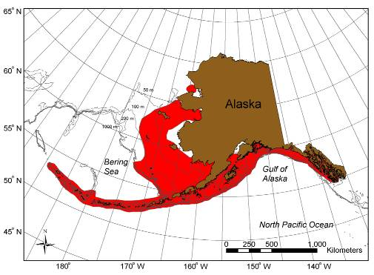

Figure 1. Red king crab distribution.

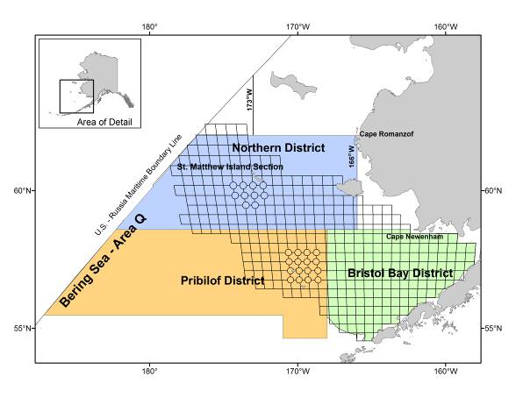

Figure 2. King crab Registration Area Q (Bering Sea) showing the Pribilof District.



Figure 3. Historical harvests and GHLs for Pribilof Island blue (diamonds) and red king crab (triangles) (Bowers et al. 2011).

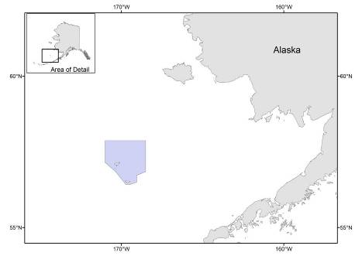

Figure 4. The shaded area shows the Pribilof Islands Habitat Conservation area.

Figure 5. Time series of Pribilof Islands red king crab estimated from the NMFS annual EBS bottom trawl survey.

Figure 6. Distribution of Pribilof Islands red king crab in 5 mm length bins by shell condition for the last 3 surveys.

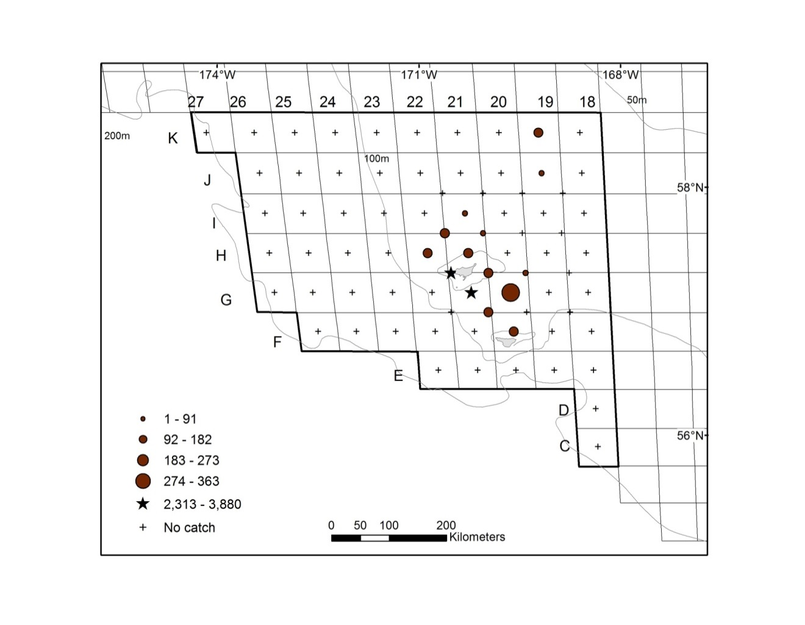

Figure 7. Total density (number nm-2) of red king crab in the Pribilof District in the 2012 EBS bottom trawl survey.

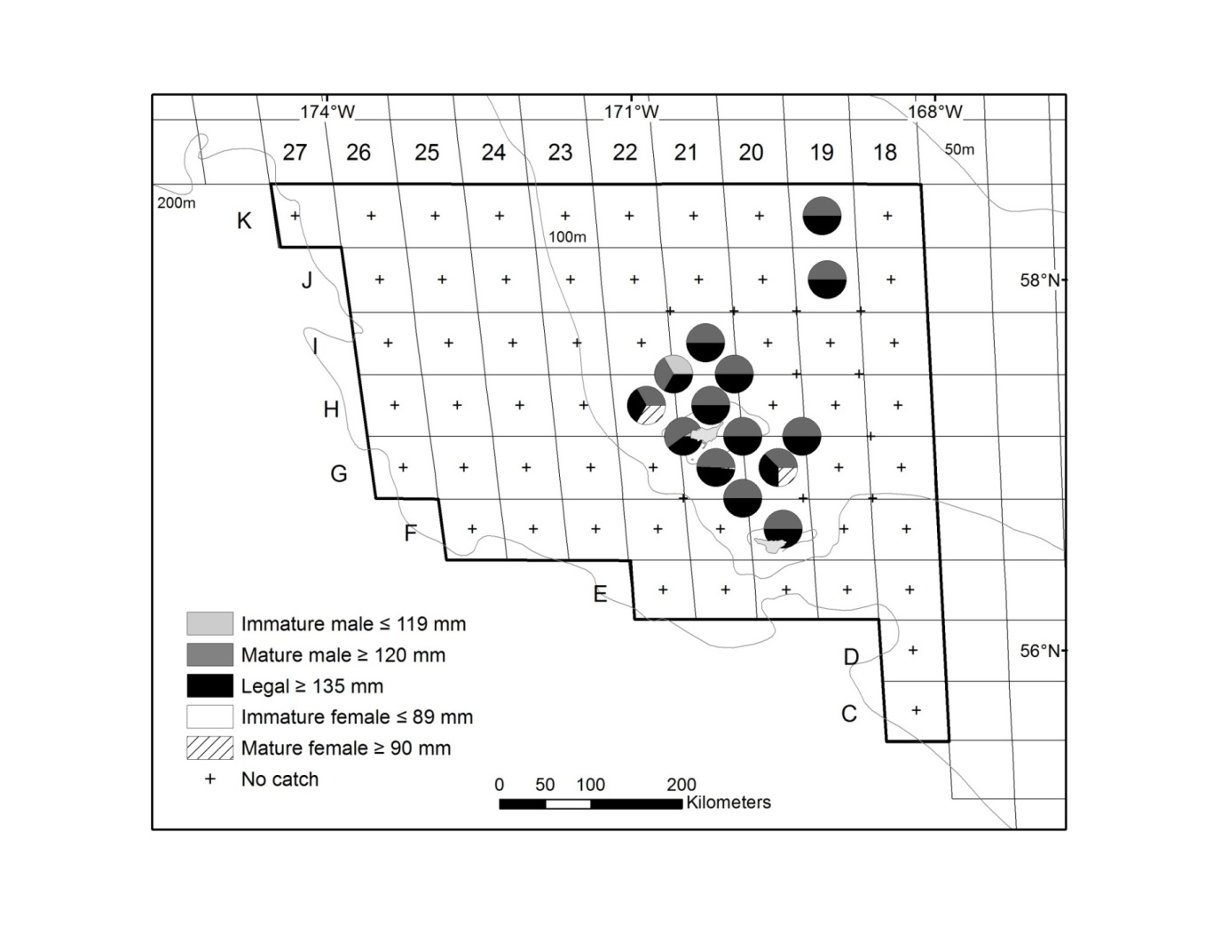

Figure 8. 2012 EBS bottom trawl survey size class distribution of red king crab in the Pribilof District.

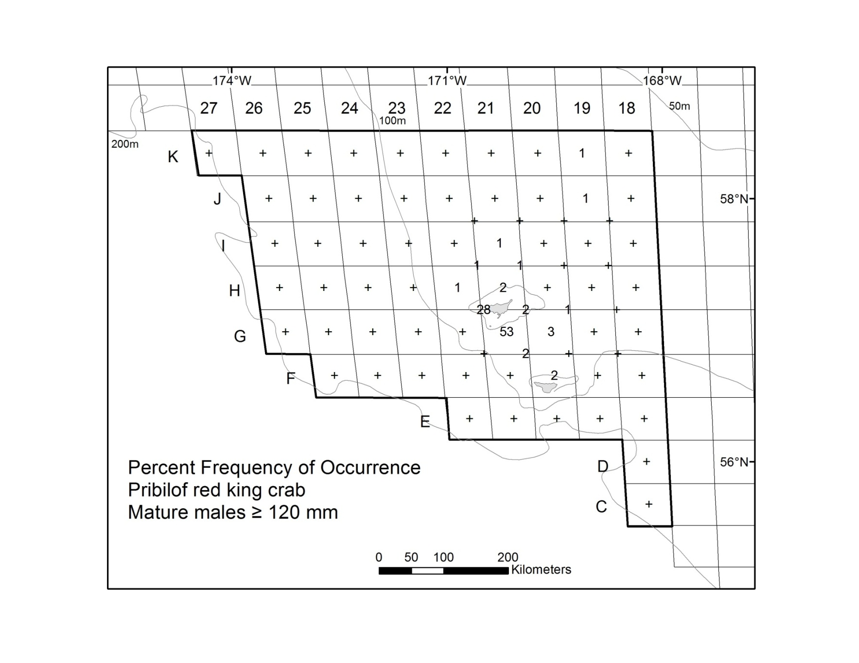

Figure 9. Percent frequency of occurrence of mature malered king crab (*Paralithodes camtschaticus*) at stations sampled in the 2013 Pribilof District.

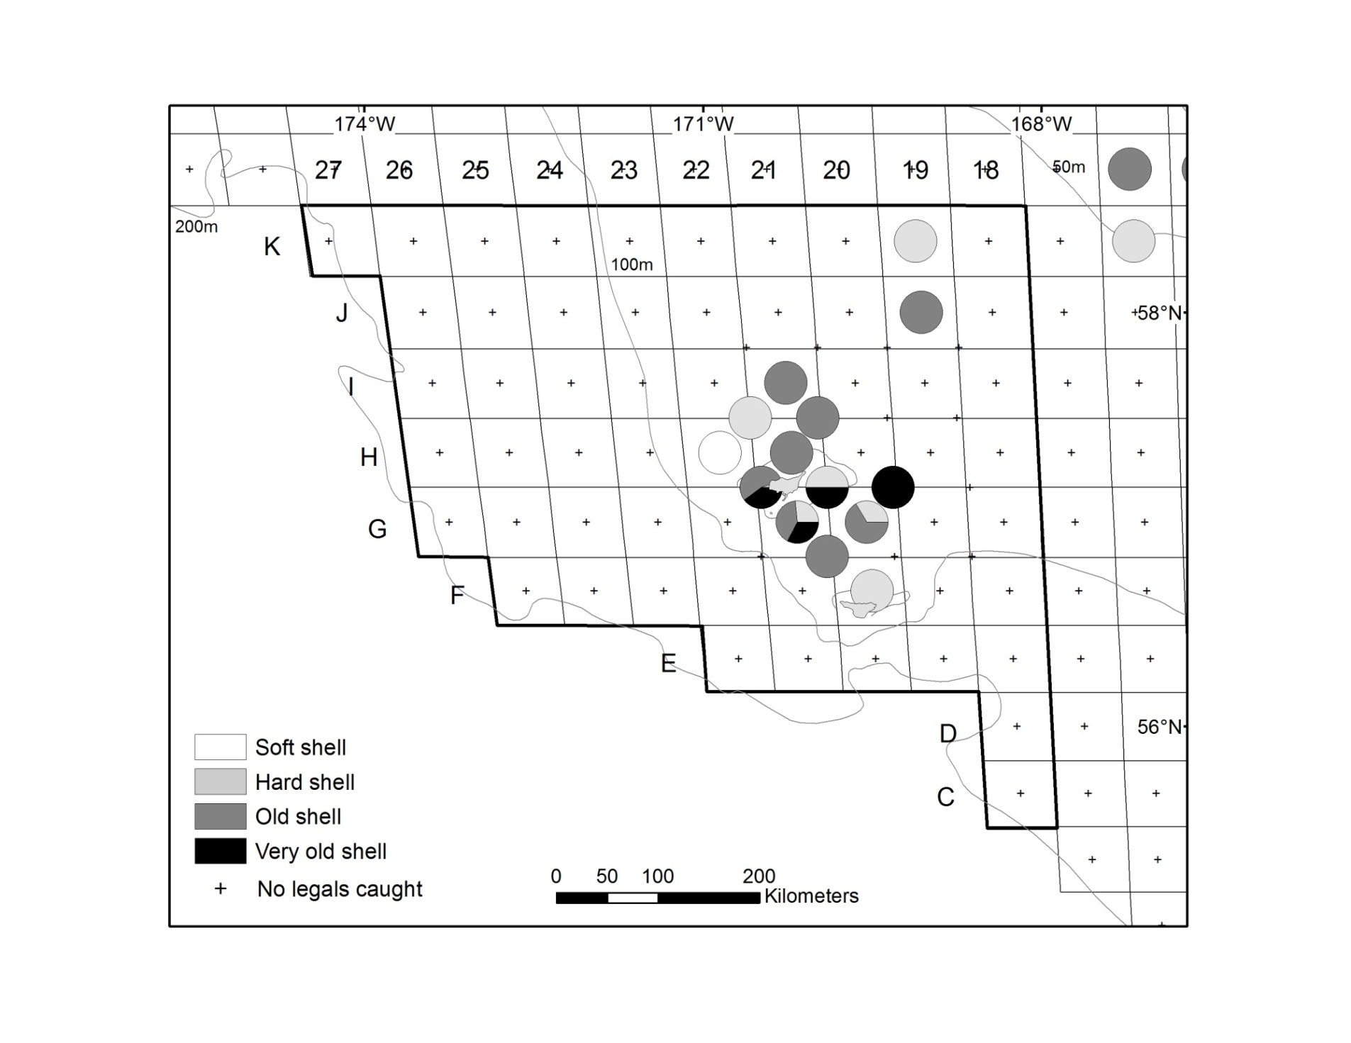

St. Paul Is.

St. George Is.

Figure 10. Distribution of legal-sized male red king crab (*Paralithodes camtschaticus*) caught at each station of the Pribilof District in 2013 and distinguished by shell condition. The outlined area depicts stations within the management district.

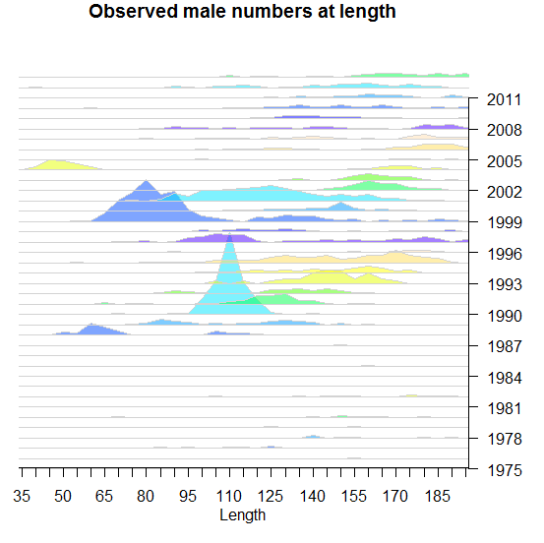

Figure 11. Observed numbers at length by 5 mm length classes of Pribilof Islands male red king crab (*Paralithodes camtschaticus*) from 1975 to 2013.

Figure 12. Size-frequency by shell condition, egg condition, and clutch fullness of Pribilof District female red king crab (*Paralithodes camtschaticus*) by 5 mm length classes in 2013.

Figure 13. Size frequency by 5 mm length classes of Pribilof Islands female red king crab (*Paralithodes camtschaticus*) from 1975 to 2013.

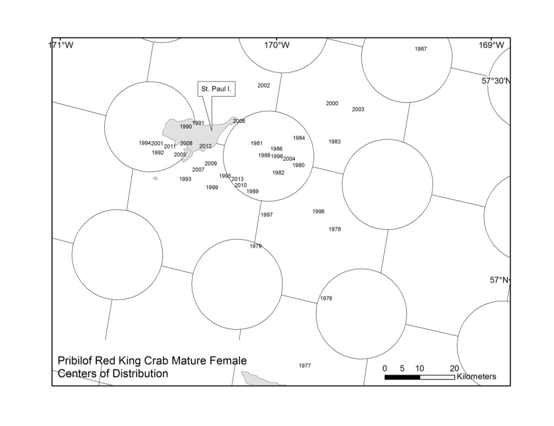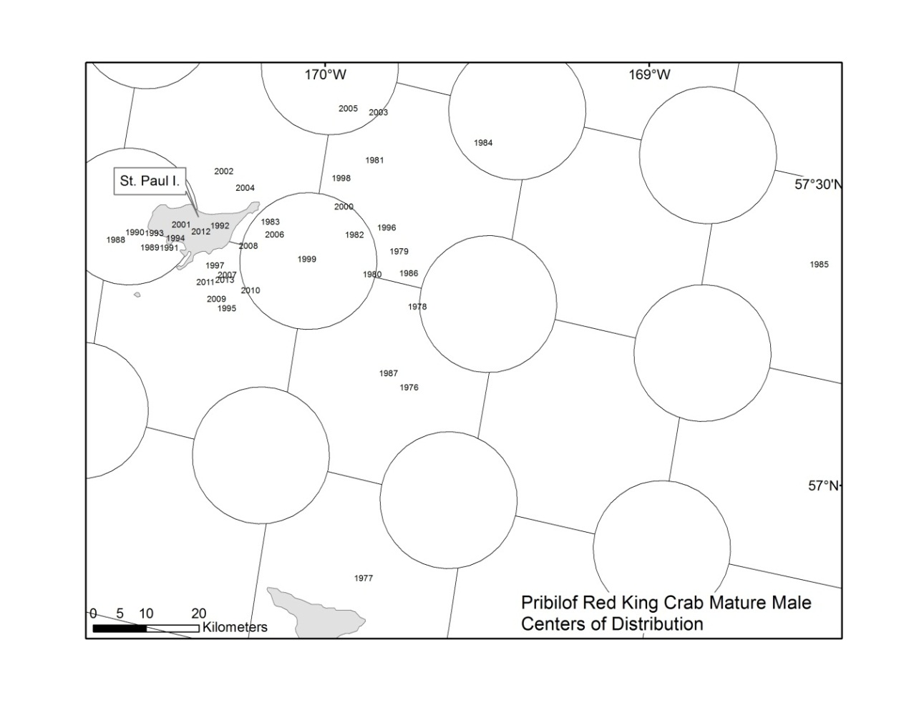

Figure 14. Centers of stock distribution of Pribilof Islands female and male red king crab (*Paralithodes camtschaticus*) from 1975 to 2013.

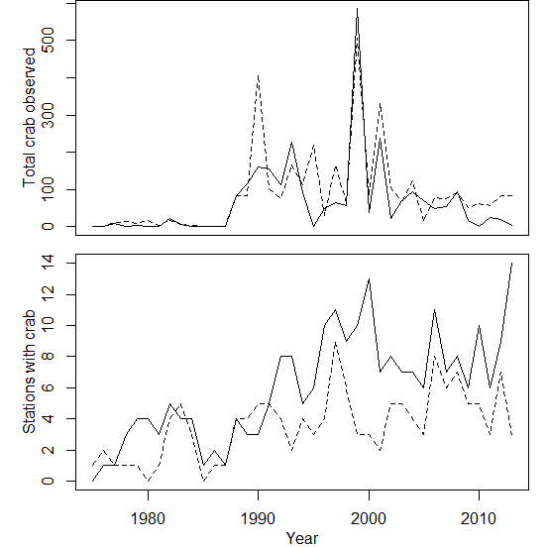

Figure 15. The number of stations that reported observations of crab (female = dashed line, male = solid line) from 1975-2013.

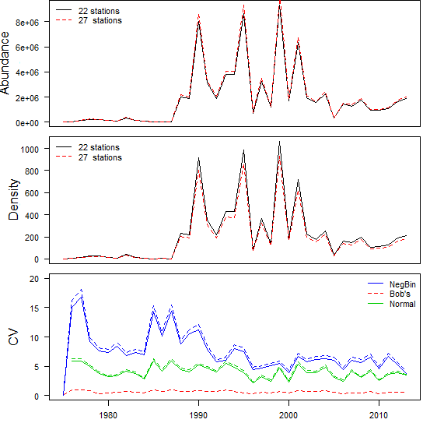

Figure 16. Estimates of abundance (top) made based on densities from area swept methods (middle) and the associated coefficients of variation (CV) with variances from three different methods of calculating the variance when only the 22 stations at which crab has ever been observed are used and when 5 extra stations where crab have never been observed, but have still been consistently surveyed, are included.

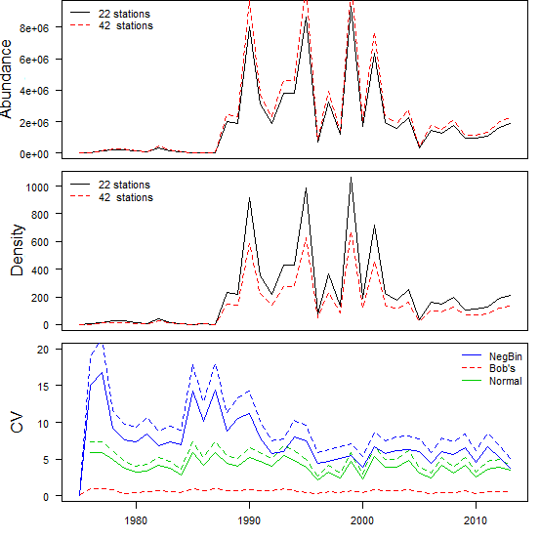

Figure 17. . Estimates of abundance (top) made based on densities from area swept methods (middle) and the associated coefficients of variation (CV) with variances from three different methods of calculating the variance when only the 22 stations at which crab has ever been observed are used and when 20 extra stations where crab have never been observed, but have still been consistently surveyed, are included.

Figure 18. Mature male biomass un-weighted and average weighted by inverse variance.

Figure 19. Time series of Pribilof Island red king crab 3 year weighted average mature male biomass (95% C.I.) and mature male biomass CV estimated from the NMFS annual EBS bottom trawl survey.



Figure 20. FOFL Control Rule for Tier 4 stocks under Amendment 24 to the BSAI King and Tanner Crabs fishery management plan. Directed fishing mortality is set to 0 below β.

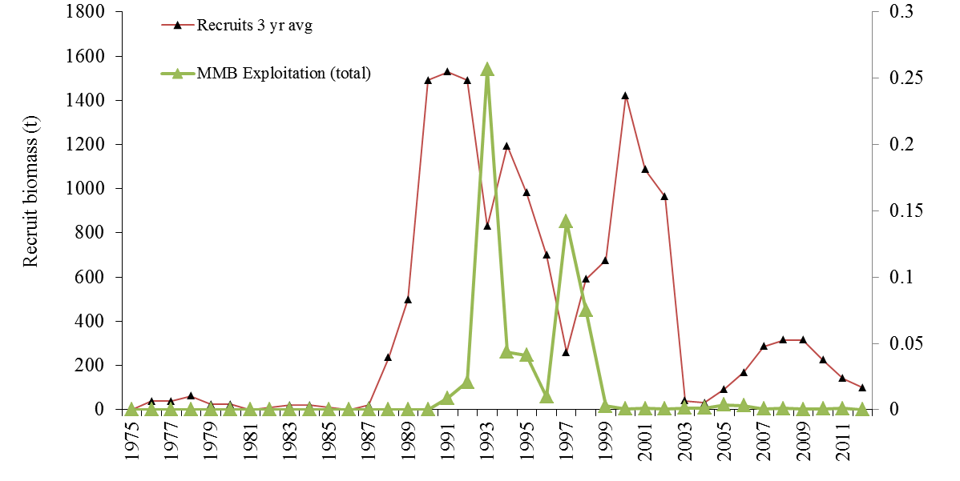

Figure 21. Time series of survey estimated recruit biomass (males 120-134 mm) and exploitation rate (based on total catch) of mature male biomass. The shaded region represents a period where commercial removals were occurring.

Figure 22. Time series of survey estimated recruit biomass (males 120-134 mm) and ln(Recruits/MMB). The shaded region represents a period where commercial removals were occurring.

Figure 23. Time series of survey estimated Pribilof Island red king crab 3 year moving averaged mature male biomass at mating (95% C.I.)

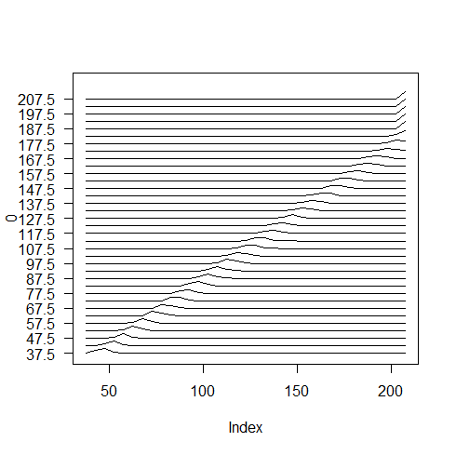

Figure 24. Size transition matrix used in the length-based assessment. Y-axis is the pre-molt carapace length , each line shows the distribution of post-molt lengths on the x-axis.

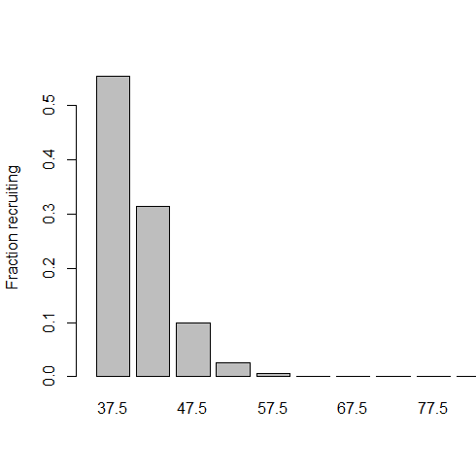

Figure 25. Fraction of incoming recruitment allocated to a given length bin.

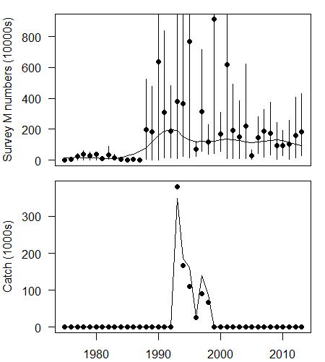

Figure 26. Model fits (black line) to observed survey numbers (black dots) with 95% bootstrapped CIs (top). Model fits (line) to observed catches in the directed fishery (dots) in numbers caught.

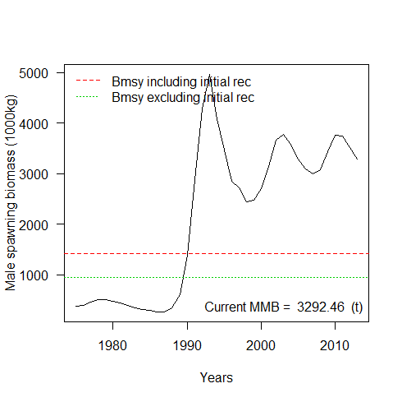

Figure 27. Estimated mature male biomass with ranges of years used to define average recruitment when calculating the BMSY proxy.

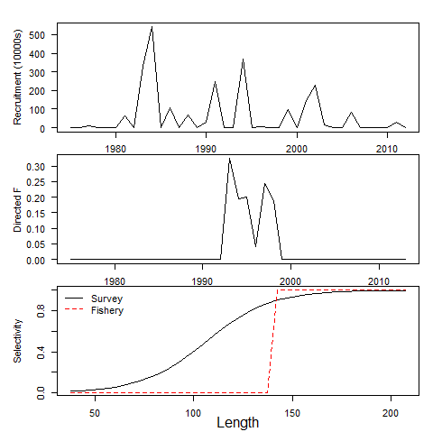

Figure 28. Estimated recruitment (top), fishing mortality in the directed fishery (middle) and survey selectivity (bottom, solid line). Fishery survey is fixed at the dashed line (bottom).

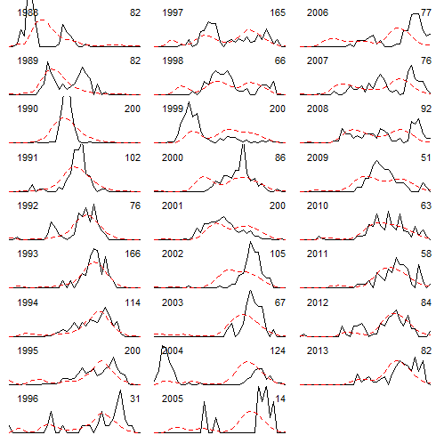

Figure 29. Model fits (red dashed line) to observed length frequencies in the survey (solid line) by year. Sample size is noted in the top right hand corner of each plot. Length frequencies for the years 1975-1987 are not shown because the associated sample sizes were <=18 and therefore held very little information.