Prediction of bycatch mortality in the Bering Sea Tanner crab (C. bairdi) fishery
Dan Urban, AFSC Kodiak Laboratory

The Tanner crab fishery in Alaska occurs from Southeast Alaska to the northwest Bering Sea although only the Bering Sea fishery currently operates under a federal management plan. The legal size for Tanner crab is 4.8 inches carapace width east of 166º W. longitude and 4.4 inches carapace width west of that longitude. Sublegal male crab and females must be returned immediately to the ocean. The numbers of crabs being discarded has roughly equaled the numbers being retained over the last 20 years. The mortality associated with the sorting and discard process is difficult to determine accurately but techniques have been developed recently which give some insight into predicting the discard mortality.
One technique which has gained some acceptance is based on the presence or absence of a suite of reflexes. Known as reflex action mortality predictor (RAMP), it has proved to be 80% accurate in predicting mortality in Tanner crab. Reflexes used in RAMP include the presence or absence of flaring of the legs, leg retraction when they are pulled forward, mouth closure, chela closure, eye retraction, and leg kick when the abdominal flap is lifted. Mortality is predicted on a sliding scale, so that a crab that retains all 6 reflexes has a predicted mortality rate of 9%, while a crab that has lost all 6 reflexes has a mortality rate of 100%. The reflexes are easy to evaluate and unambiguous in response. Previous work with snow crab on the fishing grounds found that for most temperatures occurring during the fishery, the predicted mortality was less than 5% although the rate increased rapidly when temperatures were below -6º C.
Fishery observers recorded RAMP scores during the Tanner crab fishery in the Bering Sea during the 2013/2014 fishery. Over 10,000 crab from 6 different vessels were evaluated. Pot sorting times on these vessels varied although most were in the range of 2-3 minutes (Figure1). Temperatures during the fishery observations ranged from 2º C to -14º C. Tanner crab predicted mortality averaged 11.4% over the entire range of temperatures observed with no obvious increase in reflex impairment at the coldest temperatures (Figure 2). During the fishery, 4.1% of crab were observed to have injuries with the most common injury being damaged legs (Figure 3).
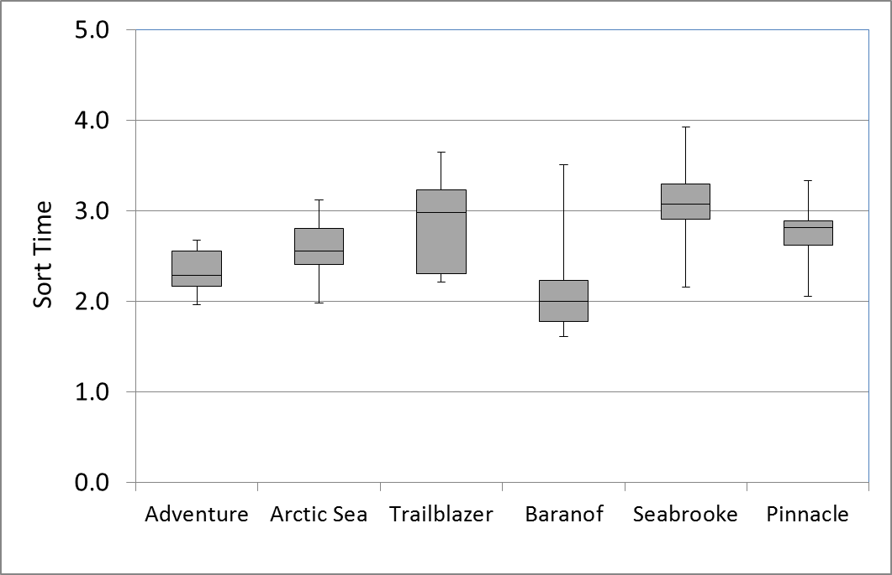
Figure 1. The time required to sort a crab pot during the Tanner crab fishery. The boxes represent the second and third quartiles with the whiskers representing maximum and minimum values.

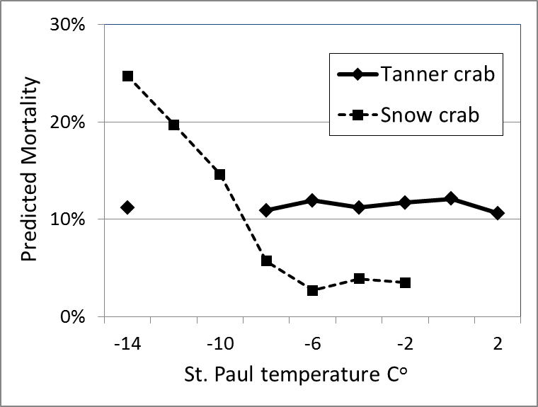
Figure 2. Predicted mortality of Tanner and snow crab during the fisheries and the associated temperatures recorded at the St. Paul airport in the Pribilof Islands.
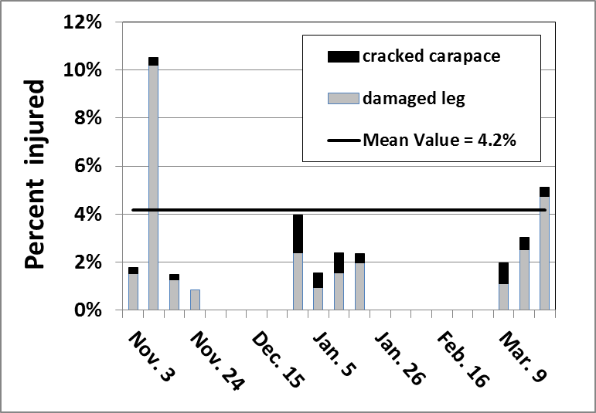
Figure 3. Percent of discarded Tanner crab that were observed to be injured during the 2013/2014 Bering Sea fishery. The horizontal dark black line represents the mean value for the fishery. The vertical bars represent the weeks when observer data is available.

