**ALTERNATIVE PRIBILOF ISLANDS GOLDEN KING CRAB**

**STOCK ASSESSMENT STRATEGY**

William Gaeuman, ADF&G Kodiak

Sept 2013

**Introduction**

As mandated by State of Alaska regulation **5 AAC 34.910 (b) (3)**, the Alaska Department of Fish and Game (ADF&G) currently manages the Pribilof Islands (Pribilof District; Figure 1) golden king crab (PIGKC) fishery as a calendar-year fishery under the terms of an ADF&G commissioner’s permit, and the stock is currently assessed in accordance with the Fishery Management Plan (FMP) for Bering Sea/Aleutian Islands King and Tanner Crabs as a Tier-5 crab stock (2012 Crab SAFE). However, both the NPFMC Crab Plan Team (CPT) and Scientific and Statistical Committee (SSC) have encouraged development of an alternative assessment strategy incorporating results from the biennial NMFS eastern Bering Sea upper continental slope trawl survey. Specifically, in June 2013 the SSC requested for Fall 2013 elaboration of a “modified Tier 5” approach that “would use the average of [slope-survey estimates of] mature male biomass for 2008, 2010, and 2012 as an estimate of current biomass, with F=M applied to estimate an OFL and a suitable buffer applied to set ABC.”[1] Though this approach falls outside the crab stock assessment Tier system, it closely corresponds to the North Pacific groundfish stock assessment Tier-5 methodology specified in the Bering Sea/Aleutian Islands Groundfish FMP, a notable difference being the use of mature male biomass (MMB) as the measure of (crab) stock biomass. This document “runs the numbers” and presents OFL and ABC calculations for the calendar-year 2014 PIGKC fishery using the requested alternative approach. Catch accounting for determination of overfishing in 2014 would then occur, hypothetically, sometime in 2015 after completion of the directed fishery. Note that this exercise is not intended as a revision of the 2014 OFL already proposed in the May draft 2013 PIGKC SAFE chapter, which provides further details on the PIGKC stock and fishery, but rather as a concrete illustration of the requested alternative assessment strategy.

**The EBS upper continental slope survey**

Details about eastern Bering Sea upper continental slope-survey methods are provided in Hoff and Britt (2011). Standardized surveys were conducted in 2002, 2004, 2008, 2010, and 2012; although intended to be biennial, no survey was performed in 2006. The survey occurs during June and July and the surveyed region consists of a swath of trawlable[2] ocean bottom at depths of 200 to 1,200 m extending northwest from near Dutch Harbor some 600 mi along the EBS continental shelf slope (Figure 2). The survey area is divided into 6 geographic subareas running south to north in the survey area: the Bering Canyon area, the Pribilof Canyon area, the inter-canyon area between Pribilof Canyon and Zhemchug Canyon, the Zhemchug Canyon area, the inter-canyon area between Zhemchug and Pervenets Canyon, and the Pervenets and Navarin Canyons area. Each subarea is partitioned into five 200-m depth zones between 200 and 1,200 m. The survey samples approximately 200 locations by stratified simple random sampling from the 30 area-by-depth-zone strata. In 2010 sampling densities within strata ranged from one haul per 112.39 km2 to one haul per 368.96 km2 (survey tow sampling is denser at depths less than 800 m), and the mean sampling density over the total surveyed area of 32,723 km2 was one haul per 204.48 km2. That sampling density compares to one haul per 400 nmi2 (1,372 km2) for the standard stations in the annual NMFS eastern Bering Sea shelf survey. The slope survey uses a Poly Nor’eastern high-opening bottom trawl equipped with mud-sweep roller gear constructed of 203 mm solid rubber disks strung over 16 mm high-tensile chain. The standard tow is 30 minutes at 2.5 knots.

**Slope-survey golden king crab catchability**

So far as the author is aware, the fishing characteristics of the slope-survey mud-sweep roller gear with respect to golden king crab (GKC) and how they compare to those of the shelf-survey gear are largely unknown. There is some conjecture that GKC catchability of the slope-survey gear is less than that of the shelf-survey gear and that the slope-survey systematically misses much of the GKC habitat in the survey area because the gear is unsuited to the rocky terrain the crab prefer.[3] If so, golden king crab slope-survey catchability may effectively be significantly less than 1 over the nominal design-specified survey region, with standard probability-survey based estimators of abundance and biomass biased low.

**2014 PIGKC Stock MMB**

The assessment methodology described here depends on an estimate of stock MMB based on results from the NMFS eastern Bering Sea upper continental slope survey, with PIGKC measuring at least 107 mm carapace length classified as mature (Otto and Commiskey 1985). Because length measurements on individual crab were not recorded during the 2002 survey[4] and incompletely so in 2004 (250 of 321 captured GKC in successful tows; Hoff and Britt 2005) and no survey was conducted in 2006, only results from the years 2008, 2010, and 2012 are suitable for this purpose. For each of these years, estimates of PIGKC MMB and its standard error were calculated by the present author in accordance with the survey’s stratified simple-random-sample design from data supplied by C. Armistead of the NMFS-AFSC Kodiak lab (Table 1). Necessary size-to-weight conversions were computed using the equation $w=αl^{β}$ relating male carapace length (CL) $l$ in millimeters to weight $w$ in grams, with α = 0.0002988 and β = 3.13 (NPFMC 2007). Note that error associated with the allometric modeling of crab weight was not taken into account.

To specify a meaningful estimate of PIGKC stock biomass from slope-survey results it is first necessary to choose the appropriate survey-design strata for use in the computation. Uncertainty about PIGKC stock distribution and spatial misalignment between survey strata and the boundaries of the PIGKC fishery complicate this choice. The PIGKC fishery area is determined by the boundaries of the Pribilof District of Registration Area Q (Figure 1) and, within that area, the fishery has occurred mostly in the Pribilof Canyon area to the south of the Pribilof Islands (Fitch et al. 2012). By contrast, the surveyed area extends north into the Northern District of Registration Area Q (north of 58° 39' N) and south and east into the Aleutian Islands Registration Area O (south of 54° 36' N and east of 168° W). Though a large proportion of the GKC encountered in the slope survey are caught in the Pribilof Canyon area, some GKC crab are captured sporadically throughout the surveyed region (Hoff and Britt 2003, 2005, 2009, 2011), and a Northern District GKC fishery has been successfully prosecuted historically, mostly to the west of St. Matthew Island in the area of the northern-most extent of the slope survey, with a peak harvest of 414,000 lb in 1987 (Fitch et al. 2012).

Three alternative areas for biomass estimation were discussed at the May 2013 CPT meeting: 1) the Pribilof Canyon slope-survey area; 2) the Pribilof District as established in state regulations; and 3) the total slope-survey area. For purposes of this assessment methodology the author has chosen as the most reasonable and straightforward approach to use the full set of 20 strata comprising subareas 2-5 of the survey region because those subareas are entirely or mostly contained within the Pribilof District (Figures 3-5). Subareas 2 and 3 lie completely within the Pribilof District, whereas subareas 4 and 5 straddle its boundary in the north. By contrast, subarea 6 lies outside the Pribilof District to the north, and only a small portion of subarea 1 intersects the Pribilof District in the southeast. Moreover, survey catches of mature male GKC in subarea 1 have occurred almost exclusively outside the Pribilof District. Proposed alternatives (1) and (3) exclude or include, respectively, relevant mature male GKC survey catches; proposed alternative (2) would introduce extra practical and theoretical complexities relating to, for example, random sample sizes, variance calculation, and determination of proper expansion factors that in the author’s view are unjustified given the close alignment of subareas 2-5 and the Pribilof District and of mature male GKC survey catches within the two regions. Although the author recommends the use of subareas 2-5 for PIGKC biomass estimation, results are provided for each subarea individually to facilitate estimation based on any combination of subareas (Table 1).

**2014 PIGKC OFL Computation**

Slope-survey estimates for the three years 2008, 2010, and 2012 based on the 20 strata within subareas 2-5 were averaged to obtain a single estimate of PIGKC MMB equal to 1.227 × 106 lb with **estimated** CV 0.16 (Table 1). In accordance with May 2013 CPT and June 2013 SSC recommendations, the 2014 PIGKC OFL was then computed by multiplying the estimate of stock MMB by the default postulated value of instantaneous natural mortality M, which is taken to be 0.18 yr-1 for BSAI king crab (NPFMC 2007). This approach, which parallels that used for Tier-5 North Pacific groundfish stocks, here yields an annual mature male OFL of

${OFL}_{MM}=M\hat{×MMB=}0.18 ×1,227,180 lb=220,892 lb$. [1]

All subsequent calculations here used to obtain estimates of discard mortality biomass required in deriving various components of the OFL rely on NMFS groundfish observer data, ADF&G crab observer length-frequency data, NMFS crab size-to-weight models, and conventional NPFMC assumptions about Bering Sea king crab handling mortality in the different fisheries.

Given the mature male OFL, the first step in determining the retained-catch portion of the OFL is to subtract suitable estimates of mature male discard mortality biomass attributable to the relevant non-directed fisheries. Based on historical fishing in the region, these consist of the Bering Sea groundfish, snow crab *Chionoecetes opilio*, and grooved Tanner crab *C. tanneri* fisheries (2012 Crab SAFE , Fitch et al. 2012, ADF&G Crab Observer Database). In the Bering Sea groundfish fisheries, Pengilly (draft May 2013 PIGKC SAFE chapt.) estimated a 10-year maximum annual PIGKC total discard mortality of 10,826 lb over the period 2002/03 through 2011/12, with the maximum value coming from 2009/10. (Relevant NMFS groundfish observer data for 2012/13 were not yet available at the time this document was prepared.) Pengilly used data from NMFS reporting areas 512, 513, and 521 and assumed standard GKC handling mortalities of 0.8 and 0.5, respectively, for trawl and fixed gear types. Extending Pengilly’s work, this author estimated a maximum PIGKC total discard mortality of 1,061 lb in the Bering Sea snow crab fishery over the 10-year period 2003/04 through 2012/13 under assumption of a 50% handling mortality. The maximum annual estimate is from the 2008/09 fishery when observers encountered 1 sublegal and 4 legal-sized GKC in pot lift sampling. Because virtually all of the few GKC captured in the snow crab fishery have been unmeasured males, the most recently reported PIGKC fishery average retained weight was used in biomass estimation and the estimated discard mortality biomass was fully ascribed to the mature male component of the stock. Groundfish discard mortality of PIGKC was likewise here assumed to affect only mature males since the underlying NMFS groundfish observer data provide limited information about size or sex of crab bycatch.

The third non-directed fishery with historical impact on the PIGKC stock, the Bering Sea grooved Tanner crab fishery, recorded a peak harvest of close to 985,000 lb in 1995 (Fitch et al. 2012). In 1999 ADF&G established a GHL range of 50,000 to 200,000 lb for this calendar-year fishery (Fitch et al. 2012). The fishery performed erratically in subsequent years and has not been prosecuted since 2005. Estimates of the ratio of mature-male-GKC-bycatch weight to retained-grooved-Tanner-crab weight based on ADF&G observer length-frequency data from the last three years in which the fishery occurred (2003, 2004, 2005) average about 6.6%. Applying a 0.5 handling morality for king crab in non-directed fixed-gear fisheries, a plausible upper bound on expected PIGKC mature male discard morality in a potential Bering Sea grooved Tanner crab fishery is thus *200,000 lb × 0.066 × 0.5 = 6,600 lb*. This leads to

${OFL}_{MM,DF}=220,892 lb-\left(10,826+1,061+6,600\right) lb=202,405 lb$ [2]

as the mature male OFL in the directed PIGKC fishery after accounting for mature male discard mortality biomass in the three relevant non-directed fisheries: Bering Sea groundfish, snow crab, and grooved Tanner crab fisheries.

The retained catch OFL in the PIGKC directed fishery is then calculated as

${OFL}_{RET}=\frac{202,405 lb}{1+\left(0.2\right)(0.129)}=197,314 lb$, [3]

where 0.129 is the average estimated ratio of mature-male-discard weight to retained-catch weight in the last three prosecuted PIGKC fisheries (2010, 2011, 2012), and 0.2 is the assumed mortality rate of discarded PGKC in the directed fishery. Note that this value is about 31% more than the 150,000-lb guideline harvest level (GHL) in place under ADF&G management of the PIGKC fishery since 2001 (Fitch et al. 2012).

The PIGKC total catch OFL may now be obtained by adjoining to the retained catch OFL appropriate estimates of expected total discard mortality. In the directed fishery estimates of the ratio of total-discard weight to retained-catch weight average 0.212 over the last three years (2010, 2011, 2012), again based on ADF&G observer length-frequency data. Assuming 20% handling mortality, an estimate of OFL total discard mortality in the directed fishery is then *0.212 × 197,314 lb* × *0.2 = 8,366 lb*. In the grooved Tanner crab fishery, average estimated total-GKC-discard weight to retained-grooved-Tanner-catch weight is 0.079 for the last three years of the fishery (2003, 2004, 2005), so an estimate of expected total PIGKC discard mortality in a fully prosecuted fishery is *0.079 × 200,000 lb × 0.5 = 7,900 lb*, assuming 50% handling mortality of PIGKC. As all PIGKC discard mortality in the Bering Sea groundfish and snow crab fisheries was assumed comprised of mature males, the PIGKC total catch OFL is thus

${OFL}_{TC}=197,314 lb+8,366 lb+10,826 lb+1,061 lb+7,900 lb=225,467 lb$. [4]

Table 2 lists the primary estimates and parameters used in obtaining this result; Table 3 lists the components in the total catch OFL and summarizes the key steps [1] – [4] in its derivation.

**2014 PIGKC ABC Calculation**

Consistent with Tier-5 crab and Tier-5 groundfish assessment methodology, the author recommends use of a 10% buffer to specify the (hypothetical) PIGKC 2014 ABC according to

$ABC=\left(1-0.1\right)OFL$. [5]

When applied to the total-catch OFL this yields an author-recommended ABC of *202,921 lb* (Table 3).

**References**

Fitch, H., M. Deiman, J. Shaishnikoff, and K. Herring. 2012. Annual management report for the commercial and subsistence shellfish fisheries of the Bering Sea, 2010/11. Pages 75-1776 [In] Fitch, H., M. Schwenzfeier, B. Baechler, T. Hartill, M. Salmon, M. Deiman, E. Evans, E. Henry, L. Wald, J. Shaishnikoff, K. Herring, and J. Wilson. 2012. Annual management report for the commercial and subsistence shellfish fisheries of the Aleutian Islands, Bering Sea and the Westward Region’s Shellfish Observer Program, 2010/11. Alaska Department of Fish and Game, Fishery Management Report No. 12-22, Anchorage.

Gaeuman, W. 2013. Summary of the 2011/12 mandatory crab observer program database for the

Bering Sea/Aleutian Islands commercial crab fisheries. Alaska Department of Fish and Game, Fishery Data Series No. 13-21, Anchorage.

Hoff, G.R., and L.L. Britt. 2003. The 2002 eastern Bering Sea upper continental slope survey of

groundfish and invertebrate resources. U.S. Dep. Commer., NOAA Tech. Memo. NMFS-AFSC-141, 261 p.

Hoff, G.R., and L.L. Britt. 2005. Results of the 2004 eastern Bering Sea upper continental slope survey of groundfish and invertebrate resources. U.S. Dep. Commer., NOAA Tech. Memo. NMFS-AFSC-156, 276 p.

Hoff, G.R., and L.L. Britt. 2009. Results of the 2008 eastern Bering Sea upper continental slope survey of groundfish and invertebrate resources. U.S. Dep. Commer., NOAA Tech. Memo. NMFS-AFSC-197, 294 p.

Hoff, G.R., and L.L. Britt. 2011. Results of the 2010 eastern Bering Sea upper continental slope survey of groundfish and invertebrate resources. U.S. Dep. Commer., NOAA Tech. Memo. NMFS-AFSC-224, 300 p.

Otto, R.S. , and P.A. Cummiskey. 1985. Observations on the reproductive biology of golden king crab (*Lithodes aequispina*) in the Bering Sea and Aleutian Islands. Pages 123–136 [In] Proceedings of the International King Crab Symposium. University of Alaska Sea Grant Report No. 85-12, Fairbanks.

North Pacific Fishery Management Council (NPFMC). 2007. Public Review Draft: Environmental assessment for proposed Amendment 24 to the Fishery Management Plan for Bering Sea and Aleutian Islands king and Tanner crabs to revise overfishing definitions. 14 November 2007. North Pacific Fishery Management Council, Anchorage.

Table 1: Author computed EBS slope-survey estimates

(103 lb) of golden king crab mature male biomass by

survey subarea. The author recommended estimate of

PIGKC MMB is 1.227 × 106 lb based on survey subareas 2

through 5. Survey data supplied by C. Armistead,

NMFS-AFSC Kodiak lab.

|  |  |  |  |  |  |  |  |
| --- | --- | --- | --- | --- | --- | --- | --- |
|  | Subarea (south to north) | | | | | | |
| Year | 1 | 2 | 3 | 4 | 5 | 6 | 2-5 |
| 2008 | 103 | 1,080 | 140 | 186 | 049 | 066 | 1,456 |
| 2010 | 370 | 970 | 173 | 101 | 022 | 056 | 1,266 |
| 2012 | 723 | 565 | 322 | 058 | 014 | 108 | 960 |
| Avg Percent | 23% | 51% | 12% | 7% | 2% | 4% | 96% |
| 3-year Avg | 399 | 872 | 212 | 115 | 028 | 77 | 1,227 |
| CV(Avg) | 0.28 | 0.19 | 0.47 | 0.33 | 0.63 | 0.27 | 0.16 |

Table 2: Key quantities used in 2014 PIGKC OFL computation.

|  |  |  |
| --- | --- | --- |
| **Estimate/Parameter** | **Value** | **Basis** |
| PIGKC MM CL | 107 mm | Otto and Commiskey 1985 |
| PIGKC stock MMB | 1,227,180 lb | average estimate from 2008, 2010, 2012 NMFS EBS  slope-survey results for subareas 2-5 |
| Bering Sea king crab natural mortality | 0.18 yr-1 | NPFMC 2007 |
| directed fishery king crab  handling mortality | 0.2 | draft May 2013 PIGKC SAFE chapt. |
| king crab handling mortality in other  fixed-gear fisheries | 0.5 | draft May 2013 PIGKC SAFE chapt. |
| king crab handling mortality in trawl  fisheries | 0.8 | draft May 2013 PIGKC SAFE chapt. |
| male GKC size-to-weight power model | CL millimeters -> grams  α=0.000298, β=3.135 | NPFMC 2007 |
| female GKC size-to-weight power model | CL millimeters -> grams  α=0.001424, β=2.781 | NPFMC 2007 |
| male grooved Tanner crab  size-to-weight power model | CW millimeters -> grams  α=0.0001186, β=3.1892 | NPFMC 2007 |
| PIGKC MM and total discard mortality in  Bering Sea groundfish fisheries | 10,826 lb | 10-year maximum estimate from draft 2013 PIGKC  SAFE chapter |
| PIGKC MM and total discard mortality in  Bering Sea snow crab fishery | 1,061 lb | 10-year maximum estimate from draft 2013 PIGKC  SAFE chapter, and author estimate for 2012/13 fishery |
| PIGK-MM-discard/retained-catch in  Bering Sea grooved Tanner fishery | 0.066 | 2003-2005 ADF&G observer length-frequency data;  NMFS size-to-weight models |
| PIGKC-MM-discard/retained-catch in  PIGKC directed fishery | 0.129 | 2010-2012 ADF&G observer length-frequency data;  NMFS size-to-weight models |
| PIGKC-total-discard/retained-catch in  PIGKC directed fishery | 0.212 | 2010-2012 ADF&G observer length-frequency data;  NMFS size-to-weight equations |
| PIGKC-total-discard/retained-catch in  Bering Sea grooved Tanner fishery | 0.079 | 2003-2005 ADF&G observer length-frequency data;  NMFS size-to-weight models |

Table 3: Steps in 2014 PIGKC OFL/ABC computation.

|  |  |  |  |
| --- | --- | --- | --- |
| **BRP** | **Description** | **Computation** | **Valuea** |
| mature male OFL | natural mortality x estimated MMB | (0.18)(1,227,180) | 221 |
| mature male OFL  in directed fishery | MM OFL less MM bycatch discard mortality  in GF, snow crab, and GT crab fisheries | 220,892 – 10,826 – 1,061 – 6,600 | 202 |
| retained catch OFL  in directed fishery | retained proportion of MM fishing mortality  in directed fishery | 202,405 / [ 1+(0.2)(0.129) ] | 197b |
| total catch OFL | retained catch OFL plus **total** discard mortality  in directed, GF, snow crab, and GT crab fisheries | 197,314 + 8,366 + 10,826 + 1,061 + 7,900 | 225c |
| ABC (total catch) | total catch OFL with 10% buffer | (1 – 0.1)(225,467) | 203d |

a 103 lb to three significant digits.

b 126 if only subarea 2 (Pribilof Canyon) is used for stock biomass estimation.

c 154 if only subarea 2 (Pribilof Canyon) is used for stock biomass estimation.

d 138 if only subarea 2 (Pribilof Canyon) is used for stock biomass estimation.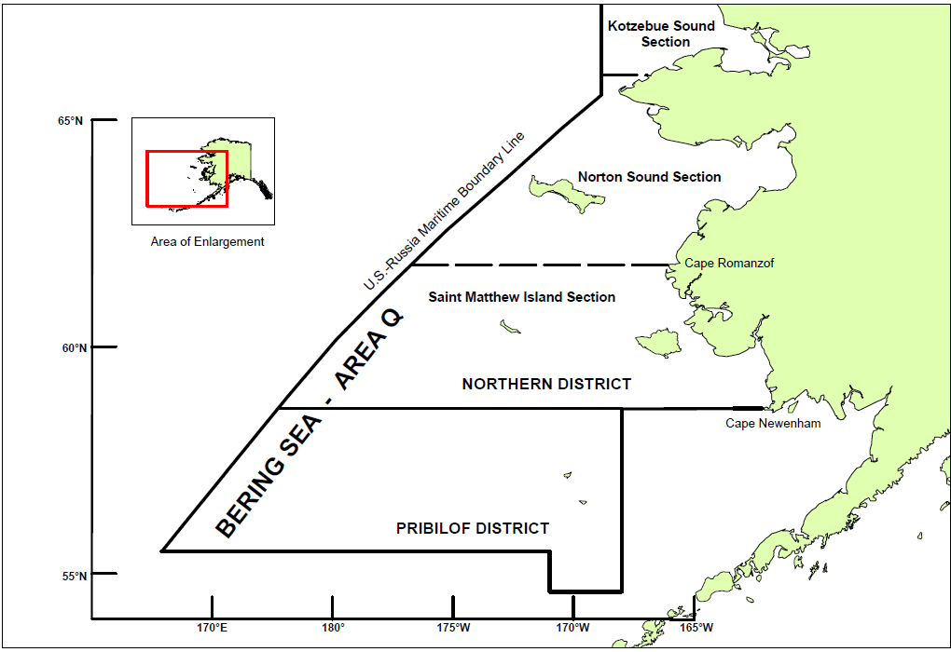

Figure 1. King crab Registration Area Q (Bering Sea), showing borders of the Pribilof District (from Figure

2-4 *in* Fitch et al. 2012).



Figure 2. Map of standard survey area for NMFS eastern Bering Sea upper continental slope trawl survey with survey subareas identified; black dots show locations of successful tows during the 2010 survey (from Figure 1 *in* Hoff and Britt 2011).

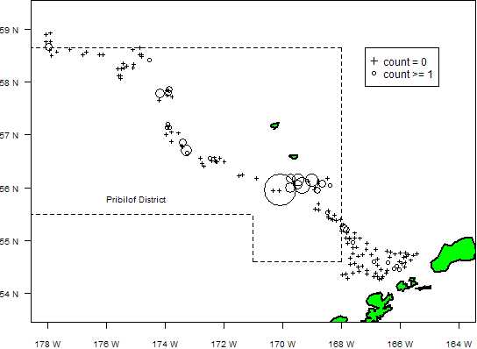

Figure 3. GKC mature male catch distribution in subareas 1-5 of the 2008 EBS continental

slope survey. Nonzero catches are proportional to symbol areas. The maximum catch was

48 GKC.

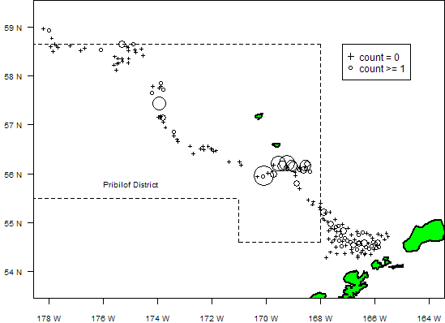

Figure 4. GKC mature male catch distribution in subareas 1-5 of the 2010 EBS continental

slope survey. Nonzero catches are proportional to symbol areas. The maximum catch was

21 GKC.

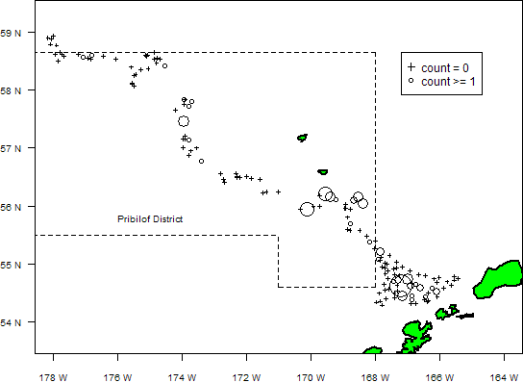

Figure 5. GKC mature male catch distribution in subareas 1-5 of the 2012 EBS continental

slope survey. Nonzero catches are proportional to symbol areas. The maximum catch was

20 GKC.

1. Report of the Scientific and Statistical Committee to the North Pacific Fishery Management Council, June 3-5, 2013, p. 10.
2. A site was considered trawlable “when the depth changed less than 50 m over the 2-nmi transect and there were no detectable obstacles in the trawl path.” (Hoff and Britt 2011, p.4)
3. D. Sommerton, 2 May 2013 email exchange with C. Rose, M. Dorn, and J. Hoff as summarized in May 2013 CPT report.
4. C. Armistead, NMFS-AFSC Kodiak Laboratory, 18 Mar 2013 email.