Standardization of CPUE from Aleutian Islands Golden King Crab Fishery Observer Data

M.S.M. Siddeek¹, J. Zheng¹, Doug Pengilly², and Gretchen Bishop¹

¹ Alaska Department of Fish and Game

Division of Commercial Fisheries
P.O. Box 115526; Juneau, Alaska 99811

² Alaska Department of Fish and Game
351 Research Court; Kodiak, Alaska 99615
shareef.siddeek@alaska.gov; jie.zheng@alaska.gov; doug.pengilly@alaska.gov; gretchen.bishop@alaska.gov

Draft summary report prepared for the Crab Plan Team Meeting, April 29-May 3, 2013.

Preamble
Our primary task is to standardize the catch-per-unit-effort (CPUE) of observer pot sample data to input to the Aleutian Islands golden king crab (GKC) assessment model (Siddeek et al., 2011). We presented an initial analysis to standardize the observer CPUE data using generalized linear model (GLM) at the May 2012 Crab Plan Team (CPT) meeting. Following CPT recommendations, we applied the GLM and generalized additive model (GAM) to analyze the fish ticket and observer sample data and presented the results at the September 2012 CPT meeting. For the February 2013 crab model workshop, we switched back to GLM because it can handle any nonlinear situation by converting the variable into factors and also GLM is based on sound statistical principles.

Following suggestions made at the February Crab Modeling Workshop, we redid the GLM analysis restricting it to observer pot sample legal size male data and divided the time series into pre (1995/96–2004/05) and post (2005/06–2010/11) rationalization periods. We treated the explanatory variables: Soak, Depth, and product of number of Vessels and mean Soak time, as continuous numeric and used the piecewise-cubic spline to describe their functional forms in the GLM. For one scenario, we departed from lognormal and binomial GLM families to the negative binomial family. We computed yearly CPUE indices with confidence intervals and a number of diagnostic statistics for areas east (EAG) and west (WAG) of 174°W longitudes.

Our analysis did not pick up significant interactions and the standardized CPUE indices were lower than the nominal CPUE indices during the post-rationalization period. The standardized CPUE trends based on the negative binomial family were similar to the CPUE trends of the combination of lognormal and binomial families.

Although observer data have been collected since 1989 (ADF&G, 2011), the quality of data improved in the mid-1990s. This restricted the current analysis to 1995/96–2010/11 data sets. We were unable to use the long-term fish ticket (1985/86–2010/11) data set because it has no soak time information, which played an important role in the post-rationalization period.

Responses to February 2013 Crab Modeling Workshop comments
General comments:
- Although considerable work was undertaken prior to and during the workshop to standardize catch and effort data to remove factors unrelated to abundance, the workshop noted that there was no guarantee that the resulting standardized indexes would be linearly proportional to abundance. For example, there is no way to be sure that the standardization has removed all of the effects of changes in fishing practices or how pots are set spatially in the fishery for Aleutian Islands golden king crab.
Response: This comment is related to the stock assessment model. Not considered here.
Major recommendations and conclusions:
- Only the observer CPUE data should be standardized and used in assessments, because it has associated soak time data. Observer CPUE should be broken into two time series, with rationalization marking the break point and a potential influence of soak time on catch included in the analysis irrespective of whether it is significant.
Response: We considered this suggestion in this analysis.

Future work
- For the May CPT meeting, provide a revised CPUE standardization which:
- analyzes pre- and post-rationalization observer data separately;
Response: We considered this suggestion in this analysis.

- includes soak time as a covariate in all models (binomial and log-normal) irrespective of whether they are selected;
Response: We considered this suggestion in this analysis.

- uses standard model selection diagnostics (e.g. changes in R²) to select other covariates; and
Response: We considered this suggestion in this analysis.

- includes all diagnostics (including influence plots) for both the binomial and log-normal components of the analysis in the document.
Response: We considered most of this suggestion in the current analysis. However, we have not as of yet used the (http://projects.trophia.com/projects/influ/repository/entry/influ.R.) diagnostics package. We are in the process of learning and implementing this routine.

- The longer-term tasks related to CPUE standardization are:
- consider a model for observer CPUE where Soak Time and Depth are treated as continuous covariates;
Response: We considered this suggestion in this analysis. We used the piecewise-cubic spline routine to fit these covariates.

- identify which types of data points appear in the tails of the q-q plots for the fish ticket data and remove aberrant data points;
Response: We are not considering fish ticket in the current analysis; however, we encountered this problem when splitting observer data into two periods. Specifically, the post-rationalization period data showed this pattern in the q-q plot. We removed some records to correct this. We provide comparative figures in the report.

- repeat the observer data analyses using an alternative distribution such as the negative binomial; and
Response: We considered the negative binomial family in one scenario.

- construct a competition covariate which, for each record, is based on the number of real days of fishing for the specific week, statistical area and gear.
Response: We constructed an explanatory variable, based on the product of number of vessels and mean Soak Time, to address this. However, the GLM did not select this explanatory variable.

Method

Preliminary data processing

Observer Pot Sample Data
We separated the observer data into EAG (fishing area east of 174°W longitudes) and WAG (fishing area west of 174°W longitudes) for CPUE standardization. Anecdotal accounts justify the separation of areas and there is hardly any commercial golden king crab abundance in the non-fishing area between the two regions. After removing some incomplete records, the Aleutian Islands golden king crab observer pot sample data totaled 102,849 records for 1990/91–2010/11, and 70095 for 1995/96–2004/05. We considered the 1995/96–2010/11 data in the analysis because of a gap in the data series (the 1994/95 fishery was not sampled) for EAG and inconsistencies in data recording in previous years. The records were further reduced by trimming Soak Time by 5% and Depth by 1% to remove unreliable entries (Table 1). We split the data series into 1995/96–2004/05 (pre-rationalization) and 2005/06–2010/11 (post-rationalization) periods for analysis. We used the core vessels’ data in the analysis for the legal component.

For EAG, there were 31972 total records (zero and positive catches), and 28669 positive catch records for 1995/96–2004/05 and respectively 4210 and 4120 for 2005/06–2010/11. For WAG, there were 32298 total records and 26685 positive catch records for 1995/96–2004/05 and respectively 5445 and 5158 for 2005/06–2010/11.

We considered the following variables from each record in the model:
Year = Federal Fisheries Management Year. This is treated as a factorial predictor variable in the model.
Month = A calendar month in a year. This is treated as a factorial predictor variable in the model.
Vessel = Identification code for a participating vessel. This is treated as a factorial predictor variable in the model.
Captain = Identification code for Captain. This is treated as a factorial predictor variable in the model.
Area = ADFG identification code for a fishing area. This is treated as a factorial predictor variable in the model. This factor variable was reduced to 10 levels defined in the subsequent section.
Catch = Number of crabs caught. This is the response variable. We considered two types of crab catch response variables, legal males (retained and non-retained legal-sized crab) and sublegal males. Because the stock assessment model is designed for males only, we did not consider female catch. This is treated as a numeric response variable in the model.
East/West = The east/west subdivision code, 1 for east and 2 for west of 174°W longitudes. We subset the data to 1, 2 or 1 & 2 for model fit.
Depth = Depth in fathoms. We considered this as an important predictor variable because crab abundance is not uniform by depth. This is treated as a numerical predictor variable in the model.
Soak = Soak time in number of days. We considered this an important predictor variable because there were significant changes in soak time duration between pre-and post-rationalization periods (Siddeek et al., 2011). This is treated as a numeric predictor variable in the model.
Gear = Identification code for different types of pot gear. Although a single gear (pot) is used in the fishery, the type and configuration varied over the years. Each type of pot has a unique number code (Table 2). We considered this an important predictor variable because gear configuration affects catch efficiency. This is treated as a factorial predictor variable in the model.
East/WestVesSoak = product of Number of vessels and average soak days by year. This is treated as a numeric predictor variable in the model.

Definition of Factor Levels
Year: 1995/96–2010/11 for observer pot sample data;
Month: 1 to 12;
Vessel: Vessel registration number;
Captain: Captain identified number code;
Gear: Gear codes. These are provided in Table 1; and
Area, Ten levels:
Statistical area code 665300– 685334 range is coded as 66;
Statistical area code 695199– 705301 range is coded as 69;
Statistical area code 715129–-735301 range is coded as 71;
Statistical area code 745130–755331 range is coded as 74;
Statistical area code 765099–775201 range is coded as 76;
Statistical area code 785100–795431 range is coded as 78;
Statistical area code 805100–815432 range is coded as 80;
Statistical area code 825099–835301 range is coded as 82;
Statistical area code 845099–865303 range is coded as 84; and
Statistical area code 875199–895331 range is coded as 87.

Core Vessel Selection
There was a maximum of 162 vessel registration codes in the crab retained catch database during 1985/86–2010/11. The maximum number of vessels dropped to 37 when the period was restricted to 1995/96–2010/11. We used the number of catch delivery instances as surrogate for trips in each year for each vessel. They are plotted in Figure 1 to assess the overlap of different vessels’ fishing activities over time. The percentage catch and vessels declined dramatically when we considered vessels with 3, 5, and 9 trips per year over time (Figure 2 for 1990/91–2010/11 data series, available time series of observer data). We considered the shorter data series (1995/96–2010/11) for analyzing observer pot sample data. We selected five delivery instances per year for at least three years as reasonable to select the core vessels. This set of core vessels produced nearly 93% of the maximum total catches and reduced the number of vessels to 37% of the maximum number of vessels for 1990/91–2010/11. The CPUE trends did not differ significantly for core and total vessels (Figures 3 and 4 for EAG and WAG, respectively).

CPUE Standardization
We used a stepwise generalized linear model (GLM) procedure to select the best model and estimate a time series of CPUE indices based on the relationship between CPUE and the predictor variables.

Following Quinn and Deriso (1999), we derived the GLM based on the lognormal distribution from the following:

$U_{ijk}=U_{0}\prod_{i}{\prod_{j}{P_{ij}^{X_{ij}}e_{}^{ε_{ijk}}}}$ (1)

where U is the observed CPUE, U₀ is the reference CPUE, P_{ij} is a factor i at level j, and X_{ij} takes
a value of 1 when the jth level of the factor P_{ij} is present and 0 when it is not. The random
error ε_{ijk} for observation k is a normal random variable with mean 0, and standard deviation σ.
Taking the logarithm of equation (1) yields an additive generalized linear model for lognormal error distribution of U:

$ln{(U}_{ijk})=\ln\left(U_{0}\right)+\sum_{i=1}^{p}{\sum_{j=1}^{n_{j}-1}{X_{ij}}\ln\left(P_{ij}\right)+ε_{ijk}}$,

or

$ln{(U}_{ijk})=β_{0}+\sum_{i=1}^{p}{\sum_{j=1}^{n_{j}-1}{X_{ij}}β_{ij}+ε_{ijk}}$. (2)

where β₀ is the intercept and β_{ij} = ln(P_{ij}).

The model described by equations 1 and 2 is over-parameterized. A common remedial solution is to set a factor coefficient to zero, usually the first, whereupon the remaining n_{j}-1 coefficients of each factor i represent incremental effects relative to the reference level.

Coefficients obtained by fixing a factor level will differ with the choice of reference level. However, the relative differences among the estimated coefficients will not be affected by the choice of constraint. Following Francis (1999), we transformed the coefficients for factor i to “canonical” coefficients over all levels j calculated relative to their geometric mean.
We calculated the geometric mean as,

$\overline{β}= \sqrt[n_{j}]{\prod_{j=1}^{n_{j}}{β_{ij}}}$ . (3)

The canonical coefficient is

${β_{i}}^{'}=\frac{β_{i}}{\overline{β}}$ . (4)

As CPUE analysis is done in the non-log space, the non-log space canonical coefficient is equivalent to

$b^{'}=e^{β_{i}-\overline{β}}$. (5)

A number of factors contribute to the variation in CPUE, including Year, Month, Vessel, Captain, Depth, Soak Time, Area, Fishing Effort, etc. Year is usually given special significance as variations between Years are interpreted as relative changes in the annual abundance of the crab. The resulting series of ‘Year’ canonical coefficients is termed as the “Standardized” annual CPUE index.

For example, consider a fitted model of the form:

$y_{i}=\ln\left({CPUE}_{i}\right)={β'}_{0}+{β'}_{1}x_{1}+{β'}_{2}x_{2}$ .

If x₂ is the factor variable Year, then ${β'}_{2}$ would take on the values ${β'}_{20}$ when Year is the reference year 0, and ${β'}_{2i}$ when Year is some other year i. So, the CPUE index for year i relative to the reference year 0 is estimated as:

${CPUEindex}_{i}= \frac{e^{y_{i}}}{e^{y_{0}}}=\frac{e^{{β'}_{0}+{β'}_{1}x_{1}+{β'}_{2i}x_{2}}}{e^{{β'}_{0}+{β'}_{1}x_{1}+{β'}_{20}x_{2}}}=e^{{β'}_{2i}-{β'}_{20}}$.

So, relative year effects are calculated by dividing the inverse of the fitted model in year i by the inverse of the fitted model in base year 0.

We applied a selection procedure to determine the relative importance of these factors in the model. The procedure involves a forward stepwise fitting algorithm which generates regression models iteratively, starting with the simplest model (null model), $\ln\left(CPUE\right)=factor \left(Year\right)+ϵ_{}$, and building in complexity subject to a stopping rule designed to include only the most important factors. Following the February 2013 model workshop recommendation, we included the Soak time predictor variable in the null model. The reason for this inclusion was that Soak time was confounded with Year, dramatically increasing after crab fishery rationalization in 2005/06 (Figure C.1, Appendix C).

We used the following general procedure to fit the models:
- Fit the GLM with each predictor variable from a maximum set of predictor (factor and numeric) variables against the natural log of CPUE (legal male catch per record).
- Generate an R² based on model deviance and number of degrees of freedom for each fit as:

$R^{2}=\frac{(null model deviance-added parameter model deviance)}{null model deviance}$ (6)

where deviance = a constant-2*Maximum log likelihood.
- Select the predictor variable that has the highest R².
- Repeat Steps 1 and 2, accumulating the number of selected predictor variables and
increasing the model degrees of freedom until the increase in residual deviance (as
measured by R²) for the final iteration is less than 0.01.

We used piecewise-cubic spline (ns) with a fixed number of degrees of freedom (number of knots=df-2) to fit numeric predictor variables thus avoiding pre-specified functional form.

The lognormal model is applicable for positive catch data. Zero catches are also encountered in observer samples. We also fitted a GLM model based on a binomial distribution and using presence or absence
of crab (success = 1/0) as the dependent variable to the same set of data using the same set of explanatory variables. The selection procedure was the same as that for the lognormal model. The binomial model will provide another series of standardized annual CPUE coefficients that is similar to the series estimated from the lognormal GLM.

We estimated a combined model which integrates the two series of relative annual changes estimated by the lognormal and binomial models using the delta distribution which allowed zero and positive catches (Vignaux 1994; Starr, 2012).

$Y_{y}^{Comb}=\frac{Y_{y}^{Ln}}{\left[1-P_{0}\left[1-\frac{1}{Y_{y}^{Binom}}\right]\right]}$ (7)

where
$Y_{y}^{Comb}$ = combined CPUE index for year y,
$Y_{y}^{Ln}$ = lognormal CPUE index for year y,
$Y_{y}^{Binom}$ = binomial CPUE index for year y, and
$P_{0}$ = proportion of zeros for base year 0.

For comparison with the standardized CPUE index, we also estimated the nominal CPUE (Arithmetic CPUE) and scaled it to the level of the standardized CPUE index.

$A_{y}=\frac{\sum_{i=1}^{n_{y}}{C_{iy}}}{\sum_{i=1}^{n_{y}}{E_{iy}}}$ (8)

$\overline{A}= \sqrt[n_{y}]{\prod_{y=1}^{n_{y}}{A_{y}}}$ (9)

${A'}_{y}=\frac{A_{y}}{\overline{A}}$ (10)

where $C_{iy}$ is catch and $E_{iy}$ is effort for each record i in year y; $\overline{A}$ is the geometric mean of the Arithmetic CPUE; and${ A}_{y}$and ${A'}_{y}$ are Arithmetic CPUE and scaled Arithmetic CPUE for year y, respectively.

Following the February 2013 workshop recommendation, we also considered the negative binomial distribution (Zuur et al., 2009) to fit the predictor variables to CPUE data. The rationale for considering an alternative distribution is that CPUE standardization suggests that some of the catches may only be one crab; the assumption of a log-normal distribution gives equal weight to catches of one crab and over 100 crabs; and data are not continuous as assumed by the lognormal distribution.
Let$Y_{i}$ be negative binomial distributed with mean $μ_{i}$ , parameter (dispersion) k, and variance of $Y_{i}= μ_{i}+ \frac{μ_{i}^{2}}{k}$.
The negative binomial family in GLM has a logarithmic link that ensures fitted values are always non-negative (i.e. CPUE >= 0). Therefore,

$\log\left(μ_{i}\right)= φ(X_{i1}, X_{i2}, …., X_{ik})$ or $μ_{i}=e^{ φ(X_{i1}, X_{i2}, …., X_{ik})}$ (11)

Bootstrap statistics
The standard errors and confidence bounds for the combined CPUE index are difficult to estimate directly because of the involvement of two different distributions, lognormal and binomial. There are two ways to estimate these statistics, jackknife sample (Manly, 1997; Ralston and Dick, 2003; Doonan, New Zealand personal communication) and bootstrap sample (Efron and Tibshirani, 1986; Jason Cope, Northwest Fisheries Science Center, USA, personal communication). We used the bootstrap procedure because earlier application of jackknife with the vessel removal process produced unreasonably high confidence intervals in recent years of the time series as a result of a dramatic drop in number of vessels. Bootstrap sampling is a process of resampling the data with replacement and estimating the statistics. Because the data is a time series, we randomly sampled the ordered indexes of records for each year, combined them, and allocated the corresponding data records to obtain a resampled data set. We used this bootstrapped data set to estimate a combined index. We obtained 1000 bootstrapped samples and calculated 1000 bootstrap combined CPUE indexes. We used the R codes provided by Jason Cope (Appendix B) for this calculation and estimated confidence intervals using Efron’s method (Efron and Tibshirani, 1986):
97.5 th percentile of the bootstrapped combined CPUE index distribution - 2.5 th percentile of the bootstrapped combined CPUE index distribution

GLM implementation for observer pot sample data analysis
To analyze observer sample data, we first used lognormal GLM on non-zero catches. We used the forward step-wise selection procedure to select the best model. We assumed the null model to be

$\ln\left({CPUE}_{i}\right)={Year}_{y_{i}}+ns\left({Soak}_{si},df=8\right)+ε_{i}$ . (12)

A piece-wise cubic spline with a given degree of freedom (interior knots) was used to fit the Soak Days numerical predictor variable.

The maximum set of model terms offered to the stepwise selection procedure was:

$\ln\left({CPUE}_{i}\right)={Year}_{y_{i}}+ns\left({Soak}_{si},df=8\right)+{Month}_{m_{i}}+{Area}_{ai}+{Vessel}_{vi}+{Captain}_{ci}+{Gear}_{gi}+ns\left({Depth}_{di},df=8\right)+ns({EastVesSoak}_{vsi},df=4)+ε_{i}$ ,
(13)
where CPUE = number of legal males caught per pot lift (catch/effort) in i th record; EASTVesSoak = number of vessels multiplied by average soak time for a year; ns= piecewise-cubic spline function, and all other predictor variables are self-explanatory by name, and subscripts are either factor levels or different numeric values.

We used a binomial GLM on the catch success (0 or 1) response variable. The maximum set of explanatory variables offered to the stepwise selection procedure was as described above. We used a binomial logit link function in the selection process.

We also used the negative binomial GLM on legal male CPUE. The maximum set of explanatory variables offered to the stepwise selection procedure was the same as on the right hand side of Equation 13, but raw CPUE values (>= 0) were used as the response variable. We used a log link function and a dispersion parameter (k) value of two in the selection process. We explored different k values, but k=2 provided acceptable residual patterns.

Software Use
We coded in R to analyze the data (Appendices A for GLM and B for bootstrap).

Results
The distributions of legal crab catch by year in observer data are skewed to the right with significant proportions of zero and positive catches (Figures C.2 and C.3, Appendix C). Thus supporting the families of distributions used in the GLM. Table 3 lists the sample size and Akaike Information Criterion (AIC) values for all the predictor variables considered under lognormal and binomial GLMs, respectively. $AIC=-2\ln\left(L\right)+2k$, where L = maximum likelihood estimate and k=number of parameters (Burnham and Anderson, 2002). The predictor variable Captain produced the lowest AIC for lognormal model whereas Vessel produced the lowest AIC for the binomial model.

The forward GLM selection procedure produced a suite of final models for the EAG and WAG subsets of data for different time periods 1995/04–2004/05 and 2005/06–2010/11 (Table 4). All final models selected the Captain predictor variable. Although the golden king crab fishery is prosecuted with only a single gear type (pots), the gear configuration has changed over the years, so different gear factor levels were considered for the model.

Tables 5 and 6 provide the analysis of deviance values for lognormal and binomial fits for EAG and WAG, respectively. Each table lists the results separately for 1995/96–2004/05 and 2005/06–2010/11 periods. The last column in each Table provides the systematic increase in R² as each selected predictor variable was added. Lognormal GLM fit on positive catches produced higher R² values than the binomial GLM fit for both regions.

We considered Year:Captain, Year:Gear, Year:Area, and Year:Month interactions one at a time for different subsets of data for EAG and WAG legal size catches. Tables 7 and 8 provide the analysis of deviance values for lognormal and binomial fits with Year:Captain interaction selection for EAG and WAG, respectively. There was an improvement in R², but not large enough to consider them as base models. Stepwise selection procedure with other interaction terms either did not select the interaction for either model or did not improve R².

The negative binomial fit slightly improved R² for the 1995/96–2004/05 data set, but did not improve R² for the 2005/06–2010/11 data set for either region (Tables 9 and 10). Table 11 compares the annual CPUE index estimates by the combined lognormal and binomial and negative binomial GLM fits. The results are similar for most of the data subsets.

Tables C.12-C.19 in Appendix C list the parameter estimates with standard errors for lognormal and negative binomial fits for 1995/06–2004/05 and 2005/06–2010/11 periods and for east (EAG) and west (WAG) of 174°W longitudes. The parameter estimates are provided in non-log space as well.

Figures 3 and 4 provide comparisons of all vessels’ and core vessels’ CPUE for the 1995/96–2010/11 time period for EAG and WAG, respectively. The CPUE trends are very similar largely due to core vessels are almost identical to all vessels during this time period. Figure 5 depicts the one-to-one relationship between each predictor variable (scatter plot matrices) offered for the EAG model selection. Significant correlations exist between Year vs. VesSoak, Month vs. VesSoak, and Year vs. SoakDays. We did not drop any of the explanatory variables offered for GLM selection based on these plots. The selection process took care of this and dropped highly correlated variables with Year, except SoakDays, which was forced into the model. Figures 6 and 7 are model diagnostic plots. Figure 6 provides studentized residual plot for the best lognormal fit to legal crab while Figure 7 depicts observed vs. predicted response variable and Pearson residuals vs. predictor variables for the 1995/96–2004/05 period for EAG. Studentized residuals are closer to the 1-1 line indicating that the residuals are nearly normal. The observed vs. predicted ln(CPUE) points are widely scattered, which is reflected in low R² value as well. Pearson residuals plotted against model selected explanatory variables and response variable appear not drastically violating any model assumptions.

The CPUE trend plots are presented in Figure 8 for the 1995/96–2004/05 data series for EAG. We also provide the combined CPUE index trend by bootstrap sampling in the same figure (bottom panel). On the top panel, five CPUE indices: Lognormal (StdIndex), Combined (CombinedIndex), Base (BaseIndex), Arithmetic (ArithIndex), and Binomial (BinomIndex) are shown. Base index considers only the Year + Soak effect disregarding the influence of all other factor variables. The combined index considers positive and zero catches in the calculation and hence is considered the best among all the indices. The lognormal CPUE index trend matches the combined CPUE index trend well. Sharp rise in all CPUE indices is apparent for the 2004/05 season.

Figure 9 provides studentized residual plots for the best lognormal fit to legal crab for the 2005/06–2010/11 data series for EAG. The top panel depicts the residual plot considering the entire core data set for that period and the bottom panel shows the trimmed data set for the same period. Trimming the data improved the residual pattern and the latter data set was used in subsequent analysis for EAG. Figure 10 depicts observed vs. predicted response variable and Pearson residuals vs. predictor variables for the 1995/96–2004/05 period for EAG. Figures 6 and 7 description in the previous paragraph applies to these figures as well.

Figure 11 shows the CPUE index trend plots for the 2005/06–2010/11 data series for EAG. On the top panel, five CPUE indices are plotted and on the bottom panel, bootstrapped combined index with two standard errors are depicted. The binomial CPUE index trend departed from the other trends with a high index value in 2009/10. Overall, the other CPUE index trends are flat during this time period.

Figure 12 depicts the one-to-one relationship between each predictor variable (scatter plot matrices) considered for the WAG model fit. Significant correlations exist between Year vs. SoakDays and Year vs. VesSoak. Figure 13 provides studentized residual plot for the best lognormal fit to legal crab while Figure 14 depicts observed vs. predicted response variable and Pearson residuals vs. predictor variables for the 1995/96–2004/05 period for WAG. Figures 6 and 7 description in the previous paragraph applies to these figures as well.

Figure 15 shows the CPUE index trend plots for the 1995/96–2004/05 data series for WAG. On the top panel, five CPUE indices are plotted and on the bottom panel, bootstrapped combined index with two standard errors are depicted. The binomial CPUE index trend matched the other CPUE index trends with a high index value in 1996/97. Overall, the CPUE index trends are flat during this time period.

Figure 16 provides studentized residual plot for the best lognormal fit to legal crab for the 2005/06–2010/11 data series for WAG. The top panel depicts the residual plot considering the entire core data set for that period and the bottom panel shows the trimmed data set for the same period. Trimming the data improved the residual pattern; therefore, the latter data set was used in subsequent analysis for WAG. Figure 17 depicts observed vs. predicted response variable and Pearson residuals vs. predictor variables for the period 2005/06–2010/11 for WAG. Figures 6 and 7 description in the previous paragraph applies to these figures as well.

Figure 18 shows the CPUE trend plots for the 2005/06–2010/11 data series for WAG. On the top panel, five CPUE indices are plotted and on the bottom panel, bootstrapped combined index with two standard errors are depicted. The binomial CPUE index trend departed from the other trends with a high index value in 2008/09. Overall, the other CPUE index trends are flat during this time period.

Figure 19 provides studentized residual plot for the best negative binomial fit to legal crab for the 1995/06–2004/05 data series for EAG. Figure 20 depicts observed vs. predicted response variable and Pearson residuals vs. predictor variables for the period 1995/96–2004/05 for EAG. The observed vs. predicted CPUE points are tighter than those in other similar plots for lognormal fits and reflected on slightly higher R² value. Figure 7 description in the previous paragraph applies to Figure 20 as well.

Figure 21 shows the CPUE trend plots for the 1995/96–2004/05 data series for EAG. Negative binomial indices with two standard errors are plotted with base and arithmetic indices. The CPUE trends are similar to those seen in Figure 8 with sharp rise in all CPUE indices in 2004/05.

Figure 22 provides studentized residual plot for the best negative binomial fit to legal crab for the 2005/06–2010/11 data series for EAG. There is a slight dip in the lower tail part of the residual distribution. Overall, the points are closer to 1-1 line, not drastically violating the normality assumption. Figure 23 depicts observed vs. predicted response variable and Pearson residuals vs. predictor variables for the period 2005/06–2010/11 for EAG. The observed vs. predicted CPUE points are scattered similar to those observed for the log normal plots and reflected on low R² value. Figure 7 description in the previous paragraph applies to Figure 23 as well.

Figure 24 shows the CPUE trend plots for the 2005/06–2010/11 data series for EAG. The three (negative binomial, base, and arithmetic) CPUE indices trends are close and flat during this time period.

Figure 25 provides studentized residual plot for the best negative binomial fit to legal crab for the 1995/06–2004/05 data series for WAG. The residuals are closer to the 1-1 line, not violating the normality assumption. Figure 26 depicts observed vs. predicted response variable and Pearson residuals vs. predictor variables for the period 1995/96–2004/05 for WAG. The observed vs. predicted CPUE points are tighter than those in other similar plots for lognormal fits and reflected on slightly higher R² value. Figure 7 description in the previous paragraph applies to Figure 26 as well.

Figure 27 shows the CPUE trend plots for the 1995/96–2004/05 data series for WAG. The three (negative binomial, base, and arithmetic) CPUE indices trends are close during most seasons and showed increasing trends since 2000. However, the arithmetic index values are lower than other indices during 1995/96 – 1997/98.

Figure 28 provides studentized residual plot for the best negative binomial fit to legal crab for the 2005/06–2010/11 data series for WAG. There is a slight dip in the lower tail part of the residual distribution. Overall, the residuals are closer to the 1-1 line, not drastically violating the normality assumption. Figure 29 depicts observed vs. predicted response variable and Pearson residuals vs. predictor variables for the period 2005/06–2010/11 for WAG. The observed vs. predicted CPUE points are scattered similar to those observed for the log normal plots and reflected on low R² value. Figure 7 description in the previous paragraph applies to Figure 29 as well.

Figure 30 shows the CPUE trend plots for the 2005/06–2010/11 data series for WAG. The three (negative binomial, base, and arithmetic) CPUE indices trends are close and flat during this time period.

Discussion
We estimated the time series of standardized combined (lognormal and binomial) and negative binomial observer data CPUE indices separately for two time periods: 1995/96–2004/05 and 2005/06–2010/11, and two regions: EAG and WAG. We provide the combined indices with confidence intervals by the bootstrap procedure. In most cases, standardized CPUE indices were lower than arithmetic CPUE indices. When the soak time was forced into the GLM, standardized CPUE index trends were in most cases flat during the post rationalization period. Soak time dramatically increased after crab rationalization and appeared to be a factor in driving arithmetic CPUE indices up in both areas.

In CPUE standardization, substantial and significant interactions of explanatory variables with Year would prevent the extraction of meaningful yearly CPUE trends using GLM. We investigated the interactions of GLM selected explanatory variables with Year, one at a time. Except for the Year:Captain interaction, the stepwise selection procedure either did not select the interaction or selected the interaction, with an insignificant increase in R². The only substantial interaction was for Year:Captain . However, even for this interaction, the R² was not significantly higher than that for the best non-interaction model. Highly variable observer data may have suppressed the selection of additional interaction terms with significantly high R². Interactions of explanatory variables with year are a common problem in CPUE standardization and other researchers have solved the problem by averaging CPUE over interacting variables (Maunder and Punt, 2004) or by incorporating interactions as a random effect variable in a Generalized Linear Mixed Model (Ortiz and Arocha, 2004).

O’Hara and Kotze (2010) argued that log-transformed count data performed poorly except when dispersion was small and mean counts large. The negative binomial is an alternative to the Poisson distribution when there is overdispersion (i.e., when var > mean) (Zuur et al., 2009). Because of the highly scattered nature of observer data, we considered the scenario of using a negative binomial family with a log link function in the GLM to standardize CPUE. The negative binomial distribution only fits into the framework of traditional GLM when the value of dispersion parameter is assumed to be known (Fox and Weisberg, 2011). After testing with different values of the dispersion parameter we fixed it to 2, which provided an acceptable residual pattern. The standardized CPUE trends based on the negative binomial family were similar to the CPUE trends of the combination of lognormal and binomial families and R² values were slightly higher for the negative binomial for the 1995/96–2004/05 data set, but lower for the 2005/06–2010/11 data set. Thus, there was no clear-cut preference for one model over the other and either family could be used in the GLM to estimate CPUE indices.

Although observer data have been collected since 1989 (ADF&G, 2011), the quality of data improved in the mid-1990s. This restricted the current analysis to 1995/96–2010/11 data sets. We were unable to use the long-term fish ticket (1985/86–2010/11) data set because it has no soak time information, which played an important role in the post-rationalization period.

In conclusion, we identified non-interacting explanatory variable sets to standardize observer CPUE data for Aleutian Islands legal male golden king crab. We also identified the limitations of fish ticket data to produce useful long-term time series of standardized CPUE indices (see Crab Model Workshop Report, NPFMC, 2013). The standardized CPUE indices with their standard errors will be used in the stock assessment model for EAG and WAG.

Acknowledgements
We thank Lee Hulbert, Vicki Vanek, Heather Fitch, Jason Cope, February 2013 Model workshop members, and industry participants for various technical input and guidance. We also thank Chris Siddon for his time to review this draft.

References
ADF&G (Alaska Department of Fish and Game). 2011. Annual management report for the commercial and subsistence shellfish fisheries of the Aleutian Islands, Bering Sea, and the Westward region’s shellfish observer program, 2009/10. Alaska Department of Fish and Game, Divisions of Sport Fish and Commercial Fisheries, Fishery Management Report No. 11-05, Anchorage, Alaska.
Burnham, K.P. and D.R. Anderson 2002. Model selection and multimodal inference: A practical information-theoretic approach, 2nd edition, Springer-Verlag, New York, NY.Efron, B. and R. Tibshirani. 1986. Bootstrap methods for standard errors, confidence intervals, and other measures of statistical accuracy. Statistical Science 1: 54-77.
Francis, R.I.C.C. 1999. The impact of correlations on standardized CPUE indices. New Zealand Fishery Assessment Research Document 1999/42. 30 p. (Unpublished report held in NIWA library, Wellington, New Zealand).
Fox, J. and S. Weisberg. 2011. An R companion to applied regression. Second edition Sage Publications, Inc. 449 p.
Manly, B.F.J. 1997. Randomization, bootstrap and Monte Carlo methods in biology. Second edition Chapman & Hall. 399 p.
Maunder, M. N. and A. E. Punt. 2004. Standardizing catch and effort data: a review of recent approaches. Fisheries Research. 70: 141-159.
NPFMC, 2013. North Pacific Fishery Management Council Crab Modeling Workshop Report. NPFMC, Anchorage, Alaska.
O’Hara, R.B. and D.J. Kotze. 2010. Do not log-transform count data. Mothods in Ecology and Evolution, 1(2):118-122.
Ortiz, M., and F. Arocha. 2004. Alternative error distribution models for standardization of catch rates of non-target species from a pelagic longline fishery: billfish species in the Venezuelan tuna longline fishery. Fisheries Research. 70(2-3): 275-297.
Quinn, T.R. and R.B. Deriso. 1999. Quantitative Fish Dynamics. Oxford University Press. 542 p.
Ralston S. and E.J. Dick. 2003. The status of black rockfish (Sebastes melanops) off Oregon and Northern California in 2003. Pacific Fishery Management Council, 2130 SW Fifth Ave., Suite 224, Portland, Oregon.
Siddeek, M.S.M., D. Pengilly, and J. Zheng. 2011. Aleutian Islands Golden King Crab (Lithodes aequispinus) Model Based Stock Assessment in Fall 2011. Presented at the Fall 2011 Crab Plan Team meeting, AFSC, Seattle.
Starr, P.J. 2012. Standardized CPUE analysis exploration: using the rock lobster voluntary logbook and observer catch sampling programmes. New Zealand Fisheries Assessment Report 2012/34, 75 p.
Vignaux, M. 1994: Catch per unit effort (CPUE) analysis of west coast South Island and Cook Strait spawning hoki fisheries, 1987–1993. N.Z. Fisheries Assessment Research Document 94/11. 29 p. (Unpublished report held in NIWA library, Wellington, New Zealand).
Zuur A.F., E.N. Ieno, N.J. Walker, A.A. Saveliev, and G.M. Smith. 2009. Mixed effects models and extensions in ecology with R. Springer, New York.

Tables
Table 1. Pre-and post-rationalization periods percentile cut off Soak time (day) and Depth (fathom) for east (EAG) and west (WAG) of 174°W longitudes. The 5%–95% percentile range for Soak time and 1%–99% percentile range for Depth were used.
Area | Variable | Percentile range
 |  | Pre-rationalization (before 2005/06) | Post-rationalization (after 2004/05)
EAG | Soak (day) | 2–11 | 5–28
 | Depth (fathom) | 75–337 | 75–337 (same)
WAG | Soak (day) | 2–25 | 9–41
 | Depth (fathom) | 77–308 | 77–308 (same)

Table 2. Gear code assigned to different types of pot gear by observers during the 1990/91–2010/11 seasons. The yellow highlighted gears are infrequent and not considered as factor levels. (Doug Pengilly, personal communication).
Gear code | Pot gear description | Total pot samples
-9 | #N/A - not recorded | 66
1 | Dungeness crab pot, small & round | 2
2 | Pyramid pot, tunnel openings usually on sides, stackable | 2,107
3 | Conical pot, opening at top of cone, stackable | 1,998
4 | 4' X 4' rectangular pot | 60
5 | 5' X 5' rectangular pot | 16,198
6 | 6' X 6' rectangular pot | 14,927
7 | 7' X 7' rectangular pot | 22,242
8 | 8' X 8' rectangular pot | 1,407
9 | 5 1/2' X 5 1/2' rectangular pot | 6,339
10 | 6 1/2' X 6 1/2' rectangular pot | 19,697
11 | 7 1/2' X 7 1/2' rectangular pot | 375
12 | Round king crab pot, enlarged version of Dungeness crab pot | 8,257
13 | 10' X 10' rectangular pot | 466
14 | 9' X 9' rectangular pot | 1
15 | 8 1/2' X 8 1/2' rectangular pot | 1
17 | 8' X 9' rectangular pot | 1
20 | 7' X 8' rectangular pot | 232
22 | snail pot | 1
23 | Dome-shaped pot, tunnel opening on top, often longlined in deep-water fisheries | 6,755
80 | Historical: Cod pot, any shape pot targeting cod, usually with tunnel fingers | 711
81 | Historical: Rectangular pot, unknown size, with escape rings | 1,122
 | Grand total | 102,965

Table 3. AIC values of different explanatory variables considered for the lognormal and binomial models. The data series are for 1995/06–2004/05 and 2005/06–2010/11 periods and for east (EAG) and west (WAG) of 174°W longitudes. n = number of records.
Link | Parameter/Variable | AIC or sample size (n)
 |  | EAG |  | WAG
 |  | 1995/06–2004/05 | 2005/06–2010/11 | 1995/06–2004/05 | 2005/06–2010/11
Lognormal | n | 28669 | 4120 | 26685 | 5158
 | Year | 77962 | 9090 | 75139 | 13000
 | Soak | 80857 | 9061 | 74151 | 12905
 | Month | 78500 | 9112 | 75128 | 12973
 | Captain | 77871 | 8956 | 72733 | 12725
 | Vessel | 79845 | 8978 | 72968 | 12753
 | Area | 81040 | 9097 | 75153 | 12788
 | Gear | 76739 | 9102 | 73972 | 12937
 | Depth | 81322 | 9140 | 75855 | 12951
 | EastVesSoak | 81020 | 9139
 | WestVesSoak |  |  | 75568 | 13015
Binomial | n | 31972 | 4210 | 32298 | 5445
 | Year | 20701 | 870 | 29506 | 2223
 | Soak | 21070 | 873 | 29260 | 2251
 | Month | 20841 | 868 | 29316 | 2227
 | Captain | 20262 | 850 | 28254 | 2215
 | Vessel | 20939 | 847 | 28192 | 2205
 | Area | 21121 | 874 | 29325 | 2243
 | Gear | 20191 | 877 | 28870 | 2246
 | Depth | 21062 | 872 | 29710 | 2244
 | EastVesSoak | 21221 | 869
 | WestVesSoak |  |  | 29777 | 2239

Table 4. Step-wise model selection for various scenarios for the Aleutian Islands golden king crab observer data. StepGLM routine was used for selection of variables and final fit. Observer data for 1995/96–2004/05 and 2005/06–2010/11 periods were used.
Area | Data series | Final model
EAG | 1995/96–2004/05 | Ln(CPUE)~Year+ns(Soak, df=8)+Gear+Captain +Month
 |  | Binomial(Success)~Year+ns(Soak, df=8)+Captain +Gear
 | 2005/06–2010/11 | Ln(CPUE)~Year+ns(Soak, df=8)+Captain+Gear +Month
 |  | Binomial(Success)~Year+ns(Soak, df=8)+Vessel+Month
WAG | 1995/96–2004/05 | Ln(CPUE)~Year+ns(Soak, df=8)+Captain +Gear
 |  | Binomial(Success)~Year+ns(Soak, df=8)+Captain +Gear
 | 2005/06–2010/11 | Ln(CPUE)~Year+ns(Soak, df=8)+Captain+Area
 |  | Binomial(Success)~Year+ns(Soak, df=8)+Month

Table 5. Analysis of deviance for stepwise lognormal and binomial models selection of the Aleutian Islands golden king crab fishery. The response variable is observer CPUE. Observer legal data from EAG (east of 174°W longitudes) for 1995/96–2004/05 and 2005/06–2010/11 were used. The 2005/06–2010/11 data series was trimmed.
Link | Data series | Variable | df (difference from null) | Deviance | Residual df | Residual deviance | R²
Lognormal | 1995/96–2004/05 | Year+Soak |  |  | 28652 | -33.86 | 0.14
 |  | Gear | -14 | -27.93 | 28638 | -61.79 | 0.21
 |  | Captain | -40 | -79.97 | 28598 | -141.76 | 0.24
 |  | Month | -11 | -21.99 | 28587 | -163.75 | 0.25
 | 2005/06–2010/11 | Year+Soak |  |  | 4236 | -27.96 | 0.04
 |  | Captain | -8 | -15.97 | 4228 | -43.93 | 0.07
 |  | Month | -7 | -13.99 | 4221 | -57.92 | 0.08
Binomial | 1995/96–2004/05 | Year +Soak |  |  | 31955 | -33.96 | 0.04
 |  | Captain | -40 | -79.97 | 31915 | -113.93 | 0.07
 |  | Gear | -14 | -27.98 | 31901 | -141.90 | 0.10
 | 2005/06–2010/11 | Year+Soak |  |  | 4196 | -27.97 | 0.03
 |  | Vessel | -7 | -13.96 | 4189 | -41.93 | 0.07
 |  | Month | -7 | -13.99 | 4182 | -55.92 | 0.08

Table 6. Analysis of deviance for stepwise lognormal and binomial models selection of the Aleutian Islands golden king crab fishery. The response variable is observer CPUE. Observer legal data from WAG (west of 174°W longitudes) for 1995/96–2004/05 and 2005/06–2010/11 were used. The 2005/06–2010/11 data series was trimmed.
Link | Data series | Variable | df (difference from null) | Deviance | Residual df | Residual deviance | R²
Lognormal | 1995/96–2004/05 | Year +Soak |  |  | 26667 | -35.91 | 0.09
 |  | Captain | -49 | -97.94 | 26618 | -133.85 | 0.15
 |  | Gear | -14 | -27.98 | 26604 | -161.83 | 0.17
 | 2005/06–2010/11 | Year+Soak |  |  | 5144 | -27.96 | 0.04
 |  | Captain | -8 | -15.96 | 5136 | -43.92 | 0.07
 |  | Area | -6 | -11.99 | 5130 | -55.91 | 0.09
Binomial | 1995/96–2004/05 | Year +Soak |  |  | 32280 | -35.97 | 0.03
 |  | Captain | -49 | -97.97 | 32231 | -133.93 | 0.07
 |  | Gear | -14 | -27.99 | 32217 | -161.92 | 0.08
 | 2005/06–2010/11 | Year+Soak |  |  | 5431 | -27.97 | 0.03
 |  | Month | -9 | -17.99 | 5422 | -45.96 | 0.04

Table 7. Analysis of deviance for stepwise lognormal and binomial models selection of the Aleutian Islands golden king crab fishery including Year: Captain interaction. The response variable is observer CPUE. Observer legal data from EAG (east of 174°W longitudes) for 1995/96–2004/05 and 2005/06–2010/11 were used. The 2005/06–2010/11 data series was trimmed.
Link | Data series | Variable | df (difference from null) | Deviance | Residual df | Residual deviance | R²
Lognormal | 1995/96–2004/05 | Year+Soak |  |  | 28652 | -33.86 | 0.14
 |  | Gear | -14 | -27.93 | 28638 | -61.79 | 0.21
 |  | Captain | -40 | -79.97 | 28598 | -141.76 | 0.24
 |  | Year:Captain | -87 | -173.97 | 28511 | -315.73 | 0.27
 | 2005/06–2010/11 | Year+Soak |  |  | 4106 | -27.96 | 0.04
 |  | Captain | -8 | -15.96 | 4098 | -43.92 | 0.08
 |  | Gear | -15 | -29.99 | 4083 | -73.91 | 0.09
 |  | Year:Captain | -5 | -9.99 | 4078 | -83.90 | 0.10
Binomial | 1995/96-2004/05 | Year+Soak |  |  | 31955 | -33.96 | 0.04
 |  | Captain | -40 | -79.97 | 31915 | -113.93 | 0.07
 |  | Gear | -14 | -27.98 | 31901 | -141.90 | 0.10
 |  | Year:Captain | -87 | -173.98 | 31814 | -315.89 | 0.11
 | 2005/06–2010/11 | Year+Soak |  |  | 4196 | -27.97 | 0.03
 |  | Vessel | -7 | -13.96 | 4189 | -41.93 | 0.07
 |  | Month | -7 | -13.99 | 4182 | -55.92 | 0.08

Table 8. Analysis of deviance for stepwise lognormal and binomial models selection of the Aleutian Islands golden king crab fishery including Year:Captain interaction. The response variable is observer CPUE. Observer legal data from WAG (west of 174°W longitudes) for 1995/96–2004/05 and 2005/06–2010/11 were used. The 2005/06–2010/11 data series was trimmed.
Link | Data series | Variable | df (difference from null) | Deviance | Residual df | Residual deviance | R²
Lognormal | 1995/96–2004/05 | Year +Soak |  |  | 26667 | -35.91 | 0.09
 |  | Captain | -49 | -97.94 | 26618 | -133.85 | 0.15
 |  | Gear | -71 | -141.97 | 26547 | -275.81 | 0.19
 |  | Year:Captain | -14 | -27.99 | 26533 | -303.81 | 0.20
 | 2005/06–2010/11 | Year+Soak |  |  | 5144 | -27.96 | 0.04
 |  | Captain | -8 | -15.96 | 5136 | -43.93 | 0.07
 |  | Area | -13 | -25.98 | 5123 | -69.91 | 0.09
 |  | Year:Captain | -6 | -11.99 | 5117 | -81.90 | 0.10
Binomial | 1995/96–2004/05 | Year +Soak |  |  | 32280 | -35.97 | 0.03
 |  | Captain | -49 | -97.97 | 32231 | -133.93 | 0.07
 |  | Year:Captain | -71 | -141.98 | 32160 | -275.91 | 0.09
 | 2005/06-2010/11 | Year+Soak |  |  | 5431 | -27.97 | 0.03
 |  | Month | -9 | -17.99 | 5422 | -45.96 | 0.04

Table 9. Step-wise model selection for various model scenarios including interactions and negative binomial family for the Aleutian Islands golden king crab observer data. StepGLM routine was used for selection of variables and final fit. Observer Data for EAG (east of 174°W longitudes) for 1995/96–2004/05 and 2005/06–2010/11 periods were used. R² determines the relative merit of each fit. The 2005/06–2010/11 data series was trimmed.
Data series | Final model | R²
1995/96–2004/05 | a. ln(CPUE)~Year+ns(Soak, df=8)+Gear+Captain +Month | 0.25
 | Binomial(Success)~Year+ns(Soak, df=8)+Captain +Gear | 0.10
 | b. ln(CPUE)~Year+ns(Soak, df=8)+Gear+Captain +Year:Gear | 0.25
 | Binomial(Success)~Year+ns(Soak, df=8)+Captain +Gear+Year:Gear | 0.11
 | c. ln(CPUE)~Year+ns(Soak, df=8)+Gear+Captain +Year:Captain | 0.27
 | Binomial(Success)~Year+ns(Soak, df=8)+Captain+Gear+Year:Captain | 0.11
 | d. Did not pick up Year:Month
 | e. Negative Binomial: CPUE~Year+ns(Soak, df=8)+Gear+Captain +Month | 0.26
2005/06–2010/11 | a. ln(CPUE)~Year+ns(Soak, df=8)+Captain+Gear +Month | 0.10
 | Binomial(Success)~Year+ns(Soak, df=8)+Vessel+Month | 0.08
 | b. ln(CPUE)~Year+ns(Soak, df=8)+Captain+Gear +Year:Captain | 0.10
 | Binomial(Success)~Year+ns(Soak, df=8)+Vessel+Month | 0.08
 | c. Did not pick up Year:Month.
 | d.Negative Binomial: CPUE~Year+ns(Soak, df=8)+Captain+Gear +Month | 0.08

Table 10. Step-wise model selection for various model scenarios including interactions and negative binomial family for the Aleutian Islands golden king crab observer data. StepGLM routine was used for selection of variables and final fit. WAG (west of 174°W longitudes) observer data for 1995/96–2004/05 and 2005/06–2010/11 periods were used. R² determines the relative merit of each fit. The 2005/06–2010/11 data series was trimmed.
Data series | Final model | R²
1995/96–2004/05 | a. ln(CPUE)~Year+ns(Soak, df=8)+Captain +Gear | 0.17
 | Binomial(Success)~Year+ns(Soak, df=8)+Captain +Gear | 0.08
 | b. ln(CPUE)~Year+ns(Soak, df=8)+Captain+Gear +Year:Gear | 0.18
 | Binomial(Success)~Year+ns(Soak, df=8)+Captain +Gear | 0.08
 | c. ln(CPUE)~Year+ns(Soak, df=8)+Captain+Gear +Year:Captain | 0.20
 | Binomial(Success)~Year+ns(Soak, df=8)+Captain +Year:Captain | 0.09
 | d. Negative Binomial: CPUE~Year+ns(Soak, df=8)+Captain +Gear | 0.19
2005/06–2010/11 | a. ln(CPUE)~Year+ns(Soak, df=8)+Captain+Area | 0.09
 | Binomial(Success)~Year+ns(Soak, df=8)+Month | 0.04
 | b. ln(CPUE)~Year+ns(Soak, df=8)+Captain+Area +Year:Captain | 0.10
 | Binomial(Success)~Year+ns(Soak, df=8)+Month | 0.04
 | c. ln(CPUE)~Year+ns(Soak, df=8)+Captain+Area +Year:Area | 0.11
 | Binomial(Success)~Year+ns(Soak, df=8)+Month | 0.04
 | d. ln(CPUE)~Year+ns(Soak, df=8)+Captain+Area | 0.09
 | Binomial(Success)~Year+ns(Soak, df=8)+Month+Year:Month | 0.08
 | e.Negative Binomial: CPUE~Year+ns(Soak,df=8)+Captain+ns(Depth, df=4) | 0.06

Table 11. Comparison of combined lognormal and binomial, and negative binomial CPUE indices with standard errors for EAG (east of 174°W longitudes) and WAG (west of 174°W longitudes) observer data for the two periods, 1995/96-2004/05 and 2005/06-2010/11.
 |  |  | Combined Lognormal and Binomial |  |  |  |  |  |  |  |  |  |  |  | Negative Binomial
 |  | EAG |  |  |  |  |  | WAG |  |  |  |  | EAG |  |  |  |  | WAG
 | Combined |  |  |  | Standard |  | Combined |  |  | Standard |  |  |  | Combined |  | Standard |  |  | Combined |  | Standard
Year | Index |  |  |  |  | Error | Index |  |  |  |  | Error |  | Index |  |  | Error |  | Index | Error
1995 |  | 0.8623 |  | 0.0009 |  |  |  | 1.1736 | 0.0012 |  |  |  | 0.5618 |  | 0.0181 |  |  | 1.1390 |  | 0.0224
1996 |  | 0.8398 |  | 0.0005 |  |  |  | 0.9650 | 0.0007 |  |  |  | 0.5520 |  | 0.0148 |  |  | 0.9622 |  | 0.0167
1997 |  | 0.8392 |  | 0.0006 |  |  |  | 0.9686 | 0.0007 |  |  |  | 0.7550 |  | 0.0170 |  |  | 1.0154 |  | 0.0196
1998 |  | 0.9735 |  | 0.0006 |  |  |  | 1.1333 | 0.0010 |  |  |  | 0.9793 |  | 0.0178 |  |  | 1.2976 |  | 0.0259
1999 |  | 0.9078 |  | 0.0006 |  |  |  | 0.9034 | 0.0006 |  |  |  | 0.9464 |  | 0.0173 |  |  | 0.8788 |  | 0.0189
2000 |  | 0.8530 |  | 0.0004 |  |  |  | 0.8424 | 0.0006 |  |  |  | 0.9876 |  | 0.0158 |  |  | 0.8691 |  | 0.0191
2001 |  | 1.1154 |  | 0.0007 |  |  |  | 0.8267 | 0.0006 |  |  |  | 1.3149 |  | 0.0183 |  |  | 0.7864 |  | 0.0203
2002 |  | 1.1650 |  | 0.0009 |  |  |  | 0.9221 | 0.0008 |  |  |  | 1.3458 |  | 0.0205 |  |  | 0.8974 |  | 0.0234
2003 |  | 1.0298 |  | 0.0007 |  |  |  | 1.1422 | 0.0009 |  |  |  | 1.2795 |  | 0.0199 |  |  | 1.0286 |  | 0.0208
2004 |  | 1.6358 |  | 0.0017 |  |  |  | 1.2179 | 0.0010 |  |  |  | 2.0608 |  | 0.0269 |  |  | 1.2492 |  | 0.0216
2005 |  | 1.1653 |  | 0.0013 |  |  |  | 0.9663 | 0.0011 |  |  |  | 1.0858 |  | 0.0217 |  |  | 1.0552 |  | 0.0246
2006 |  | 0.9409 |  | 0.0008 |  |  |  | 0.9412 | 0.0010 |  |  |  | 0.9252 |  | 0.0221 |  |  | 1.0000 |  | 0.0268
2007 |  | 1.1248 |  | 0.0010 |  |  |  | 0.9196 | 0.0011 |  |  |  | 1.0638 |  | 0.0225 |  |  | 0.8998 |  | 0.0255
2008 |  | 1.0814 |  | 0.0010 |  |  |  | 1.1155 | 0.0010 |  |  |  | 1.0486 |  | 0.0260 |  |  | 1.0408 |  | 0.0261
2009 |  | 0.8825 |  | 0.0010 |  |  |  | 1.0640 | 0.0010 |  |  |  | 0.9391 |  | 0.0308 |  |  | 1.0808 |  | 0.0280
2010 |  | 0.8524 |  | 0.0011 |  |  |  | 1.0108 | 0.0010 |  |  |  | 0.9502 |  | 0.0301 |  |  | 0.9363 |  | 0.0280

Figures

Figure 1. Golden king crab catch reporting frequency by vessel from Aleutian Islands. Fish ticket data from combined east and west of 174°W for 1985/86–2010/11 were used.

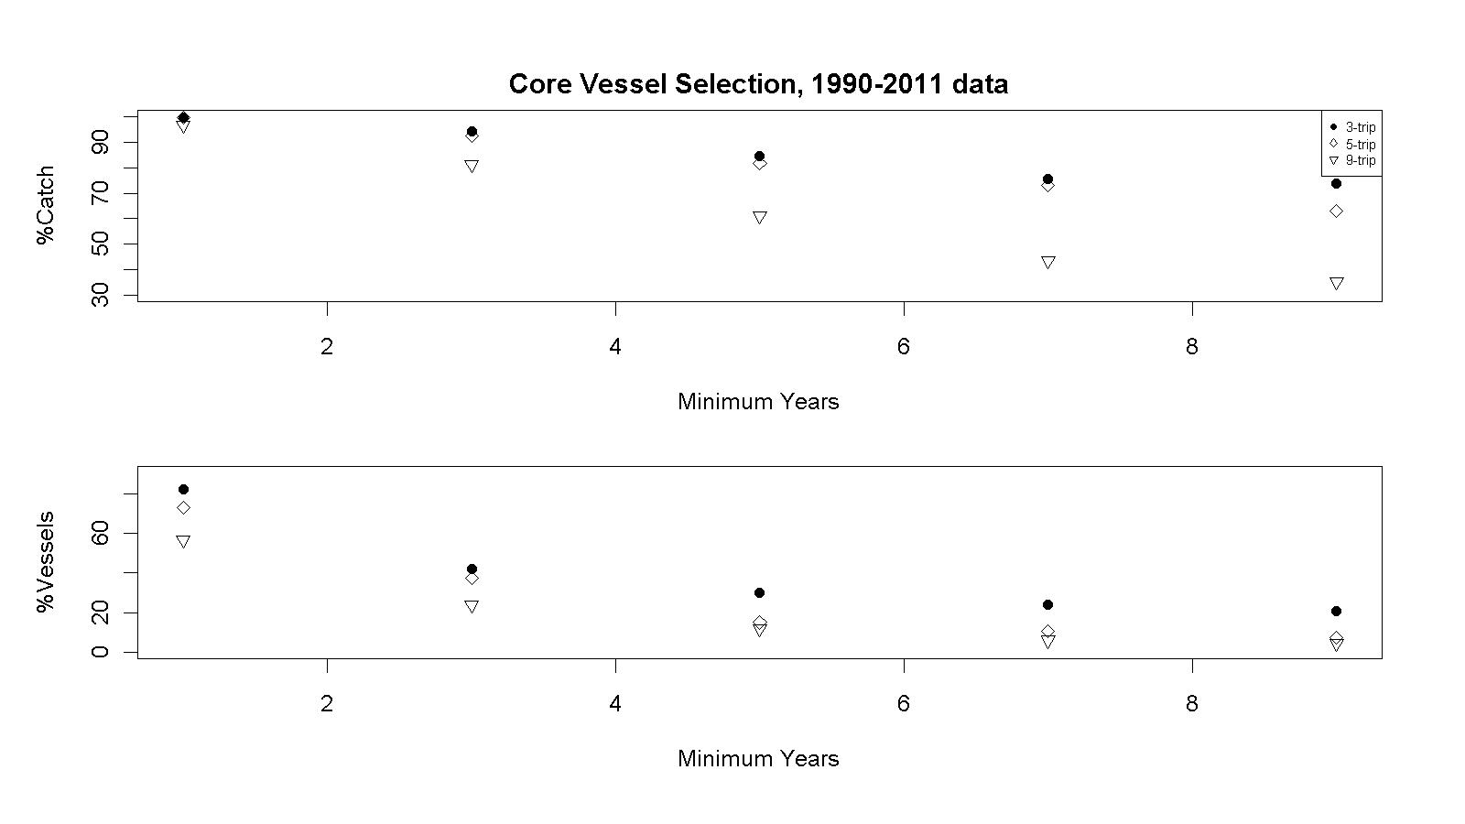
Figure 2. Core vessel selection based for the Aleutian Islands golden king crab fishery. Fish ticket data from combined east and west of 174°W longitudes for 1990/91–2010/11 were used. 3-trip = three trips per year; 5-trip = five trips per year; and 9-trip = nine trips per year. The percentage catch and vessels dropped as the number of minimum years the vessels with those yearly reporting rates increased.

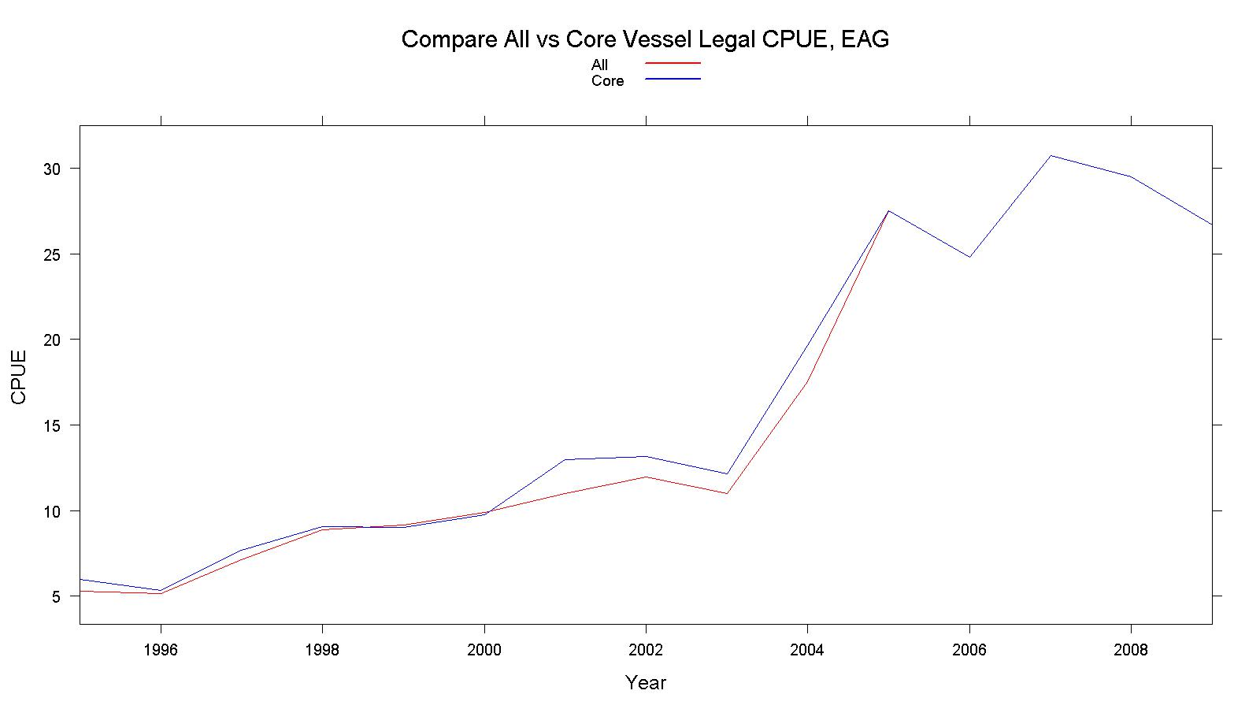
Figure 3. Comparison of legal male CPUE of all vessels and core vessel for 1995/96–2009/10 for EAG (east of 174°W longitudes).
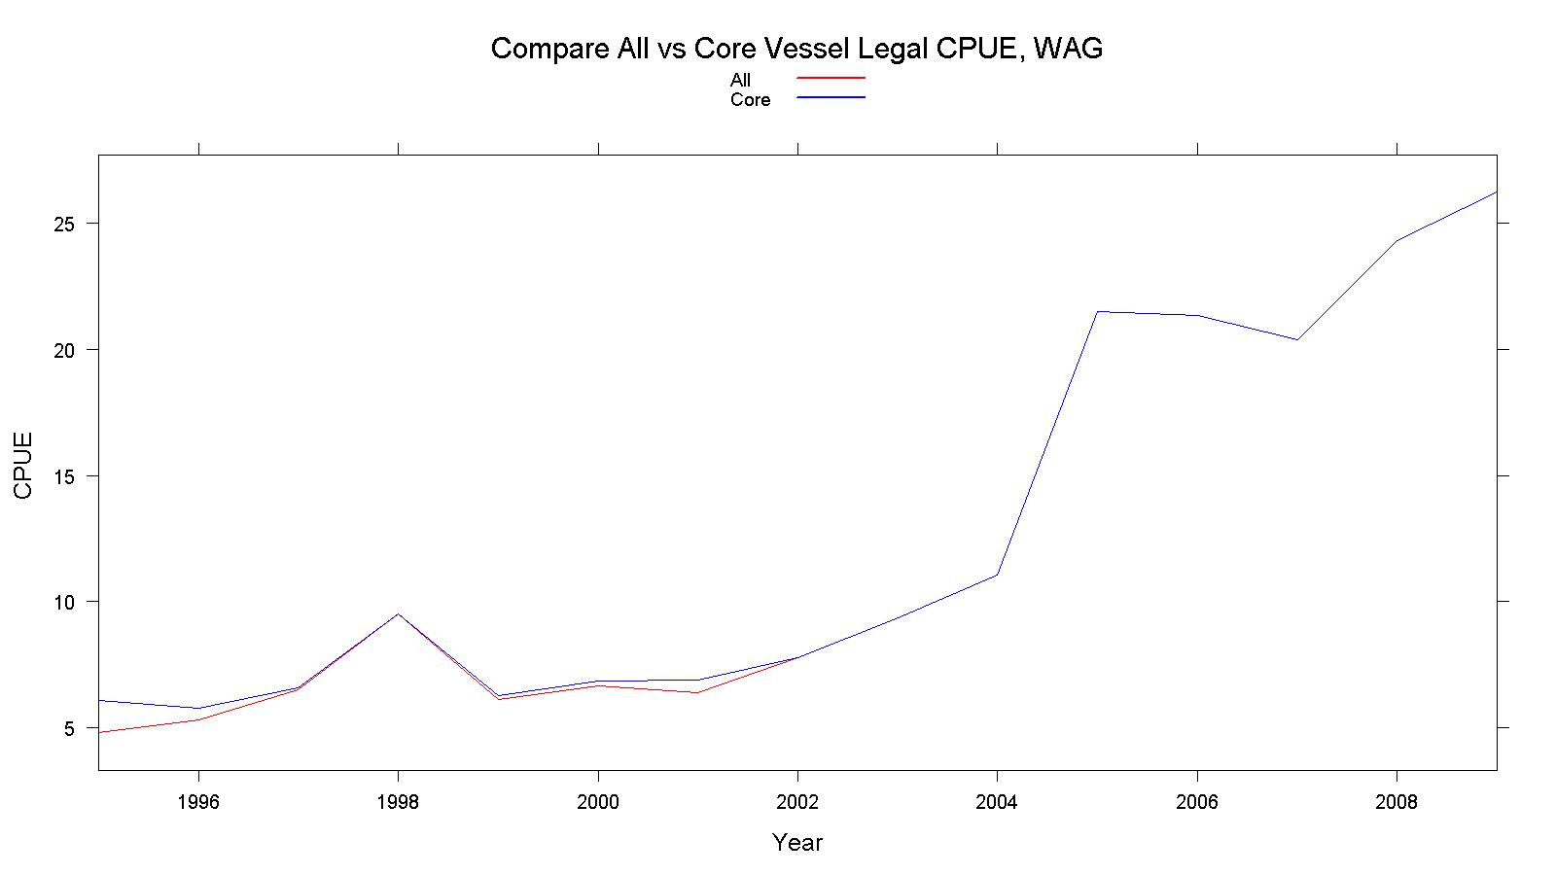
Figure 4. Comparison of legal male CPUE of all vessels and core vessel for 1995/96–2009/10 for WAG (west of 174°W longitudes).
Figure 5. Scatter plot matrices for EAG (east of 174°W longitudes) all vessels’ observer sample predictor variables. Lowess smooth curves are shown in red. High correlations exist between EastVesSoak vs. Year and Month, and SoakDays vs. Year.

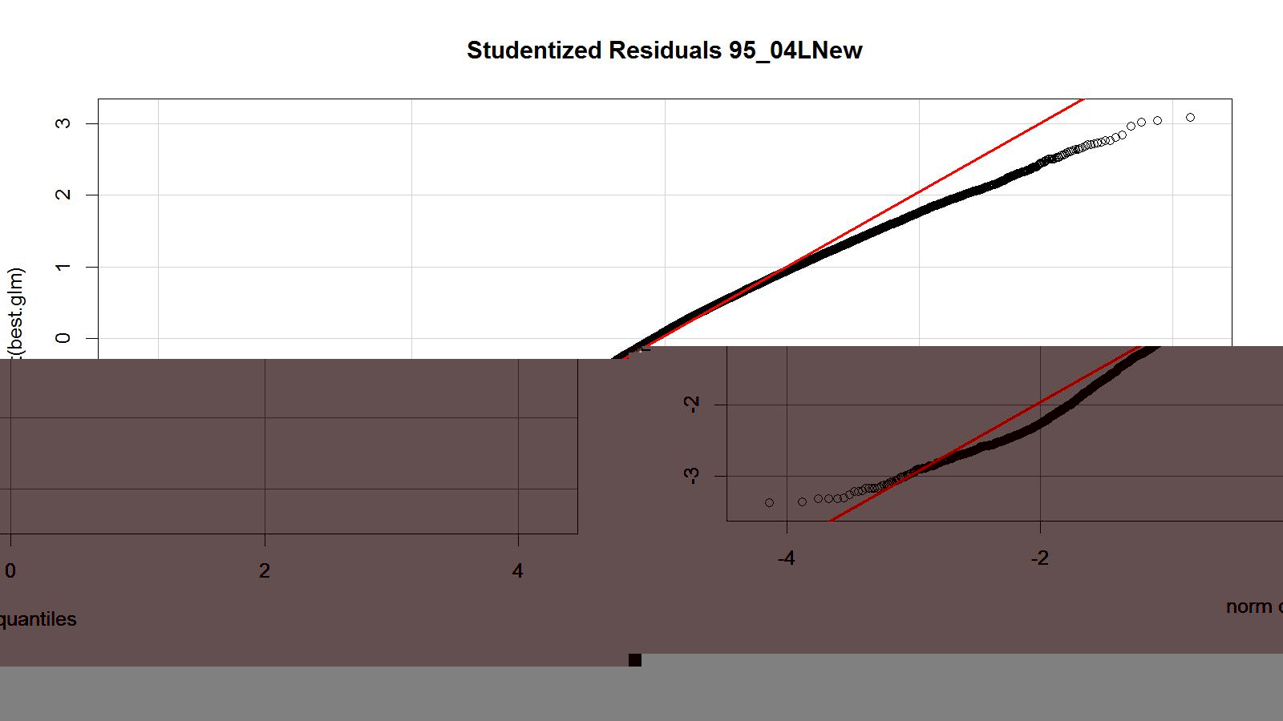
Figure 6. Studentized residual plot of the best lognormal fit model for legal size crab CPUE. Observer data from EAG (east of 174°W longitudes) for 1995/96–2004/05 were used.

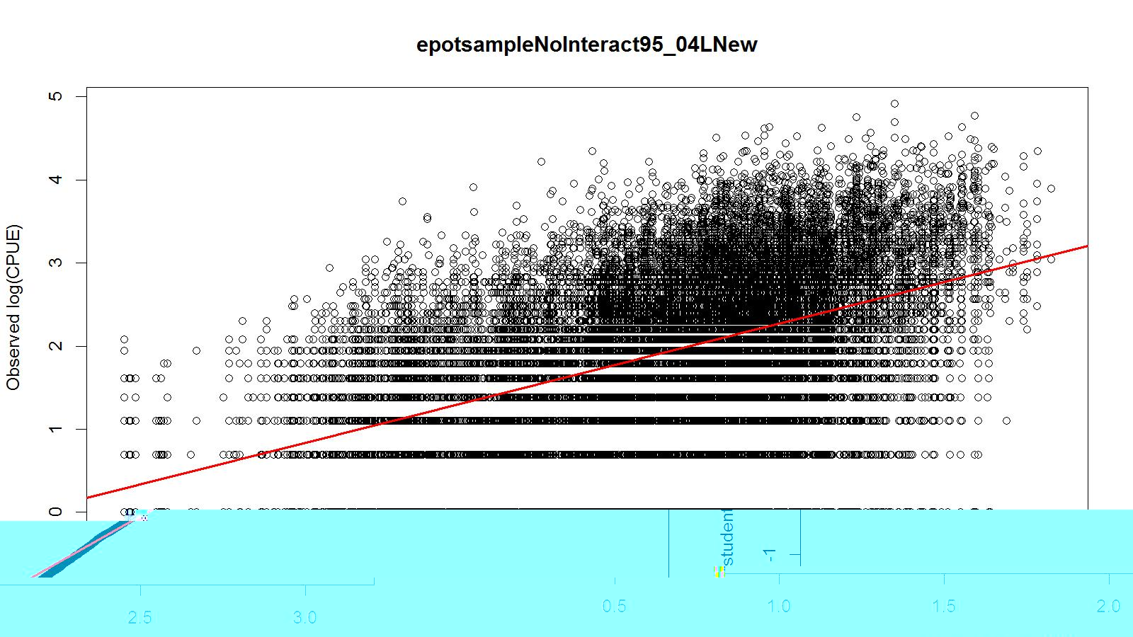
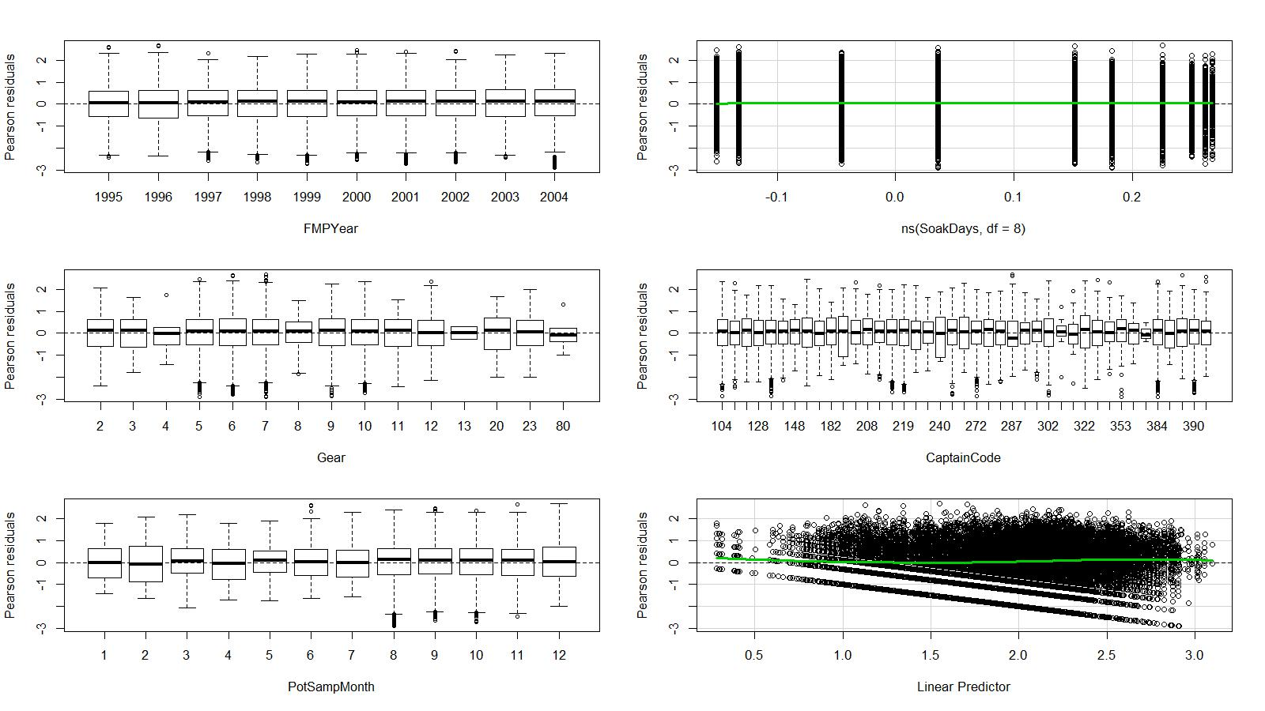

Figure 7. Predicted vs. observed ln(CPUE), Pearson residuals vs. explanatory and response variables of the best lognormal fit model for legal size crab CPUE. Observer data from EAG (east of 174°W longitudes) for 1995/96–2004/05 were used.

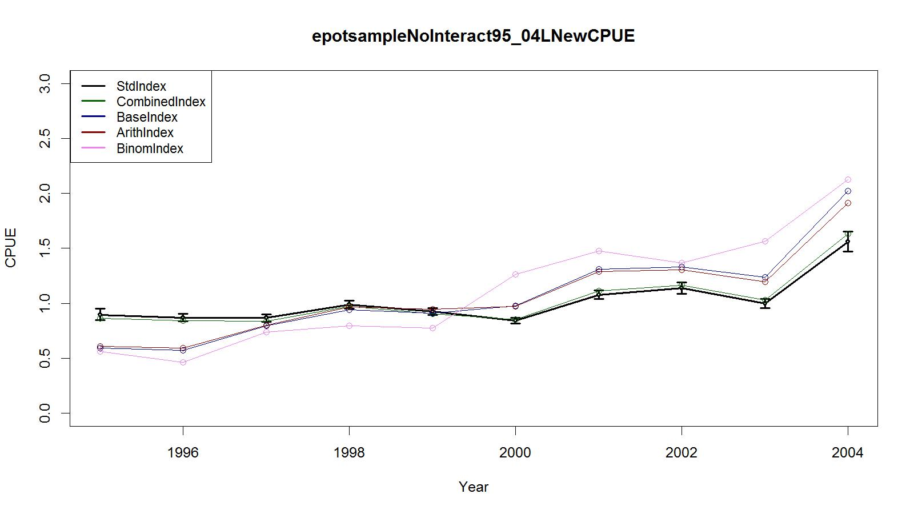
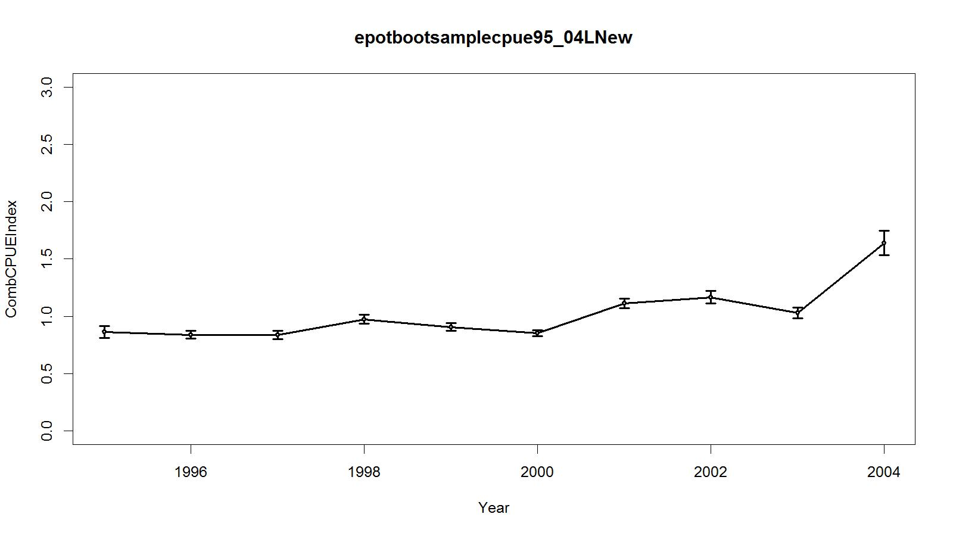
Figure 8. Trends in observer CPUE indices for legal size crab data for the Aleutian Islands golden king crab fishery. Top panel: Standardized Index (Lognormal): black line with two standard errors; Base Index: blue line; and Arithmetic Index: red line. Bottom panel: Bootstrap estimate of combined CPUE index with confidence limits. Observer data from EAG (east of 174°W longitudes) for 1995/96–2004/05 were used.

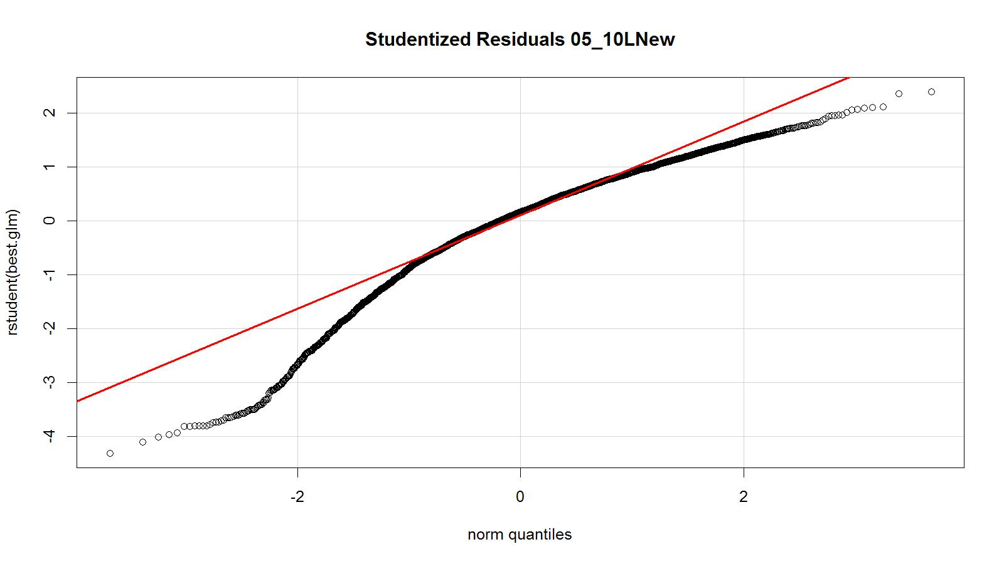
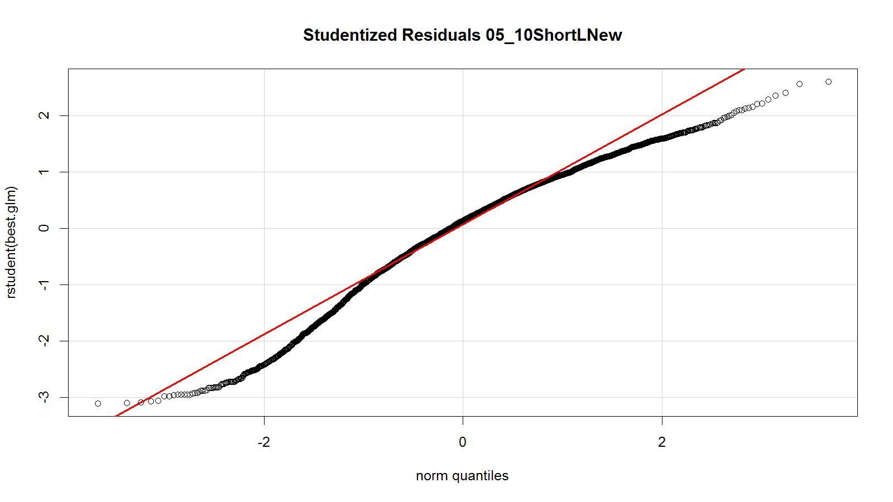
Figure 9. Studentized residual plot of the best lognormal fit model for legal size crab CPUE. Observer data (all core vessel records) from EAG (east of 174°W longitudes) for 2005/06–2010/11 were used. All core vessel records (top panel) and trimmed core vessel data (bottom panel)

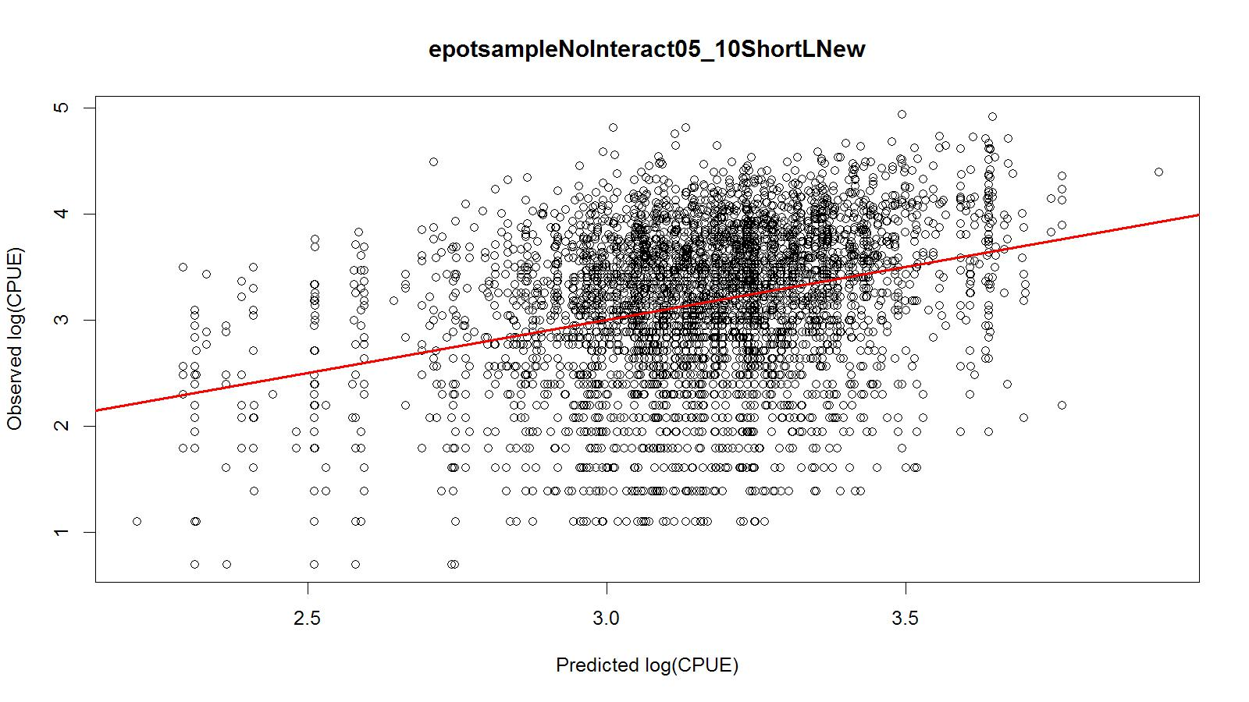
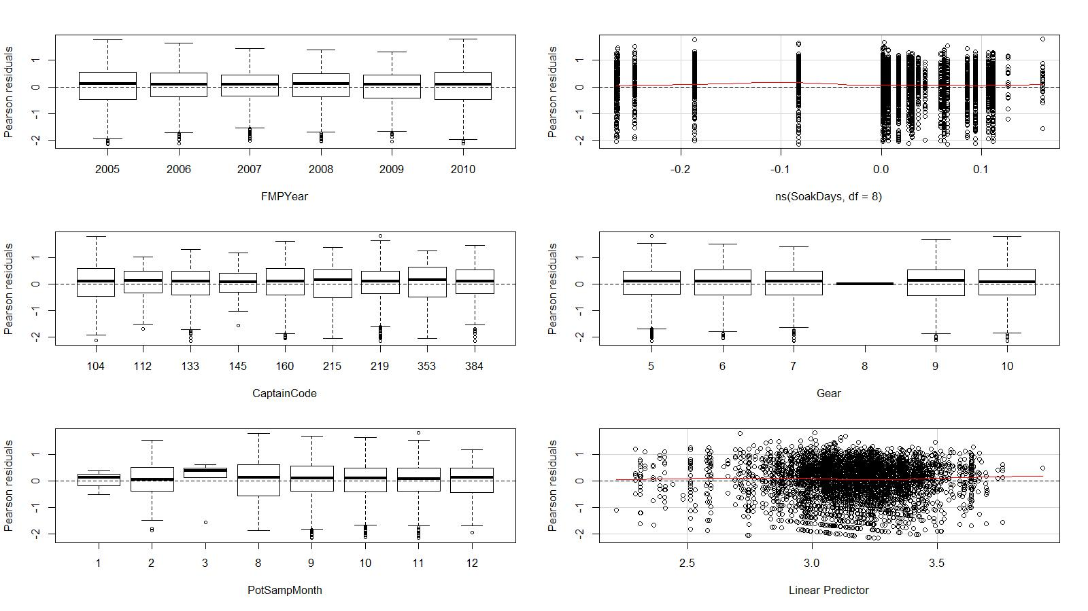
Figure 10. Predicted vs. observed ln(CPUE), Pearson residuals vs. explanatory and response variables of the best lognormal fit model for legal size crab CPUE. Trimmed observer data from EAG (east of 174°W longitudes) for 2005/06–2010/11 were used.

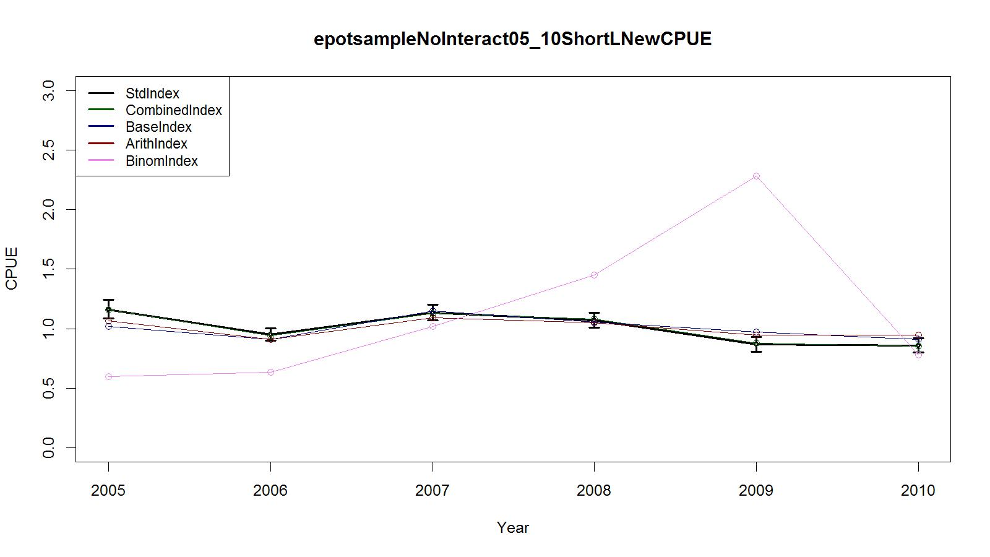
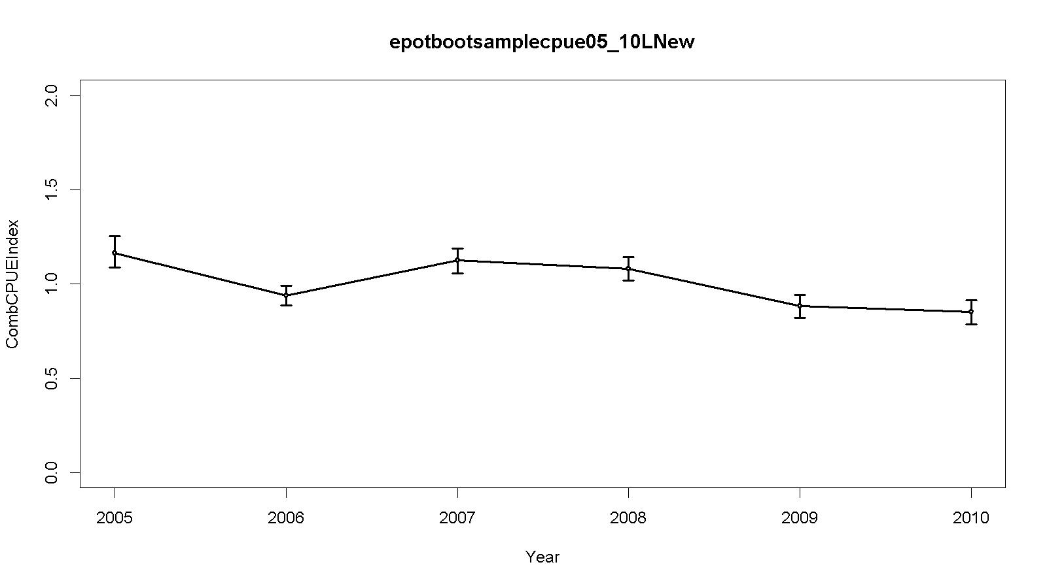
Figure 11. Trends in observer CPUE indices for legal size crab data for the Aleutian Islands golden king crab fishery. Top panel: Standardized Index (Lognormal): black line with two standard errors; Combined Index: green; Base Index: blue line; Binomial index: purple; and Arithmetic Index: red line. Bottom panel: Bootstrap estimate of combined CPUE index with confidence limits. Trimmed observer data from EAG (east of 174°W longitudes) for 2005/06–2010/11 were used.
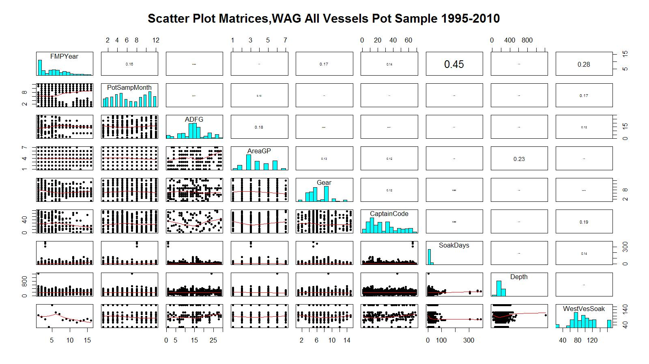
Figure 12. Scatter plot matrices for WAG (west of 174°W longitudes) all vessels’ observer sample predictor variables. Lowess smooth curves are shown in red. High correlations exist between SoakDays vs. Year and WestVesSoak vs. Year.

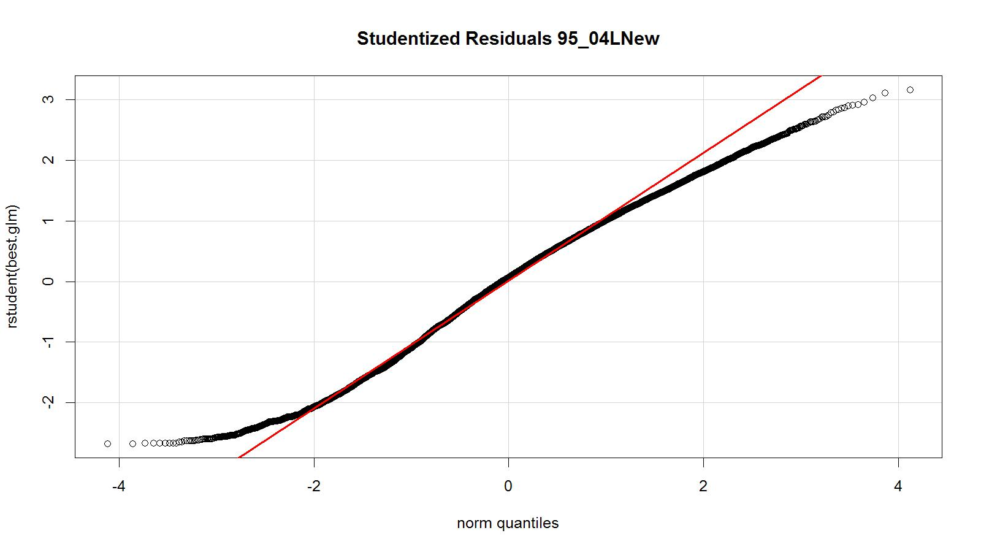
Figure 13. Studentized residual plot of the best lognormal fit model for legal CPUE. Observer data from WAG (west of 174°W longitudes) for 1995/96–2004/05 were used.

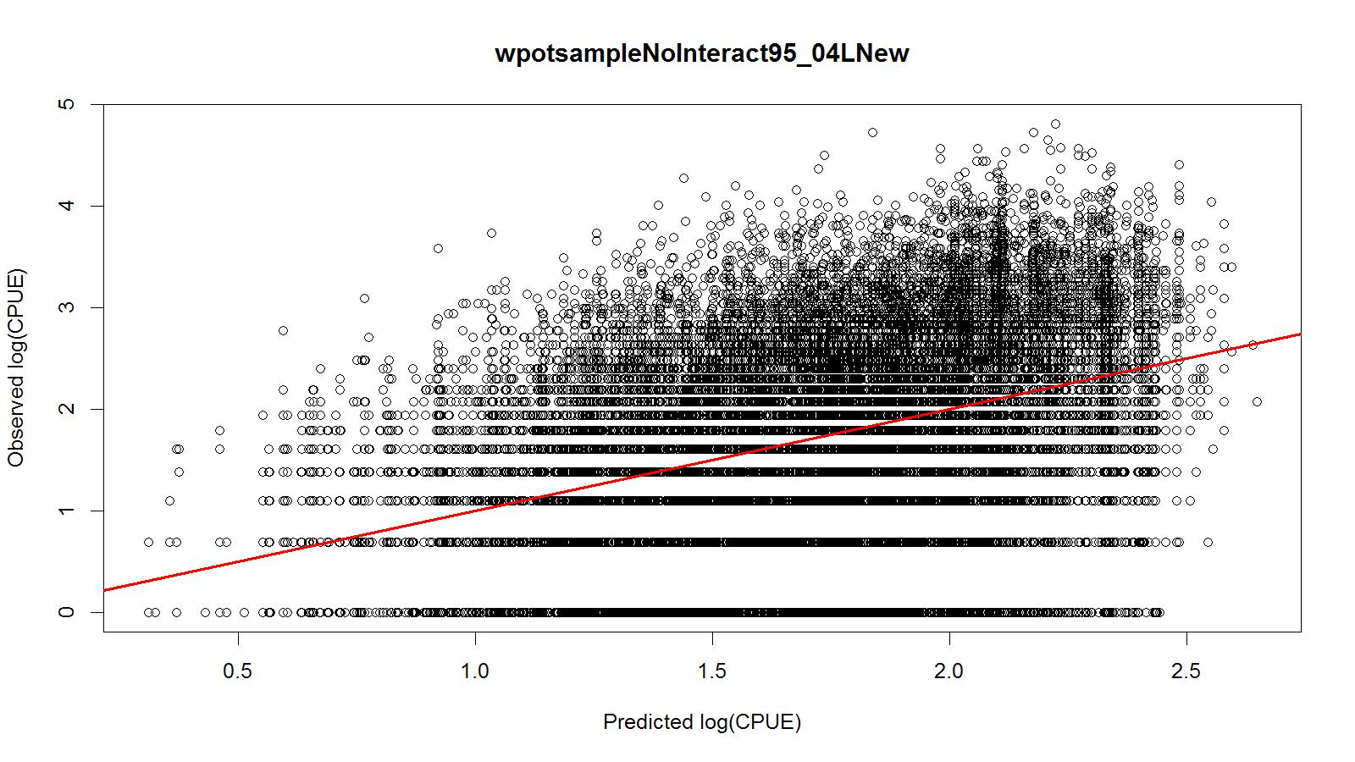
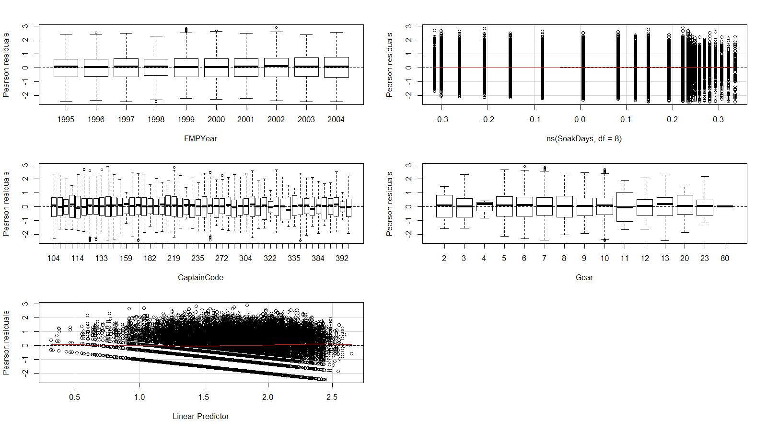
Figure 14. Predicted vs. observed ln(CPUE), Pearson residuals vs. explanatory and response variables of the best lognormal fit model for legal CPUE. Observer data from WAG (west of 174°W longitudes) for 1995/96–2004/05 were used.

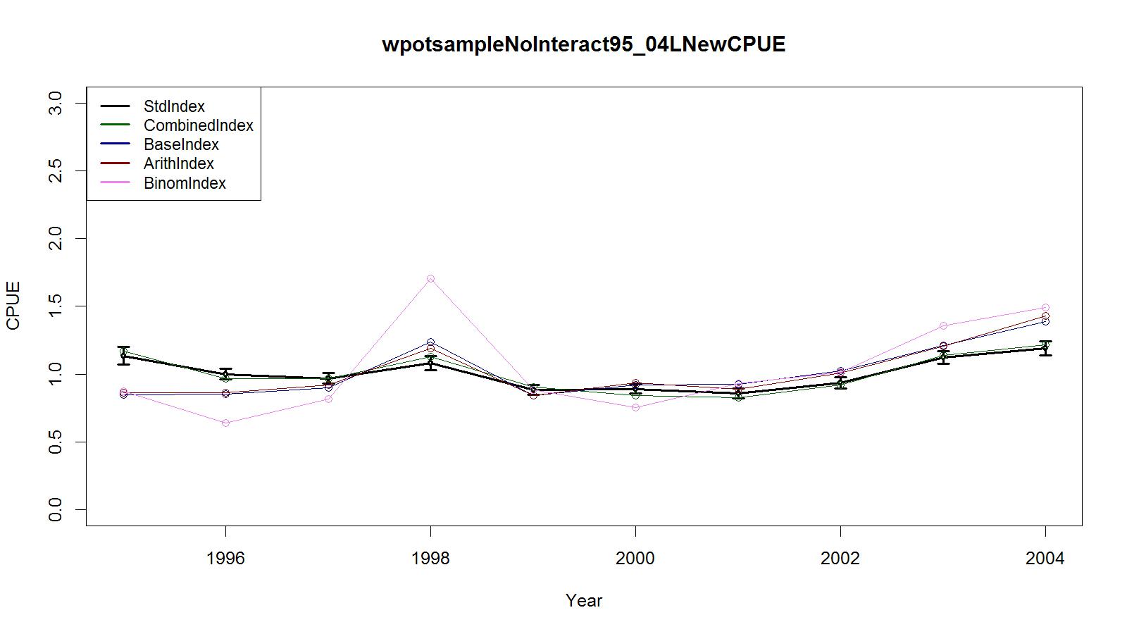
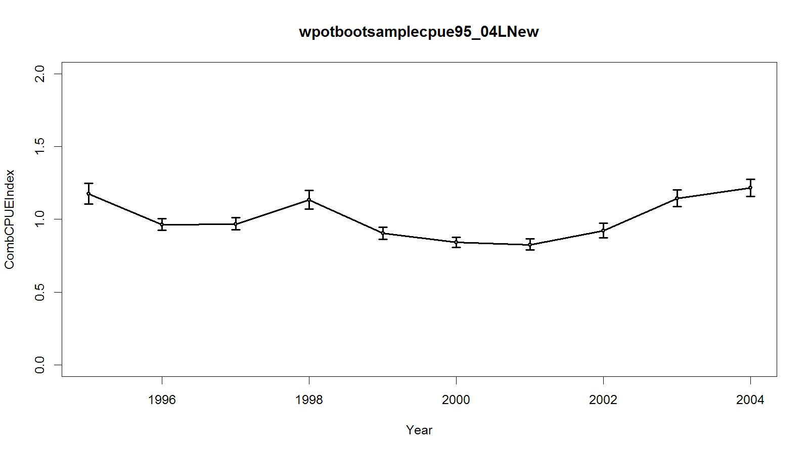
Figure 15. Trends in observer CPUE indices for legal crab data for the Aleutian Islands golden king crab fishery. Top panel: Standardized Index (Lognormal): black line with two standard errors; Combined Index: green; Base Index: blue line; Binomial index: purple; and Arithmetic Index: red line. Bottom panel: Bootstrap estimate of combined CPUE index with confidence limits. Observer data from WAG (west of 174°W longitudes) for 1995/06–2004/05 were used.
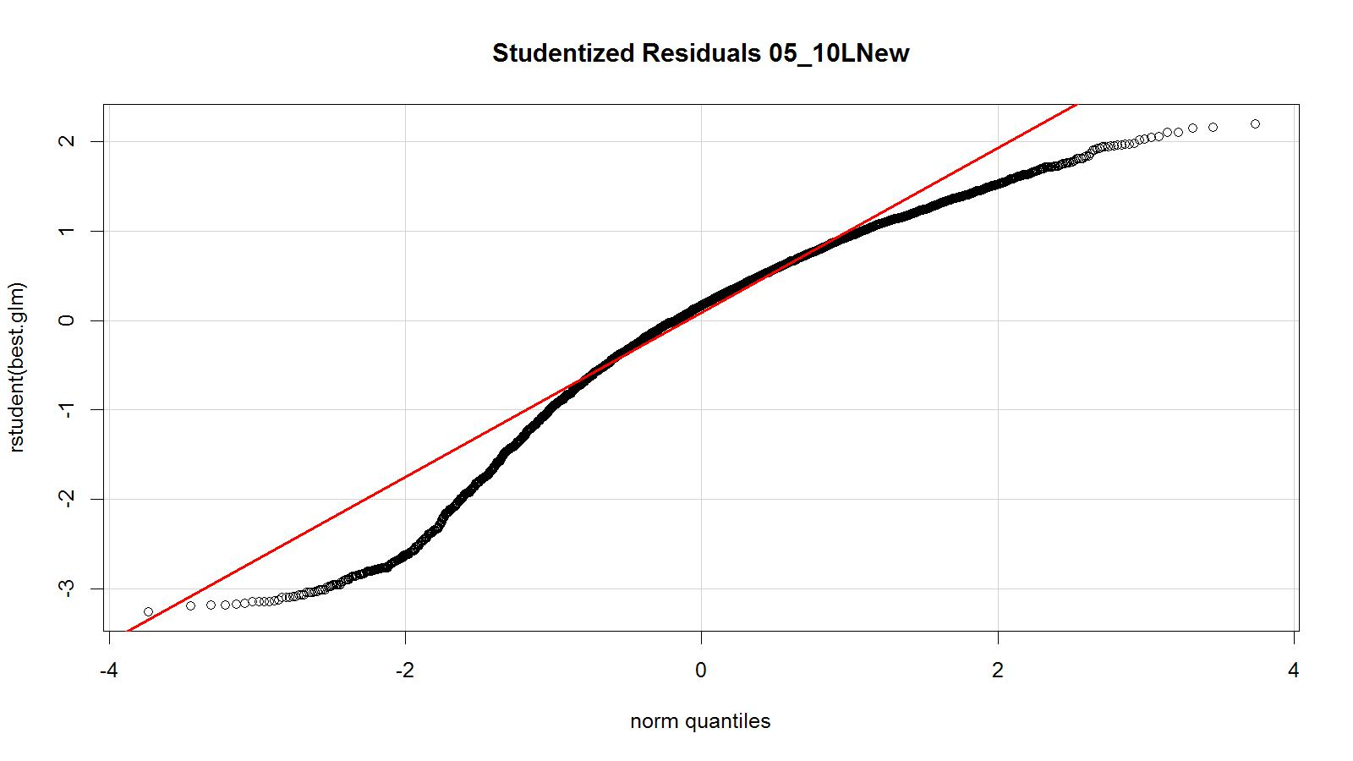
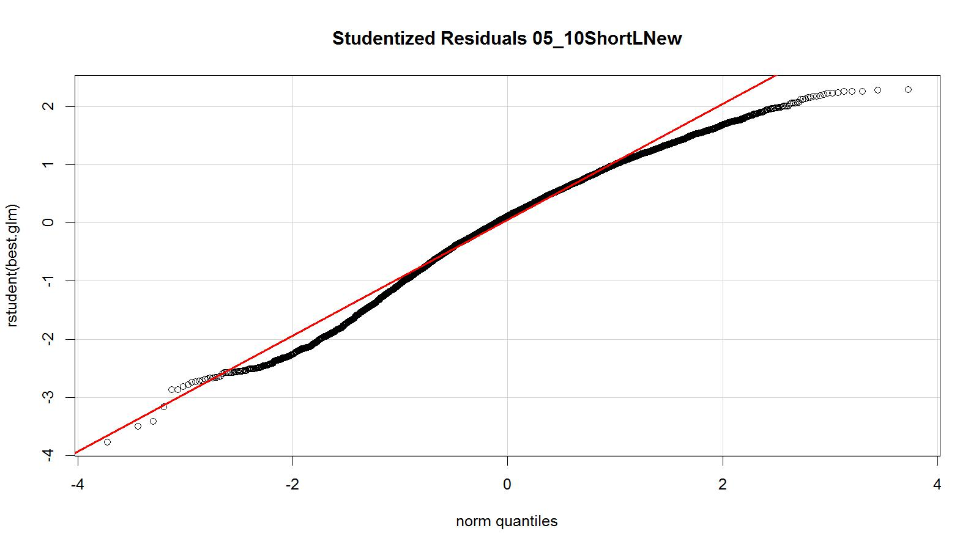
Figure 16. Studentized residual plot of the best lognormal fit model for legal size crab CPUE. Observer data (all core vessel records) from WAG (west of 174°W longitudes) for 2005/06–2010/11 were used. All core vessel records (top panel) and trimmed core vessel data (bottom panel).
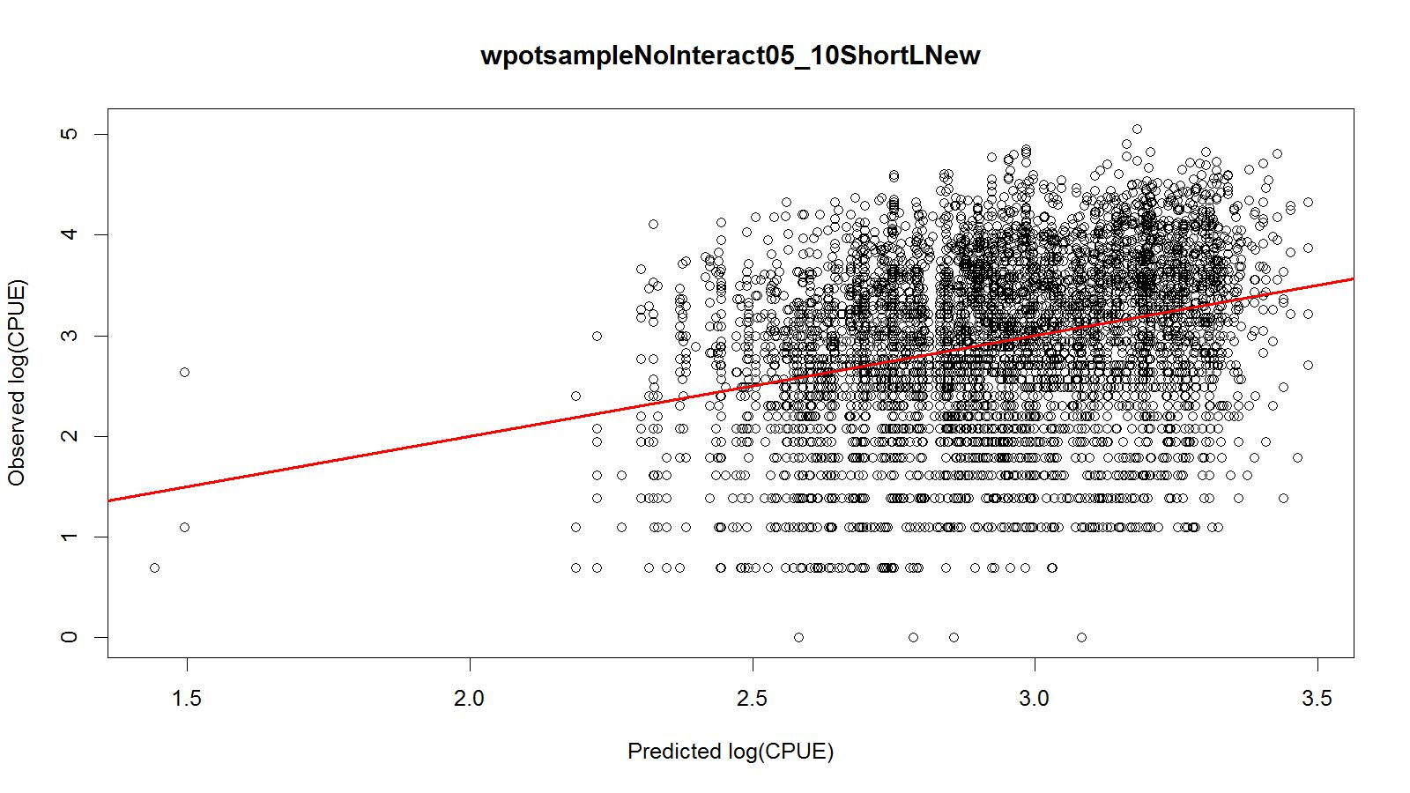
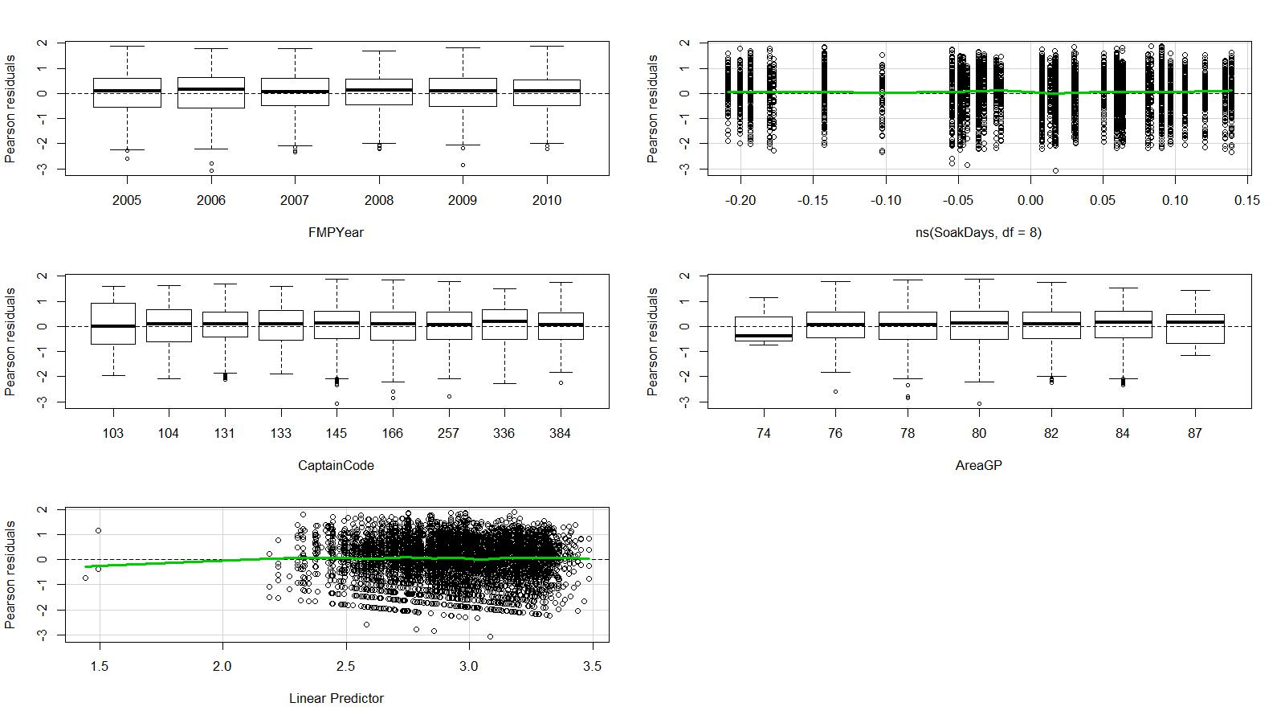
Figure 17. Predicted vs. observed ln(CPUE), Pearson residuals vs. explanatory and response variables of the best lognormal fit model for legal size crab CPUE. Trimmed observer data from WAG (west of 174°W longitudes) for 2005/06–2010/11 were used.

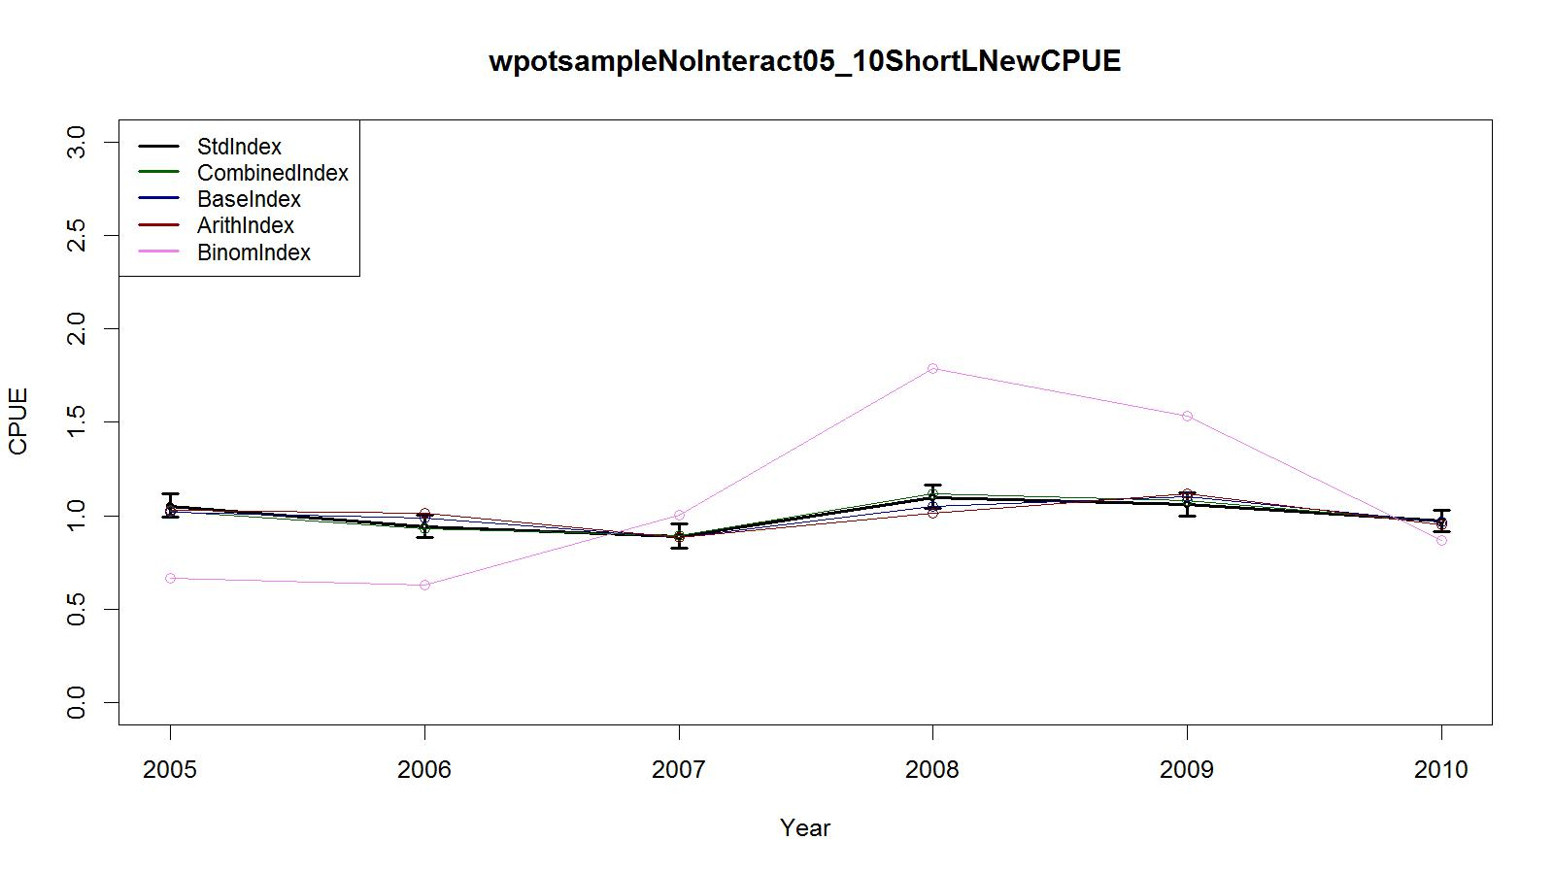
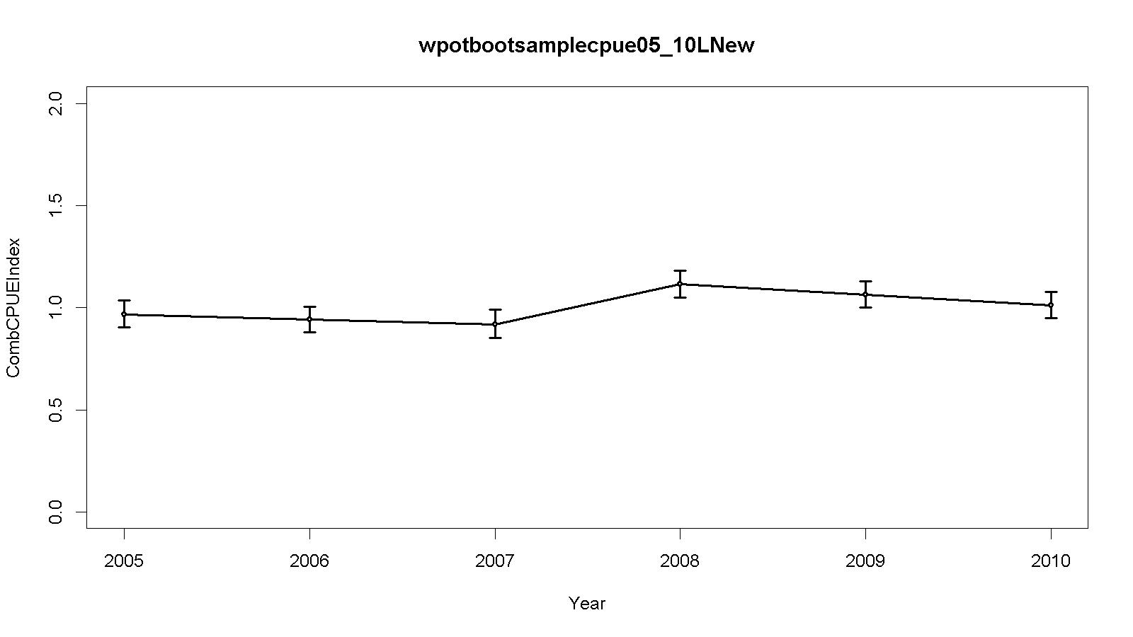
Figure 18. Trends in observer CPUE indices for legal size crab data for the Aleutian Islands golden king crab fishery. Top panel: Standardized Index (Lognormal): black line with two standard errors; Combined Index: green; Base Index: blue line; Binomial index: purple; and Arithmetic Index: red line. Bottom panel: Bootstrap estimate of combined CPUE index with confidence limits. Trimmed observer data from WAG (west of 174°W longitudes) for 2005/06–2010/11 were used.
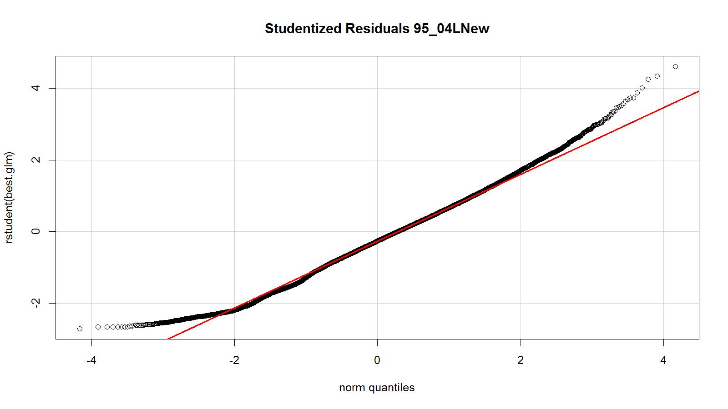
Figure 19. Studentized residual plot of the best negative binomial fit model for legal CPUE. Observer data from EAG (east of 174°W longitudes) for 1995/96–2004/05 were used.

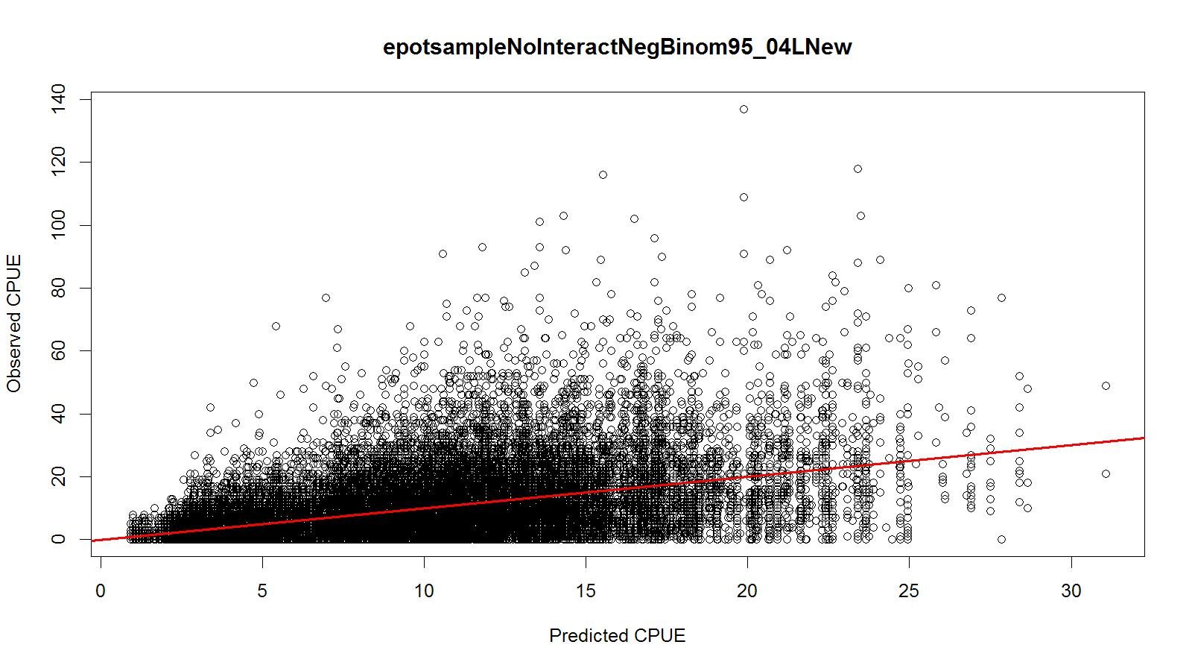
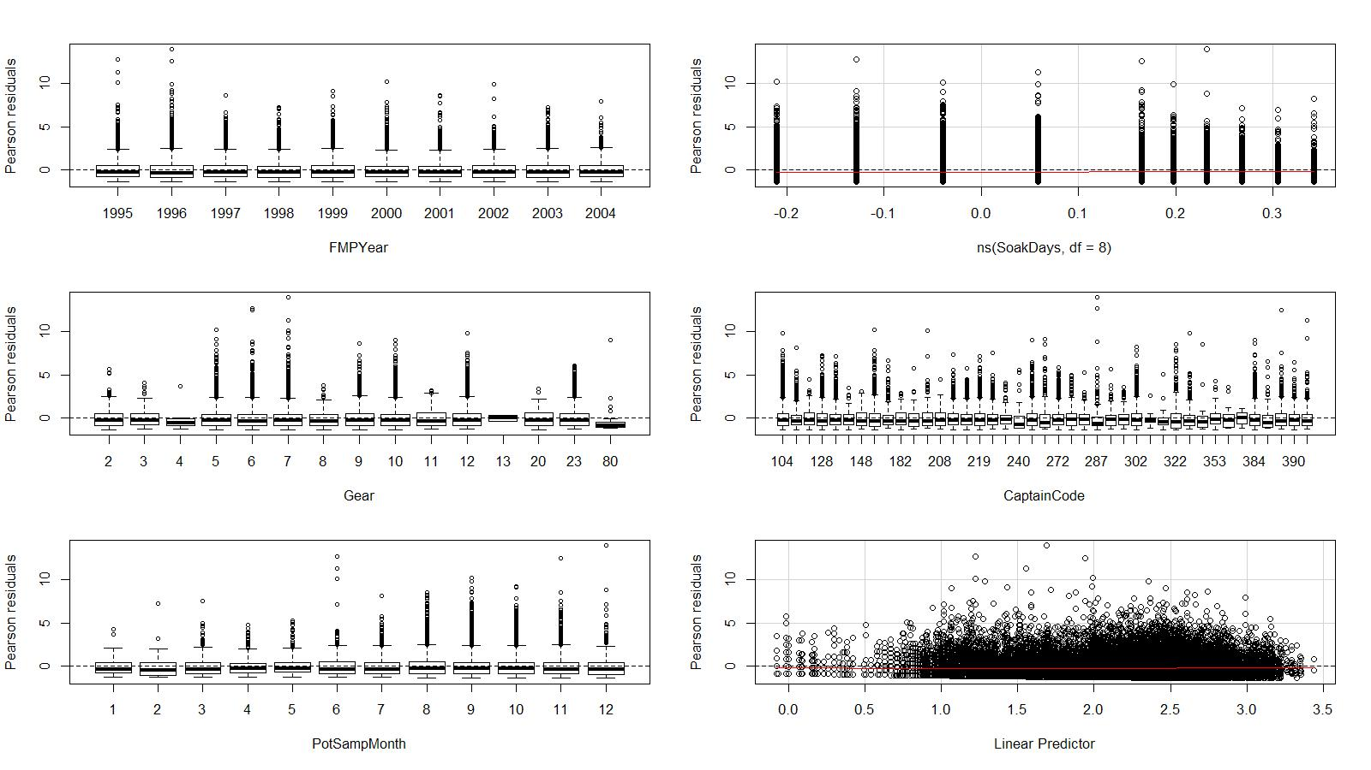
Figure 20. Predicted vs. observed CPUE, Pearson residuals vs. explanatory and response variables of the best negative binomial fit model for legal size crab CPUE. Observer data from EAG (east of 174°W longitudes) for 1995/96–2004/05 were used.

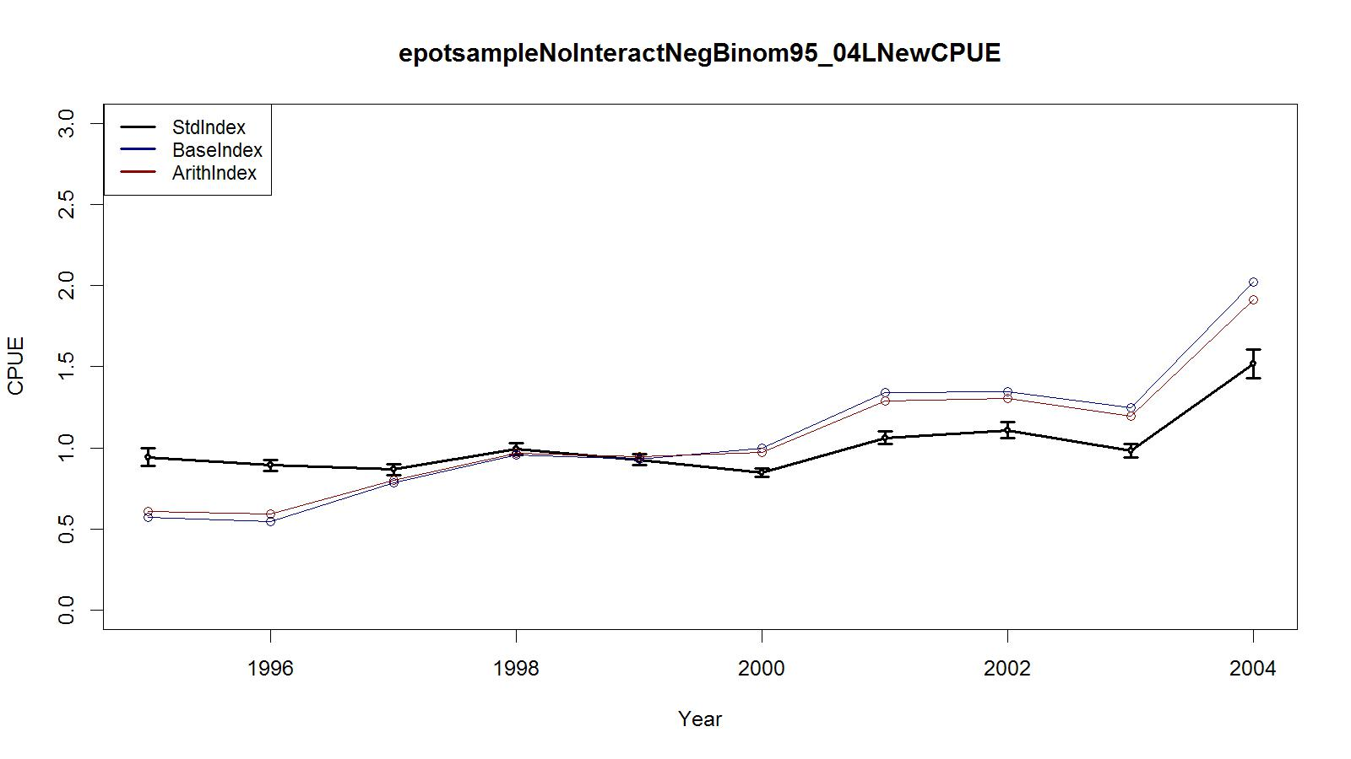
Figure 21. Trends in observer CPUE indices for legal size crab data for the Aleutian Islands golden king crab fishery. Standardized Index (negative binomial): black line with 2 standard errors; Base Index: blue line; and Arithmetic Index: red line. Observer data from EAG (east of 174°W longitudes) for 1995/96–2004/05 were used.

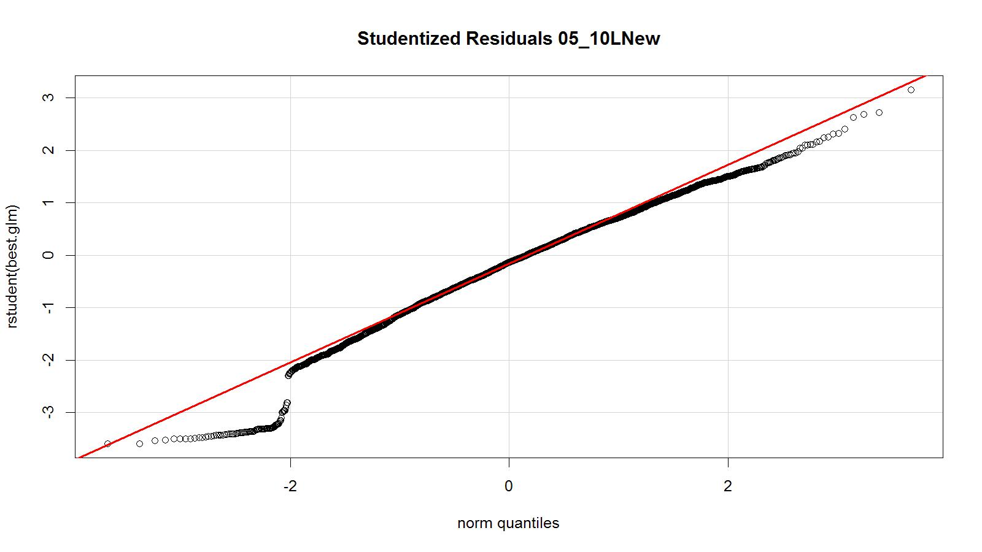
Figure 22. Studentized residual plot of the best negative binomial fit model for legal CPUE. Observer data from EAG (east of 174°W longitudes) for 2005/06–2010/11 were used.

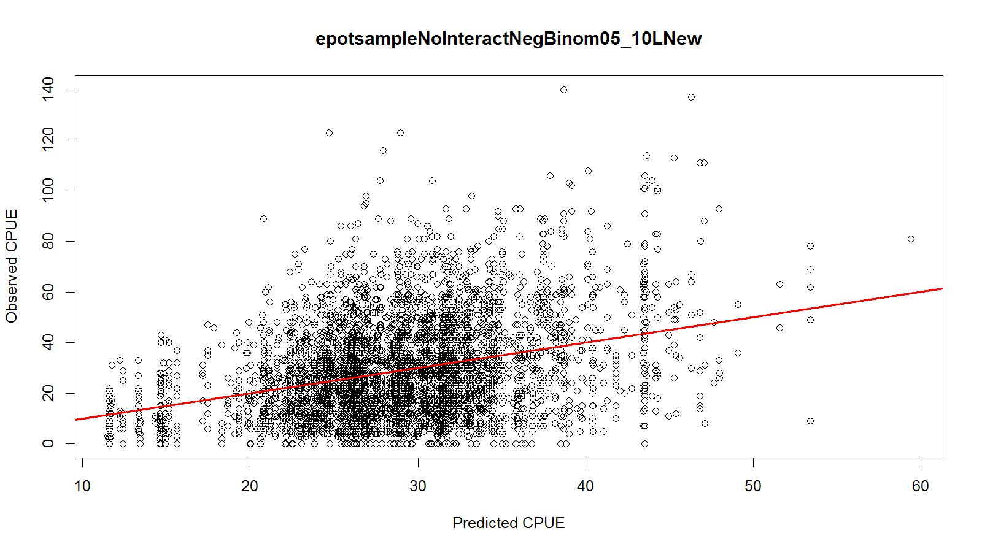
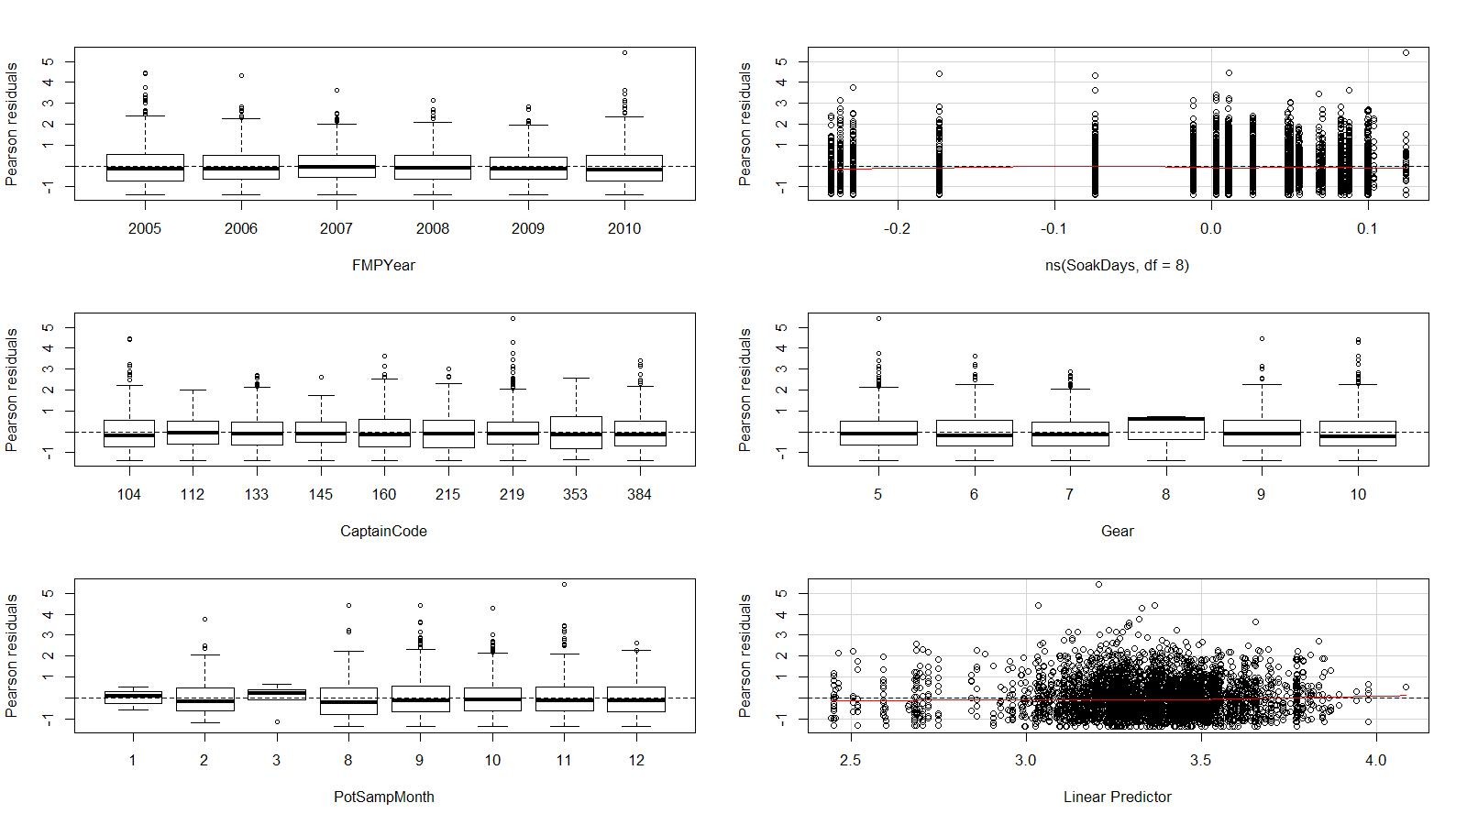
Figure 23. Predicted vs. observed CPUE, Pearson residuals vs. explanatory and response variables of the best negative binomial fit model for legal size crab CPUE. Observer data from EAG (east of 174°W longitudes) for 2005/06–2010/11 were used.

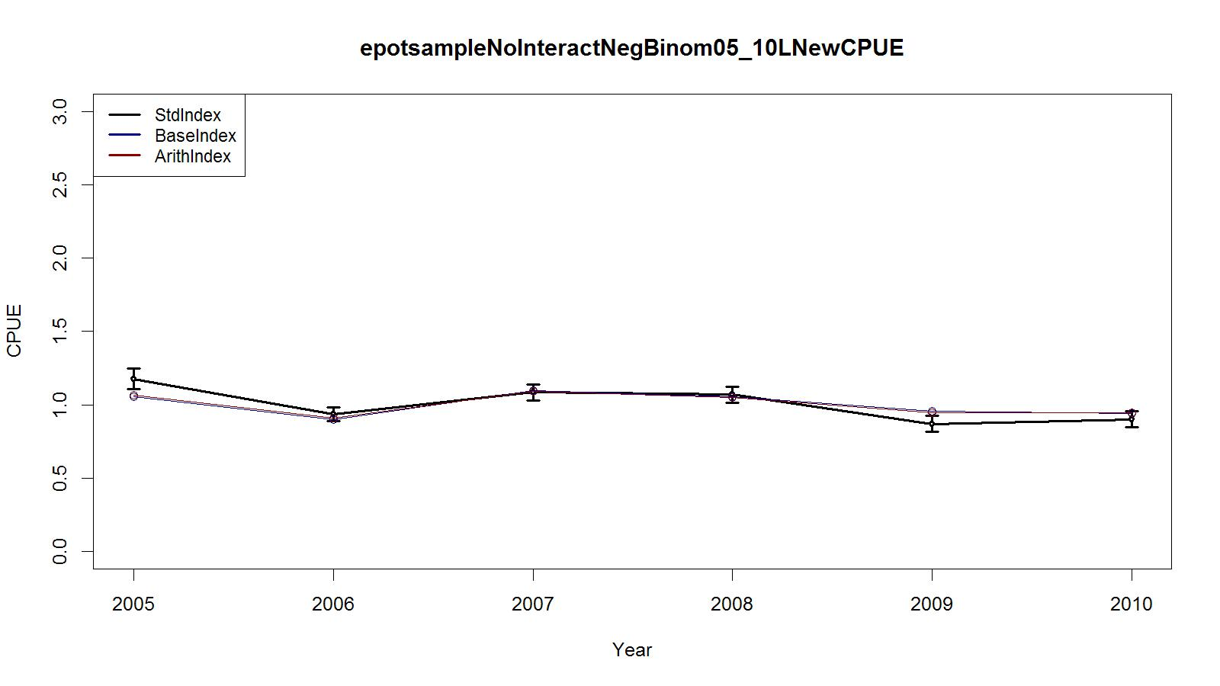
Figure 24. Trends in observer CPUE indices for legal size crab data for the Aleutian Islands golden king crab fishery. Standardized Index (negative binomial): black line with two standard errors; Base Index: blue line; and Arithmetic Index: red line. Observer data from EAG (east of 174°W longitudes) for 2005/06–2010/11 were used.

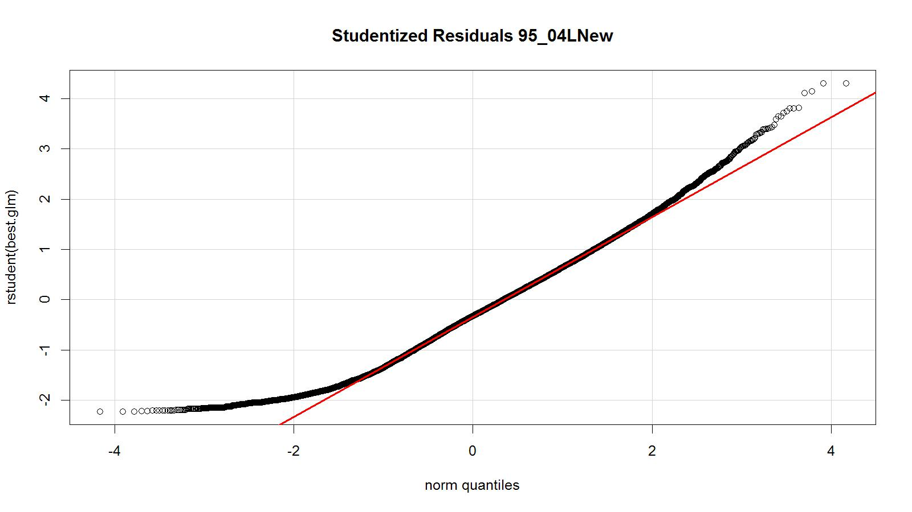
Figure 25. Studentized residual plot of the best negative binomial fit model for legal CPUE. Observer data from WAG (west of 174°W longitudes) for 1995/96–2004/05 were used.

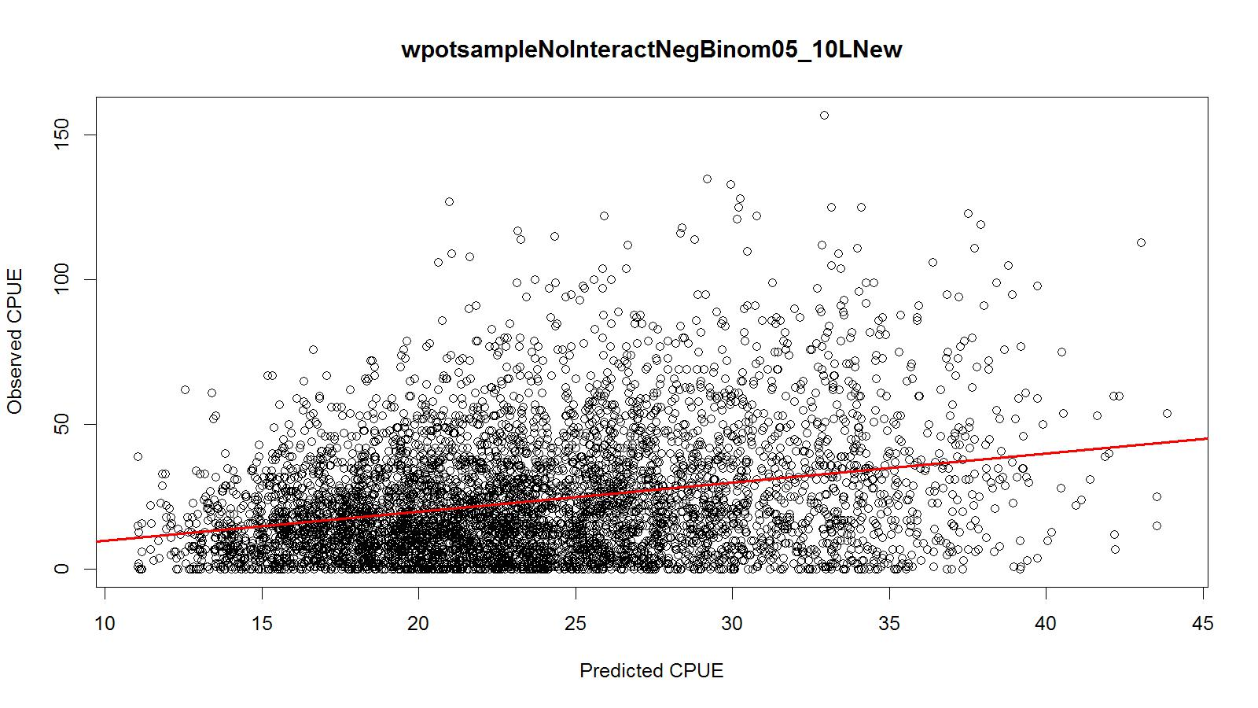
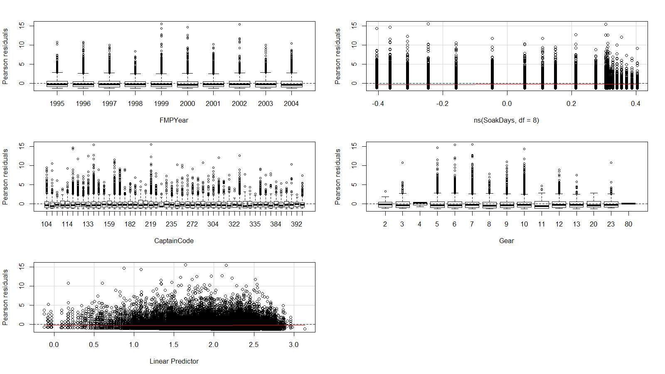
Figure 26. Predicted vs. observed CPUE, Pearson residuals vs. explanatory and response variables of the best negative binomial fit model for legal size crab CPUE. Observer data from WAG (west of 174°W longitudes) for 1995/96–2004/05 were used.

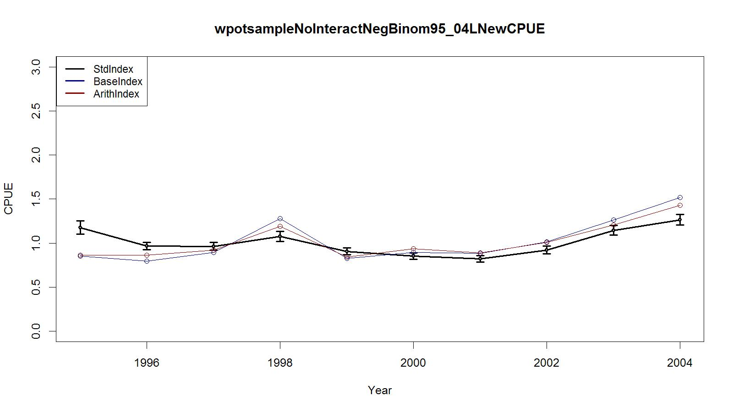
Figure 27. Trends in observer CPUE indices for legal size crab data for the Aleutian Islands golden king crab fishery. Standardized Index (negative binomial): black line with two standard errors; Base Index: blue line; and Arithmetic Index: red line. Observer data from WAG (west of 174°W longitudes) for 1995/96–2004/05 were used.

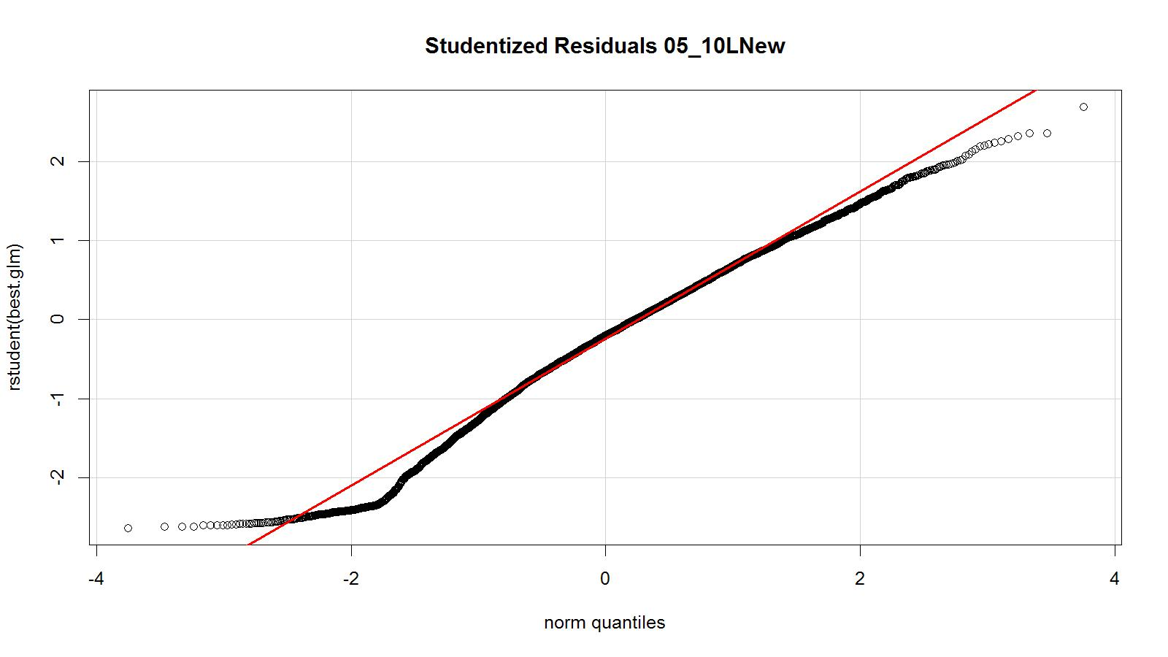
Figure 28. Studentized residual plot of the best negative binomial fit model for legal CPUE. Observer data from WAG (west of 174°W longitudes) for 2005/06–2010/11 were used.

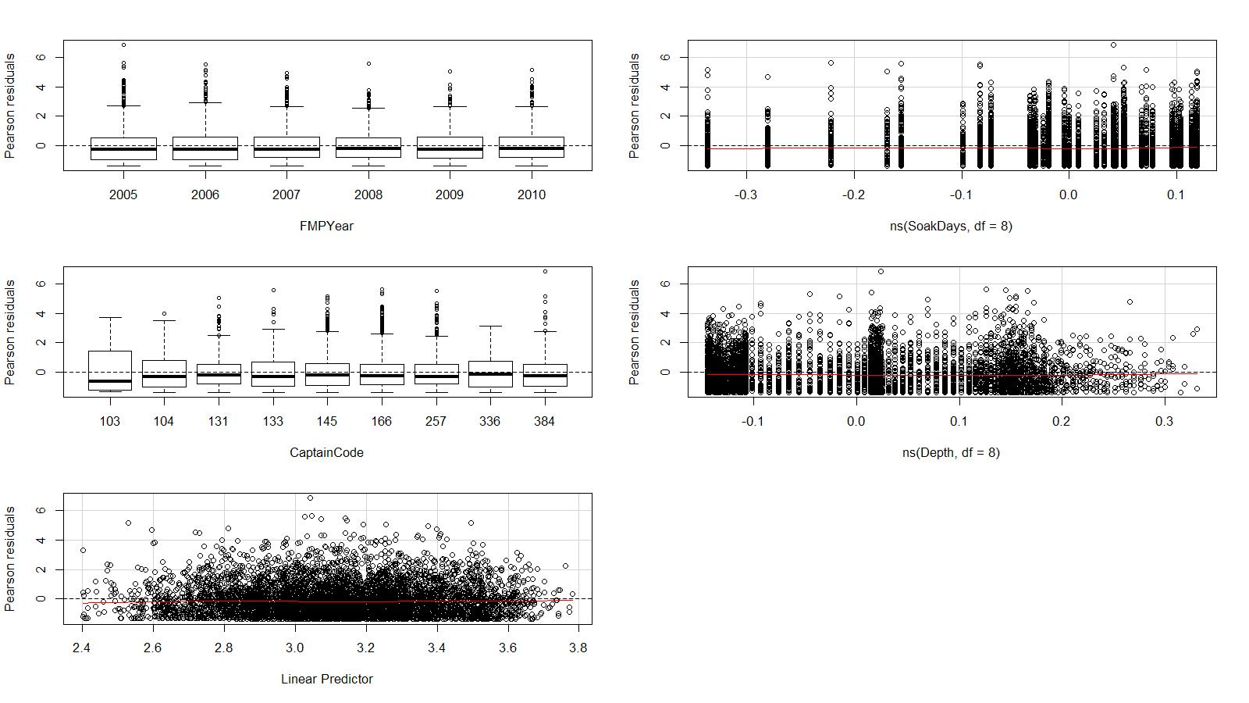
Figure 29. Predicted vs. observed CPUE, Pearson residuals vs. explanatory and response variables of the best negative binomial fit model for legal size crab CPUE. Observer data from WAG (west of 174°W longitudes) for 2005/06–2010/11 were used.

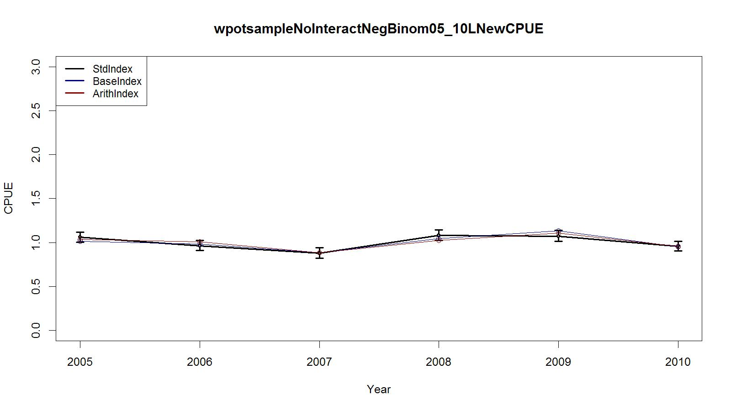
Figure 30. Trends in observer CPUE indices for legal size crab data for the Aleutian Islands golden king crab fishery. Standardized Index (negative binomial): black line with two standard errors; Base Index: blue line; and Arithmetic Index: red line. Observer data from WAG (west of 174°W longitudes) for 2005/06–2010/11 were used.

Appendix A
R script used in CPUE standardization. The step CPUE (two R code files provided by Paul Starr) and the data file (restricted because of ADF&G privacy policy) are available with the first author.
# Initial environment variable setting
options(contrasts=c("contr.treatment", "contr.poly"))
options(object.size =100000000)
#
# Read the observer data file
allpotsample<- read.csv("C:/Users/ssiddeek/Documents/WorkR26Feb13ObserverRev3/allpotsampleAddAreaTrip95.csv", header=TRUE)
#Create a data frame with selected variables
allpotsampleSub<- as.data.frame(list(allpotsample$FMPYear,allpotsample$PotSampMonth,allpotsample$FTPotLifts,allpotsample$ADFG,allpotsample$EastWest, allpotsample$StatArea,allpotsample$Depth,allpotsample$SoakDays,allpotsample$Gear,allpotsample$Sublegal, allpotsample$LegalRet, allpotsample$LegalNR,allpotsample$CaptainCode,allpotsample$AreaGP,allpotsample$Yrsof5Tr,allpotsample$EastVess,allpotsample$WestVess,allpotsample$TotalVess, allpotsample$EastVesSoak,allpotsample$WestVesSoak))
names(allpotsampleSub)<- c("FMPYear","PotSampMonth","FTPotLifts","ADFG","EastWest","StatArea","Depth","SoakDays","Gear","Sublegal", "LegalRet","LegalNR","CaptainCode","AreaGP","Yrsof5Tr","EastVess","WestVess","TotalVess",
"EastVesSoak","WestVesSoak")
# Restrict the data set to 1995 -2004
allpotsampleSub<- allpotsampleSub[allpotsampleSub$FMPYear <1995,]
# Select core data with a minimum five trips per year for three years
allpotsampleSub<- allpotsampleSub[allpotsampleSub$Yrsof5Tr>=3,]
# Remove records of NA, unusual gear codes, missing value -9 from the data frame
allpotsampleSub<-na.omit(allpotsampleSub)
allpotsampleSub<- allpotsampleSub[allpotsampleSub$FMPYear != -9,]
allpotsampleSub<- allpotsampleSub[allpotsampleSub$PotSampMonth != -9,]
allpotsampleSub<- allpotsampleSub[allpotsampleSub$EastWest != -9,]
allpotsampleSub<- allpotsampleSub[allpotsampleSub$ADFG != -9,]
allpotsampleSub<- allpotsampleSub[allpotsampleSub$SoakDays != -9,]
allpotsampleSub<- allpotsampleSub[allpotsampleSub$SoakDays != 0,]
allpotsampleSub<- allpotsampleSub[allpotsampleSub$StatArea != -9,]
allpotsampleSub<- allpotsampleSub[allpotsampleSub$AreaGP != -9,]
allpotsampleSub<- allpotsampleSub[allpotsampleSub$Depth != -9,]
allpotsampleSub<- allpotsampleSub[allpotsampleSub$Depth != 0,]
allpotsampleSub<- allpotsampleSub[allpotsampleSub$Gear != -9,]
allpotsampleSub<- allpotsampleSub[allpotsampleSub$Gear != 1,]
allpotsampleSub<- allpotsampleSub[allpotsampleSub$Gear != 14,]
allpotsampleSub<- allpotsampleSub[allpotsampleSub$Gear != 15,]
allpotsampleSub<- allpotsampleSub[allpotsampleSub$Gear != 17,]
allpotsampleSub<- allpotsampleSub[allpotsampleSub$Gear != 22,]
# Select EAG data
epotsampleSub<- allpotsampleSub[allpotsampleSub$EastWest==1,]
# Subset pre rationalization years for EAG
eprepotsampleSub<- epotsampleSub[epotsampleSub$FMPYear<2005,]
# 5% and 95% trimmed by pre and post rationalization, and data combined for EAG
eprepotsampleSubcut <- eprepotsampleSub[eprepotsampleSub$SoakDays>1 & eprepotsampleSub$SoakDays<12,]
epotsampleSubtrim<- eprepotsampleSubcut
# 1% and 99% trimmed on depth
epotsampleSubtrim <- epotsampleSubtrim[epotsampleSubtrim$Depth>74 & epotsampleSubtrim$Depth<338,]
# Change some data frame variables to factors for EAG
epotsampleSubtrim$FMPYear<- as.factor(epotsampleSubtrim$FMPYear)
epotsampleSubtrim$PotSampMonth<- as.factor(epotsampleSubtrim$PotSampMonth)
epotsampleSubtrim$ADFG<- as.factor(epotsampleSubtrim$ADFG)
epotsampleSubtrim$AreaGP<- as.factor(epotsampleSubtrim$AreaGP)
epotsampleSubtrim$Gear<- as.factor(epotsampleSubtrim$Gear)
epotsampleSubtrim$CaptainCode<- as.factor(epotsampleSubtrim$CaptainCode)
# Create a column of a selected response variable for analysis
epotsampleSubtrim$Legals<- epotsampleSubtrim$LegalRet+epotsampleSubtrim$LegalNR
# Add a (binomial) variable to the data set to reflect success or failure
epotsampleSubtrim$success[epotsampleSubtrim$Legals>0]<- 1
epotsampleSubtrim$success[epotsampleSubtrim$Legals==0]<- 0
# Select core data of minimum five trips per year for three years
datacore<- epotsampleSubtrim
# Calculate the series of proportions zero (unsuccessful)
prop.zero<- (table(datacore$FMPYear)-table(datacore$FMPYear[datacore$success==1]))/table(datacore$FMPYear)
# Subset core data by positive catch values
datacore1<- datacore[datacore$success==1,]
# Find the best model from lognormal fit
library(splines)
glm.object<- glm(log(Legals)~FMPYear+ns(SoakDays,df=8),data=datacore1)
epotsampleout1<- stepCPUE(glm.object,scope=list(upper= ~(FMPYear+ns(SoakDays,df=8)+PotSampMonth+ADFG+CaptainCode+AreaGP+Gear+ns(Depth,df=8)+ns(EastVesSoak,df=4)),lower= ~FMPYear+ns(SoakDays,df=8)),direction="forward",trace=9,r2.change=0.01)
# Find the best model from negative binomial fit
# glm.object<- glm(Legals~FMPYear+ns(SoakDays,df=8),family = negative.binomial(2),data=datacore)
# epotsampleout1<- stepCPUE(glm.object,scope=list(upper= ~(FMPYear+ns(SoakDays,df=8)+PotSampMonth+ADFG+CaptainCode+AreaGP+Gear+ns(Depth,df=8) +ns(EastVesSoak,df=8)),lower= ~FMPYear+ns(SoakDays,df=8)), family = negative.binomial(2), direction="forward",trace=9,r2.change=0.01)
# Results from lognormal fit of the best model
# best.glm<- glm(Legals~ FMPYear+ns(SoakDays,df=8)+Gear+CaptainCode+PotSampMonth,family = negative.binomial(2),y=TRUE, data=datacore)

# Get results from lognormal fit of the best model
best.glm<- glm(log(Legals)~ FMPYear+ns(SoakDays,df=8)+Gear+CaptainCode+PotSampMonth,y=TRUE, data=datacore1)
# Get R-squared for the best fit
Rsq.bestglm<- (best.glm$null.deviance-best.glm$deviance)/best.glm$null.deviance
cat("RSquared for bestglm1=",Rsq.bestglm,"\n") # Get results from the best lognormal model fit
# Get relative lognormal indices (with the base year =1)
sumglm<-summary(best.glm)
coefsglm <- exp(as.numeric(c(0, sumglm$coefficients[2:10,1])))
# Get canonical lognormal indices
cpue1.glm<-getCPUE(best.glm,2:10, 1995:2004)
# Write the output to a file
write.csv(cpue1.glm,"C:/Users/ssiddeek/Documents/WorkR26Feb13ObserverRev3/epotsampleNoInteractYearlyLnCPUE95.csv",row.names=F)
# Get base relative lognormal indices (with the base year =1)
base.glm<-glm(log(Legals)~ FMPYear+ns(SoakDays,df=8), y=TRUE, data=datacore1)
sumglm1<-summary(base.glm)
coefsbaseglm <- exp(as.numeric(c(0, sumglm1$coefficients[2:10,1])))
# Get canonical lognormal indices for the base index
cpue2.glm<-getCPUE(base.glm,2:10, 1995:2004)
# Write the output to a file
write.csv(cpue2.glm,"C:/Users/ssiddeek/Documents/WorkR26Feb13ObserverRev3/epotsampleNoInteractBaseYearLnCPUE95.csv",row.names=F)
# Find the best model from the binomial fit
glm.object2<- glm(success~FMPYear+ns(SoakDays,df=8),family=binomial(link=logit),data=datacore)
epotsampleout2<- stepCPUE(glm.object2,scope=list(upper= ~(FMPYear+ns(SoakDays,df=8)+PotSampMonth+ADFG+CaptainCode+AreaGP+Gear+ns(Depth,df=8)+ns(EastVesSoak,df=4)),lower= ~FMPYear+ns(SoakDays,df=8)),family=binomial(link=logit),direction="forward",trace=9,r2.change=0.01)
## Get results from binomial fit of the best model
best2.glm<-glm(success ~ FMPYear+ns(SoakDays,df=8)+CaptainCode+Gear,family=binomial(link=logit),y=TRUE,data=datacore)
## Get R-squared for the best fit
Rsq.bestglm<- (best2.glm$null.deviance-best2.glm$deviance)/best2.glm$null.deviance
cat("RSquared for bestglm2=",Rsq.bestglm,"\n")
detach(package:splines)
#Get relative binomial indices (with the base year =1)
sumglm2<-summary(best2.glm)
coefsbin <- exp(as.numeric(c(0, sumglm2$coefficients[2:10,1])))
# Get canonical binomial indices
cpue3.glm<-getCPUE(best2.glm,2:10, 1995:2004)
# Write the output to a file
write.csv(cpue3.glm,"C:/Users/ssiddeek/Documents/WorkR26Feb13ObserverRev3/epotsampleNoInteractYearlyBinomCPUE95.csv",row.names=F)
# Get base relative binomial indices (with the base year =1)
base3.glm<-glm(success~ FMPYear+ns(SoakDays,df=8),family=binomial(link=logit),y=TRUE, data=datacore)
sumglm3<-summary(base3.glm)
coefsbasebin <- exp(as.numeric(c(0, sumglm3$coefficients[2:10,1])))
detach(package:splines)
# Get canonical binomial indices for the base index
cpue4.glm<-getCPUE(base3.glm,2:10, 1995:2004)
# Write the output to a file
write.csv(cpue4.glm,"C:/Users/ssiddeek/Documents/WorkR26Feb13ObserverRev3/epotsampleNoInteractBaseBinomCPUE95.csv",row.names=F)
# Calculate combined CPUE indices
n<-length(coefsglm)
Comb<-rep(0,n)
for(i in 1:n){
Comb[i]<-coefsglm[i]/(1-prop.zero[1]*(1-1/coefsbin[i]))}
# Get canonical combined indices
Combined <- Comb/exp(mean(log(Comb)))
# Write the output to a file
write.csv(Combined,"C:/Users/ssiddeek/Documents/WorkR26Feb13ObserverRev3/epotsampleNoInteractCombCPUE95.csv",row.names=F)
# Write positive observed CPUE from core data to a file
write.csv(datacore1,"C:/Users/ssiddeek/Documents/WorkR26Feb13ObserverRev3/epotsampleNoInteractCatches95.csv",row.names=F)
# Calculate Arithmetic CPUE index
RCPUE<- tapply(datacore1$Legals,datacore1$FMPYear,mean)
GMRCPUE<- exp(mean(log(RCPUE)))
RCPUEdash<- RCPUE/GMRCPUE
# Write the output to a file
write.csv(RCPUEdash,"C:/Users/ssiddeek/Documents/WorkR26Feb13ObserverRev3/epotsampleNoInteractScaledArithCPUE95.csv",row.names=F)
# Get parameter estimates with standard errors
bestglm<- summary(best.glm)
# Write the output to a file
write.csv(bestglm$coefficients,"C:/Users/ssiddeek/Documents/WorkR26Feb13ObserverRev3/epotsampleNoInteractparameters.csv",row.names=T)
# Combine various CPUEs into a data frame
allpotsample.cpue<- as.data.frame(cbind(cpue1.glm$Year,cpue2.glm$Index,RCPUEdash,cpue1.glm$Index,cpue1.glm$Upper,cpue1.glm$Lower,Combined))
names(allpotsample.cpue)<- list("Year", "BaseInd","ArithInd","StdInd", "StdUpper","StdLower","CombInd")
write.csv(allpotsample.cpue,"C:/Users/ssiddeek/Documents/WorkR26Feb13ObserverRev3/epotsampleNoInteractcpue95LSc1.csv",row.names=F)
# Plot various CPUE
# Read the file
epotsample.CPUE<- read.csv("C:/Users/ssiddeek/Documents/WorkR26Feb13ObserverRev3/epotsampleNoInteractcpue95LSc1.csv",header=T)
# Set the plotting parameters
# Load the gplots package
library(gplots)
attach(epotsample.CPUE)
jpeg(file="C:/Users/ssiddeek/Documents/WorkR26Feb13ObserverRev3/epotsampleNoInteractCPUE95Fig1.jpg",width=1600,height=900,res=150)
plotCI(x=Year,y=StdInd,ui=StdUpper,li=StdLower,xlim=c(1995,2004),ylim=c(0,3),type="o",lty="solid",cex=0.5,lwd=2,pch=21,gap=0,sfrac=0.005, xlab="Year",ylab="CPUE", main="epotsampleNoInteract95CPUE")
plotCI(x=Year,y=CombInd,ui=CombUpper,li=CombLower,cex=1,type="o",col="darkgreen",add=TRUE)
plotCI(x=Year,y=BaseInd,ui=NULL,li=NULL,cex=1,type="o",col="darkblue",add=TRUE)
plotCI(x=Year,y=ArithInd,ui=NULL,li=NULL,cex=1,type="o",col="darkred",add=TRUE) legend("topleft",c("StdIndex","CombinedIndex","BaseIndex","ArithIndex"),lty=c("solid","solid","solid","solid"),col=c("black","darkgreen","darkblue","darkred"),lwd=2,cex=0.9)
dev.off()
detach(epotsample.CPUE)
detach(package:gplots)
# Collect model fit diagnostic values
Yhat<- best.glm$fitted.values # predicted log(Legals)
Ytemp<- datacore1$Legals
Yobs<- log(Ytemp) # observed log(Legals)
# Make scatter plot of Yobs vs Yhat
jpeg(file="C:/Users/ssiddeek/Documents/WorkR26Feb13ObserverRev3/epotsampleNoInteractObsYPredY95Fig2.jpg",width=1600,height=900,res=150)
plot(Yobs~Yhat,xlab= "Predicted log(CPUE)",ylab="Observed log(CPUE)",main="epotsampleNoInteract")
abline(a=0,b=1,col="red",lwd=2)
dev.off()
# Plot residuals of log(CPUE)
library(car)
jpeg(file="C:/Users/ssiddeek/Documents/WorkR26Feb13ObserverRev3/epotsampleNoInteractCPUEManyRes95Fig3.jpg",width=1600,height=900,res=150)
residualPlots(best.glm,~.,fitted=TRUE,id.method="o") # against all predictors and fitted values
dev.off()
# Make qqPlot of studentized residuals from the car package
jpeg(file="C:/Users/ssiddeek/Documents/WorkR26Feb13ObserverRev3/epotsampleNoInteractCPUEStudentRes95Fig4.jpg",width=1600,height=900,res=150)
qqPlot(rstudent(best.glm),envelope=FALSE,main="Studentized Residuals")
dev.off()
detach(package:car)
# Make qqnorm plot of residuals from stat package
jpeg(file="C:/Users/ssiddeek/Documents/WorkR26Feb13ObserverRev3/epotsampleNoInteractCPUENormRes95Fig5.jpg",width=1600,height=900,res=150)
qqnorm(rstandard(best.glm))
abline(a=0,b=1,col="red",lwd=2)
dev.off()
# Test for collinearity
library(car)
epotsampleNoInteract95mod.vif<- vif(best.glm)
# Write the output to a file
write.csv(epotsampleNoInteract95mod.vif,"C:/Users/ssiddeek/Documents/WorkR26Feb13ObserverRev3/epotsampleNoInteract95VIF.csv",row.names=T)
detach(package:car)
# Check adding interactions
bestglm.add<- add1(best.glm, ~.^2,test="Chisq")
write.csv(bestglm.add,"C:/Users/ssiddeek/Documents/WorkR26Feb13ObserverRev3/epotsampleNoInteractaddinteractions95.csv",row.names=TRUE)
elapsed<-proc.time()-ptm
cat("Elapsed time in seconds",elapsed,"\n")
###########

Appendix B
# Bootstrap code
library(lattice)
BootSize=1000 # bootstrap repeat
FileSize<-dim(epotsampleSubtrim) # dimension of the file
index<-FileSize[1] # first column value, number of records
##
epotsumBootSuccesses<- vector(mode="numeric",length=BootSize)
BootIndex<- as.data.frame(matrix(nrow=length(levels(epotsampleSubtrim$FMPYear)),ncol=BootSize))
CombinedIndex<- as.data.frame(matrix(nrow=length(levels(epotsampleSubtrim$FMPYear)),ncol=BootSize))
##
Freqs<-table(epotsampleSubtrim[,1]) # sum of number of observations by year
indexyears<-order(epotsampleSubtrim[,1]) #index number in ascending order
cumyrcounts<-cumsum(Freqs) # cumulative sum by year
## Resample epotsampleSubtrim
for (ii in 1:BootSize)
{
print(ii)
Bootrows<-sample(indexyears[1:cumyrcounts[1]],Freqs[1],replace=T) #sample the ordered index numbers for the first year
for (j in 2:length(levels(epotsampleSubtrim$FMPYear)))
{
booti<-sample(indexyears[(cumyrcounts[j-1]+1):cumyrcounts[j]],Freqs[j],replace=T)
Bootrows<-c(Bootrows,booti) # merge the sorted indexes vectors one after the other as one vector
}
BootData<- Rows(epotsampleSubtrim,Bootrows) # extract rows from epotsampleSubtrim by Bootrows index values. This data set will be used for combined CPUE index estimation by Appendix A codes.
#####
Appendix C
Table C.12. Parameter estimates for the lognormal GLM fit. EAG observer data for 1995/96–2004/05 were used. The parameter values in the last column are in normal space.
Parameter | Estimate | Std. Error | t value | Pr(>|t|) | Exp(Estimate)
(Intercept) | 1.035516 | 0.152084 | 6.808854 | 1.00E-11 | 2.81656
FMPYear1996 | -0.02939 | 0.032009 | -0.91817 | 0.35854 | 0.971038
FMPYear1997 | -0.03514 | 0.03499 | -1.00426 | 0.315263 | 0.965471
FMPYear1998 | 0.09494 | 0.034092 | 2.784846 | 0.005359 | 1.099593
FMPYear1999 | 0.03049 | 0.034744 | 0.877564 | 0.380188 | 1.030959
FMPYear2000 | -0.06346 | 0.034514 | -1.83858 | 0.065987 | 0.938516
FMPYear2001 | 0.183604 | 0.037119 | 4.94637 | 7.60E-07 | 1.20154
FMPYear2002 | 0.237922 | 0.040525 | 5.871064 | 4.38E-09 | 1.268611
FMPYear2003 | 0.106752 | 0.03985 | 2.678857 | 0.007392 | 1.112658
FMPYear2004 | 0.55362 | 0.045903 | 12.06078 | 2.05E-33 | 1.739539
ns(SoakDays, df = 8)1 | -0.7894 | 0.08156 | -9.67877 | 4.01E-22 | 0.454115
ns(SoakDays, df = 8)2 | 0.557827 | 0.593858 | 0.939328 | 0.34757 | 1.746873
ns(SoakDays, df = 8)3 | -0.3461 | 0.592942 | -0.58371 | 0.559423 | 0.70744
ns(SoakDays, df = 8)4 | 0.391346 | 0.269653 | 1.451295 | 0.146709 | 1.478969
ns(SoakDays, df = 8)5 | 0.271679 | 0.062461 | 4.349568 | 1.37E-05 | 1.312166
ns(SoakDays, df = 8)6 | 0.069855 | 0.070206 | 0.994999 | 0.319745 | 1.072353
ns(SoakDays, df = 8)7 | 1.166167 | 0.099833 | 11.68118 | 1.88E-31 | 3.209665
Gear3 | -0.14459 | 0.082091 | -1.76132 | 0.078195 | 0.865378
Gear4 | -0.25852 | 0.359237 | -0.71962 | 0.471763 | 0.772197
Gear5 | 0.165041 | 0.061036 | 2.703999 | 0.006855 | 1.179441
Gear6 | 0.126825 | 0.062304 | 2.035589 | 0.041801 | 1.135218
Gear7 | 0.098729 | 0.061767 | 1.598427 | 0.109959 | 1.103768
Gear8 | 0.463379 | 0.118524 | 3.909569 | 9.27E-05 | 1.589435
Gear9 | 0.196069 | 0.062663 | 3.12896 | 0.001756 | 1.216611
Gear10 | 0.152761 | 0.062109 | 2.459551 | 0.013917 | 1.165046
Gear11 | -0.07488 | 0.142475 | -0.52556 | 0.599201 | 0.927856
Gear12 | -0.60241 | 0.062803 | -9.59217 | 9.30E-22 | 0.547488
Gear13 | 1.241137 | 0.617866 | 2.008747 | 0.044573 | 3.459544
Gear20 | 0.054374 | 0.153845 | 0.353432 | 0.723767 | 1.055879
Gear23 | -0.52192 | 0.063121 | -8.26853 | 1.41E-16 | 0.593379
Gear80 | 0.104458 | 0.35978 | 0.29034 | 0.771558 | 1.110109
CaptainCode105 | -0.04366 | 0.039708 | -1.09952 | 0.271549 | 0.957279
CaptainCode108 | 0.113008 | 0.069504 | 1.625921 | 0.103977 | 1.119641
CaptainCode128 | 0.00084 | 0.037787 | 0.022223 | 0.98227 | 1.00084
CaptainCode133 | 0.249058 | 0.032229 | 7.727815 | 1.13E-14 | 1.282816
CaptainCode145 | 0.146246 | 0.101071 | 1.446962 | 0.147918 | 1.157481
CaptainCode148 | -0.12156 | 0.155649 | -0.78098 | 0.434822 | 0.885539
Table C.12 continued.
CaptainCode160 | -0.00948 | 0.028821 | -0.32896 | 0.742188 | 0.990564
CaptainCode161 | 0.234023 | 0.053343 | 4.387109 | 1.15E-05 | 1.263674
CaptainCode182 | -0.22333 | 0.113531 | -1.96712 | 0.049179 | 0.799852
CaptainCode188 | -0.32145 | 0.107418 | -2.99256 | 0.002769 | 0.725093
CaptainCode204 | -0.2095 | 0.06522 | -3.21228 | 0.001318 | 0.810986
CaptainCode208 | 0.219236 | 0.092463 | 2.371064 | 0.017744 | 1.245125
CaptainCode210 | -0.04934 | 0.032972 | -1.49649 | 0.134536 | 0.951856
CaptainCode213 | 0.312407 | 0.031789 | 9.827608 | 9.30E-23 | 1.366711
CaptainCode219 | 0.24228 | 0.029328 | 8.261044 | 1.51E-16 | 1.274151
CaptainCode232 | 0.290674 | 0.042163 | 6.894074 | 5.53E-12 | 1.337328
CaptainCode233 | 0.12816 | 0.08105 | 1.581244 | 0.113833 | 1.136735
CaptainCode240 | -0.80506 | 0.169833 | -4.74031 | 2.14E-06 | 0.447061
CaptainCode247 | -0.05028 | 0.024985 | -2.0125 | 0.044177 | 0.950961
CaptainCode271 | -0.38869 | 0.055145 | -7.04848 | 1.85E-12 | 0.677947
CaptainCode272 | 0.155966 | 0.031972 | 4.878188 | 1.08E-06 | 1.168786
CaptainCode276 | 0.039649 | 0.049145 | 0.806771 | 0.419805 | 1.040445
CaptainCode281 | 0.082119 | 0.069205 | 1.186613 | 0.23539 | 1.085586
CaptainCode287 | -0.22492 | 0.072097 | -3.11969 | 0.001812 | 0.798579
CaptainCode291 | -0.25829 | 0.075189 | -3.4352 | 0.000593 | 0.772372
CaptainCode300 | -0.38629 | 0.069445 | -5.56253 | 2.68E-08 | 0.679575
CaptainCode302 | 0.108539 | 0.028001 | 3.876297 | 0.000106 | 1.114648
CaptainCode304 | 0.119322 | 0.291444 | 0.409416 | 0.682237 | 1.126732
CaptainCode315 | 0.367788 | 0.214002 | 1.71862 | 0.085694 | 1.444536
CaptainCode322 | -0.04889 | 0.046667 | -1.04762 | 0.294822 | 0.952286
CaptainCode326 | -0.23829 | 0.051794 | -4.60067 | 4.23E-06 | 0.787977
CaptainCode328 | -0.06567 | 0.168428 | -0.38989 | 0.696619 | 0.936441
CaptainCode353 | 0.081516 | 0.080423 | 1.013585 | 0.310789 | 1.08493
CaptainCode358 | -0.52708 | 0.220158 | -2.39409 | 0.016668 | 0.590327
CaptainCode359 | 0.194636 | 0.502535 | 0.387309 | 0.69853 | 1.214869
CaptainCode384 | 0.290682 | 0.029604 | 9.819169 | 1.01E-22 | 1.337339
CaptainCode388 | -0.41381 | 0.116926 | -3.53909 | 0.000402 | 0.661126
CaptainCode389 | -0.10476 | 0.040329 | -2.59763 | 0.009392 | 0.900542
CaptainCode390 | 0.644109 | 0.042815 | 15.04417 | 5.91E-51 | 1.90429
CaptainCode392 | -0.15017 | 0.049817 | -3.01435 | 0.002578 | 0.860565
PotSampMonth2 | -0.04834 | 0.214118 | -0.22578 | 0.821378 | 0.952807
PotSampMonth3 | 0.251782 | 0.14595 | 1.725126 | 0.084516 | 1.286315
PotSampMonth4 | 0.06902 | 0.148108 | 0.466008 | 0.641214 | 1.071457
PotSampMonth5 | 0.197232 | 0.144827 | 1.361839 | 0.173259 | 1.218026
PotSampMonth6 | 0.172703 | 0.143324 | 1.204987 | 0.228218 | 1.188513
PotSampMonth7 | 0.10448 | 0.142796 | 0.731674 | 0.464374 | 1.110133
PotSampMonth8 | 0.741089 | 0.140364 | 5.279764 | 1.30E-07 | 2.09822
PotSampMonth9 | 0.611713 | 0.139722 | 4.378068 | 1.20E-05 | 1.843587
PotSampMonth10 | 0.483571 | 0.140065 | 3.452474 | 0.000556 | 1.621856
PotSampMonth11 | 0.373659 | 0.14101 | 2.649874 | 0.008057 | 1.453042
PotSampMonth12 | 0.29241 | 0.143869 | 2.03248 | 0.042114 | 1.339652

Table C.13. Parameter estimates for the lognormal GLM fit. Trimmed EAG observer data for 2005/06–2010/11 were used. The parameter values in the last column are in normal space.
Parameter | Estimate | Std. Error | t value | Pr(>|t|) | Exp(Estimate)
(Intercept) | 2.892074 | 0.444356 | 6.508465 | 8.51E-11 | 18.03067
FMPYear2006 | -0.19956 | 0.041807 | -4.7734 | 1.87E-06 | 0.819091
FMPYear2007 | -0.02428 | 0.048668 | -0.49881 | 0.617939 | 0.976016
FMPYear2008 | -0.08259 | 0.048717 | -1.69522 | 0.090109 | 0.920732
FMPYear2009 | -0.29303 | 0.05714 | -5.12831 | 3.06E-07 | 0.745997
FMPYear2010 | -0.30249 | 0.054284 | -5.57238 | 2.67E-08 | 0.738974
ns(SoakDays, df = 8)1 | 0.331007 | 0.085762 | 3.859587 | 0.000115 | 1.39237
ns(SoakDays, df = 8)2 | 0.255784 | 0.097128 | 2.633474 | 0.008483 | 1.291474
ns(SoakDays, df = 8)3 | 0.271196 | 0.091786 | 2.95466 | 0.003148 | 1.311532
ns(SoakDays, df = 8)4 | 0.326479 | 0.09369 | 3.48466 | 0.000498 | 1.386079
ns(SoakDays, df = 8)5 | 0.414639 | 0.096121 | 4.313714 | 1.64E-05 | 1.513824
ns(SoakDays, df = 8)6 | 0.219674 | 0.092276 | 2.380629 | 0.017329 | 1.245671
ns(SoakDays, df = 8)7 | 0.332052 | 0.174283 | 1.905252 | 0.056817 | 1.393825
ns(SoakDays, df = 8)8 | 0.431744 | 0.108659 | 3.973382 | 7.21E-05 | 1.539941
CaptainCode112 | 0.477117 | 0.092822 | 5.140108 | 2.87E-07 | 1.611422
CaptainCode133 | 0.333466 | 0.051725 | 6.446845 | 1.27E-10 | 1.395797
CaptainCode145 | -0.04686 | 0.155793 | -0.30079 | 0.763591 | 0.95422
CaptainCode160 | 0.183608 | 0.047525 | 3.863392 | 0.000114 | 1.201545
CaptainCode215 | -0.09599 | 0.078812 | -1.21793 | 0.223321 | 0.908476
CaptainCode219 | 0.248512 | 0.038645 | 6.430554 | 1.42E-10 | 1.282116
CaptainCode353 | -0.32218 | 0.072768 | -4.42751 | 9.78E-06 | 0.724568
CaptainCode384 | 0.18138 | 0.056744 | 3.196457 | 0.001402 | 1.19887
Gear6 | 0.150621 | 0.034344 | 4.38568 | 1.19E-05 | 1.162556
Gear7 | 0.284833 | 0.045013 | 6.327801 | 2.75E-10 | 1.32954
Gear8 | 0.943718 | 0.496974 | 1.898928 | 0.057644 | 2.569518
Gear9 | 0.031031 | 0.038806 | 0.79964 | 0.423966 | 1.031517
Gear10 | 0.097338 | 0.038811 | 2.508028 | 0.012179 | 1.102233
PotSampMonth2 | -0.04377 | 0.441777 | -0.09907 | 0.92109 | 0.957178
PotSampMonth3 | 0.491344 | 0.521446 | 0.942271 | 0.34611 | 1.634511
PotSampMonth8 | -0.35594 | 0.443611 | -0.80237 | 0.422387 | 0.700515
PotSampMonth9 | -0.05764 | 0.434779 | -0.13257 | 0.894539 | 0.94399
PotSampMonth10 | -0.10618 | 0.433522 | -0.24491 | 0.806536 | 0.899267
PotSampMonth11 | -0.25214 | 0.433577 | -0.58153 | 0.560916 | 0.777138
PotSampMonth12 | -0.35444 | 0.438066 | -0.80911 | 0.418497 | 0.701563
Table C.14. Parameter estimates for the lognormal GLM fit. WAG observer data for 1995/96–2004/05 were used. The parameter values in the last column are in normal space.
Parameter | Estimate | Std. Error | t value | Pr(>|t|) | Exp(Estimate)
(Intercept) | 1.396927 | 0.190067 | 7.349671 | 2.04E-13 | 4.042758
FMPYear1996 | -0.12765 | 0.031303 | -4.07796 | 4.56E-05 | 0.880159
FMPYear1997 | -0.15839 | 0.034501 | -4.59075 | 4.44E-06 | 0.85352
FMPYear1998 | -0.04995 | 0.038021 | -1.31384 | 0.18891 | 0.951274
FMPYear1999 | -0.25066 | 0.036367 | -6.89233 | 5.61E-12 | 0.77829
FMPYear2000 | -0.2428 | 0.03621 | -6.70519 | 2.05E-11 | 0.78443
FMPYear2001 | -0.2811 | 0.038315 | -7.3366 | 2.25E-13 | 0.754951
FMPYear2002 | -0.19517 | 0.039855 | -4.89689 | 9.79E-07 | 0.822697
FMPYear2003 | -0.01221 | 0.04008 | -0.30473 | 0.760573 | 0.987861
FMPYear2004 | 0.04639 | 0.039988 | 1.160095 | 0.246021 | 1.047483
ns(SoakDays, df = 8)1 | 0.111317 | 0.042993 | 2.589185 | 0.009626 | 1.117749
ns(SoakDays, df = 8)2 | 0.213439 | 0.049082 | 4.348625 | 1.38E-05 | 1.237928
ns(SoakDays, df = 8)3 | 0.432982 | 0.048153 | 8.991836 | 2.59E-19 | 1.541848
ns(SoakDays, df = 8)4 | 0.438766 | 0.042928 | 10.22091 | 1.77E-24 | 1.550793
ns(SoakDays, df = 8)5 | 0.548758 | 0.040664 | 13.49497 | 2.29E-41 | 1.731102
ns(SoakDays, df = 8)6 | 0.54508 | 0.047012 | 11.59459 | 5.21E-31 | 1.724746
ns(SoakDays, df = 8)7 | 0.617519 | 0.070114 | 8.807316 | 1.36E-18 | 1.854321
ns(SoakDays, df = 8)8 | 0.644128 | 0.052651 | 12.23381 | 2.54E-34 | 1.904325
CaptainCode108 | -0.42439 | 0.075813 | -5.59794 | 2.19E-08 | 0.654166
CaptainCode112 | -0.79139 | 0.131041 | -6.03925 | 1.57E-09 | 0.453214
CaptainCode113 | -0.18864 | 0.104271 | -1.8091 | 0.070447 | 0.828087
CaptainCode114 | -0.27008 | 0.074422 | -3.62909 | 0.000285 | 0.763316
CaptainCode128 | -0.49522 | 0.045346 | -10.9209 | 1.05E-27 | 0.609434
CaptainCode130 | 0.240288 | 0.039013 | 6.159252 | 7.41E-10 | 1.271616
CaptainCode131 | 0.159571 | 0.05579 | 2.860212 | 0.004237 | 1.173007
CaptainCode133 | -0.46038 | 0.05785 | -7.95807 | 1.82E-15 | 0.631046
CaptainCode145 | -0.18813 | 0.040967 | -4.59216 | 4.41E-06 | 0.82851
CaptainCode146 | 0.030175 | 0.059649 | 0.505877 | 0.612947 | 1.030635
CaptainCode157 | -0.20474 | 0.050651 | -4.0422 | 5.31E-05 | 0.814858
CaptainCode159 | -0.13764 | 0.247697 | -0.5557 | 0.578424 | 0.871409
CaptainCode160 | -0.20777 | 0.04167 | -4.98609 | 6.20E-07 | 0.812394
CaptainCode166 | 0.009827 | 0.042033 | 0.233797 | 0.815145 | 1.009876
CaptainCode176 | -0.10694 | 0.083572 | -1.2796 | 0.200696 | 0.898581
CaptainCode182 | -0.33489 | 0.097427 | -3.43732 | 0.000588 | 0.715419
CaptainCode188 | -0.35913 | 0.075249 | -4.77252 | 1.83E-06 | 0.698286
CaptainCode210 | -0.22166 | 0.112498 | -1.97031 | 0.048813 | 0.801191
CaptainCode213 | 0.057497 | 0.098728 | 0.582382 | 0.560314 | 1.059183
CaptainCode219 | -0.12903 | 0.040609 | -3.1774 | 0.001488 | 0.878947
CaptainCode230 | -0.79959 | 0.065362 | -12.2333 | 2.55E-34 | 0.449513
CaptainCode232 | -0.41375 | 0.200312 | -2.06555 | 0.038881 | 0.661163
Table C.14 continued.
CaptainCode234 | -0.17518 | 0.077239 | -2.26807 | 0.023333 | 0.839303
CaptainCode235 | -0.3063 | 0.07055 | -4.34159 | 1.42E-05 | 0.736167
CaptainCode244 | -0.34951 | 0.089315 | -3.91322 | 9.13E-05 | 0.705034
CaptainCode257 | 0.129655 | 0.055903 | 2.319297 | 0.020386 | 1.138435
CaptainCode271 | -0.6332 | 0.108504 | -5.83572 | 5.42E-09 | 0.530891
CaptainCode272 | -0.38222 | 0.061299 | -6.23524 | 4.58E-10 | 0.682348
CaptainCode277 | -0.27118 | 0.06871 | -3.94667 | 7.94E-05 | 0.762482
CaptainCode287 | -0.27245 | 0.067011 | -4.06582 | 4.80E-05 | 0.761509
CaptainCode302 | -0.35368 | 0.070174 | -5.04009 | 4.68E-07 | 0.702098
CaptainCode304 | -0.48076 | 0.062863 | -7.64769 | 2.12E-14 | 0.618316
CaptainCode308 | -0.06773 | 0.053604 | -1.26348 | 0.206427 | 0.934515
CaptainCode315 | -0.59392 | 0.076769 | -7.73643 | 1.06E-14 | 0.552159
CaptainCode318 | -0.59709 | 0.072187 | -8.27147 | 1.38E-16 | 0.55041
CaptainCode322 | -0.83517 | 0.213341 | -3.91472 | 9.07E-05 | 0.433801
CaptainCode326 | -0.28234 | 0.045645 | -6.18564 | 6.28E-10 | 0.754014
CaptainCode328 | -0.57598 | 0.146711 | -3.92596 | 8.66E-05 | 0.562154
CaptainCode332 | -0.55586 | 0.154371 | -3.60081 | 0.000318 | 0.573578
CaptainCode335 | -0.48571 | 0.154626 | -3.14117 | 0.001685 | 0.615263
CaptainCode336 | 0.05181 | 0.046293 | 1.119179 | 0.263074 | 1.053176
CaptainCode359 | -0.28909 | 0.069056 | -4.18636 | 2.84E-05 | 0.748943
CaptainCode369 | -0.49536 | 0.10068 | -4.92017 | 8.70E-07 | 0.60935
CaptainCode384 | -0.38852 | 0.068437 | -5.67704 | 1.38E-08 | 0.678059
CaptainCode387 | -0.63145 | 0.107528 | -5.87242 | 4.35E-09 | 0.53182
CaptainCode389 | -0.33181 | 0.060291 | -5.50344 | 3.76E-08 | 0.717624
CaptainCode390 | -0.20501 | 0.086331 | -2.3747 | 0.01757 | 0.814638
CaptainCode392 | -1.06599 | 0.278618 | -3.826 | 0.000131 | 0.344386
CaptainCode394 | -0.0475 | 0.070475 | -0.67404 | 0.500289 | 0.953607
Gear3 | -0.37365 | 0.191896 | -1.94713 | 0.05153 | 0.688221
Gear4 | 0.300787 | 0.496395 | 0.605942 | 0.544559 | 1.350921
Gear5 | 0.247363 | 0.185088 | 1.336463 | 0.181409 | 1.280644
Gear6 | 0.286328 | 0.184117 | 1.55514 | 0.119925 | 1.331529
Gear7 | 0.314143 | 0.183755 | 1.709574 | 0.087356 | 1.369086
Gear8 | 0.168426 | 0.189111 | 0.890623 | 0.37314 | 1.183441
Gear9 | 0.304463 | 0.187229 | 1.626156 | 0.103928 | 1.355897
Gear10 | 0.382989 | 0.183352 | 2.088818 | 0.036734 | 1.466662
Gear11 | 0.48172 | 0.251589 | 1.914712 | 0.05554 | 1.618856
Gear12 | -0.30335 | 0.187086 | -1.62145 | 0.104932 | 0.738339
Gear13 | 0.59903 | 0.191889 | 3.121747 | 0.0018 | 1.820353
Gear20 | 0.289621 | 0.28376 | 1.020654 | 0.307428 | 1.335921
Gear23 | -0.48131 | 0.193835 | -2.48312 | 0.01303 | 0.617971
Gear80 | 0.909787 | 0.934302 | 0.97376 | 0.330184 | 2.483793

Table C.15. Parameter estimates for the lognormal GLM fit. Trimmed WAG observer data for 2005/06–2010/11 were used. The parameter values in the last column are in normal space.
Parameter | Estimate | Std. Error | t value | Pr(>|t|) | Exp(Estimate)
(Intercept) | 1.018982 | 0.517257 | 1.969974 | 0.048895 | 2.770374
FMPYear2006 | -0.11154 | 0.047233 | -2.36141 | 0.018243 | 0.894459
FMPYear2007 | -0.16812 | 0.053412 | -3.14762 | 0.001655 | 0.845253
FMPYear2008 | 0.043794 | 0.042094 | 1.040372 | 0.298216 | 1.044767
FMPYear2009 | 0.005884 | 0.042997 | 0.136837 | 0.891165 | 1.005901
FMPYear2010 | -0.07938 | 0.045047 | -1.76216 | 0.078101 | 0.923689
ns(SoakDays, df = 8)1 | 0.351592 | 0.085672 | 4.103924 | 4.13E-05 | 1.421328
ns(SoakDays, df = 8)2 | 0.067497 | 0.097584 | 0.691679 | 0.489171 | 1.069827
ns(SoakDays, df = 8)3 | 0.231995 | 0.089577 | 2.589894 | 0.009628 | 1.261114
ns(SoakDays, df = 8)4 | 0.342895 | 0.107069 | 3.202569 | 0.00137 | 1.409021
ns(SoakDays, df = 8)5 | -0.01345 | 0.108116 | -0.12436 | 0.901031 | 0.986644
ns(SoakDays, df = 8)6 | 0.504855 | 0.085732 | 5.888766 | 4.14E-09 | 1.656745
ns(SoakDays, df = 8)7 | 0.108075 | 0.175382 | 0.616224 | 0.537774 | 1.114131
ns(SoakDays, df = 8)8 | 0.047592 | 0.086373 | 0.551009 | 0.581651 | 1.048743
CaptainCode104 | 0.160733 | 0.211964 | 0.758304 | 0.448304 | 1.174372
CaptainCode131 | 0.116482 | 0.198551 | 0.586661 | 0.557457 | 1.123538
CaptainCode133 | 0.224929 | 0.199771 | 1.125938 | 0.260245 | 1.252234
CaptainCode145 | 0.556053 | 0.193638 | 2.871617 | 0.004101 | 1.743777
CaptainCode166 | 0.388809 | 0.194875 | 1.995176 | 0.046076 | 1.475223
CaptainCode257 | 0.446013 | 0.201298 | 2.215684 | 0.026757 | 1.562072
CaptainCode336 | 0.340469 | 0.20048 | 1.698269 | 0.089518 | 1.405607
CaptainCode384 | 0.232033 | 0.201142 | 1.15358 | 0.248726 | 1.261161
AreaGP76 | 1.047835 | 0.476189 | 2.200462 | 0.027819 | 2.851471
AreaGP78 | 1.304807 | 0.474791 | 2.748173 | 0.006014 | 3.686977
AreaGP80 | 1.420243 | 0.475884 | 2.984433 | 0.002854 | 4.138127
AreaGP82 | 1.482946 | 0.477296 | 3.106972 | 0.0019 | 4.405906
AreaGP84 | 1.544903 | 0.477214 | 3.237336 | 0.001214 | 4.687517
AreaGP87 | 1.167703 | 0.527029 | 2.215633 | 0.02676 | 3.214599

Table C.16. Parameter estimates for the Negative binomial GLM fit. EAG observer data for 1995/96–2004/05 were used. The parameter values in the last column are in normal space.
Parameter | Estimate | Std. Error | t value | Pr(>|t|) | Exp(Estimate)
(Intercept) | 1.218103 | 0.163677 | 7.442128 | 1.02E-13 | 3.380768
FMPYear1996 | -0.05218 | 0.033193 | -1.57211 | 0.115935 | 0.949156
FMPYear1997 | -0.08305 | 0.036136 | -2.2983 | 0.021551 | 0.920303
FMPYear1998 | 0.053119 | 0.035043 | 1.515817 | 0.129576 | 1.054555
FMPYear1999 | -0.01626 | 0.035655 | -0.45615 | 0.648287 | 0.983868
FMPYear2000 | -0.10386 | 0.035479 | -2.92746 | 0.00342 | 0.901348
FMPYear2001 | 0.119393 | 0.037902 | 3.150014 | 0.001634 | 1.126812
FMPYear2002 | 0.163406 | 0.041198 | 3.966337 | 7.31E-05 | 1.177515
FMPYear2003 | 0.042082 | 0.040561 | 1.037497 | 0.299512 | 1.04298
FMPYear2004 | 0.476019 | 0.04621 | 10.30111 | 7.62E-25 | 1.609654
ns(SoakDays, df = 8)1 | -0.92745 | 0.083618 | -11.0915 | 1.56E-28 | 0.39556
ns(SoakDays, df = 8)2 | 0.32087 | 0.606353 | 0.529181 | 0.596684 | 1.378327
ns(SoakDays, df = 8)3 | 0.021615 | 0.605472 | 0.035699 | 0.971523 | 1.02185
ns(SoakDays, df = 8)4 | 0.344998 | 0.275375 | 1.252831 | 0.210276 | 1.411987
ns(SoakDays, df = 8)5 | 0.374938 | 0.063913 | 5.866342 | 4.50E-09 | 1.454902
ns(SoakDays, df = 8)6 | -0.00104 | 0.071884 | -0.01443 | 0.988488 | 0.998963
ns(SoakDays, df = 8)7 | 1.497533 | 0.102436 | 14.6192 | 3.04E-48 | 4.470645
Gear3 | -0.30062 | 0.084467 | -3.55908 | 0.000373 | 0.740357
Gear4 | -0.28551 | 0.358091 | -0.79731 | 0.425277 | 0.751631
Gear5 | 0.163484 | 0.061863 | 2.6427 | 0.008229 | 1.177607
Gear6 | 0.15916 | 0.062817 | 2.533721 | 0.011291 | 1.172526
Gear7 | 0.133788 | 0.062235 | 2.149701 | 0.031586 | 1.14315
Gear8 | 0.389156 | 0.116065 | 3.35292 | 0.000801 | 1.475734
Gear9 | 0.190411 | 0.063342 | 3.006071 | 0.002649 | 1.209747
Gear10 | 0.183871 | 0.062434 | 2.94503 | 0.003232 | 1.201861
Gear11 | -0.03672 | 0.146091 | -0.25132 | 0.801568 | 0.96395
Gear12 | -0.83203 | 0.063697 | -13.0623 | 6.80E-39 | 0.435164
Gear13 | 1.043902 | 0.626813 | 1.665412 | 0.09584 | 2.840279
Gear20 | 0.09901 | 0.15886 | 0.623256 | 0.533121 | 1.104078
Gear23 | -0.74972 | 0.064144 | -11.6879 | 1.70E-31 | 0.472501
Gear80 | -1.09012 | 0.256145 | -4.25586 | 2.09E-05 | 0.336177
CaptainCode105 | -0.05226 | 0.041318 | -1.26486 | 0.205929 | 0.949081
CaptainCode108 | 0.084454 | 0.071129 | 1.187343 | 0.235101 | 1.088123
CaptainCode128 | -0.04062 | 0.038866 | -1.04503 | 0.296019 | 0.960198
CaptainCode133 | 0.210189 | 0.032726 | 6.422742 | 1.36E-10 | 1.233911
CaptainCode145 | 0.075394 | 0.102553 | 0.735172 | 0.46224 | 1.078309
CaptainCode148 | -0.40404 | 0.15941 | -2.53459 | 0.011263 | 0.667618
CaptainCode160 | 0.034106 | 0.029251 | 1.16599 | 0.243627 | 1.034694
CaptainCode161 | 0.364667 | 0.057023 | 6.395142 | 1.63E-10 | 1.440035
CaptainCode182 | -0.2484 | 0.115687 | -2.14714 | 0.031789 | 0.78005
Table C.16 continued.
CaptainCode188 | -0.22857 | 0.114694 | -1.99288 | 0.046283 | 0.795669
CaptainCode204 | -0.44783 | 0.071556 | -6.25845 | 3.94E-10 | 0.639015
CaptainCode208 | 0.196197 | 0.097095 | 2.020672 | 0.043322 | 1.216767
CaptainCode210 | -0.08569 | 0.034848 | -2.45884 | 0.013944 | 0.917882
CaptainCode213 | 0.293384 | 0.032284 | 9.087551 | 1.07E-19 | 1.340958
CaptainCode219 | 0.257328 | 0.030229 | 8.512563 | 1.77E-17 | 1.293469
CaptainCode232 | 0.43029 | 0.045488 | 9.45947 | 3.30E-21 | 1.537704
CaptainCode233 | 0.0819 | 0.087692 | 0.933951 | 0.350336 | 1.085347
CaptainCode240 | -0.90745 | 0.164196 | -5.52666 | 3.29E-08 | 0.403551
CaptainCode247 | -0.06715 | 0.025567 | -2.62643 | 0.008633 | 0.935055
CaptainCode271 | -0.54292 | 0.054171 | -10.0224 | 1.32E-23 | 0.581047
CaptainCode272 | 0.11137 | 0.032591 | 3.417174 | 0.000634 | 1.117809
CaptainCode276 | 0.003705 | 0.049443 | 0.074925 | 0.940275 | 1.003711
CaptainCode281 | 0.082045 | 0.070939 | 1.156542 | 0.247468 | 1.085504
CaptainCode287 | -0.38352 | 0.073807 | -5.19621 | 2.05E-07 | 0.681461
CaptainCode291 | -0.40125 | 0.079719 | -5.03331 | 4.85E-07 | 0.669484
CaptainCode300 | -0.45939 | 0.071612 | -6.41502 | 1.43E-10 | 0.631668
CaptainCode302 | 0.216957 | 0.028614 | 7.58209 | 3.49E-14 | 1.242291
CaptainCode304 | 0.152168 | 0.308814 | 0.492749 | 0.622194 | 1.164355
CaptainCode315 | 0.438529 | 0.214104 | 2.048211 | 0.040547 | 1.550425
CaptainCode322 | -0.00281 | 0.045221 | -0.06205 | 0.950523 | 0.997198
CaptainCode326 | -0.24619 | 0.053623 | -4.59119 | 4.42E-06 | 0.781771
CaptainCode328 | -0.10663 | 0.167112 | -0.63809 | 0.523421 | 0.898856
CaptainCode353 | 0.055683 | 0.080072 | 0.695412 | 0.486802 | 1.057262
CaptainCode358 | -0.81782 | 0.225187 | -3.63172 | 0.000282 | 0.441394
CaptainCode359 | -0.21614 | 0.522002 | -0.41406 | 0.67883 | 0.805621
CaptainCode384 | 0.264878 | 0.029906 | 8.857113 | 8.63E-19 | 1.303271
CaptainCode388 | -0.72308 | 0.116234 | -6.22094 | 5.00E-10 | 0.485254
CaptainCode389 | -0.15865 | 0.041408 | -3.83145 | 0.000128 | 0.853293
CaptainCode390 | 0.671935 | 0.04266 | 15.75112 | 1.09E-55 | 1.958023
CaptainCode392 | -0.21474 | 0.051615 | -4.16039 | 3.19E-05 | 0.806754
PotSampMonth2 | -0.19054 | 0.220475 | -0.86425 | 0.387458 | 0.826509
PotSampMonth3 | 0.218775 | 0.158377 | 1.381354 | 0.16718 | 1.244551
PotSampMonth4 | 4.50E-05 | 0.161484 | 0.000279 | 0.999778 | 1.000045
PotSampMonth5 | 0.158691 | 0.15782 | 1.005515 | 0.314657 | 1.171975
PotSampMonth6 | 0.148826 | 0.156259 | 0.952432 | 0.340885 | 1.160471
PotSampMonth7 | 0.036972 | 0.155527 | 0.237723 | 0.812098 | 1.037664
PotSampMonth8 | 0.845602 | 0.152621 | 5.540532 | 3.04E-08 | 2.32938
PotSampMonth9 | 0.681285 | 0.152033 | 4.481159 | 7.45E-06 | 1.976415
PotSampMonth10 | 0.527042 | 0.152356 | 3.459282 | 0.000542 | 1.693914
PotSampMonth11 | 0.399826 | 0.15333 | 2.607618 | 0.009122 | 1.491565
PotSampMonth12 | 0.332321 | 0.156133 | 2.128448 | 0.033308 | 1.3942

Table C.17. Parameter estimates for the Negative binomial GLM fit. EAG observer data for 2005/06–2010/11 were used. The parameter values in the last column are in normal space.
Parameter | Estimate | Std. Error | t value | Pr(>|t|) | Exp(Estimate)
(Intercept) | 3.147169 | 0.418581 | 7.518657 | 6.69E-14 | 23.27009
FMPYear2006 | -0.22274 | 0.038586 | -5.77264 | 8.35E-09 | 0.800322
FMPYear2007 | -0.03938 | 0.044951 | -0.87597 | 0.381094 | 0.961389
FMPYear2008 | -0.07934 | 0.044831 | -1.76986 | 0.076822 | 0.923722
FMPYear2009 | -0.28421 | 0.052654 | -5.39773 | 7.11E-08 | 0.752608
FMPYear2010 | -0.25097 | 0.0499 | -5.02936 | 5.12E-07 | 0.778048
ns(SoakDays, df = 8)1 | 0.334072 | 0.079022 | 4.227585 | 2.41E-05 | 1.396643
ns(SoakDays, df = 8)2 | 0.235126 | 0.089604 | 2.62406 | 0.00872 | 1.265068
ns(SoakDays, df = 8)3 | 0.217132 | 0.084403 | 2.572551 | 0.010128 | 1.242508
ns(SoakDays, df = 8)4 | 0.288567 | 0.086407 | 3.339616 | 0.000846 | 1.334513
ns(SoakDays, df = 8)5 | 0.357145 | 0.088628 | 4.029696 | 5.68E-05 | 1.429243
ns(SoakDays, df = 8)6 | 0.273051 | 0.084635 | 3.226211 | 0.001264 | 1.313968
ns(SoakDays, df = 8)7 | 0.253874 | 0.159816 | 1.588535 | 0.112239 | 1.289009
ns(SoakDays, df = 8)8 | 0.325246 | 0.097787 | 3.326077 | 0.000888 | 1.384371
CaptainCode112 | 0.436723 | 0.085132 | 5.12996 | 3.03E-07 | 1.547627
CaptainCode133 | 0.291495 | 0.04779 | 6.099476 | 1.16E-09 | 1.338426
CaptainCode145 | -0.22028 | 0.143642 | -1.53351 | 0.125223 | 0.802296
CaptainCode160 | 0.142226 | 0.043684 | 3.255826 | 0.001139 | 1.152837
CaptainCode215 | -0.09391 | 0.072193 | -1.30081 | 0.193393 | 0.910366
CaptainCode219 | 0.234317 | 0.035914 | 6.524483 | 7.61E-11 | 1.264045
CaptainCode353 | -0.38693 | 0.067143 | -5.76268 | 8.86E-09 | 0.679141
CaptainCode384 | 0.174066 | 0.052489 | 3.316203 | 0.00092 | 1.190134
Gear6 | 0.173306 | 0.031701 | 5.466832 | 4.84E-08 | 1.18923
Gear7 | 0.307127 | 0.041462 | 7.407502 | 1.54E-13 | 1.359514
Gear8 | 0.126328 | 0.346705 | 0.364366 | 0.715603 | 1.134654
Gear9 | 0.046807 | 0.035814 | 1.306954 | 0.191298 | 1.04792
Gear10 | 0.130167 | 0.035798 | 3.636162 | 0.00028 | 1.139019
PotSampMonth2 | -0.05824 | 0.416611 | -0.1398 | 0.888822 | 0.94342
PotSampMonth3 | 0.746144 | 0.489612 | 1.523949 | 0.127595 | 2.108853
PotSampMonth8 | -0.38806 | 0.417621 | -0.92921 | 0.352831 | 0.678373
PotSampMonth9 | -0.11644 | 0.41001 | -0.28398 | 0.776436 | 0.890086
PotSampMonth10 | -0.16693 | 0.408897 | -0.40825 | 0.683108 | 0.846256
PotSampMonth11 | -0.30374 | 0.408941 | -0.74275 | 0.457671 | 0.738051
PotSampMonth12 | -0.38121 | 0.412573 | -0.92398 | 0.355547 | 0.683034

Table C.18. Parameter estimates for the Negative binomial GLM fit. WAG observer data for 1995/96–2004/05 were used. The parameter values in the last column are in normal space.
Parameter | Estimate | Std. Error | t value | Pr(>|t|) | Exp(Estimate)
(Intercept) | 1.59689 | 0.217352 | 7.347032 | 2.07E-13 | 4.937652
FMPYear1996 | -0.19584 | 0.034651 | -5.65186 | 1.60E-08 | 0.822143
FMPYear1997 | -0.19872 | 0.038205 | -5.20142 | 1.99E-07 | 0.819779
FMPYear1998 | -0.08992 | 0.042181 | -2.13177 | 0.033033 | 0.914004
FMPYear1999 | -0.26067 | 0.040527 | -6.43219 | 1.28E-10 | 0.770532
FMPYear2000 | -0.32001 | 0.039996 | -8.00106 | 1.27E-15 | 0.726142
FMPYear2001 | -0.35976 | 0.042306 | -8.50368 | 1.91E-17 | 0.697847
FMPYear2002 | -0.2423 | 0.043901 | -5.51931 | 3.43E-08 | 0.784819
FMPYear2003 | -0.02499 | 0.043967 | -0.56847 | 0.569718 | 0.975316
FMPYear2004 | 0.073062 | 0.043847 | 1.666306 | 0.095662 | 1.075797
ns(SoakDays, df = 8)1 | 0.112837 | 0.049229 | 2.292099 | 0.021906 | 1.119449
ns(SoakDays, df = 8)2 | 0.220748 | 0.055688 | 3.964017 | 7.39E-05 | 1.247009
ns(SoakDays, df = 8)3 | 0.501958 | 0.051504 | 9.745928 | 2.06E-22 | 1.651953
ns(SoakDays, df = 8)4 | 0.531104 | 0.047801 | 11.1107 | 1.25E-28 | 1.700808
ns(SoakDays, df = 8)5 | 0.734678 | 0.045676 | 16.08472 | 5.50E-58 | 2.084811
ns(SoakDays, df = 8)6 | 0.674149 | 0.050146 | 13.44372 | 4.33E-41 | 1.962363
ns(SoakDays, df = 8)7 | 0.791 | 0.075859 | 10.42727 | 2.04E-25 | 2.205601
ns(SoakDays, df = 8)8 | 0.789522 | 0.057285 | 13.78224 | 4.32E-43 | 2.202343
CaptainCode108 | -0.73885 | 0.081027 | -9.11858 | 8.04E-20 | 0.477662
CaptainCode112 | -0.94082 | 0.157151 | -5.98675 | 2.16E-09 | 0.390307
CaptainCode113 | -0.29404 | 0.11575 | -2.54032 | 0.01108 | 0.745244
CaptainCode114 | -0.33378 | 0.082164 | -4.06235 | 4.87E-05 | 0.716212
CaptainCode128 | -0.68521 | 0.049949 | -13.7181 | 1.04E-42 | 0.503985
CaptainCode130 | 0.212448 | 0.043031 | 4.937061 | 7.97E-07 | 1.236702
CaptainCode131 | 0.159496 | 0.06206 | 2.570008 | 0.010174 | 1.17292
CaptainCode133 | -0.59904 | 0.063129 | -9.48921 | 2.48E-21 | 0.549338
CaptainCode145 | -0.18106 | 0.044516 | -4.06722 | 4.77E-05 | 0.834389
CaptainCode146 | 0.034991 | 0.06394 | 0.547259 | 0.584205 | 1.035611
CaptainCode157 | -0.18588 | 0.05722 | -3.24847 | 0.001161 | 0.830376
CaptainCode159 | -0.5964 | 0.264417 | -2.25553 | 0.024107 | 0.550791
CaptainCode160 | -0.30187 | 0.045059 | -6.69952 | 2.13E-11 | 0.739434
CaptainCode166 | -0.05463 | 0.045785 | -1.19312 | 0.232832 | 0.946839
CaptainCode176 | -0.08123 | 0.09274 | -0.8759 | 0.381094 | 0.921981
CaptainCode182 | -0.6833 | 0.105666 | -6.46657 | 1.02E-10 | 0.504949
CaptainCode188 | -0.49727 | 0.083025 | -5.98941 | 2.13E-09 | 0.60819
CaptainCode210 | -0.53145 | 0.120405 | -4.41384 | 1.02E-05 | 0.587753
CaptainCode213 | 0.037241 | 0.110153 | 0.338086 | 0.735301 | 1.037943
CaptainCode219 | -0.18095 | 0.043574 | -4.15268 | 3.29E-05 | 0.834477
CaptainCode230 | -0.94148 | 0.073073 | -12.884 | 6.87E-38 | 0.390049
CaptainCode232 | -0.80007 | 0.245271 | -3.26198 | 0.001108 | 0.449298
Table C.18 Continued.
CaptainCode234 | -0.02394 | 0.089445 | -0.26768 | 0.788949 | 0.976342
CaptainCode235 | -0.29481 | 0.083294 | -3.53945 | 0.000402 | 0.744671
CaptainCode244 | -0.43707 | 0.096459 | -4.53118 | 5.89E-06 | 0.645924
CaptainCode257 | 0.053239 | 0.061559 | 0.864847 | 0.387129 | 1.054681
CaptainCode271 | -1.07143 | 0.118955 | -9.00701 | 2.23E-19 | 0.34252
CaptainCode272 | -0.5673 | 0.068059 | -8.33549 | 8.02E-17 | 0.567052
CaptainCode277 | -0.30384 | 0.077046 | -3.94359 | 8.04E-05 | 0.737982
CaptainCode287 | -0.40408 | 0.077448 | -5.21746 | 1.83E-07 | 0.66759
CaptainCode302 | -0.44937 | 0.079344 | -5.66356 | 1.50E-08 | 0.638029
CaptainCode304 | -0.62722 | 0.070179 | -8.93744 | 4.19E-19 | 0.534075
CaptainCode308 | -0.08199 | 0.058051 | -1.41239 | 0.157844 | 0.921281
CaptainCode315 | -0.8532 | 0.084513 | -10.0955 | 6.28E-24 | 0.426048
CaptainCode318 | -0.88208 | 0.08113 | -10.8724 | 1.74E-27 | 0.413921
CaptainCode322 | -1.55568 | 0.241803 | -6.43367 | 1.26E-10 | 0.211046
CaptainCode326 | -0.35172 | 0.049875 | -7.052 | 1.80E-12 | 0.70348
CaptainCode328 | -0.7469 | 0.165467 | -4.5139 | 6.39E-06 | 0.473832
CaptainCode332 | -0.92528 | 0.174173 | -5.31241 | 1.09E-07 | 0.396421
CaptainCode335 | -0.57568 | 0.180856 | -3.18309 | 0.001458 | 0.562321
CaptainCode336 | 0.052042 | 0.050829 | 1.023857 | 0.30591 | 1.053419
CaptainCode359 | -0.42799 | 0.076819 | -5.57136 | 2.55E-08 | 0.651819
CaptainCode369 | -0.69958 | 0.108627 | -6.44019 | 1.21E-10 | 0.496795
CaptainCode384 | -0.59688 | 0.076766 | -7.77522 | 7.76E-15 | 0.550529
CaptainCode387 | -0.9666 | 0.121707 | -7.94202 | 2.05E-15 | 0.380374
CaptainCode389 | -0.42697 | 0.068941 | -6.19328 | 5.96E-10 | 0.652483
CaptainCode390 | -0.2464 | 0.09398 | -2.6218 | 0.008751 | 0.781613
CaptainCode392 | -1.47791 | 0.333658 | -4.42943 | 9.48E-06 | 0.228113
CaptainCode394 | -0.07989 | 0.078542 | -1.01721 | 0.309063 | 0.923214
Gear3 | -0.63088 | 0.219686 | -2.87172 | 0.004085 | 0.532124
Gear4 | 0.296611 | 0.620877 | 0.477729 | 0.632846 | 1.345292
Gear5 | 0.240684 | 0.211766 | 1.13656 | 0.255731 | 1.27212
Gear6 | 0.270192 | 0.210839 | 1.281508 | 0.200024 | 1.310216
Gear7 | 0.329475 | 0.210464 | 1.565467 | 0.117483 | 1.390237
Gear8 | 0.162046 | 0.215955 | 0.750369 | 0.453038 | 1.175915
Gear9 | 0.323254 | 0.214101 | 1.509819 | 0.131099 | 1.381616
Gear10 | 0.436639 | 0.209969 | 2.079536 | 0.037576 | 1.547497
Gear11 | 0.848411 | 0.280168 | 3.028225 | 0.002462 | 2.335931
Gear12 | -0.67232 | 0.213899 | -3.14319 | 0.001673 | 0.51052
Gear13 | 0.61184 | 0.218912 | 2.794914 | 0.005194 | 1.843821
Gear20 | 0.389056 | 0.319626 | 1.217221 | 0.223529 | 1.475587
Gear23 | -0.96356 | 0.222716 | -4.32641 | 1.52E-05 | 0.381532
Gear80 | 0.386412 | 1.050337 | 0.367894 | 0.712955 | 1.471692

Table C.19. Parameter estimates for the Negative binomial GLM fit. WAG observer data for 2005/06–2010/11 were used. The parameter values in the last column are in normal space.
Parameter | Estimate | Std. Error | t value | Pr(>|t|) | Exp(Estimate)
(Intercept) | 2.782401 | 0.224934 | 12.36988 | 1.06E-34 | 16.15777
FMPYear2006 | -0.09448 | 0.044854 | -2.1064 | 0.035213 | 0.909845
FMPYear2007 | -0.18366 | 0.050846 | -3.61204 | 0.000306 | 0.83222
FMPYear2008 | 0.021105 | 0.040756 | 0.517831 | 0.604596 | 1.021329
FMPYear2009 | 0.012897 | 0.041287 | 0.312384 | 0.75476 | 1.012981
FMPYear2010 | -0.10195 | 0.042883 | -2.37741 | 0.017467 | 0.903075
ns(SoakDays, df = 8)1 | 0.49245 | 0.08262 | 5.960394 | 2.67E-09 | 1.63632
ns(SoakDays, df = 8)2 | 0.182572 | 0.093299 | 1.956847 | 0.050414 | 1.200301
ns(SoakDays, df = 8)3 | 0.439988 | 0.085019 | 5.175203 | 2.35E-07 | 1.552689
ns(SoakDays, df = 8)4 | 0.496361 | 0.101317 | 4.899083 | 9.89E-07 | 1.642732
ns(SoakDays, df = 8)5 | 0.169466 | 0.105618 | 1.604516 | 0.108656 | 1.184672
ns(SoakDays, df = 8)6 | 0.533488 | 0.084686 | 6.299612 | 3.21E-10 | 1.704868
ns(SoakDays, df = 8)7 | 0.483082 | 0.166805 | 2.896094 | 0.003793 | 1.621063
ns(SoakDays, df = 8)8 | 0.051444 | 0.084275 | 0.61043 | 0.541602 | 1.05279
CaptainCode104 | 0.140728 | 0.189637 | 0.742091 | 0.458063 | 1.151112
CaptainCode131 | 0.116178 | 0.177929 | 0.652945 | 0.513818 | 1.123195
CaptainCode133 | 0.228867 | 0.177162 | 1.291853 | 0.19646 | 1.257175
CaptainCode145 | 0.581111 | 0.171784 | 3.38279 | 0.000722 | 1.788023
CaptainCode166 | 0.353586 | 0.1737 | 2.03561 | 0.041836 | 1.424165
CaptainCode257 | 0.364926 | 0.179465 | 2.033407 | 0.042058 | 1.440407
CaptainCode336 | 0.321389 | 0.179846 | 1.787021 | 0.073987 | 1.379042
CaptainCode384 | 0.189354 | 0.180087 | 1.051459 | 0.293092 | 1.208469
ns(Depth, df = 8)1 | -0.19218 | 0.12216 | -1.57315 | 0.115739 | 0.825161
ns(Depth, df = 8)2 | -0.35594 | 0.153222 | -2.32307 | 0.02021 | 0.700511
ns(Depth, df = 8)3 | -0.26504 | 0.140527 | -1.88604 | 0.059341 | 0.767176
ns(Depth, df = 8)4 | -0.45269 | 0.145044 | -3.12102 | 0.001811 | 0.635918
ns(Depth, df = 8)5 | -0.48759 | 0.13956 | -3.49374 | 0.00048 | 0.614107
ns(Depth, df = 8)6 | -0.34577 | 0.106466 | -3.24769 | 0.00117 | 0.707676
ns(Depth, df = 8)7 | -0.59441 | 0.302735 | -1.96346 | 0.049641 | 0.55189
ns(Depth, df = 8)8 | -0.39343 | 0.156378 | -2.51587 | 0.011901 | 0.674742

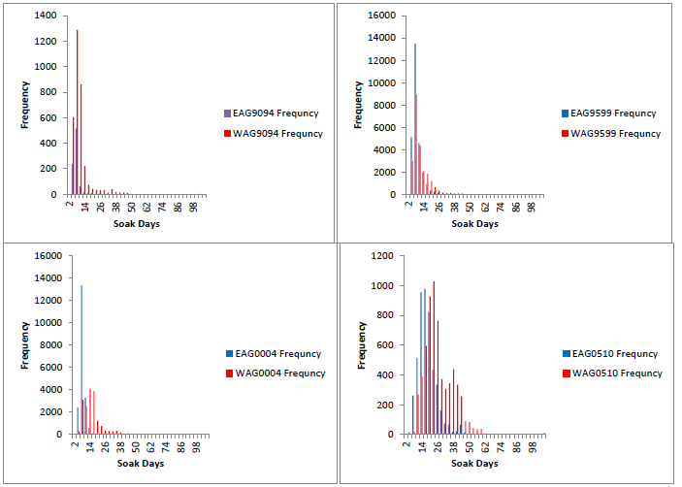

Figure C.1. Histograms of soak times by area (EAG and WAG) for five-year periods. Note that the y-axes are different scales.

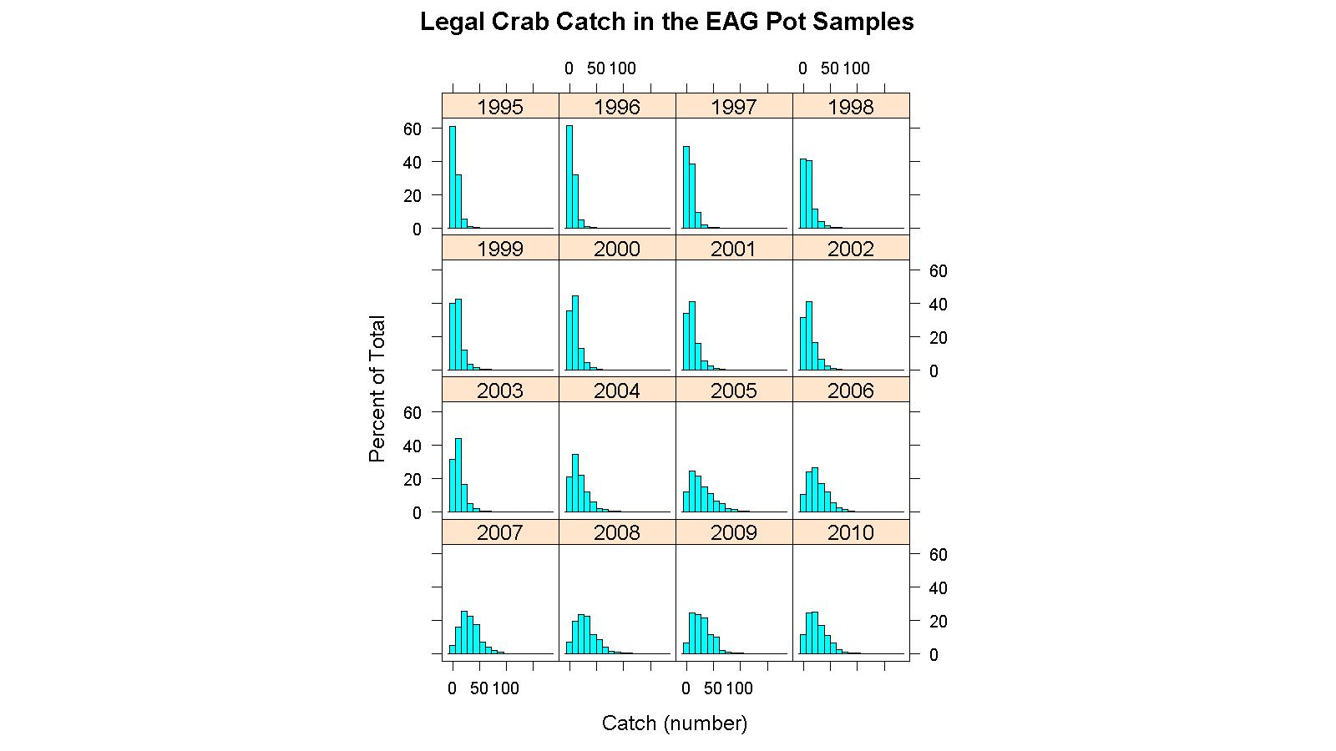
Figure C.2. Frequency distribution of legal crab catch in observer data by year for EAG.

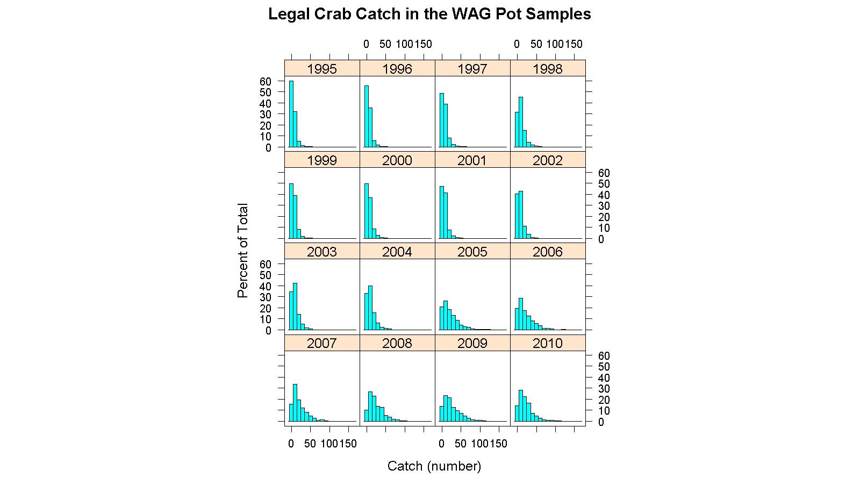
Figure C.3. Frequency distribution of legal crab catch in observer data by year for WAG.

